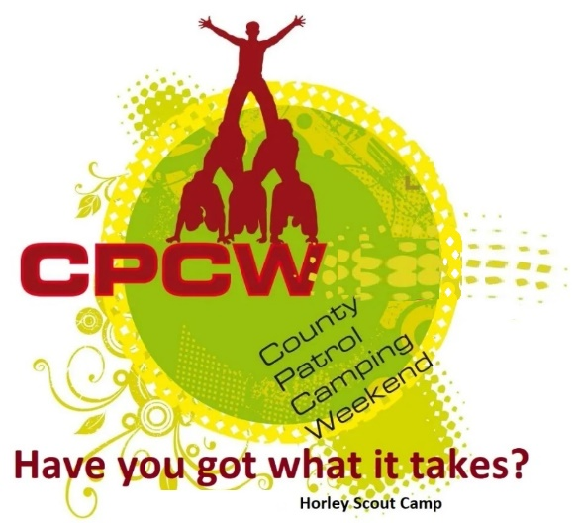
Activity Instruction Sheet
Woggle Making
Supervising Adults should have read the risk assessment for this activity before running.
Equipment required: Woggle blanks & laser engraver
Description of Activity
Opportunity to make a Woggle of a Scouts’ own design as a souvenir [UNSCORED]
Activity Set Up Instructions
Select a quieter craft area with a table and chairs.
Receive instruction from Andy Scully on safe engraver use before starting.
Note that the equipment has physical guards to prevent exposure to the laser, these must not be bypassed and the equipment must only be used with the provided leather woggle blanks.

Risk Assessment
What could go wrong? | What is Risk from it? | Who is at risk? | What are you going to do about it?
Lack of appropriate supervision | Unsupervised Scouts are likely to harm themselves or each other doing the activity or misusing the equipment provided. | Young people | Activity must have an adult present.
Laser safety | Laser burn or loss of sight | Young people, adult volunteers and visitors | Supervision to ensure participants rfollow the operating procedure for the laser engraver. Laser engraver has physical guard controls which must not be bypassed.

