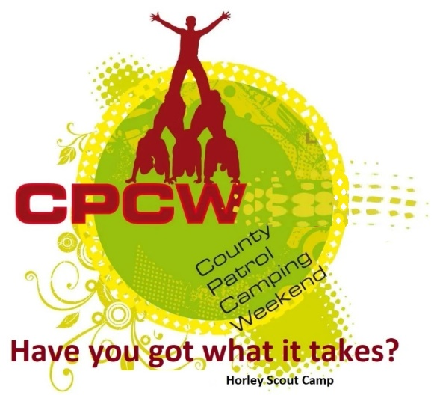
Activity Instruction Sheet
Welly Wanging Activity
Supervising Adults/Explorers should have read the risk assessment for this activity before running.
Equipment required: Wellies & Hoola Hoops, cones to make throwing area safe, Marking sheet.
Description of Activity
The Welly Wanging is a 20 minute event with patrols given points on how well they are able complete the task.
Activity Set Up Instructions
Select a good flat grass area that is clear from overhead and other obstructions.
Set up a wanging line to throw from and the hoola hoops as targets for the patrols to hit with the wellies.
Then use cones to zone off the area of throwing.
The task is for the patrol members to take it in turn to wang a welly and as a patrol hit each of the hoola hoop targets in the given time. They should not change throwing order once they have started.
Once set up the distance of the hoola hoops should not change to ensure it is fare on both days.
Instructions for Participants
You task is to one at a time wang a welly and land it in a hoola hoop target.
You should stay in the order you start and wang wellies in this order.
As a patrol you need to lad a welly in each hoola hoop.
Only wellies IN or partially in hoola hoops count. If they bounce out, then they do not count.
If you run out of wellies, then on the instructions of your supervisors, you should collect the wellies NOT in the hoola hoops, return them to the wanging line and start again.

You will receive 5 points if you complete the task well within the time given and show excellent teamwork.
You will receive 4 points if you complete the task within the time given and show good teamwork.
You will receive 3 points if you complete most of the task within the time given and show good teamwork.
You will receive 2 points if you complete some of the task within the time given and show good teamwork.
You will receive 1 points if you complete some of the task within the time given and show reasonable teamwork.

If an instructor tells you to stop, you are to stop immediately.

Risk Assessment
What could go wrong? | What is Risk from it? | Who is at risk? | What are you going to do about it?
Lack of appropriate supervision | Unsupervised Scouts are likely to harm themselves or each other doing the activity or misusing the equipment provided. | Young people | Activity must have an adult present.
Slips, trips and falls | Slips, trips and fall related injuries | Young people, adult volunteers and visitors | Keep activity areas of trip hazards.
Weather | Injury from high winds or lightning | Young people, adult volunteers and visitors | Activities that may have to be stopped during strong winds, heavy rain or if thunderstorms are predicted. Event Lead responsible for monitoring.
Being struck by objects from the game | Struck-by injury | Young people, adult volunteers and visitors | Instruct participants to stay behind person throwing and to only enter the danger area when instructed by the Leader. Maintain good separation of queue in the layout. Leader to monitor area and stop anyone going into the area whilst the game is being played. Any dangerous throws (i.e. no control over direction) should be dealt with immediately, point out danger. If next throw still not in the right direction ask them not to participate further. Person reponsible for retrieving should be alert and facing throwers at all times.

