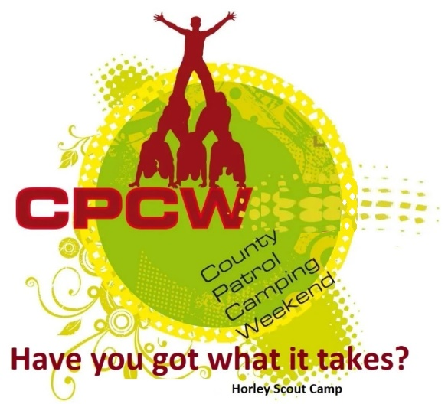
Activity Instruction Sheet
Leaky Tube
Supervising Adults/Explorers should have read the risk assessment for this activity before running.
Equipment required: Cones, Pegs & Mallet (to secure), Bin of water (and access to water), filling cups, Scoring sheet.
Description of Activity
The Leaky Tube activity is a 20 minute where the best teamwork will the most CPCW points. Patrols attempt to fill the leaky tube with water to float the duck so that is is level with the top of the tube, at which point the task in complete.
Activity Set Up Instructions
Select a good flat grass area that is clear from overhead and other obstructions, but near to one of the taps available.
Set up a start line and the Leaky Tube (pegs should be level with the ground so that they do not create a hazard). Also set up cones to cordon off the game area.
The same number of filling cups (3) should be available for each team.
The filling bin should be placed behind the start line and filled with water. (This will need topping up during the day).
If required (due to very wet slippery / muddy ground), move the area to a new section of the field.
Instructions for Participants
Your task is to fill the tube with water so that the duck rises so that it is level with the top of the tube. The team that do this and show great teamwork will win maximum points.
All Patrol members must take part.
The game area will be wet and slippy, so you must WALK, NOT RUN.
You only have filling 3 cups and at no time should you throw these otherwise a penalty point will be allocated.
You may not move the filling bin or the tube.
Work as a team.
If the leader shouts stop, you must stop immediately.
DO NOT reach into the tube to raise the duck or you will have to start again.
Risk Assessment
What could go wrong? | What is Risk from it? | Who is at risk? | What are you going to do about it?
Slips, trips and falls | Slips, trips and fall related injuries | Young people, adult volunteers and visitors | Keep activity areas of trip hazards.
Weather | Injury from high winds or lightning | Young people, adult volunteers and visitors | Activities that may have to be stopped during strong winds, heavy rain or if thunderstorms are predicted. Event Lead responsible for monitoring.
Collision between team members | Ability for colliding parties to injure each other | Young people, adult volunteers and visitors | Stop the activity if speed is escalating and likely to cause an accident.

