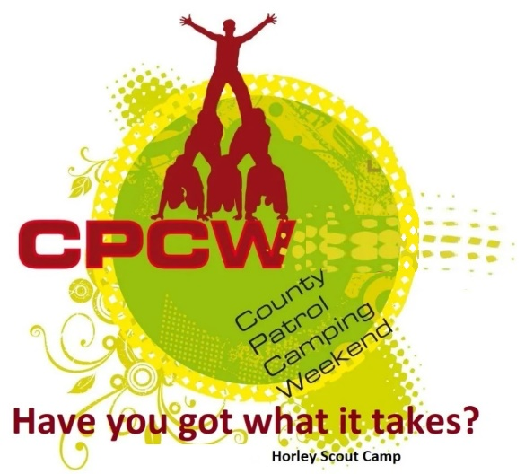
Activity Instruction Sheet
Straw Tower Activity
Supervising Adults/Explorers should have read the risk assessment for this activity before running.
Equipment required: Paper Straws and sticky tape, measuring tape, Paper cups, Marking sheet.
Description of Activity
The Straw Tower is a 20 minute event with patrols given points on how well they are able to make their item in the time given.
Activity Set Up Instructions
Select a good flat grass area that is clear from overhead and other obstructions. This could be in the activity tent.
Prepare the straws and tape ensuring there is the same amount for each participating group.
Give the instruction below and when their time is up, place the item (paper cup or alternative) on the top.
Measure the height of the tower, post item addition and award the points accordingly.
Instructions for Participants
You task is to build the tallest self-supporting tower your team can in the time given, with the items you are given.
The tower must also be able to support the item you are given on the top of it without collapsing, if it does collapse , then it will only be measured from it’s highest point AFTER the collapse.

Points are awarded for height of the tower, whether it can support the weight of given object that must sit on the top and your teamwork in this task.
You will receive 5 points for a tower of 3 meters plus that will support the item and that you have shown excellent teamwork.
You will receive 4 points for a tower of 2.5 meters plus that will support the item and that you have shown very good teamwork.
You will receive 3 points for a tower of 2 meters plus that will support the item and that you have shown good teamwork.
You will receive 2 points for a tower of 1.5 meters plus that will support the item and that you have shown good teamwork.
You will receive 1 points for a tower of less than 1.5 meters that will support the item and that you have shown good teamwork.

If an instructor tells you to stop, you are to stop immediately.

Risk Assessment
What could go wrong? | What is Risk from it? | Who is at risk? | What are you going to do about it?
Slips, trips and falls | Slips, trips and fall related injuries | Young people, adult volunteers and visitors | Keep activity areas of trip hazards.
Cutting with tools | Cuts and abrasions from a slip towards the body | Young people | Supervision required to ensure participants are cutting away from the body. Position cutters far enough apart and in a safety cordon to eliminate risk to others, use seating to try to keep cutters static.

