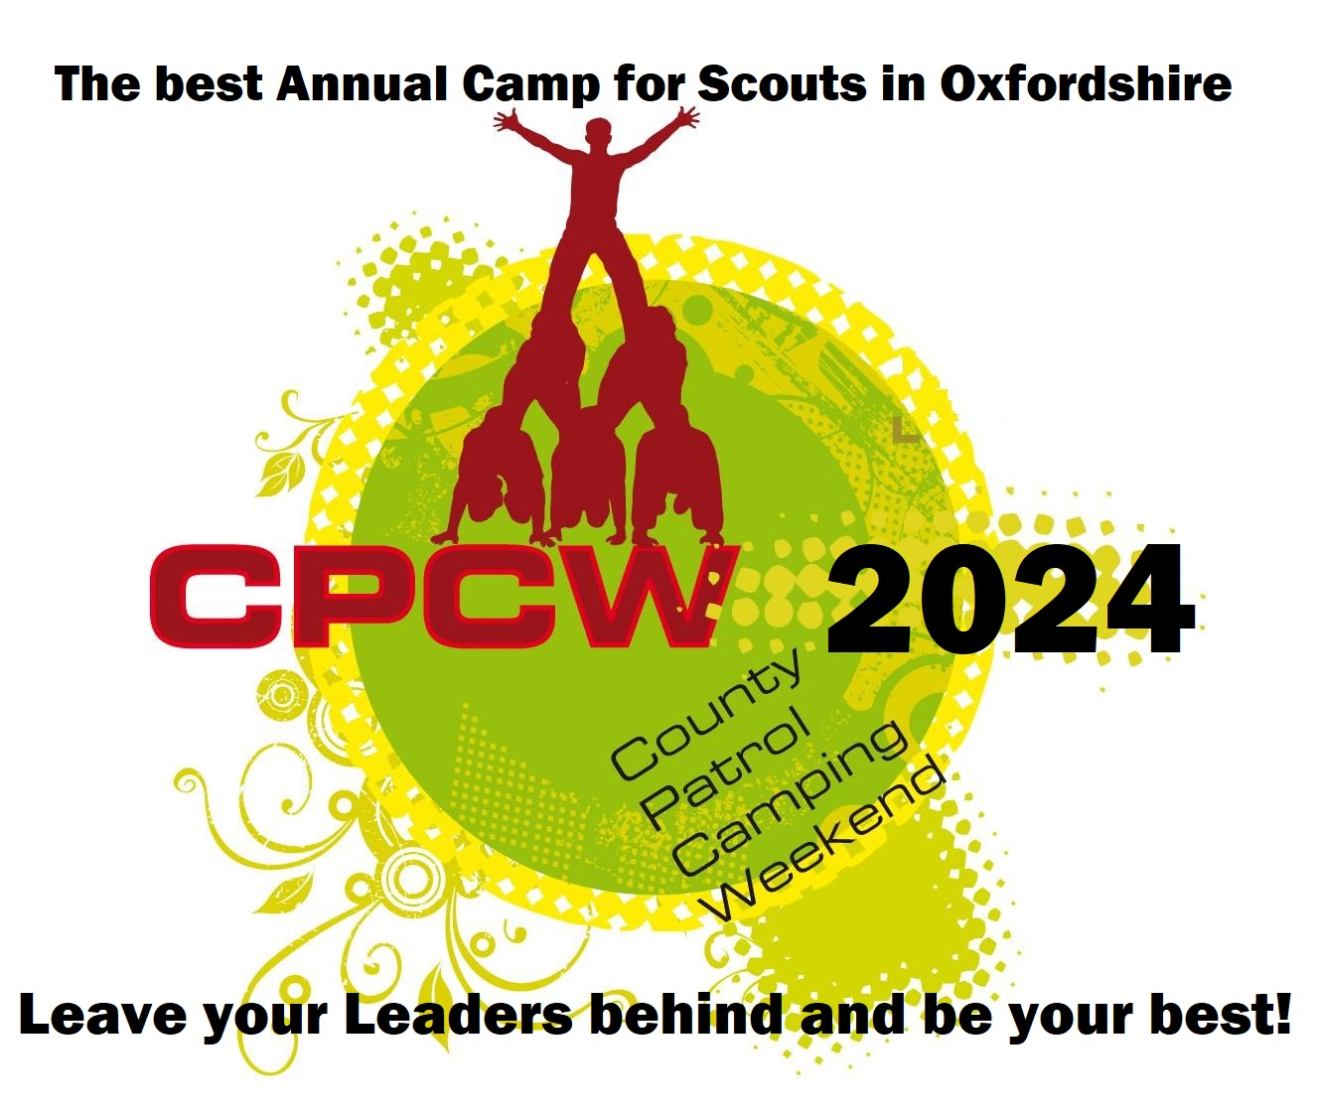 | COUNTY PATROL CAMPING WEEKEND  4th – 6th October 2024  The Marking Scheme and Competition

These notes are for Scout Leaders and Scouts who want to know how we mark the competition and what feedback you will receive.
- The County Patrol Camping Weekend (CPCW) has been running for over 25 years and over that time we have changed the way in which the competition is marked according to feedback from Scouts and Leaders.
- As well as the competition element to the weekend, we want to ensure that the Scouts and their Leaders get feedback about the Scouts’ camping skills.
- Marking is given over a set number of points which can only be allocated over a set number of Patrols, allocating the most points to the most competent and the lowest number of points to the least competent.
The Competition
- There is a separate County Cooking Competition this year again on Saturday for all three hot meals cooked during the day (based on the camp theme of TRAFFIC LIGHTS). The three meals on Saturday, (breakfast, lunch and dinner) will be judged by Zone staff on each Zone and then the winning Patrol of each Zone will go forward to a Ready Steady Cook type final on the main stage of the CPCW Marquee on the Saturday evening, with ingredients supplied by CPCW and cooking on gas stoves.
- We will have other individual competitions over the weekend for Archery, Shooting and more, based on total Patrol points scored and Individual highest scores, with tiebreakers settled over knock out style final rounds. Patrols will be given the choice to either take part in the Archery or Rifle Shooting competition upon registration on a ‘first come first served basis’. If Archery is full by the time your Patrol registers, you will compete in the Rifle Shooting and vice-versa.
- The main competition is marked over the entire weekend, and it takes into account how well each Patrol participates in the event, together with how well the Patrol camps. We are marking the competition by giving Patrols a certain number of woggles (‘points’ if you like) for various things:
- Teamwork
- Camping skills
- Safety & Personal Hygiene
- Food and meals
- Working with others
- Theme of ‘Sustainability’ across the weekend
- Participation in the activities
- The Patrol will be marked at various points over the weekend by Zone staff and activity staff. By the end of the weekend, the winner is the Patrol with the highest number of woggle points awarded to them. This year we hope to reduce or see an end to paper scoring as much as possible and will be using our registration software ‘Woggle-events.co.uk’ to keep scores for Patrols over the weekend. All in keeping with the theme of Sustainability where we can!
- Event staff will be able to award extra points to Patrols when they see good deeds and acts of kindness to others throughout the event / camp.

Feedback
- The zone staff will complete a short report on each Patrol and give it to the Patrol Leader at the end of the event. We will also scan in the report and that can be made available to Leaders after the event on request.
- We will provide feedback on what the Patrol did well and what the Patrol could improve in the following areas: teamwork, joining-in, campsite, skills, menu, food and the competition meal.
- The form that we will use to provide the feedback is on the DOWNLOADS section of the event website www.cpcw-oxon.events

Awards
- All Scouts and Leaders attending the camp will be given an Event Woggle to take home at the end of the camp.
- The winning Patrol will receive the CPCW Trophy to keep for the year and they will be asked to return this before the following year, and we hope return to defend their title.
- Trophies will be given for the CPCW County Archery and Rifle Shooting Competition to the winning Patrol and the winning individual highest score. These again will be needed to be returned for the following year please.
- Patrol Certificates will also be given to Patrol Leaders showing their position in the camp.

