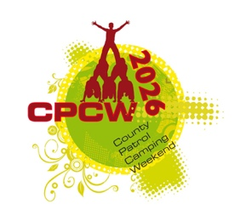 | COUNTY PATROL CAMPING WEEKEND  2nd – 4th October 2026  Patrols Event / Camp Program

Here is how we hope that things are going to go over the weekend. We of course try our best to keep to schedule, but some things are out of our control and can change things quite dramatically. So, this is a guide to how we expect our fun filled weekend to go:

THEME: WHY SCOUT?

We are this year rerunning the popular, ‘CPCW has got talent’. This is an opportunity for anyone in your Patrol that has got a talent, or as a Patrol you would like to sing a song, act out a sketch or do something really just wacky, based around our theme for the event maybe, then the Zone Leaders will judge who is best to go through and represent the Zone at the Saturday Night Campfire final.

FRIDAY

- Patrols arrive from 6:00pm to 8:00pm at registration (make sure you know your Patrol name and Scout Group name please before you arrive to checking-in).
- 6:00pm to 9:00pm – Patrols put up tents and camp on Zone
- 9:00pm – 10:30pm – Camp Disco and BBQ
- 11:00pm – Camp Quiet

SATURDAY

- 6:00am – 8:30am – Patrols cook breakfast Cooking Competition START
- 8:45am – Flag Break
- 9:30am – 12:00pm - Activities
- 12:30pm – 2:00pm – Lunch Cooking Competition
- 2:00pm – 4:30pm – Activities
- 5:00pm – 6:30pm – Dinner Cooking Competition
- 7:30pm – Silent Disco / Camp Fire, sing-along, CPCW Got Talent & s’mores / Activities
- 11:00pm Camp Quiet

SUNDAY

- 6:00am – 8:30am – Patrols cook breakfast
- 8:45am – Flag Break
- 9:00am – 11:30am - Ready Steady Cook Zone Winners Cooking Competition & Activities
- 11:30am – 12:30am – Lunch
- 12:30am – BREAK CAMP
- 2:00pm – 3:00pm FLAG BREAK and PRESENTATIONS

