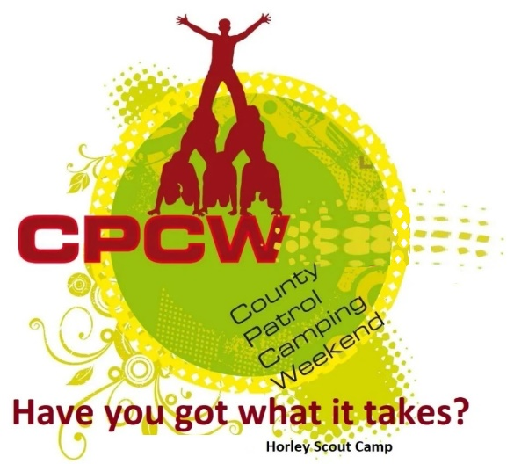
Activity Instruction Sheet
Painting by Feet Activity
Supervising Adults/Explorers should have read the risk assessment for this activity before running.
Equipment required: Paint, Brushes, Paper, Rinsing Water, Benches to sit on, Marking sheet.
Description of Activity
The Painting by feet Activity is a 20 minute event with patrols given points on how well they are able to complete their paintings time given.
Activity Set Up Instructions
Select a good flat grass area that is clear from overhead and other obstructions.
(This could be inside the main activity tent).
Set up the paints, brushes and water then explain the task.
Instructions for Participants
You task is for each of you to use your feet to hold a paint-brush, to paint 3 pictures.
Each patrol member should help contribute to EVERY picture.
The pictures you paint should be of different recognisable wild animals.
The better the quality of the pictures the more points you will earn.
----------------------------
For 3 Excellent wild animals paintings where all patrol members contribute to all 3 paintings you will score 5 points.
For 3 very good wild animals paintings where all patrol members contribute to all 3 paintings you will score 4 points.
For 3 good wild animals paintings where all patrol members contribute to all 3 paintings you will score 3 points.
For 3 poor wild animals paintings where all patrol members contribute to all 3 paintings you will score 2 points.
For 3 or less poor wild animals paintings where not all patrol members contribute to all paintings you will score 1 point.
If an instructor tells you to stop, you are to stop immediately.

Risk Assessment
What could go wrong? | What is Risk from it? | Who is at risk? | What are you going to do about it?
Slips, trips and falls | Slips, trips and fall related injuries | Young people, adult volunteers and visitors | Keep activity areas of trip hazards.
Weather | Injury from high winds or lightning | Young people, adult volunteers and visitors | Activities that may have to be stopped during strong winds, heavy rain or if thunderstorms are predicted. Event Lead responsible for monitoring.
Allergies | Allergic reaction to foods or substances (e.g. paint) | Young people and adult volunteers | Cross check allergy list on woggle events, discuss non-participation with affected individuals. Same with any self-presenting allergies.

