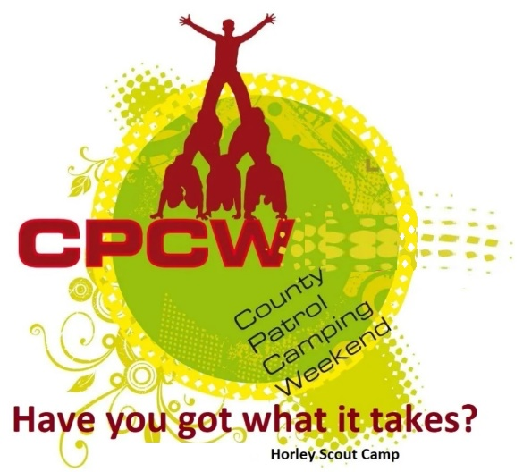
Activity Instruction Sheet
Soap Carving Activity
Supervising Adults/Explorers should have read the risk assessment for this activity before running.
Equipment required: Soap Bars, soap carving tools, pens/pencils, Marking sheet.
Description of Activity
The soap carving is a 20 minute event with patrols given points on how well they are able to make their items in the time given (Without injuring themselves!)
Activity Set Up Instructions
Select a good flat grass area that is clear from obstructions (this could be in the activity tent).

Instructions for Participants
Each scout to carve their bar of soap into a recognisable animal – Points are awarded for accuracy and how easily the animal is identified.
- Get a bar of soap and all your tools.
- Draw your design onto the soap.
- Using your tools gently carve away at the soap to create your design.
- Be careful when using knives and sharp tools.
- Take care not to get the soap in your eyes or mouth – wash the soap out with cold water if you do.

If you all are able to carve an excellent animal from your soap in the time given you will be awarded 5 points.
If you all are able to carve a very good animal from your soap in the time given you will be awarded 4 points.
If you all are able to carve an good animal from your soap in the time given you will be awarded 3 points.
If you all are able to carve an OK animal from your soap in the time given you will be awarded 2 points.
If not all of you are able to carve a recognisable animal from your soap in the time given or you show poor teamwork you will be awarded 1 points.

If an instructor tells you to stop, you are to stop immediately.

Risk Assessment
What could go wrong? | What is Risk from it? | Who is at risk? | What are you going to do about it?
Lack of appropriate supervision | Unsupervised Scouts are likely to harm themselves or each other doing the activity or misusing the equipment provided. | Young people | Activity must have an adult present.
Cutting with tools | Cuts and abrasions from a slip towards the body | Young people | Supervision required to ensure participants are cutting away from the body. Position cutters far enough apart and in a safety cordon to eliminate risk to others, use seating to try to keep cutters static.
Allergies | Allergic reaction to foods or substances (e.g. paint) | Young people and adult volunteers | Cross check allergy list on woggle events, discuss non-participation with affected individuals. Same with any self-presenting allergies.

