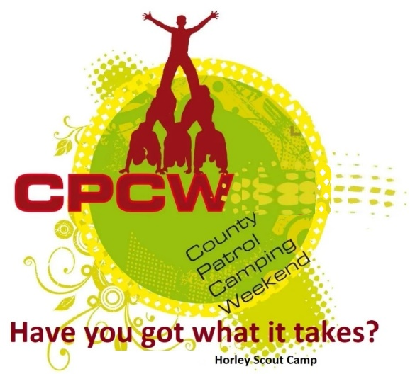
Activity Instruction Sheet
Tug-o-War
Supervising Adults/Explorers should have read the risk assessment for this activity before running.
Equipment required: Tug-o-war rope
Description of Activity
Knockout competition to run throughout Sat, finals on Sunday
Activity Set Up Instructions
Select a suitable piece of ground near the flagpole.
Run competition according to available entries and teams.

Risk Assessment
What could go wrong? | What is Risk from it? | Who is at risk? | What are you going to do about it?
Lack of appropriate supervision | Unsupervised Scouts are likely to harm themselves or each other doing the activity or misusing the equipment provided. | Young people | Activity must have an adult present.
Slips, trips and falls | Slips, trips and fall related injuries | Young people, adult volunteers and visitors | Keep activity areas of trip hazards.
Weather | Injury from high winds or lightning | Young people, adult volunteers and visitors | Activities that may have to be stopped during strong winds, heavy rain or if thunderstorms are predicted. Event Lead responsible for monitoring.
Friction burns | Abrasion injury | Young people | Teams to be warned about handing the rope and the risk of friction burns occuring if they let the rope run through their hands.
Rope failure or Off-balance | Surprise fall | Young people, adult volunteers and visitors | Check all rope is in good condition.  Regular inspections of the rope to take place.  Important not to catch participants offguard or off balance by using clear and appropriately timed 'take the strain' and 'heave' commands.

