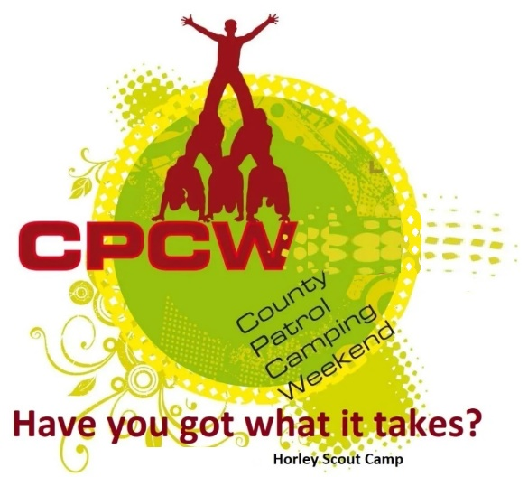
Activity Instruction Sheet
Patrol Tent Activity
Supervising Adults/Explorers should have read the risk assessment for this activity before running.
Equipment required: 2 patrol tents, “How to” instruction sheets, Marking sheet.
Description of Activity
The Patrol tent activity is a 20 minute event with patrols given points on how well they are able to erect then take down and fold a canvas patrol tent.
Activity Set Up Instructions
Select a good flat grass area that is clear from overhead and other obstructions.
The Patrol tent should be removed from the bag and laid out as it is to be returned.
The 2nd Patrol Tent is in case a team runs out of time and you need to run the next patrol
Safety Notice: Teams MUST have 2 members holding the poles until the main guy lines are sufficiently secured.
The doors must be capable of closing (but do not need to be closed).
Bottom pegs (that secure the sides to the floor) do not need to be pegged, but all other lines must be secured.
Instructors are to give verbal instructions on when the patrol can let go of the poles and when the tent is up and ready to be taken down.
When putting down All lines must be hanked correctly. This may need demonstrating before the teams start.
If required (due to wet slippy ground), move the area to a new section of the field.
Instruction sheets are provided that can be read before taking part in the race.
Instructions for Participants
You task is to put up the Patrol Tent fully to the instructors standard and take it down and pack it in the shortest time possible (safely). You are marked on completing the task in the given time & Teamwork, not speed.
There are instruction cards for you to quickly read (if you need to) before you start.
Safety Notice: Teams MUST have 2 members holding the poles until the main guy lines are sufficiently secured. You will be told by the instructors when it is safe to let go.
The doors must be capable of closing (but does not need to be closed).
Bottom pegs (that secure the sides to the floor) do not need to be pegged, but all other lines must be secured.
When the Instructors are happy that the tent is correctly and safely up, you will be intructed to take it down and pack it up.
All lines and guy lines must be hanked correctly, Pegs in the peg bag, poles in the pole bag and canvas folded as you see it here at the start.
If an instructor tells you to stop, you are to stop immediately. These big tents and large poles are heavy and can cause injury if you do not use them safely.
Risk Assessment

What could go wrong? | What is Risk from it? | Who is at risk? | What are you going to do about it?
Lack of appropriate supervision | Unsupervised Scouts are likely to harm themselves or each other doing the activity or misusing the equipment provided. | Young people | Activity must have an adult present.
Slips, trips and falls | Slips, trips and fall related injuries | Young people, adult volunteers and visitors | Keep activity areas of trip hazards.
Weather | Injury from high winds or lightning | Young people, adult volunteers and visitors | Activities that may have to be stopped during strong winds, heavy rain or if thunderstorms are predicted. Event Lead responsible for monitoring.
Dropping canvas and poles on someone | Heavy equipment creating head injury or brusing | Young people, adult volunteers | Check poles are in working order. Be vigilant during the unguyed part of the pitching and striking of the tent.
Using mallets | Impact injury to hands or feet | Young people, adult volunteers and visitors | Check mallet heads before use and be vigilant to improper use.

