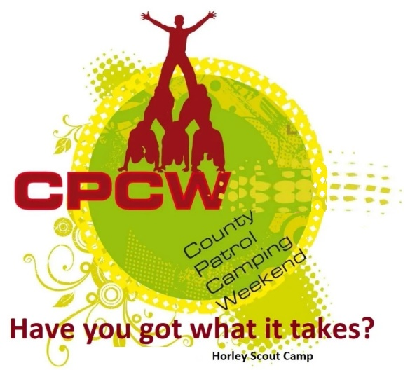
Activity Instruction Sheet
What’s That Flavour? Activity
Supervising Adults/Explorers should have read the risk assessment for this activity before running.
Equipment required: Different flavour Crisps, Bowls, pens, answer sheet, Marking sheet.
Description of Activity
What’s That Flavour? is a 20 minute event with patrols given points on how well they are able to recognise the Exact flavour of the crisps. They are given to taste.
Activity Set Up Instructions
Select a good flat grass area that is clear of obstructions (this could be in the activity tent sat on benches at a table).
The Patrol should take it in turns to taste one of the different flavours of crisps and write down the flavour in the sections on the answer sheet.
The Letter on the Answer sheet are randomised so that following teams do not get the same order (or hopefully the same flavours) as the previous team. Once the team has tasted and filled in the sheet, you will tell them which answers are incorrect. They can then (in tern) try those and guesses again.
ONLY AN EXACT ANSWER as per the packet description, will be correct.
The Team is allowed a maximum of 15 minutes & 5 attempts at any one flavour.
Instructions for Participants
You task is to Guess the EXACT flavour of the crisps and write them down on your answer sheet.
One at a time, taste the Crisps following the order on your sheet.
Once a Scout tastes a crisp, they should put their guess in the answer sheet, then the next scout can try the next flavour and so on.
Once you have filled in all the boxes on your answer sheet your instructor will tell you if you are right and which (if any) are incorrect.
You will then (in tern) be able to taste and re-guess those incorrect flavours.
HOWEVER – you can only guess any flavour a maximum of 5 times.
You will receive 5 points if you identify each flavour exactly in the time given AND work excellently as a team.
You will receive 4 points if you almost identify all flavour in the time given AND work excellently as a team.
You will receive 3 points if you don’t identify 2 flavours in the time given AND work well as a team.
You will receive 2 points if you don’t identify 3 flavours in the time given AND work well as a team.
You will receive 1 points if you don’t identify 4+ flavours in the time given and don’t work well as a team.

Risk Assessment
What could go wrong? | What is Risk from it? | Who is at risk? | What are you going to do about it?
Allergies | Allergic reaction to foods or substances (e.g. paint) | Young people and adult volunteers | Cross check allergy list on woggle events, discuss non-participation with affected individuals. Same with any self-presenting allergies.

