**Goat Therapy Program**

Favorite Oasis is a 501(c)3 Ohio-based nonprofit farm sanctuary. Our mission is to provide lifelong care for abandoned, neglected, and unwanted farm animals with the dual purpose of creating co-beneficial animal assisted therapy programs targeted to highlight the mutually beneficial interactions between humans and animals.

Pet therapy programs are currently taking off across the county and globally. People everywhere are realizing the benefits that can come from interaction with animals. These benefits take many forms such as:

* Decreased anxiety
* Lower blood pressure
* Reduced risk of heart attack or stroke
* Lower rates of depression

**Meet the Goats**

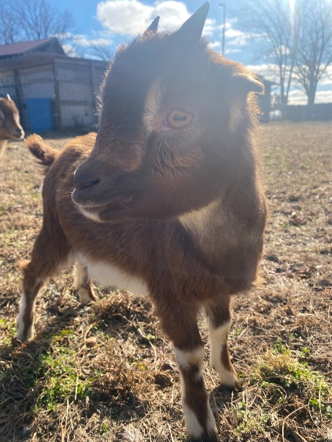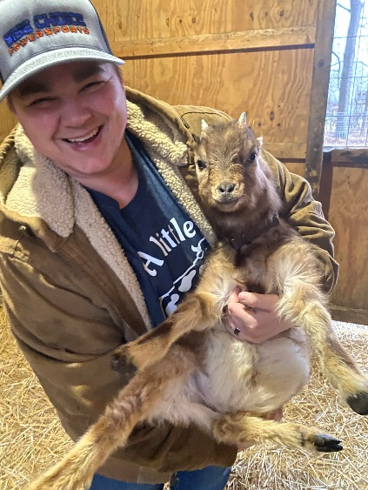

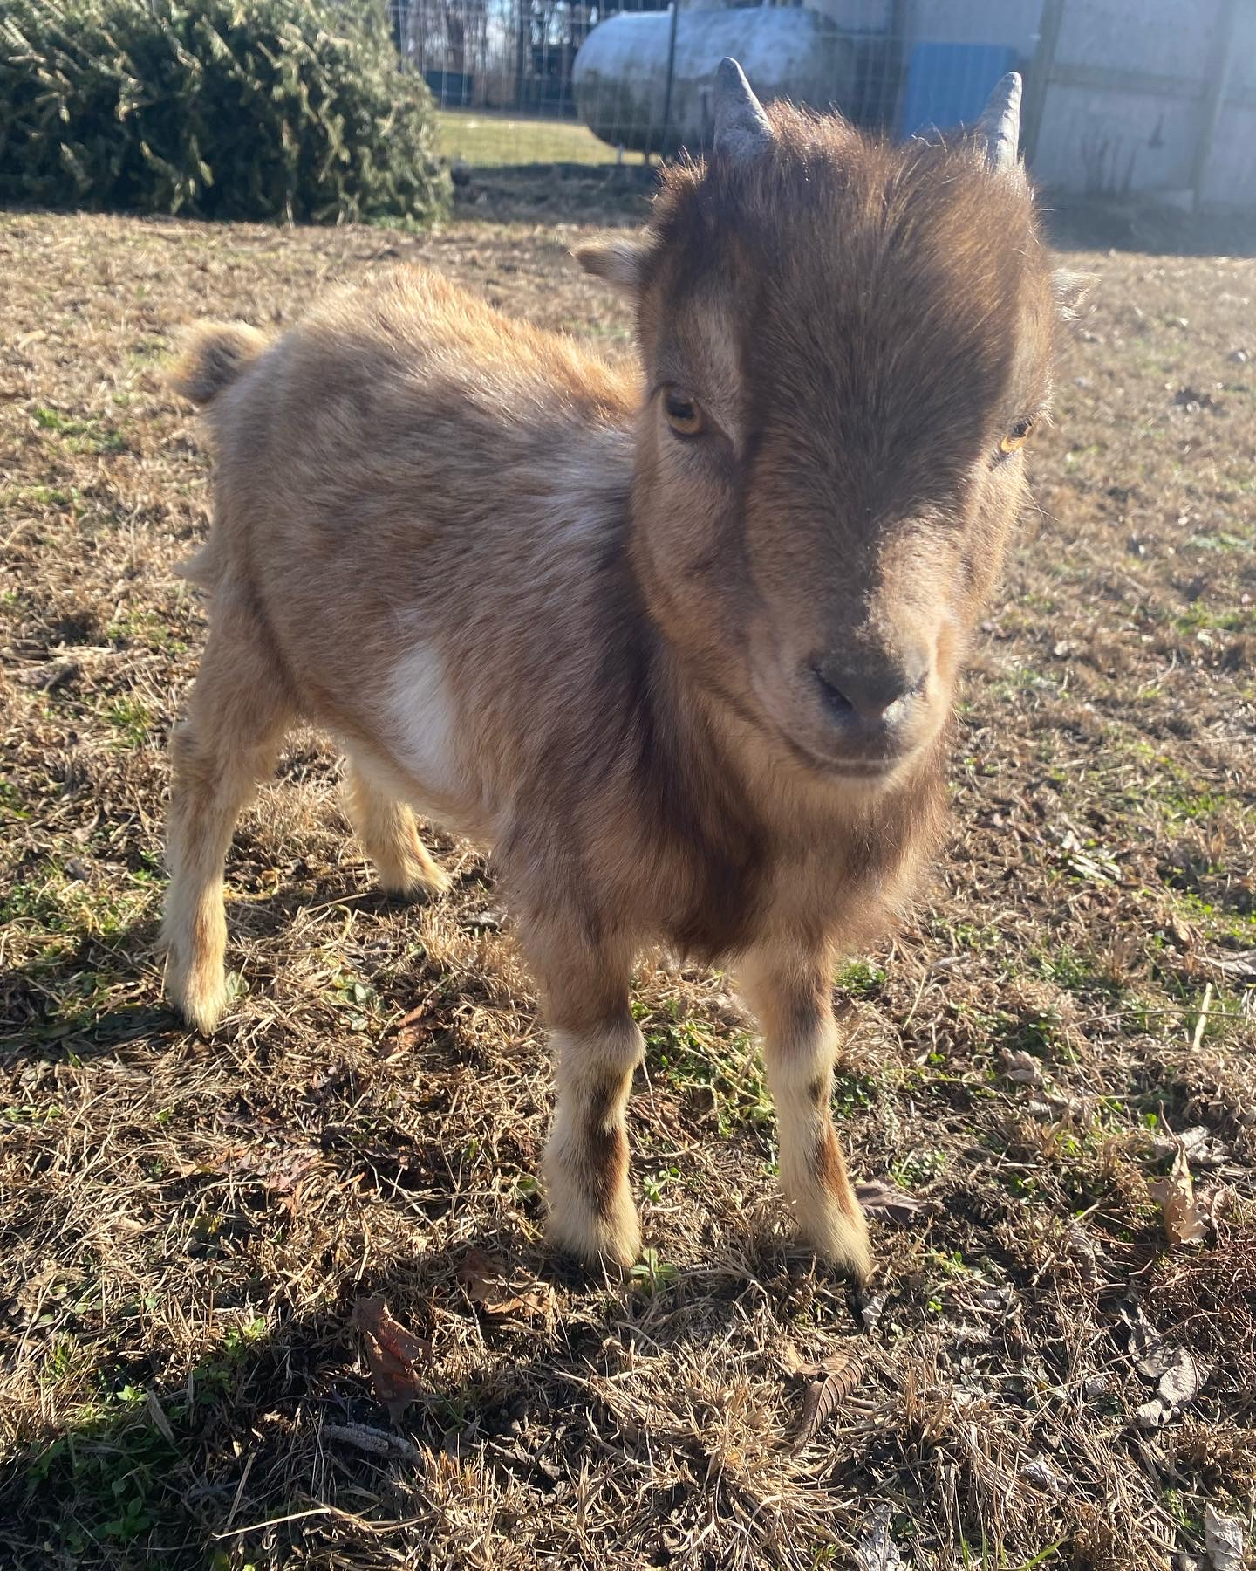

Junie and Allan are Nigerian dwarf crosses who were born in 2022. Since this is a milking breed, wethers are the byproduct of this industry often holding the fate of being sent to the meat market. These loving brothers were picked up by the team and now spend their days enjoying sanctuary life and interacting with people of all kinds during therapy visits.

Any interest and inquiries, please contact Taylor Favorite at [taylor@favoriteoasis.org](mailto:taylor@favoriteoasis.org) or 419-261-8539 for further information.