Certified Translation of _ | Traducción certificada de _
I, _, certify that I am fluent in the English and Spanish languages, competent to translate the attached document(s), and that this translation is true, complete and accurate to the best of my ability. Any alterations or attachments to these pages invalidate my certification. Square brackets indicate a translator’s note not found in the original document. | Yo, _, certifico que domino los idiomas inglés y español, y que soy competente para traducir el (los) documento(s) adjunto(s), y que esta traducción es verdadera, completa y precisa según mi mejor capacidad. Cualquier alteración o documento agregado a estas páginas invalida mi certificación. Los corchetes indican una nota del traductor referente a información que no está presente en el documento original.

Translator’s signature: _____________________________
Firma del traductor

Date signed: ______________________
Fecha de firma:

[contact information]

STATE OF TEXAS, COUNTY OF TRAVIS

On (date) ________________, before me, the undersigned, a Notary Public in and for said State, personally appeared _, ( ) personally known to me -OR- ( ) proved to me on the basis of satisfactory evidence to be the person whose name is subscribed to this instrument and acknowledged to me that he executed the same in his authorized capacity, and that by his signature on the instrument the person, or the entity on behalf of which the person acted, executed the instrument.
WITNESS my hand and official seal.

Signature _________________________________

Printed name ______________________________

Date my commission expires __________________ (Seal)

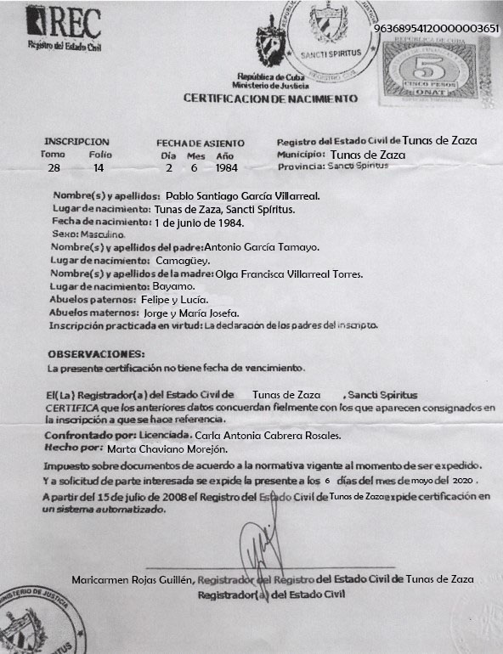

[logo] REC  Vital Statistics Registry |  | [coat of arms]  Republic of Cuba  Ministry of Justice  CERTIFICATE OF BIRTH |  |  |  |  | [circular rubber stamp]  REPUBLIC OF CUBA MINISTRY OF JUSTICE  [coat of arms]  SANCTI SPIRITUS  VITAL STATISTICS | 96368954120000003651
[tax stamp]
REPUBLIC OF CUBA
MINISTRY OF FINANCE
5
FIVE CONVERTIBLE PESOS
ONAT [National Tax Administration Office]
TAX STAMPS
REGISTRATION |  |  | DATE OF FILING |  |  | Vital Statistics Registry of Tunas de Zaza
Volume  28 | Page  14 |  | Day  2 | Month  6 | Year  1984 | Municipality: Tunas de Zaza  Province: Sancti Spiritus

Full name: Pablo Santiago Garcia Villarreal
Place of birth: Tunas de Zaza, Sancti Spiritus
Date of birth: June 1, 1984
Sex: Male
Father’s full name: Antonio Garcia Tamayo
Place of birth: Camaguey
Mother’s full name: Olga Francisca Villarreal Torres
Place of birth: Bayamo
Paternal grandparents: Felipe and Lucia
Maternal grandparents: Jorge and Maria Josefa
Registration performed by: Statement from the registrant’s parents

NOTES:
This certificate does not have an expiration date.

The Registrar of Vital Statistics of Tunas de Zaza, Sancti Spiritus
CERTIFIES that the above information faithfully corresponds to that which appears on record in the registration referenced.
Verified by: Carla Antonia Cabrera Rosales, Licensed Professional
Drawn up by: Marta Chaviano Morejon
Document tax according to the current legislation at the time of issue.
And at the request of the interested party, this document is issued on May 6, 2020.
As of July 15, 2008 the Registrar of Vital Statistics of Tunas de Zaza issues certificates through an automated system.

[circular rubber stamp]  [cut off] MINISTRY OF JUSTICE  [coat of arms]  [cut off] SPIRITUS | [signature]  Maricarmen Rojas Guillen, Registrar of the Vital Statistics Registry of Tunas de Zaza  Vital Statistics Registrar | [illegible embossed stamp]
--------------------------------------------------------------------------------------------------------------------------------------------------
[end of translation] [fin de la traducción]

