|  |  |
| --- | --- |
| **Certified Translation of _** | ***Traducción certificada de _*** |
| I, _, certify that I am fluent in the English and Spanish languages, competent to translate the attached document(s), and that this translation is true, complete and accurate to the best of my ability. Any alterations or attachments to these pages invalidate my certification. Square brackets indicate a translator’s note not found in the original document. | *Yo, _, certifico que domino los idiomas inglés y español, y que soy competente para traducir el (los) documento(s) adjunto(s), y que esta traducción es verdadera, completa y precisa según mi mejor capacidad. Cualquier alteración o documento agregado a estas páginas invalida mi certificación. Los corchetes indican una nota del traductor referente a información que no está presente en el documento original.* |

Translator’s signature: _____________________________

*Firma del traductor*

Date signed: ______________________

*Fecha de firma:*

[contact information]

STATE OF TEXAS, COUNTY OF TRAVIS

On *(date)* ________________, before me, the undersigned, a Notary Public in and for said State, personally appeared _, ( ) personally known to me -OR- ( ) proved to me on the basis of satisfactory evidence to be the person whose name is subscribed to this instrument and acknowledged to me that he executed the same in his authorized capacity, and that by his signature on the instrument the person, or the entity on behalf of which the person acted, executed the instrument.

WITNESS my hand and official seal.

Signature _________________________________

Printed name ______________________________

Date my commission expires __________________ *(Seal)*

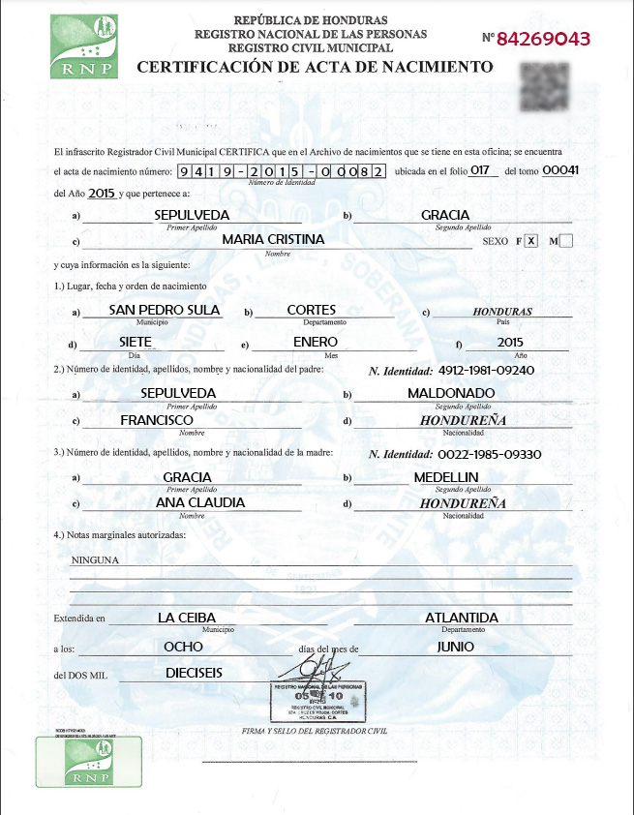

|  |  |  |  |  |  |  |  |  |  |  |  |  |  |  |  |  |  |  |  |  |  |  |  |  |  |  |  |  |  |  |  |  |  |  |  |
| --- | --- | --- | --- | --- | --- | --- | --- | --- | --- | --- | --- | --- | --- | --- | --- | --- | --- | --- | --- | --- | --- | --- | --- | --- | --- | --- | --- | --- | --- | --- | --- | --- | --- | --- | --- |
| [square, green logo]  RNP [National Registry of Persons] | | | | | **REPUBLIC OF HONDURAS**  **NATIONAL REGISTRY OF PERSONS**  **MUNICIPAL VITAL STATISTICS** | | | | | | | | | | | | | | | | | | | | | | | | | | | | NUMBER | | **84269043** |
| [background watermark with coat of arms]  REPUBLIC OF HONDURAS, FREE, SOVEREIGN AND INDEPENDENT  **BIRTH CERTIFICATE** | | | | | | | | | | | | | | | | | | | | | | | | | | | | | | | | | | | [QR code] |
| The undersigned Municipal Vital Statistics Registrar CERTIFIES that in the records contained in this institution | | | | | | | | | | | | | | | | | | | | | | | | | | | | | | | | | | | |
| birth certificate number | | | | | | **9** | **4** | **1** | | | **9** | | **-** | **2** | | | **0** | | **1** | | | **5** | | **-** | **0** | **0** | **0** | | | **8** | **2** | is found; located on page | | | |
|  | | | | | | | | | | | | | *Identity Number* | | | | | | | | | | | | | | | | | | | | | | |
| **017** | | of volume | | | **00041** | | | | of the year | | | | | | | | | **2015** | | | | | | | and which pertains to: | | | | | | | | | | |
| a) | | | **SEPULVEDA** | | | | | | | | | | | | | | | | | | b) | | | **GRACIA** | | | | | | | | | | | |
|  | | | *First Surname* | | | | | | | | | | | | | | | | | |  | | | *Second Surname* | | | | | | | | | | | |
| c) | | | **MARIA CRISTINA** | | | | | | | | | | | | | | | | | | | | | | | | | | | | | | SEX | **F**  **M** | |
|  | | | *Given Name* | | | | | | | | | | | | | | | | | | | | | | | | | | | | | |  |  | |
| and whose information is as follows:  1.) Place, date and order of birth: | | | | | | | | | | | | | | | | | | | | | | | | | | | | | | | | | | | |
| a) | | | **SAN PEDRO SULA** | | | | | | | b) | | | | | **CORTES** | | | | | | | | | | | | | c) | | | | | ***HONDURAS*** | | |
|  | | | Municipality | | | | | | |  | | | | | Department | | | | | | | | | | | | |  | | | | | Country | | |
| d) | | | **SEVEN** | | | | | | | e) | | | | | **JANUARY** | | | | | | | | | | | | | f) | | | | | **2015** | | |
|  | | | Day | | | | | | |  | | | | | Month | | | | | | | | | | | | |  | | | | | Year | | |
| 2.) Full name and nationality of father: | | | | | | | | | | | | | | | | | | | | | | | ***Identification Number: 0501-1976-00883*** | | | | | | | | | | | | |
| a) | | | **SEPULVEDA** | | | | | | | | | | | | | | | | | | b) | | | **MALDONADO** | | | | | | | | | | | |
|  | | | *First Surname* | | | | | | | | | | | | | | | | | |  | | | *Second Surname* | | | | | | | | | | | |
| c) | | | **FRANCISCO** | | | | | | | | | | | | | | | | | | d) | | | ***HONDURAN*** | | | | | | | | | | | |
|  | | | *Given Name* | | | | | | | | | | | | | | | | | |  | | | *Nationality* | | | | | | | | | | | |
| 3.) Full name and nationality of mother: | | | | | | | | | | | | | | | | | | | | | | | ***Identification Number: 0318-1987-00280*** | | | | | | | | | | | | |
| a) | | | **GRACIA** | | | | | | | | | | | | | | | | | | b) | | | **MEDELLIN** | | | | | | | | | | | |
|  | | | *First Surname* | | | | | | | | | | | | | | | | | |  | | | *Second Surname* | | | | | | | | | | | |
| c) | | | **ANA CLAUDIA** | | | | | | | | | | | | | | | | | | d) | | | ***HONDURAN*** | | | | | | | | | | | |
|  | | | *Name* | | | | | | | | | | | | | | | | | |  | | | *Nationality* | | | | | | | | | | | |
| 4.) Authorized marginal notes: | | | | | | | | | | | | | | | | | | | | | | | | | | | | | | | | | | | |
|  | NONE | | | | | | | | | | | | | | | | | | | | | | | | | | | | | | | | | | |
|  |  | | | | | | | | | | | | | | | | | | | | | | | | | | | | | | | | | | |
| Issued in | | | | **LA CEIBA** | | | | | | | | | | | | | | | |  | | | | **ATLANTIDA** | | | | | | | | | | | |
|  | | | | Municipality | | | | | | | | | | | | | | | |  | | | | Department | | | | | | | | | | | |
| on: | **JUNE 8, 2016** | | | | | | | | | | | | | | | | | | | [signature] | | | | | | | | | | | | | | | |
|  | | | | | | | | | | | | [rubber stamp]  **NATIONAL REGISTRY OF PERSONS**  **05** [RNP logo] **10**  MUNICIPAL VITAL STATISTICS  LA CEIBA, ATLANTIDA  HONDURAS, CENTRAL AMERICA  *SIGNATURE AND SEAL OF CIVIL REGISTRAR* | | | | | | | | | | | | | | | | |  | | | | | | |
| RODB (3670535975)  0268064316799/171.13.75.112 VENET  [square, green logo]  RNP [National Registry of Persons] | | | | | | | | | | | | | | | |

--------------------------------------------------------------------------------------------------------------------------------------------------

[end of translation] [*fin de la traducción*]