Certified Translation of _ | Traducción certificada de _
I, _, certify that I am fluent in the English and Spanish languages, competent to translate the attached document(s), and that this translation is true, complete and accurate to the best of my ability. Any alterations or attachments to these pages invalidate my certification. Square brackets indicate a translator’s note not found in the original document. | Yo, _, certifico que domino los idiomas inglés y español, y que soy competente para traducir el (los) documento(s) adjunto(s), y que esta traducción es verdadera, completa y precisa según mi mejor capacidad. Cualquier alteración o documento agregado a estas páginas invalida mi certificación. Los corchetes indican una nota del traductor referente a información que no está presente en el documento original.

Translator’s signature: _____________________________
Firma del traductor

Date signed: ______________________
Fecha de firma:

[contact information]

STATE OF TEXAS, COUNTY OF TRAVIS

On (date) ________________, before me, the undersigned, a Notary Public in and for said State, personally appeared _, ( ) personally known to me -OR- ( ) proved to me on the basis of satisfactory evidence to be the person whose name is subscribed to this instrument and acknowledged to me that he executed the same in his authorized capacity, and that by his signature on the instrument the person, or the entity on behalf of which the person acted, executed the instrument.
WITNESS my hand and official seal.

Signature _________________________________

Printed name ______________________________

Date my commission expires __________________ (Seal)

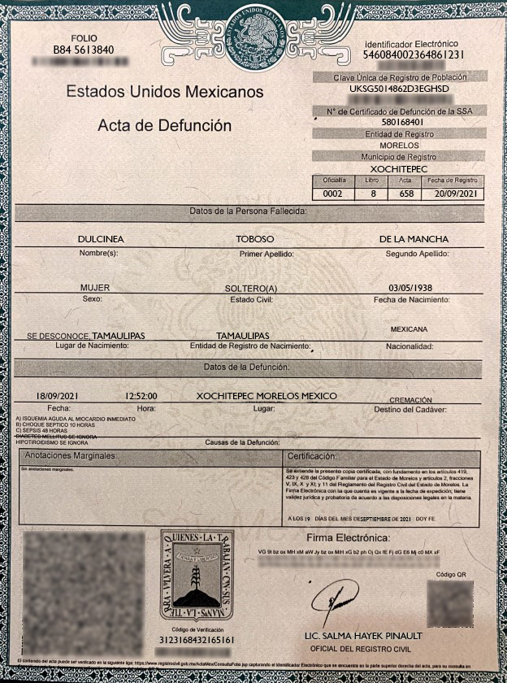

[decorative border surrounds page]
[watermark in center of page with circular seal of Mexico] UNITED MEXICAN STATES I am Mexico
PAGE  B84 5613840  [bar code] |  |  | [circular seal of Mexico]  UNITED MEXICAN STATES |  |  | Electronic Identifier  546084002364861231  [bar code]
United Mexican States  Death Certificate |  |  |  |  |  | Unique Population Registry Code
UKSG5014862D3EGHSD
[bar code]
 |  |  |  |  |  | Death Certificate Number from the Health Department
 |  |  |  |  |  | 580168401
 |  |  |  |  |  | Registering Entity
 |  |  |  |  |  | MORELOS
 |  |  |  |  |  | Registering Municipality
 |  |  |  |  |  | XOCHITEPEC
 |  |  |  |  |  | Office |  | Book | Certificate |  | Registration Date
 |  |  |  |  |  | 0002 |  | 8 | 658 |  | 9/20/2021
Decedent’s Information:
DULCINEA |  |  | TOBOSO |  |  |  | DE LA MANCHA
Name(s): |  |  | First Surname: |  |  |  | Second Surname:
FEMALE |  |  | SINGLE |  |  |  | 5/3/1938
Gender: |  |  | Marital Status: |  |  |  | Date of Birth:
UNKNOWN, TAMAULIPAS |  |  | TAMAULIPAS |  |  |  | MEXICAN
Place of Birth: |  |  | State of Birth Registration: |  |  |  | Nationality:
Information Regarding the Death:
9/18/2021 |  | 12:52:00 [P.M.] | XOCHITEPEC, MORELOS, MEXICO |  |  |  |  |  |  | CREMATION
Date: |  | Time: | Place: |  |  |  |  |  |  | Method of Disposition:
A) ACUTE MYOCARDIAL ISCHEMIA, IMMEDIATE
B) SEPTIC SHOCK, 10 HOURS
C) SEPSIS, 48 HOURS
DIABETES MELLITUS, UNKNOWN
HYPOTHYROIDISM, UNKNOWN
Causes of Death:
Marginal Notes: |  |  |  |  | Certification:
No marginal notes. |  |  |  |  | This certified copy is issued, based on Articles 419, 423, and 428 of the State Family Code of Morelos; 4, 7, and Article 2, Sections V, IX, X, and XI; and Article 11 of the Vital Statistics Regulations of the State of Morelos. The Electronic Signature that it bears is current at the date of issue; it has legal and probatory validity in accordance with the legal provisions on the matter.  ON SEPTEMBER 19, 2021, I ATTEST.
[QR code] | [shield] THE LAND SHALL RETURN TO THOSE WHO WORK IT WITH THEIR HANDS [image]  LAND AND FREEDOM  Verification Code  3123168432165161  [bar code] |  |  | ELECTRONIC SIGNATURE:  [three-line alphanumeric sequence]  [signatura]  SALMA HAYEK PINAULT, LICENSED PROFESSIONAL  VITAL STATISTICS OFFICER |  |  |  |  |  |  |  | QR Code  [QR code]
The contents of this certificate can be verified at the following link: https://www.registrocivil.gob.mx/ActaMex/ConsultaFolio.jsp using the Electronic Identifier that is found upper right side of the certificate, or on mobile devices, download an app to read the QR code.

[QR code] | [circular seal]  UNITED MEXICAN STATES | SEGOB  SECRETARIAT OF STATE | NATIONAL POPULATION AND PERSONAL IDENTITY REGISTRY OFFICE | [logo]  CONAFREC  National Council of Vital Statistics Officers

[shield]
THE LAND SHALL RETURN TO THOSE WHO WORK IT WITH THEIR HANDS
LAND AND FREEDOM
Morelos

--------------------------------------------------------------------------------------------------------------------------------------------------

[end of translation] [fin de la traducción]

