Certified Translation of _ | Traducción certificada de _
I, _, certify that I am fluent in the English and Spanish languages, competent to translate the attached document(s), and that this translation is true, complete and accurate to the best of my ability. Any alterations or attachments to these pages invalidate my certification. Square brackets indicate a translator’s note not found in the original document. | Yo, _, certifico que domino los idiomas inglés y español, y que soy competente para traducir el (los) documento(s) adjunto(s), y que esta traducción es verdadera, completa y precisa según mi mejor capacidad. Cualquier alteración o documento agregado a estas páginas invalida mi certificación. Los corchetes indican una nota del traductor referente a información que no está presente en el documento original.

Translator’s signature: _____________________________
Firma del traductor

Date signed: ______________________
Fecha de firma:

[translator’s contact information]

STATE OF TEXAS, COUNTY OF TRAVIS

On (date) ________________, before me, the undersigned, a Notary Public in and for said State, personally appeared _, ( ) personally known to me -OR- ( ) proved to me on the basis of satisfactory evidence to be the person whose name is subscribed to this instrument and acknowledged to me that he executed the same in his authorized capacity, and that by his signature on the instrument the person, or the entity on behalf of which the person acted, executed the instrument.
WITNESS my hand and official seal.

Signature _________________________________

Printed name ______________________________

Date my commission expires __________________ (Seal)

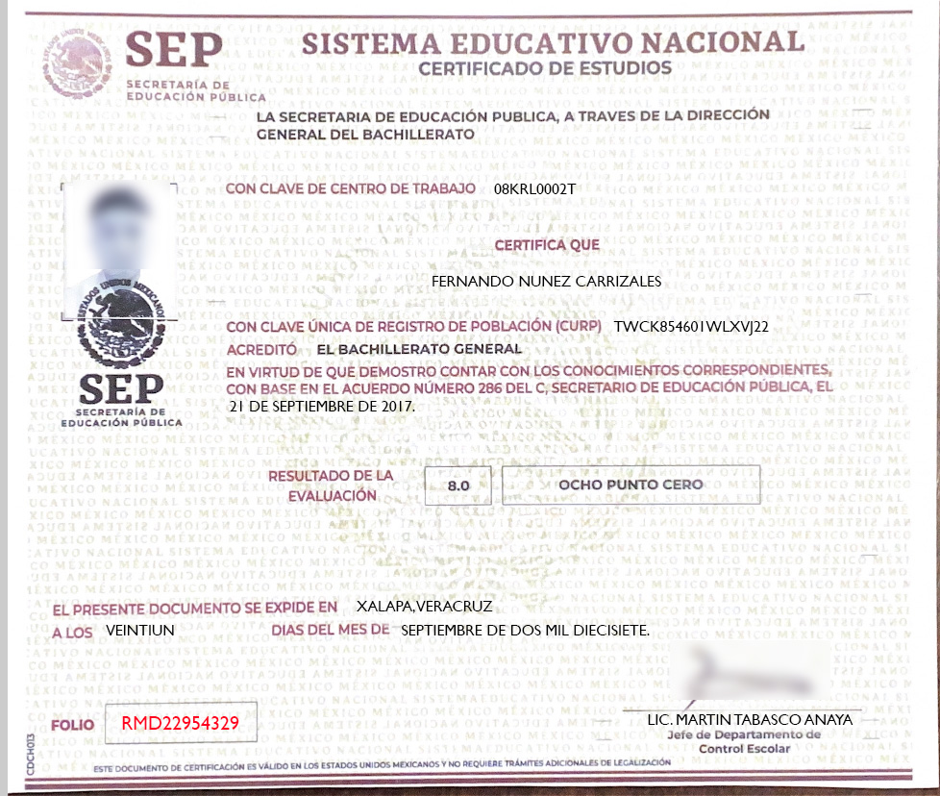

--------------------------------------------------------------------------------------------------------------------------------------------------

[left blank intentionally] [sin texto]

[watermark of circular seal of Mexico in center background] UNITED MEXICAN STATES
[repeated in background] MEXICO
NATIONAL EDUCATION SYSTEM

[circular seal of Mexico]  UNITED MEXICAN STATES |  | SEP  DEPARTMENT OF PUBLIC EDUCATION |  | NATIONAL EDUCATION SYSTEM  DIPLOMA
[photo of person]  [rubber stamp with  circular seal of Mexico]  UNITED MEXICAN STATES  SEP  DEPARTMENT OF  PUBLIC EDUCATION |  |  |  | THE DEPARTMENT OF PUBLIC EDUCATION, THROUGH THE MAIN OFFICE OF HIGH SCHOOL EDUCATION  WITH WORKCENTER CODE 08KRL0002T  CERTIFIES THAT  FERNANDO NUNEZ CARRIZALES  WITH UNIQUE POPULATION REGISTRY CODE (CURP) TWCK85460IWLXVJ22  EARNED A HIGH SCHOOL DIPLOMA  BY HAVING DEMONSTRATED THAT HE HAS THE APPROPRIATE KNOWLEDGE,  BASED ON AGREEMENT NUMBER 286 OF THE SECRETARY OF PUBLIC EDUCATION ON  SEPTEMBER 21, 2017.
 |  |  |  | EVALUATION  RESULTS |  | 8.0 |  | EIGHT POINT ZERO
THIS DOCUMENT IS ISSUED IN XALAPA, VERACRUZ
ON SEPTEMBER 21, 2017.

 |  |  |  |  |  |  |  |  | [signature]
CDCH013 | PAGE |  | RMD22954329 |  |  |  |  |  | MARTIN TABASCO ANAYA,  LICENSED PROFESSIONAL  Supervisor, Department of the Registrar
 | THIS CERTIFICATION DOCUMENT IS VALID IN THE UNITED MEXICAN STATES AND DOES NOT REQUIRE ADDITIONAL LEGALIZATION PROCESSING

--------------------------------------------------------------------------------------------------------------------------------------------------

[left blank intentionally] [sin texto]

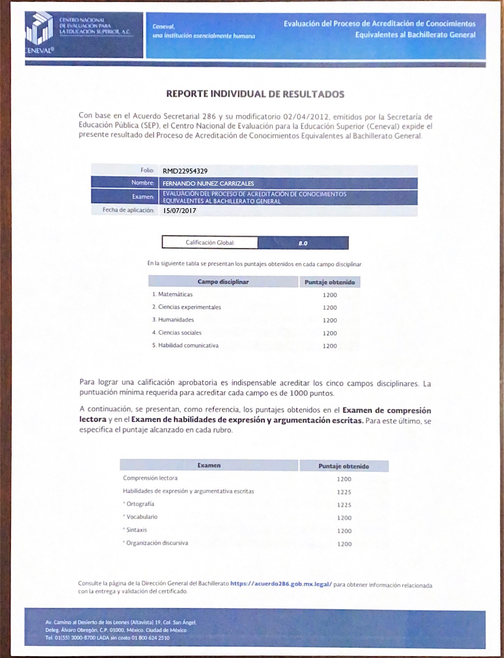

[logo]  CENEVAL |  | NATIONAL EVALUATION  CENTER FOR  HIGHER EDUCATION, NON-PROFIT CORPORATION  [illegible] |  |  |  |  | Ceneval,  an essentially human institution |  | Evaluation of the Process for Earning  High School Equivalency Credit
REPORT OF INDIVIDUAL RESULTS
 | Based on Departmental Agreement 286 and its modification on 2/April/2012, issued by the Department of Public Education (SEP), the National Evaluation Center for Higher Education (Ceneval) issues these results from the Evaluation of the Process for Earning High School Equivalency Credit.
 |  |  | Page: |  | RMD22954329
 |  |  | Name: |  | FERNANDO NUNEZ CARRIZALES
 |  |  | Exam: |  | Evaluation of the Process for Earning  High School Equivalency Credit
 |  |  | Effective Date: |  | 15/JULY/2017
 |  |  |  |  |  | Overall Grade: |  | 8.0
 |  |  |  | The following table shows the points received for each disciplinary field.
 |  |  |  | Disciplinary Field |  |  |  |  |  | Points received
 |  |  |  | 1. Math |  |  |  |  |  | 1200
 |  |  |  | 2. Experimental Sciences |  |  |  |  |  | 1200
 |  |  |  | 3. Humanities |  |  |  |  |  | 1200
 |  |  |  | 4. Social Sciences |  |  |  |  |  | 1200
 |  |  |  | 5. Communications |  |  |  |  |  | 1200
To earn a passing grade, a student must receive credit in the five disciplinary fields. The minimum point value required to pass each field is 1000 points.

The points received on the Reading Comprehension Exam and the Written Expression and Reasoning Abilities Exam are shown below for reference. For the latter, the score earned for each section is specified.

 |  |  | Disciplinary Field |  |  |  |  |  |  | Points received
 |  |  | Reading Comprehension |  |  |  |  |  |  | 1200
 |  |  | Written Expression and Reasoning Abilities |  |  |  |  |  |  | 1225
 |  |  | * Spelling |  |  |  |  |  |  | 1225
 |  |  | * Vocabulary |  |  |  |  |  |  | 1200
 |  |  | * Syntax |  |  |  |  |  |  | 1200
 |  |  | * Logical Organization |  |  |  |  |  |  | 1200
 | Visit the Main Office of High School Education page at https://acuerdo286.gob.mx.legal/ to get information regarding the submission and validation of the certificate.
[address] Avenida Camino al Desierto de los Leones (Altavista) 19, Colonia San Angel,
Delegacion Alvaro Obregon C.P. [ZIP code] 01000, Mexico, Ciudad de Mexico
Phone 01(55) 3000-8700 LADA [long distance] toll free 01 800 624 2510

--------------------------------------------------------------------------------------------------------------------------------------------------
[end of translation] [fin de la traducción]

