Certified Translation of _ | Traducción certificada de _
I, _, certify that I am fluent in the English and Spanish languages, competent to translate the attached document(s), and that this translation is true, complete and accurate to the best of my ability. Any alterations or attachments to these pages invalidate my certification. Square brackets indicate a translator’s note not found in the original document. | Yo, _, certifico que domino los idiomas inglés y español, y que soy competente para traducir el (los) documento(s) adjunto(s), y que esta traducción es verdadera, completa y precisa según mi mejor capacidad. Cualquier alteración o documento agregado a estas páginas invalida mi certificación. Los corchetes indican una nota del traductor referente a información que no está presente en el documento original.

Translator’s signature: _____________________________
Firma del traductor

Date signed: ______________________
Fecha de firma:

[contact information]

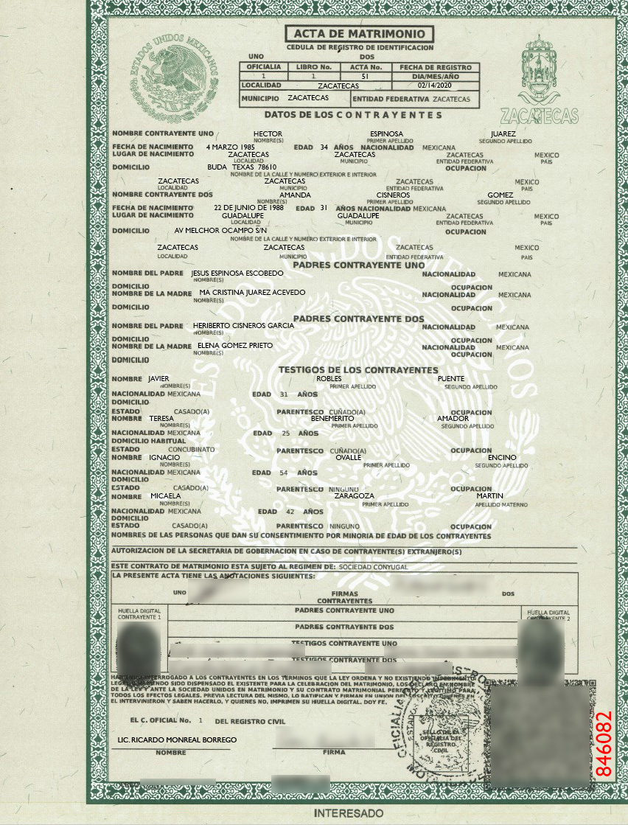

[decorative green border surrounds the page]
[watermark in center background with seal of Mexico] UNITED MEXICAN STATES
[circular seal of Mexico] UNITED MEXICAN STATES | MARRIAGE CERTIFICATE  REGISTRATION IDENTITY DOCUMENT  ONE TWO  OFFICE BOOK NUMBER ACT NUMBER DATE OF REGISTRATION  1 1 51 DAY/MONTH/YEAR  LOCALITY ZACATECAS 14/FEBRUARY/2020  MUNICIPALITY ZACATECAS STATE ZACATECAS  INFORMATION ABOUT THE COUPLE | [coat of arms]  ZACATECAS
NAME OF SPOUSE ONE HECTOR ESPINOSA JUAREZ
FIRST AND MIDDLE NAME(S) FIRST SURNAME SECOND SURNAME
DATE OF BIRTH 4 MARCH 1985 AGE 34 YEARS NATIONALITY MEXICAN
PLACE OF BIRTH ZACATECAS ZACATECAS ZACATECAS MEXICO
LOCALITY MUNICIPALITY STATE COUNTRY
ADDRESS BUDA TEXAS 78610 OCCUPATION
NAME OF THE STREET, BUILDING AND UNIT NUMBERS
ZACATECAS ZACATECAS ZACATECAS MEXICO
LOCALITY MUNICIPALITY STATE COUNTRY

NAME OF SPOUSE TWO AMANDA CISNEROS GOMEZ
FIRST AND MIDDLE NAME(S) FIRST SURNAME SECOND SURNAME
DATE OF BIRTH 22 JUNE 1988 AGE 31 YEARS NATIONALITY MEXICAN
PLACE OF BIRTH GUADALUPE GUADALUPE ZACATECAS MEXICO
LOCALITY MUNICIPALITY STATE COUNTRY
ADDRESS AVENIDA MELCHOR OCAMPO SIN/NUMERO OCCUPATION
NAME OF THE STREET, BUILDING AND UNIT NUMBERS
ZACATECAS ZACATECAS ZACATECAS MEXICO
LOCALITY MUNICIPALITY STATE COUNTRY
PARENTS OF SPOUSE ONE
FATHER’S NAME JESUS ESPINOSA ESCOBEDO NATIONALITY MEXICAN
NAME(S)
ADDRESS OCCUPATION
MOTHER’S NAME MA[RIA] CRISTINA JUAREZ ACEVEDO
NAME(S)
ADDRESS OCCUPATION

PARENTS OF SPOUSE TWO
FATHER’S NAME HERIBERTO CISNEROS GARCIA NATIONALITY MEXICAN
NAME(S)
ADDRESS OCCUPATION
MOTHER’S NAME ELENA GOMEZ PRIETO
NAME(S)
ADDRESS OCCUPATION

WITNESSES FOR THE COUPLE
NAME JAVIER ROBLES PUENTE
FIRST AND MIDDLE NAME(S) FIRST SURNAME SECOND SURNAME
NATIONALITY MEXICAN AGE 31 YEARS
ADDRESS
STATUS MARRIED RELATIONSHIP BROTHER(SISTER)-IN-LAW OCCUPATION

NAME TERESA BENEMERITO AMADOR
FIRST AND MIDDLE NAME(S) FIRST SURNAME SECOND SURNAME
NATIONALITY MEXICAN AGE 25 YEARS
USUAL ADDRESS
STATUS COMMON-LAW MARRIAGE RELATIONSHIP BROTHER(SISTER)-IN-LAW OCCUPATION

NAME IGNACIO OVALLE ENCINO
FIRST AND MIDDLE NAME(S) FIRST SURNAME SECOND SURNAME
NATIONALITY MEXICAN AGE 54 YEARS
ADDRESS
STATUS MARRIED RELATIONSHIP NONE OCCUPATION

NAME MICAELA ZARAGOZA MARTIN
FIRST AND MIDDLE NAME(S) FIRST SURNAME SECOND SURNAME
NATIONALITY MEXICAN AGE 42 YEARS
ADDRESS
STATUS MARRIED RELATIONSHIP NONE OCCUPATION

NAME(S) OF THE PERSON(S) WHO GIVE CONSENT FOR BRIDE/GROOM NOT OF LEGAL AGE:

AUTHORIZATION OF THE DEPARTMENT OF THE INTERIOR (FOREIGN SPOUSE)

THIS MARRIAGE CONTRACT IS SUBJECT TO THE ARRANGEMENT OF: COMMUNITY PROPERTY

THIS CERTIFCATE HAS THE FOLLOWING ANNOTATIONS:

ONE SIGNATURES TWO
[signature] OF SPOUSES [signature]
SPOUSE 1 FINGERPRINT  [fingerprint] | SPOUSE ONE’S PARENTS | SPOUSE 2 FINGERPRINT  [fingerprint]
 | SPOUSE TWO’S PARENTS
 | SPOUSE ONE’S WITNESSES
 | SPOUSE TWO’S WITNESSES
I HAVE QUESTIONED THE COUPLE IN THE TERMS ESTABLISHED BY LAW, AND FINDING NO LEGAL IMPEDIMENT TO PERFORMING THEIR MARRIAGE, OR ANY SUCH IMPEDIMENT HAVING BEEN RESOLVED, I DECLARE THEM, IN THE NAME OF THE LAW AND BEFORE SOCIETY, TO BE UNITED IN MARRIAGE, AND THEIR MARITAL CONTRACT COMPLETE AND LEGITIMATE FOR ALL LEGAL PURPOSES. AFTER I READ THIS CERTIFICATE, THE PARTICIPANTS CONFIRMED IT AND SIGNED (IF THEY KNEW HOW TO DO SO; IF NOT, THEY INDICATED WITH A FINGERPRINT). I ATTEST.
[QR code]
OFFICER NUMBER 1 OF THE VITAL STATISTICS OFFICE [round rubber stamp]
RICARDO MONREAL BORREGO, LICENSED PROFESSIONAL  NAME | [signature]  SIGNATURE | SEAL OF THE VITAL STATISTICS OFFICE  [circular rubber stamp with seal of Mexico]  VITAL STATISTICS OFFICE  UNITED MEXICAN STATES  MOYAHUA DE ESTRADA | 846082
[illegible number] [COPY FOR THE] PARTY CONCERNED
--------------------------------------------------------------------------------------------------------------------------------------------------
[end of translation] [fin de la traducción]

