Certified Translation of _ | Traducción certificada de _
I, _, certify that I am fluent in the English and Spanish languages, competent to translate the attached document(s), and that this translation is true, complete and accurate to the best of my ability. Any alterations or attachments to these pages invalidate my certification. Square brackets indicate a translator’s note not found in the original document. | Yo, _, certifico que domino los idiomas inglés y español, y que soy competente para traducir el (los) documento(s) adjunto(s), y que esta traducción es verdadera, completa y precisa según mi mejor capacidad. Cualquier alteración o documento agregado a estas páginas invalida mi certificación. Los corchetes indican una nota del traductor referente a información que no está presente en el documento original.

Translator’s signature: _____________________________
Firma del traductor

Date signed: ______________________
Fecha de firma:

[translator’s contact information]

STATE OF TEXAS, COUNTY OF TRAVIS

On (date) ________________, before me, the undersigned, a Notary Public in and for said State, personally appeared _, ( ) personally known to me -OR- ( ) proved to me on the basis of satisfactory evidence to be the person whose name is subscribed to this instrument and acknowledged to me that he executed the same in his authorized capacity, and that by his signature on the instrument the person, or the entity on behalf of which the person acted, executed the instrument.
WITNESS my hand and official seal.

Signature _________________________________

Printed name ______________________________

Date my commission expires __________________ (Seal)

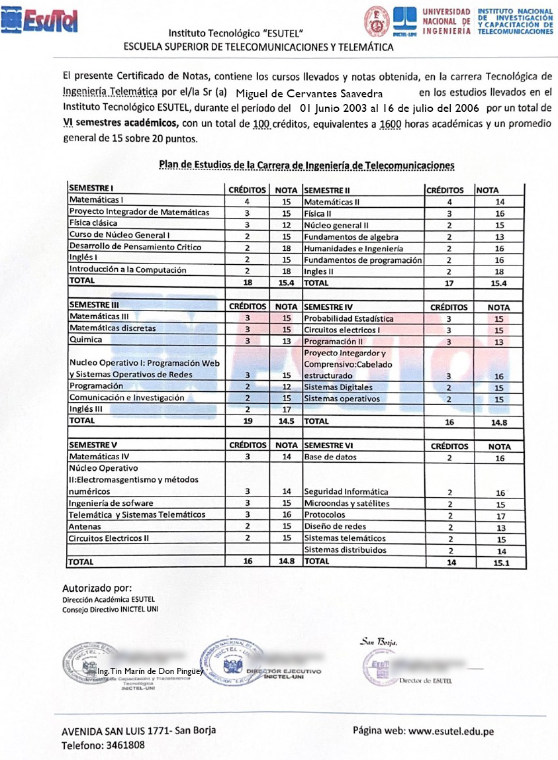
[watermark in center of page] ESUTEL
[logo]  ESUTEL [Higher Education in Telecommunications and Telematics] | [coat of arms]  UNIVERSIDAD NACIONAL DE INGENERIA [National University of Engineering]  [Latin motto] SCIENTIA ET LABOR  LIMA, PERU  1876 | [logo] | UNIVERSIDAD NACIONAL DE INGENERIA | INSTITUTO NACIONAL DE INVESTIGACION Y CAPACITACION DE TELECOMUNICACIONES [National Institute of Research and Training in Telecommunications]
ESUTEL Instituto Tecnologico [Technological Institute]
ESCUELA SUPERIOR DE TELECOMUNICACIONES Y TELEMATICA [Higher Education in Telecommunications and Telematics]

This Report Card contains the courses taken and grades received in the major of Telematics Engineering Technologist by Mr./Ms. Miguel de Cervantes Saavedra, in the studies taken at the Instituto Tecnologico ESUTEL during the period of June 1, 2003, to July 16, 2006, for a total of VI academic semesters, with a total of 100 credits, equal to 1600 academic hours and an overall average of 15 points out of 20.
Curriculum for the Telecommunications Engineering Major

SEMESTER I | CREDITS | GRADE | SEMESTER II | CREDITS | GRADE
Mathematics I | 4 | 15 | Mathematics II | 4 | 14
Mathematics Integration Project | 3 | 15 | Physics II | 3 | 16
Classical Physics | 3 | 12 | General Core II | 2 | 15
General Core Class I | 2 | 15 | Algebra Fundamentals | 2 | 13
Critical Thinking Development | 2 | 18 | Humanities and Engineering | 2 | 16
English I | 2 | 15 | Programming Fundamentals | 2 | 16
Introduction to Computer Science | 2 | 18 | English II | 2 | 18
TOTAL | 18 | 15.4 | TOTAL | 17 | 15.4
SEMESTER III | CREDITS | GRADE | SEMESTER IV | CREDITS | GRADE
Mathematics III | 3 | 15 | Statistical Probability | 3 | 15
Discrete Mathematics | 3 | 15 | Electric Circuits I | 3 | 15
Chemistry | 3 | 13 | Programming II | 3 | 13
Operational Core I: Web Programming and Network Operating Systems | 3 | 15 | Integrative and Comprehensive Project: Structured Cabling | 3 | 16
Programming | 2 | 12 | Digital Systems | 2 | 15
Communication and Research | 2 | 15 | Operating Systems | 2 | 15
English III | 2 | 17
TOTAL | 19 | 14.5 | TOTAL | 16 | 14.8
SEMESTER V | CREDITS | GRADE | SEMESTER VI | CREDITS | GRADE
Mathematics IV | 3 | 14 | Database | 2 | 16
Operational Core II: Electromagnetism and Numeric Methods | 3 | 14 | Computer Security | 2 | 16
Software Engineering | 3 | 15 | Microwaves and Satellites | 2 | 15
Telematics and Telematic Systems | 3 | 16 | Protocols | 2 | 17
Antennas | 2 | 15 | Network Design | 2 | 13
Electric Circuits II | 2 | 15 | Telematic Systems | 2 | 15
 |  |  | Distributed Systems | 2 | 14
TOTAL | 16 | 14.8 | TOTAL | 14 | 15.1

Authorized by:
ESUTEL Academic Office
INICTEL UNI Executive Board
San Borja
[circular seal]  INSTITUTO NACIONAL DE INVESTIGACION Y CAPACITACION DE TELECOMUNICACIONES [National Institute of Research and Training in Telecommunications] – UNI [National University of Engineering] | [circular seal]  INSTITUTO NACIONAL DE INVESTIGACION Y CAPACITACION DE TELECOMUNICACIONES UNICTEL – UNI  EXECUTIVE BOARD |  | [circular seal]  [illegible] ESUTEL [Telecommunications and Telematics Institute]
[signature]  Tin Marin de Don Pinguey, Engineer  Director of Technology Training and Transfer  INICTEL – UNI | [signature]  EXECUTIVE DIRECTOR  INICTEL - UNI |  | [signature]  Director of ESUTEL [Telecommunications and Telematics Institute]
[address] AVENIDA SAN LUIS 1771- San Borja  Phone: 3461808 |  | Website: www.esutel.edu.pe
--------------------------------------------------------------------------------------------------------------------------------------------------
[end of translation] [fin de la traducción]

