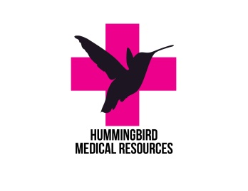Suggested Packing List for Belize



\*We will be taking 1 carry on and 1 personal item. Our checked bags will be reserved for bins containing our medical supplies.

\*Organize daily clothes or alike clothes in to zip lock bags and compress to let air out. This saves a lot of room and then you have bags to put dirty clothes in as well.

\*There is a washer at the basecamp

1. Hummingbird Medical Resources (HMR) scrub top and hat

2. 3 pair of scrubs (top and bottoms)

3. Shoes-hiking sandals that can get wet. Closed toe is preferred. Casual shoes (sandals, flip flops)

4. Casual clothes for non-clinical times. Shorts (appropriate length) tank tops (no spaghetti straps)

5. Pajamas- There will be no air conditioning but there will be fans.

6. Swimsuit. No bikini unless rash guard/shirt covering stomach. Tankini ok.

7. Towels (Bath and beach towels)

8. Underwear and bras (suggested at least two per day due to humidity and sweat factor)

9. Stethoscope and blood pressure cuff (strongly suggested)

10. Personal toiletries (3oz or less due to carry on bag please) We can purchase items at local store.

11. Prescription medication-with enough for 2 weeks

12. BUG SPRAY at least 50% DEET. Suggested: Jungle juice and natural oils such as eucalyptus

13. SUN SCREEN The sun is really intense and even on a cloudy day

14. Refillable water bottle

15. Phone charger and other electronic chargers. Everything is US outlets, no need for converters

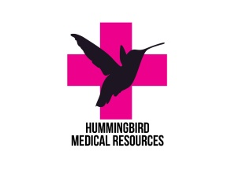

16. Journal and pen. You’re going to want to document and remember your adventure

17. Camera

18. Glasses/contacts

19. Over the counter meds for yourself (Tylenol, ibuprofen, motion sickness meds, anti-diarrhea ect

20. Emergency snacks-protein bars, trail mix, crackers ect.

21. One “business casual” outfit. Linen pants or skirt (almost knee length) will be just fine