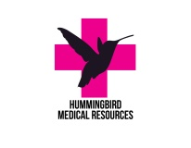Hummingbird Medical Resources

June 2019 Outreach
Name____________________________________________
Address__________________________________________
Phone____________________________________________
Passport number___________________________________

Skills/Strengths/Interests__________________________________________________________________________________________________________________________________________________________________________________________________________________________________________

Medical alerts/allergies (food, environment) __________________________________________________________________________________________________________________________________________________________________________
Emergency contact person and phone ______________________________________________________
Traveler’s insurance_____________________________________________________________________

Document checklist (Licensed travelers)
- Passport___
- CPR certification___
- Copy of college diploma___
- Copy of active license___

Why are you going? ____________________________________________________________________________________________________________________________________________________________________________________________________________________________________________________________________________________________________________________________________________________

