<Company Logo>

IT Process Management and
Governance Guide
DRAFT

Document Owner:  Document Manager:  Author:  Date:  Version:  Classification: | Thorsten Manthey  Thorsten Manthey  Thorsten Manthey  2019-11-10  V01  Limited Distribution
Document Management
Document Source
This document is maintained as an online document and can be found at: http://www.tmanthey.com/ProcessGovernance

Document Revision History
Date | Revision | Description | Author
01/01/2019 | V01 | Initial Release | Thorsten Manthey

Document Owners and Approvers
Name | Role | Signature | Date
Thorsten Manthey | Document owner
NN | Approver
NN | Approver
NN | Approver
NN | Approver

Target Audience
The intended audience for this document is anyone within IT who uses, executes, manages, owns or is responsible for an IT process.
Ownership
The Document Owner has the accountability for ensuring that the governance framework is followed and improved.
Any proposed improvements and changes to the IT Process and Governance Guide must be approved by the Document Owner and communicated to the Process Manager Technical Review Council (PMTRC) and to the Process Owner Architecture Council (POAC).

Feedback and Comments
Feedback and comments on the contents of this document can be submitted to the Document Owner.

Contents
1. Introduction 8
1.1 IT Governance 8
1.2 What Is Process Governance 9
1.3 IT Process Management 9
1.4 Process Governance Definition 10
1.5 Decision Making Process 11
2. Roles, Responsibilities and Governing Elements 12
2.1 Process Sponsor 12
2.2 Process Owner 13
2.2.1 Accountabilities 13
2.2.2 Activities 13
2.3 Process Manager 15
2.4 Process Subject Matter Experts 17
2.5 Working Together 18
2.6 Process Implementation 19
2.6.1 Execution and Stabilization of the Process 19
2.6.2 Process Maturity Assessment / Self-Assessment / Health Check 19
2.6.3 Process Audits 20
3. Process Governance – POAC and PMTRC 21
3.1 Process Owner Architecture Council and Process Manager Technical Review Council 21
3.2 Process Owner Architecture Council 22
3.3 Process Manager Technical Review Council 24
3.4 Process Management Responsibility Matrix (RACI Matrix) 25
3.4.1 Responsibility 25
3.4.2 Accountability 25
3.4.3 RACI Models 25
3.4.4 Consistent Process Execution 26
4. Processes and Procedures 28
4.1 What is a Process and Procedure? 28
4.2 What is an Activity? 29
4.3 Trigger Events and Stakeholders 29
4.3.1 Process Input 29
4.3.2 Process Output 30
4.4 Process and Procedure Flow 31
4.4.1 Flow Symbols 31
4.5 Why do we need Process Documentation? 32
4.6 Processes across Organizations 33
5. ITIL® and IT Service Management 34
5.1 ITIL® v3 & v4 34
5.2 Guiding Principles Overview 35
5.2.1 Principles 35
5.2.2 Rationale 35
5.2.3 Implications 36
6. Continuous Process Improvement 37
6.1 Reason for Improvement 37
6.2 Process Improvement Model 37
6.3 Process Enablers 38
6.4 Small Improvement Steps 39
6.5 Deming Wheel 39
6.5.1 Plan 40
6.5.2 Do 40
6.5.3 Check 40
6.5.4 Act 40
6.6 Process Measurements 41
6.6.1 Why Measure the Process 41
6.6.2 Measurement Types 42
7. Process Documentation 44
7.1 Document Approval and Administration 44
7.1.1 Checklist for the Process Manager 44
8. Document Naming and Maintenance 45
8.1 File Name and Uniqueness 45
8.2 Document Version Control 45
8.3 Information Security Classification Standard 46
8.3.1 Information Classification 46
8.3.2 Classification Responsibility 46
8.3.3 Default Classification 46
8.3.4 Information Classification Matrix 46
8.4 Document Templates 48
Appendix A: Abbreviations and Acronyms 49

List of Figures
Figure 1: Process Governance Description 9
Figure 2: Process Sponsor description 12
Figure 3: Process Ownership Responsibilities 14
Figure 4: Process Owner Description 14
Figure 5: Process Manager 15
Figure 6: Process Manager Responsibilities 16
Figure 7: Process Subject Matter Expert 17
Figure 8: Process Responsibilities by Role 18
Figure 9: Process Manager Technical Review Council vs. Process Owner Architecture Council 21
Figure 10: Process Owner Council Objectives 23
Figure 11: Process Owner Council Value Proposition 23
Figure 12: Process Manager Technical Review Council Objectives 24
Figure 13: Generic Process Model 28
Figure 14: Process across Organizations 33
Figure 15: ITIL® V3 Lifecycle 34
Figure 16: Guiding Principles, Rationale, Implication 35
Figure 17: Process Improvement Model 37
Figure 18: Many Small Improvements – Stable Process 39
Figure 19: Deming Wheel – Continuous Step-by-Step Improvement 39
Figure 20: Critical Success Factors and Key Performance Indicators 41

List of Tables
Table 1: RACI Assignments 26
Table 2: Example of required Input Table 30
Table 3: Example of required Output Table 30
Table 4: Flowchart Symbols 32
Table 5: Improvement Motivations 37
Table 6: Key Performance Indicators 42
Table 7: Unique Document Naming Convention 45
Table 8: Draft and Approved Document Version Control 46
Table 9: Information Classification Levels 47
Table 10: Abbreviations 49
Table 11: Process Acronyms and Definitions 55

- Introduction
The purpose of this document is to provide a guide and reference to IT Process Management and Governance as implemented at <COMPANY’s> IT organization. The document is a source of information to assist in executing and managing IT Service Management and Process Governance.
This document describes the detailed concepts of IT Process Management and the IT Process Governance framework within the IT Organization.
The framework describes the structures that need to be put in place, the roles that need to be assigned, responsibilities and accountabilities for each role and the meetings and council groups to be established in order to operate and govern the IT Processes within the IT organization. The framework will also identify the process management guidelines, templates, flows and process documentation standards to be used when documenting processes.
This document is intended to enable IT through process delivery excellence, the opportunity to provide quality IT Services to the business based on business needs, market requirements and IT resources and capabilities.
The purpose of this framework is to:
- Obtain a common view and understanding of IT Process Governance.
- Make sure that all IT Processes are consistently described across the IT organization using a common standard definition set.
- Support the Process Sponsor, Process Owner, Process Owner Architecture Council (POAC), Process Manager, Process Manager Technical Review Council (PMTRC), and Process Subject Matter Experts (SME) / Process Practitioners by providing guidelines to govern, develop, document, implement, execute, retire, measure, monitor and improve the IT Processes.
- Provide clarity of the roles, responsibility and accountability to those involved in IT Process execution and IT process governance.

  - IT Governance
IT Governance is the responsibility of the board of directors and executive management. It is an integral part of Enterprise Governance and consists of the leadership, organizational structures and processes that ensure that the organization’s IT sustains and extends the organization’s strategies and objectives.

  - What Is Process Governance
The definition IT will be using in the context of IT Process and IT Service governance is:
The organizational structures that need to be put in place, the roles that need to be assigned, responsibilities and accountabilities for each role, documented processes, strategies and work rules to be established and the meetings and councils to be established in order to operate and govern the IT Services and IT Processes within the IT organization.
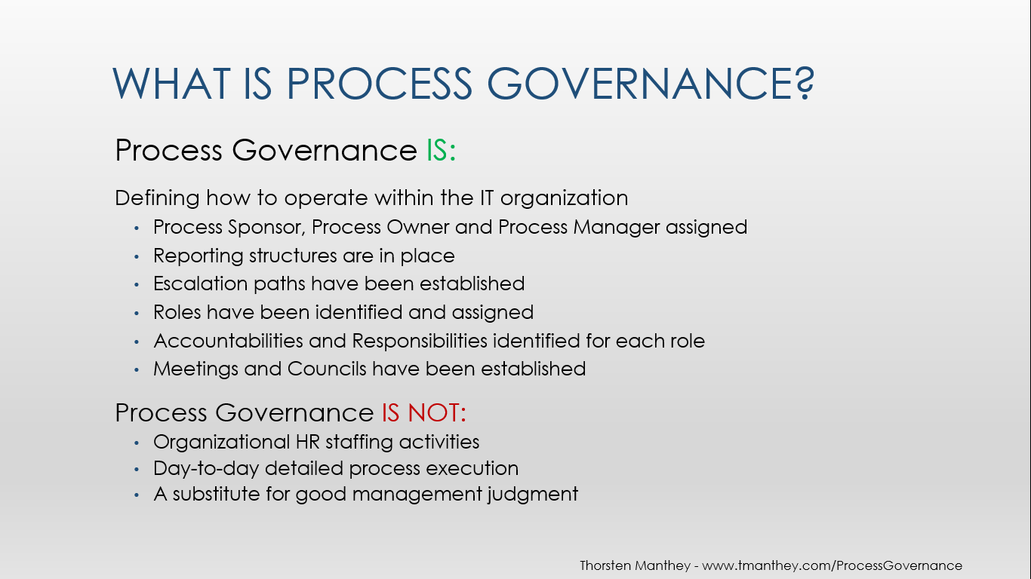
Figure 1: Process Governance Description

  - IT Process Management
IT Process Management is a structured way to identify, develop, document, implement, execute, govern, and continually improve IT Processes.
IT Process execution is governed by the IT Management Team. The IT Management team has the executive authority and power to make decisions and resolve issues across the IT organization as related to the standardization of the IT Processes.
  - Process Governance Definition
IT Process Governance defines a structure of relationships and processes that direct and control the IT undertaking by focusing on the quality of the IT infrastructure processes and the quality of the services that IT provides to its customers. These processes establish the capability to achieve IT's goals. The governance adds value by balancing risk versus return across all IT processes and services.
This governance defines and establishes the management framework for conducting IT process activities. In that regard, it outlines, as an example, the management model, guiding principles, methods, organization design, information framework, process structure, policies and practices to guide the IT organization towards its stated goals. Once the management framework is defined and implemented, a continuous evaluation process will be executed to enable better decision making by executives as to whether the business model is succeeding or should be modified to achieve the objectives better.
Governance considers and sets the fundamental direction for the management framework – how the IT management team directs the operations of its business. Governance is a decision rights and accountability framework for directing, controlling and executing IT Processes and delivering IT Services in order to determine and achieve desired behaviors and results. Governance involves defining the management model and creating governing or guiding principles.
This includes:
- Who makes directing, controlling, and executing decisions, including defining the ultimate authority
- How the decisions will be made, including escalation and arbitration procedures
- What information is required to make the decisions
- With what frequency decisions must be made or revisited
- What decision making mechanisms should be required
- How exceptions will be handled
- How decisions are communicated to concerned parties
- How the governance results should be reviewed and improved.

Process Governance Scope: The scope of the IT Process Governance is the set of processes within the purview of our IT Service Management initiative. Over time, the scope will be expanded to include the entirety of IT and the suppliers of IT services to the organization.

  - Decision Making Process
Decision rights and escalations within IT Service Management fall into three categories:
- intra-process,
- inter-process and
- inter-organizational
Decisions with a scope wholly contained within a process are the responsibility of the Process Manager with advice and counsel from the Process Owner, the Process Manager Technical Review Council (PMTRC) and the SME community. Should the decision involve changes to other processes, such changes must be communicated to the PMTRC. Escalations within this arena must be made to the Process Owner and/or the Service Owner if changes will or may impact a service.
Decisions on issues or opportunities between processes are usually made within the context of the Process Manager Technical Review Council (PMTRC) but may, for expediency, be made between the involved Process Managers. Decisions made by the Process Managers must be brought to the PMTRC for ratification. Escalation between the processes will be from the Process Manager Technical Review Council to the Process Owners of the involved processes. Second level escalation will be to the Process Sponsor.
- Roles, Responsibilities and Governing Elements
Roles are defined for people accountable and responsible for an IT process, those carrying out the procedures/activities, and managers dedicated to an organizational unit. Governing elements are organizational or procedural structures implemented to facilitate the execution of the process, e.g. the Process Manager Council.
  - Process Sponsor
The Process Sponsor is a thought leader and defines the IT service management vision and strategy together with IT management and is accountable for the delivery of business value through IT service management.
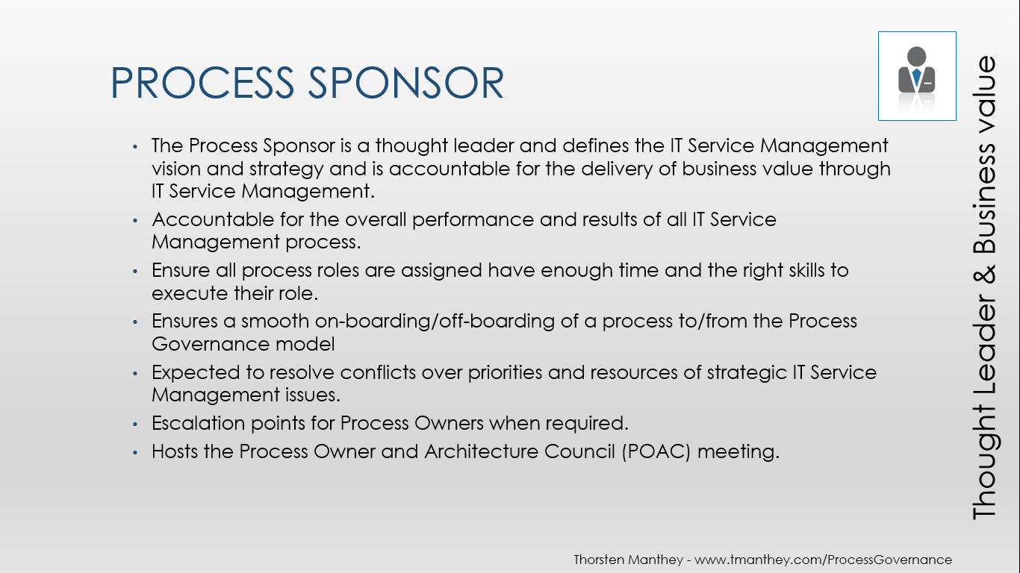
Figure 2: Process Sponsor description
  - Process Owner
The Process Owner is the individual appointed by management who has the accountability and authority for ensuring that the total process is effective, efficient, and adaptable.

Accountabilities
The Process Owner is accountable for the following:
- Accountable for the strategic direction and long term vision of the process
- Accountable for the overall performance and results of the process
- Responsible to define process scope and goals and execution compliance
- Accountable to ensure support and commitment of resources
- Responsible for identifying and managing a Process Manager
- Expected to resolve conflicts over priorities in his or her domain
- Approval of the process by all IT Managers
- Performance monitoring and reporting
- Process assessments and audits
- Integration of the IT process with the business process
- Set goals for process improvements
- Communication to the key stakeholders on process initiative progress and process performance issues

Activities
Activities required to carry out the above Accountabilities include:
- Sets direction for process and approve/monitor work plan
- Supports the Process Manager in championing the process
- Assigns a Process Manager and ensure he/she has the time required to fulfill the function
- Requests reviews when required, (Periodic or ad-hoc) performed by the Process Manager or someone outside the process area.
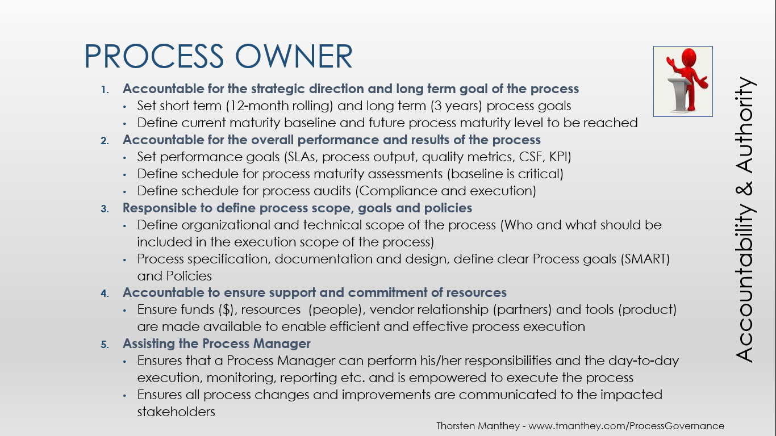
Figure 3: Process Ownership Responsibilities

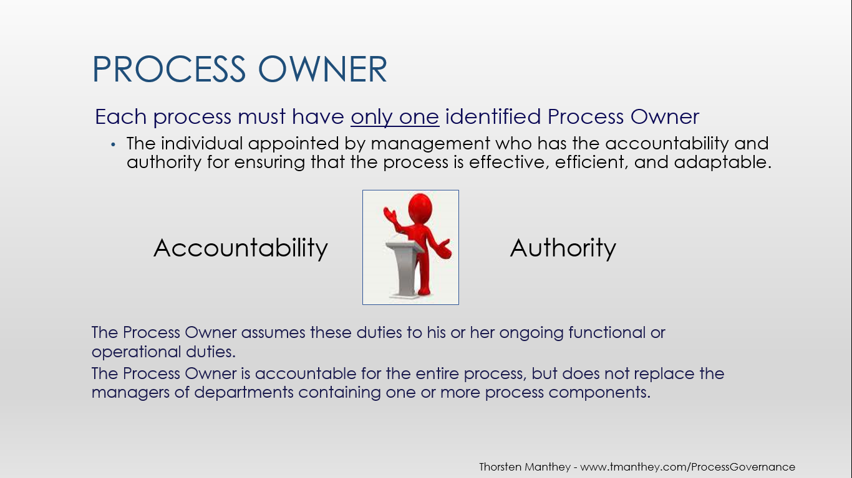
Figure 4: Process Owner Description
  - Process Manager
The Process Manager is responsible for the process definition, development, documentation, execution and improvement and is the repository of process knowledge. The Process Manager is the champion for the process and leads and co-ordinates the Subject Matter Experts (SME) and makes sure the process information is published and communicated.
He/She is a champion for consistent processes and tool usage, and ensures standardization, consistency and harmonization of these activities. He/she is the custodian of process related documentation and training material.
Some of the activities would include:
- Continuous reporting on defined Key Performance Indicators (KPIs) and compliance reporting e.g. Sarbanes-Oxley (SOX) audits
- Continuous process improvements, maturity assessments
- Monitors and measures the quality and content of the delivery/output of the process
- Regularly reviews and adjusts the process in concert with the SMEs to maintain efficiency and effectiveness
The Process Manager participates in the Process Manager Technical Review Council (PMTRC) and is responsible to make sure the process is integrated with other IT processes.
The Process Manager is responsible for the implementation and the Process Owner assist (as he/she is accountable for the implementation) to ensure consistency across the organization.
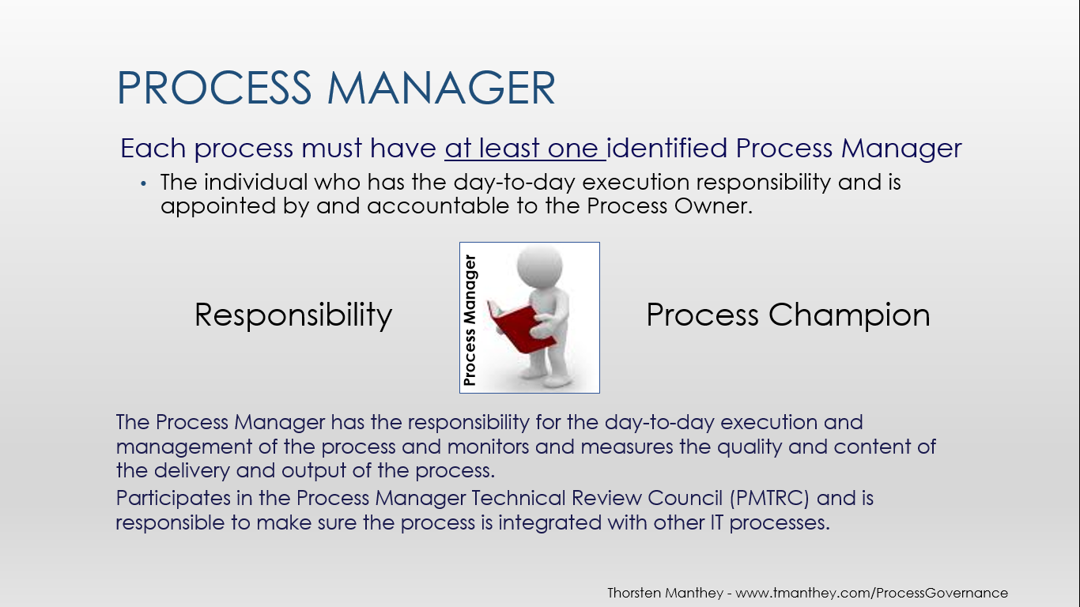
Figure 5: Process Manager
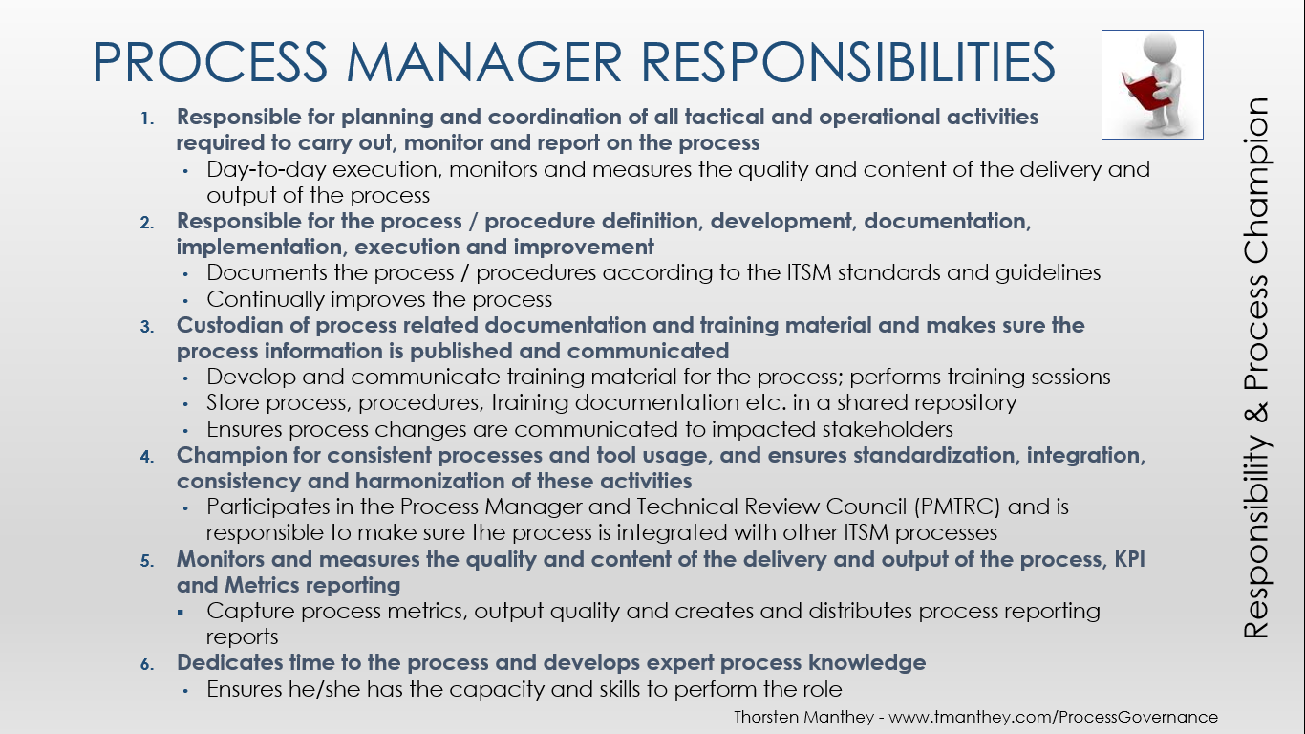
Figure 6: Process Manager Responsibilities
  - Process Subject Matter Experts
The process Subject Matter Experts (SMEs) are individual(s) from each IT department/group/organization/function who execute the process and represent that specific entity. They support the Process Manager in the execution, development, documentation, implementation, reporting and continuous process improvements of processes.

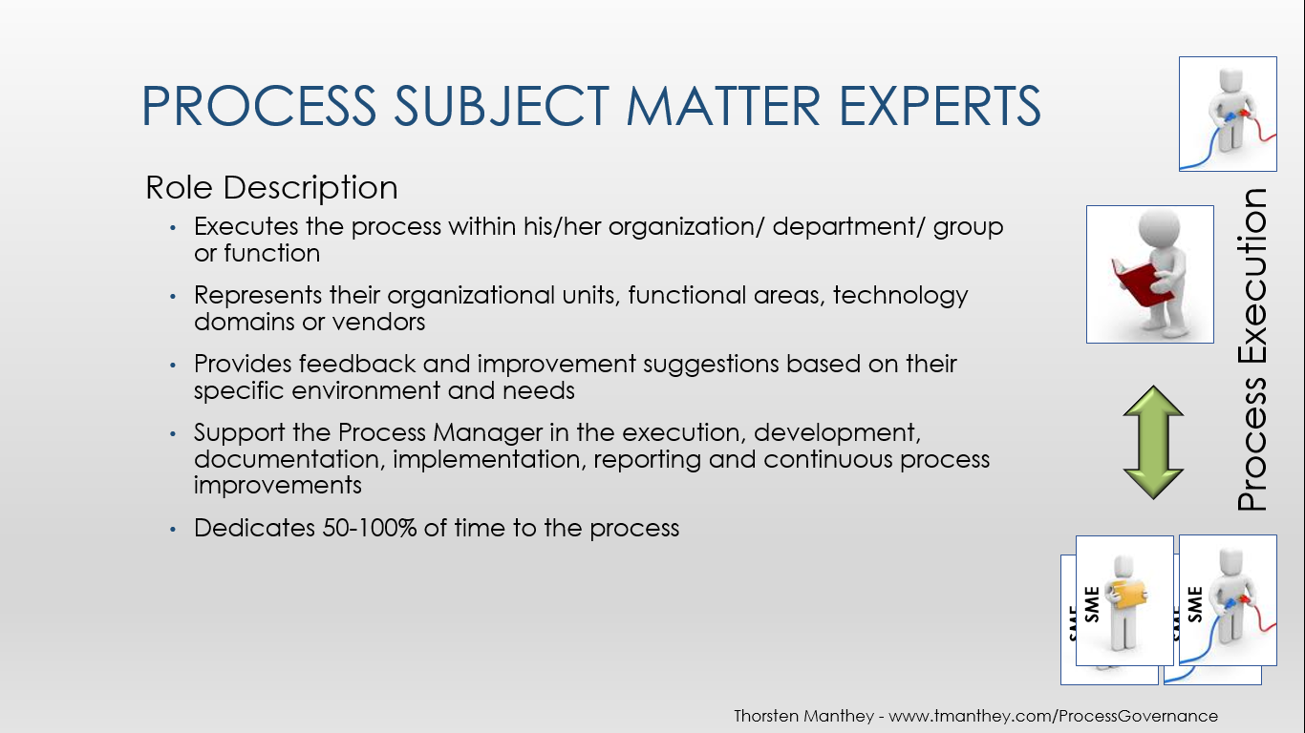
Figure 7: Process Subject Matter Expert
  - Working Together
Process Sponsors, Process Owners, Process Managers and process Subject Matter Experts must all work together in a collaborative way across the organization. As the organizational structure might not be the same as the process role structure it is imperative that an excellent communication channels and clear reporting structures have been established.
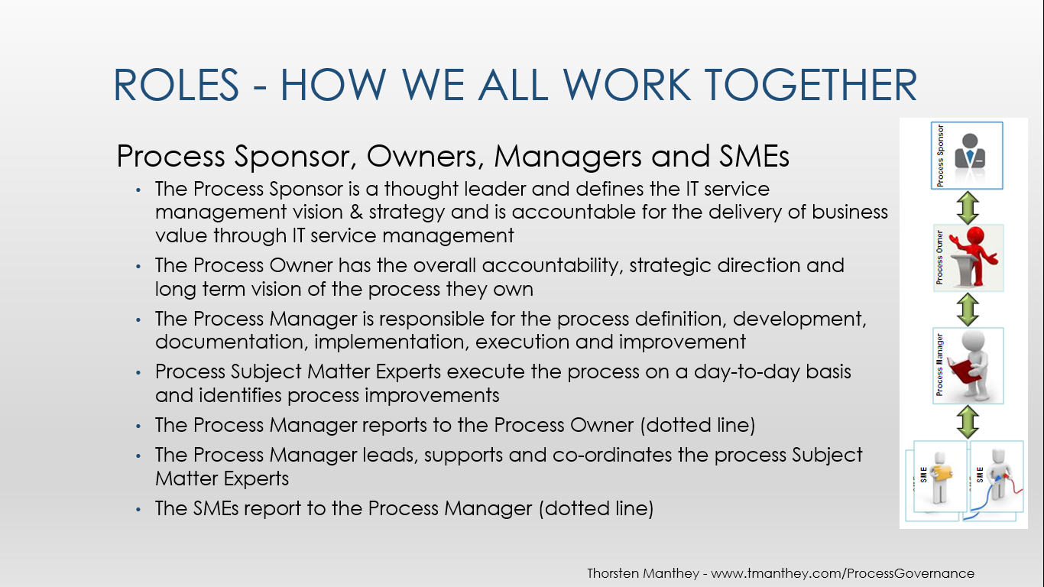
Figure 8: Process Responsibilities by Role

Every process has a Process Sponsor who reports to the CIO and who may be from any of the functions within IT.
- The Process Sponsor is a senior executive within IT
- The Process Owners report to the Process Sponsors (dotted line)
Note that it is not unlikely that a single executive may “Own” multiple processes.
- The Process Managers represent and provides day-to-day management of a process across all IT organizations.
- The PMs may report to their respective Process Owners but this is not a requirement for a robust, vital process.
There will be at least a dotted line relationship between the Process Manager and the Owner of the Process. Process Manager may be either a role or a position description and the deciding factor is how much activity is required of the PM by the process.
There are PMs who are dedicated, full time to their processes and PMs who have responsibilities other than the management of their processes.
Each of the organizational units that is effected by a process will have within it an individual or individuals - Subject Matter Expert(s) – who will represent the unit in discussions of the process and will act as the “go to” person within the unit for questions or concerns about the process. SMEs are dotted line responsible to the Process Manager for day-to-day operation of the process. Subject Matter Expert is a role, not a position description.

  - Process Implementation
What does Implementation mean?
- Allocate resources (staff and tools)
- Initiate instructions to the SMEs executing the process
- Provide process and tool training
- Ensure integration in the IT Service delivered to clients
- Present and distribute the new process documents
- Implement performance metrics and KPIs

Execution and Stabilization of the Process
The Process Manager:
- Is responsible for ensuring that the process is carried out according to the process and procedure documents
- Monitors the KPIs of the process
- Evaluates and analyzes measurements
- Observes the process and collects information for the process improvement
- Checks the execution and the interfaces to other processes
- Documents success or failure and informs the responsible individual
- Involves the Process Owner if support is needed or if the process needs a major change
- Ensures process training material is available
- Reacts if the process source has changed the process input

Process Maturity Assessment / Self-Assessment / Health Check
The Process Manager should monitor and report continuously on the KPIs defined for the process.
In addition to measuring the KPIs, ad-hoc Process Self Assessments or Health Checks should be performed on a regular basis, or when requested by the Process Owner.
Regular Process Maturity Assessments should be performed by the process manager.
Process Maturity Assessments and Self Assessment will prepare the process for internal audits and SOX compliance.

Process Audits
A process audit ensures compliance between process execution and the process documents or Compliance audits e.g. SOX. The auditing of the IT Service Management (ITSM) processes will be determined by the Process Owner or IT Auditors.
- Process Governance – POAC and PMTRC
Process execution is governed by the IT management team. The IT management team has the executive authority and power to make decisions and resolve issues across the organization as related to the standardization of the IT processes.
A Process Owner Architecture Council and Process Manager Technical Review Council consist of IT leaders that establishes the ITSM Goals and Vision, IT process governance maturity, and efficient and effective IT process execution.
  - Process Owner Architecture Council and Process Manager Technical Review Council
A Process Manager Technical Review Council (PMTRC) focuses on tactical process topics and process executions and the Process Owner Architecture Council (POAC) are Process Owners / IT leaders focusing on Strategic Process Roadmaps, ITM Vision and Goals.
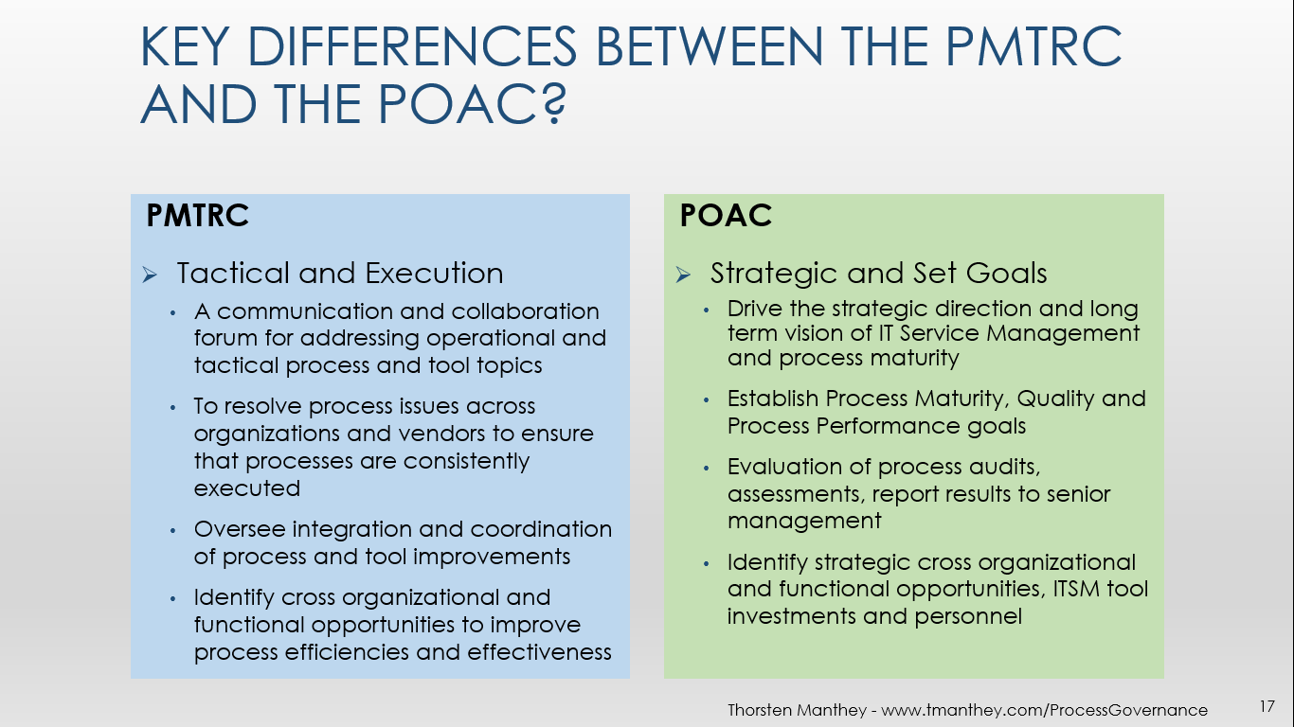
Figure 9: Process Manager Technical Review Council vs. Process Owner Architecture Council

  - Process Owner Architecture Council
The Process Owner Architecture Council (POAC) helps define the overall strategic direction and long-term vision of the IT Service Management initiative. The POAC is accountable for the long-term maturity goals and scope definition of our ITIL processes and the overall performance and results of the process.
The POAC reviews both short (6-12 months) and long term (1-3 years) strategic process goals. The POAC reviews and synchronizes the Strategic Process Roadmaps continuously and make sure they are driving process maturity and compliance.
The POAC members decide on process audits and process assessments to be performed. The POC will ensure that IT improves our maturity as a service centric delivery organization, improves the efficiency and effectiveness of our processes and services we deliver to our customers.
The POAC focuses on enabling business success and improving the customer experience with IT. The POAC members are accountable to ensure support and commitments of resources are assigned to implement the IT Service Management strategy and vision, and supports the Process Manager for each process.
The POAC members are expected to resolve conflicts over priorities in his or her domain and identify opportunities to improve process integration, execution and optimized service delivery to ensure business success and a continual focus on customer experience.
The Process Management Architecture Council:
- Meets regularly
- Has a standard and relevant agenda
- Records meeting minutes and action points among members
- Agrees on POAC Charter
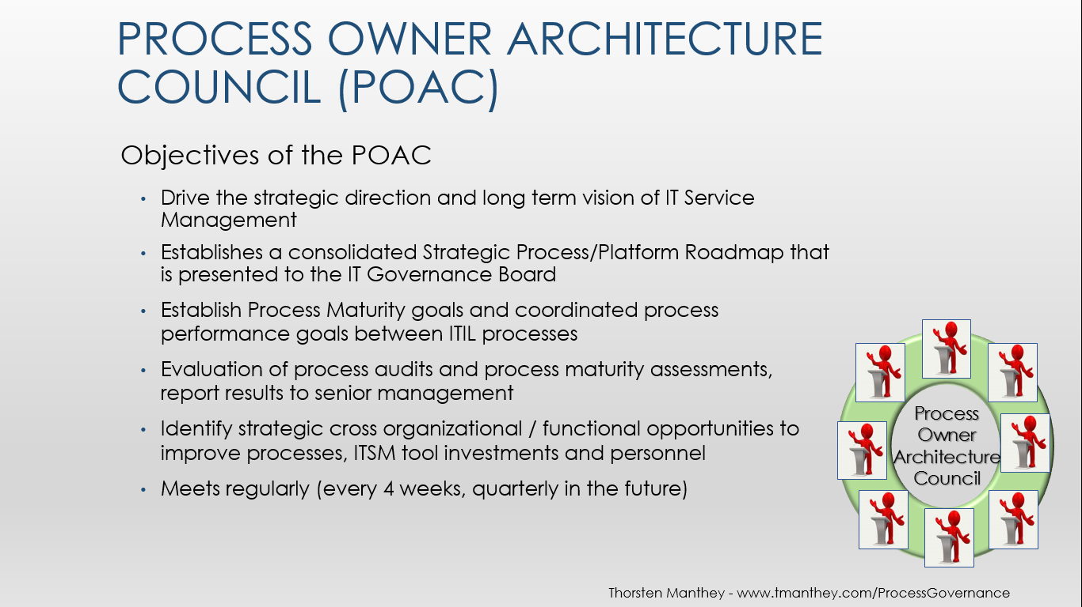
Figure 10: Process Owner Council Objectives

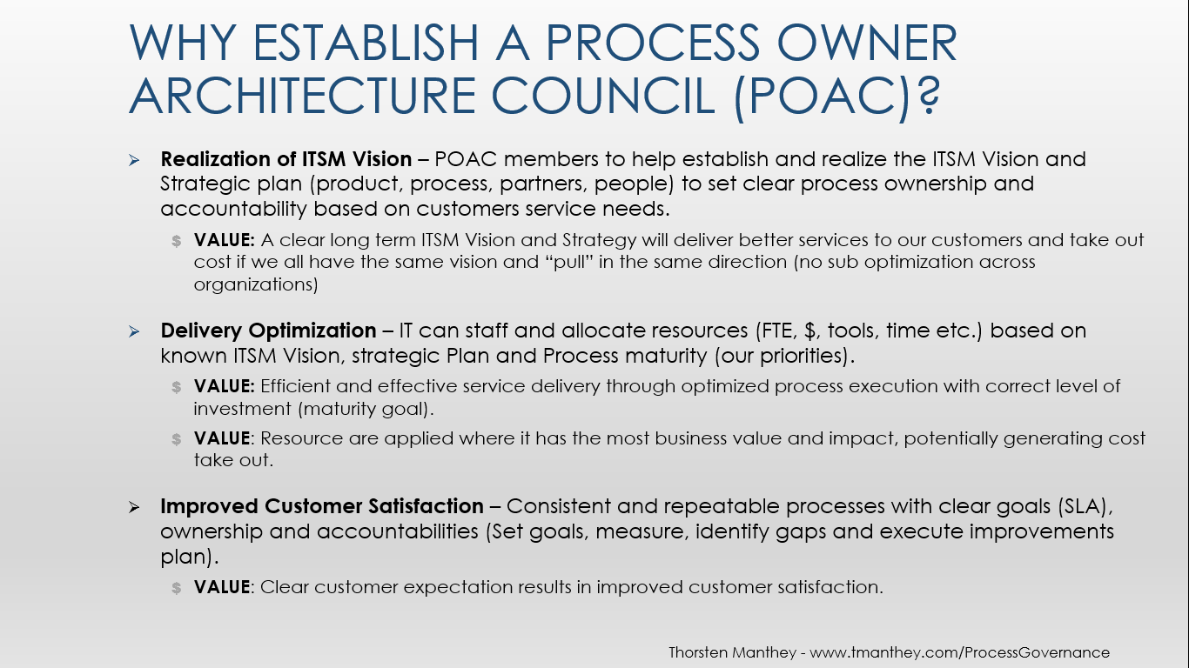
Figure 11: Process Owner Council Value Proposition
  - Process Manager Technical Review Council
The Process Manager Technical Review Council (PMTRC) oversees process integration and coordination points and identifies opportunities to improve service support and service delivery.
The PMTRC is responsible to look across the IT processes and ensure that the individual activities performed in one process area are complimentary to the overall IT service management program and does not conflict with any other IT process. They would also look for common items and ensure that those are integrated and implemented in a common way across the processes. For example, if changing the classification in one process (e.g. Incident Management) will have impact on other processes (e.g. Problem Management).
The Process Management Council:
- Meets Regularly
- Meeting Chair
- Standard Agenda
- Meeting Minutes are captured
- Agree on PMTRC Charter

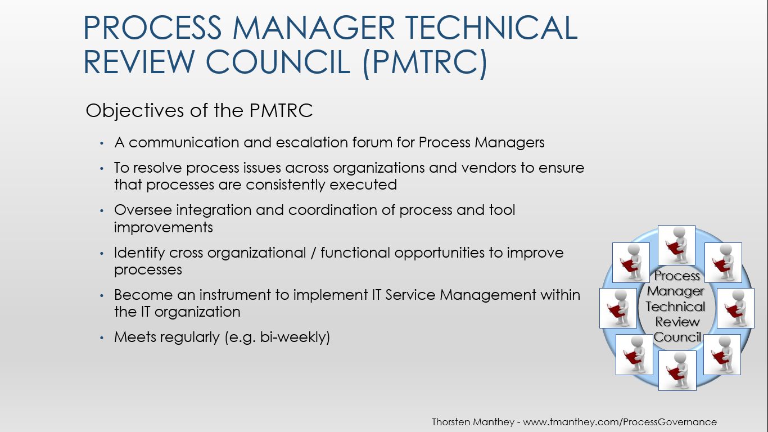
Figure 12: Process Manager Technical Review Council Objectives

The Process Owner Architecture Council and the Process Manager Technical Review Council is comprised of representatives of all the processes under the control of the councils. Each process has a Sponsor, an Owner, a Manager and one or more Subject Matter Experts associated with it.
  - Process Management Responsibility Matrix (RACI Matrix)
RACI - R = Responsible; A = Accountable; C = Consulted; I = Information Receiver
Responsibility and Accountability roles are singular, meaning one role is the focal point for execution and measurement respectively. It is essential that everyone in the organization understand the difference between accountability and responsibility.
The roles of consultant and information receiver may be performed and received by multiple participants in the process.

Responsibility
Those with an “R” in the matrix hold responsibility for execution of the process and are engaged to perform one or several tasks. These roles “report” to the role accountable for the completion of the execution. One main role is Responsible to perform a task. When other groups or organizations also have responsibility for the execution of the process, they are considered as having secondary responsibility and as such are given a designation of “r” on the RACI Matrix. An example would be of a process that is executed by both IT and one of our service providers. IT holds the primary responsibility (R); the service provider has secondary responsibility (r).

Accountability
Those with an “A” in the matrix hold accountability for the output of the process and its quality. The role must ensure that the service levels are met according to the appropriate Service Level Agreement (SLA). This role may engage other resources to perform the execution, but is ultimately accountable for the result, quality and customer satisfaction. Only one role is assigned Accountability.
Roles that have accountability for an activity must ensure that the task is done.

RACI Models
Mapping of Roles and Responsibilities to Processes and Activities

Process or Activity | Process Owner | Process  Manager | Process SMEs
Establish the long term process strategy and vision | A | C | I
Define the process goal for the development and implementation | A | C | I
Definition of the process scope | A | R | C
Assign Process Manager | A/R | C | I
Assign Process SMEs | A | R | I
Commitment of time and resources for the process development by the Process Manager and Process SMEs | A | R | C
Planning of time and resources for process development | I | A/R | C
Process development and documentation | C | A/R | C
Get approval from the IT Managers to publish process | A | R | -
Administration of process documents (retention of master copy) | I | A/R | I
Coach, instruct and train the Process SMEs | - | A/R | I
Define, Implement, monitors and reports on Key Performance Indicators (KPI) | A | R | -
Perform process execution | I | A | R
Monitor and report on process execution compliance | A | R | C
Manage process assessments and audits | A | R | C
Set goals for process improvements | A | R | C
Perform improvements and adjustments | I | A | R
Manage continuous process improvement (P-D-C-A) | A | R | C
Table 1: RACI Assignments

Consistent Process Execution
A process must be executed consistently across organizations and the governance model uses the defined roles of Process Sponsor, Process Owner, Process Manager and Process Subject Matter Experts.
Establishing process governance includes:
- Ensuring that a Process Sponsor has been identified and has accepted his or her role
- Ensuring that Process Owners have been identified and have accepted their roles
- Ensuring Process Managers have been identified and have been trained on their roles
- Ensuring that Subject Matter Experts have been identified by each Process Manager and that there are SMEs representing all key organizational units, functional areas, technology domains or vendors within IT and have been trained for the process they execute
- Establishing a Process Owner Council to drive the long term process vision and strategy across the processes and across the IT organization
- Establishing a Process Manager Council to coordinate process improvements and changes across the processes and across the IT organization
- Implementing a matrix organization within IT to support the roles and activities described above
- Creating and maintaining process reporting and communication structures to create, monitor and distribute KPIs and management reports for each process
- Adherence to the IT Process Management and Governance Guide through effective communications and quality implementation.

- Processes and Procedures
  - What is a Process and Procedure?
Definition: A process is a set of activities initiated by the earliest triggering event (input) and directed to achieve a result of value, such as a product or service, for one or more stakeholders (output).
A process is a collection of related activities that take inputs, transforms them, and produces outputs that support an enterprise goal. Activities are broken down into a sequence of tasks that are executed to transform inputs into outputs. Implemented processes are enabled through people, tools, and information.
Procedure - An ‘in context’ set of detailed steps on how to perform a task or set of tasks. It provides a sequence for the practitioner (role), referencing tools (products), and directing flows based on required decisions. Procedure steps included are suggested by activities, but are filtered by the reality of the context, including tools, and thus are not bounded by the activity definition.
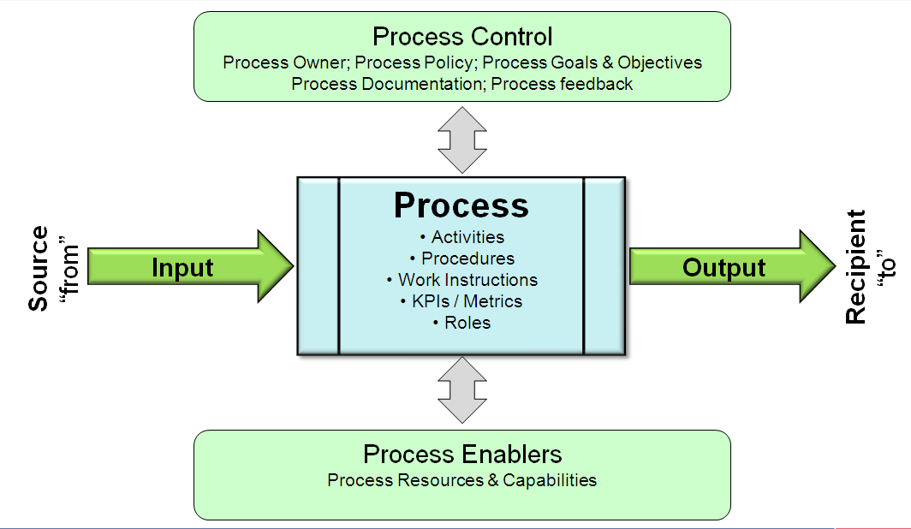
A procedure is a more detailed description of the process. It is usually system and tool specific of the activities and tasks to be performed, divided into individual steps to be executed. A process can consist of one or more procedures.

Figure 13: Generic Process Model
  - What is an Activity?
An activity is a step in the flowchart. The activity name should have a verb that clearly communicates the result of the activity. For example, "Decide Form Completeness" is a good name for an activity, while "Review Form" is not a good name. An activity can represent varying levels of detail corresponding to the level of detail of the flow diagram.
There are a number of ways and level of details that an activity flow captures. Depending on the information to be communicated to the reader of the flow chart, three levels of details can be considered:

Handoff - a high level where one activity box is drawn each time an actor has the work. This level of diagramming is useful for understanding the actors involved and the sequence of work from beginning to end.

Milestone - each activity represents a major milestone performed by an actor. This level of diagramming is useful for understanding what is achieved, while still being able to see the process from beginning to end.

Task - each activity represents a task performed by an actor. While it may be beneficial for certain parts of the process, this level of diagramming is too detailed for a beginning-to-end flowchart of the whole process. The information may be better captured in other ways, such as procedure manuals or checklists.

  - Trigger Events and Stakeholders
The Trigger Event of a process is the input from where/whom this input is received; this can be a person (organizational function), system, or another process.
The Stakeholder of a process receives the produced output of the process; this could be a person (organizational function), system, or another process.

Process Input
The input that supplies the process must be analyzed based upon:
- What initiates the process?
- What input is sufficient to produce the output?
- What characteristics must the input have?
All inputs to the process and the source of the input must be stated. The process does not only get input before it starts. Input can be continuous and occur during the execution. The handover between processes is usually where most breakdowns take place. Internal process deliverables are not listed in the input table.
Process inputs can be:
- Information
- Documents (e.g., work sheets, minutes)
- Hardware / Software
- Time related events
All input objects received by the process, their form, and from where they are received must be documented.

Input | Source of Input | Media
Input (What) | From (customer, process) | Format (How)
Table 2: Example of required Input Table

Process Output
The process output should align with the process goal and should be measurable. Characteristics of outputs are:
- They are visible or measurable, such as format, function, dimension, configuration and quantity.
- They can be assigned to the object, such as deadline, delivery method, lead time and process costs etc.
All outputs of the process and the recipient (stakeholder) must be stated. Internal process deliverables are not listed in the output table.
All output objects delivered by the process, their form, and to where they are delivered must be documented.

Output | Output Destination | Media
Output (What) | To (stakeholder, customer, process) | Format (How)
Table 3: Example of required Output Table
  - Process and Procedure Flow
The process flows are usually included in the process guide document but, if required for ease of use they can be separate documents. Process flows illustrate the process with all activities/phases/tasks and interfaces, starting with the process input and ending with the process output.
The process flow is drawn from left to right in a swim-lane diagram. Note that the flows do not capture the time aspect on the horizontal axis.
It is suggested to use the symbols displayed below, which are available in a Visio flow template for “dragging-and-dropping”.
Swim-lane flow diagrams are recommended where each swim lane represents a role/function/system within the process.
A flowchart is a good way to represent a process at high to medium level. For example, a flowchart is appropriate for showing how the work flows between different roles and/or systems (highlighting all the handoffs between the roles and/or systems), or the flow of work as well as major milestones achieved.
When documenting how tasks are performed in detail, other types of documentation (checklists, procedure manuals, etc.) are likely to be better for capturing the information.
Each flow chart has its own versioning to be able to capture and follow changes and updates.

Flow Symbols
The flows are part of the process and procedure descriptions or can be a separate document. Process flows illustrate the process/procedure with all procedures/phases/steps and interfaces, starting with the input objects and ending with the process output objects.
The process flow is drawn from left to right in a swim-lane diagram. It is suggested to use the symbols displayed below, which are available in a Vision flow template for “dragging-and-dropping”.
Swim-lane flow diagram is recommended where each swim lane represents a role/function within the process/procedure.

Symbol | Description
High Level  Business Process | High level business processes are shown using the “fish” symbol including the name of the process.
Process or  Procedure name  Identifier | A Process or Procedure is shown using a rectangle and includes the process/ procedure name and the identifier (process number).
#  Name of step  Org. unit | Procedure steps are shown in rectangles and include the responsible unit or organization, and the number and name of this step according to the description.
Object | Input/ output objects are indicated within the “connector-line”. Each step has a minimum of one input/ output-object.
From  Input  object | Event - The process input source is always connected to an object.
To  Output  object | Event - The process output recipient is always connected to an object.
A  A | Indicates a cross-reference within the same page of the flow.
2  2 | Indicates a cross-reference to another page of the flow.
1  Object | Measuring points must relate to an object.  The measuring symbol must contain a number.  PIs or KPIs usually measured in-between two measuring points. See section Error! Reference source not found.
 | Sarbanes-Oxley control and control number.
Table 4: Flowchart Symbols

  - Why do we need Process Documentation?
We need processes documentation to:
- Make sure everybody knows what to do
- Clarify responsibilities
- Promote a consistent way of working and thinking across our organizational borders
- Improve efficiency, effectiveness, and customer satisfaction by understanding how we do our work
- Secure process continuity
- Conform to regulatory requirements
- Make it easier for new employees to learn their jobs
- Make the areas of improvement visible
- Clarify interfaces
  - Processes across Organizations
Processes should be independent of the organization as much as possible. Organizational changes should have minimal impact of the process executions and process changes must minimize the effect of the organizational structure.
Processes are designed to deliver efficient and effective IT Services, the focus is on optimization of the process and not the organizational structure or specific staff executing the process activities.
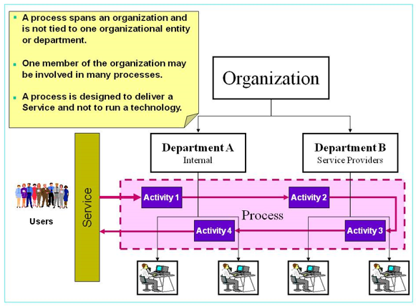
Figure 14: Process across Organizations

As outlined previously, the implementation uses the multi-departmental mapping across most, if not all, the IT processes to illustrate the relationship between processes and organization structure.

- ITIL® and IT Service Management
ITIL® (the IT Infrastructure Library) is the most widely accepted approach to IT Service Management in the world. It is a comprehensive documentation of best practices for IT Service Management. Used by many thousands of organizations around the world, a whole IT philosophy has grown up around the guidance contained within ITIL®.
  - ITIL® v3 & v4
ITIL® v3, released in 2007, focuses on the lifecycle of an IT Service, the value IT provides to the business, Return on Investment (ROI) and Value on Investment (VOI). ITIL® v3 is more aligned with the business requirements IT needs to fulfill by providing efficient and effective IT services. An updated version of the ITIL V3 framework was released in 2011.
ITIL v4 was released in 2019.
There are approximately twenty-six processes and their key functions described in five core books:
- Service Strategy
- Service Design
- Service Transition
- Service Operation
- Continual Service Improvement
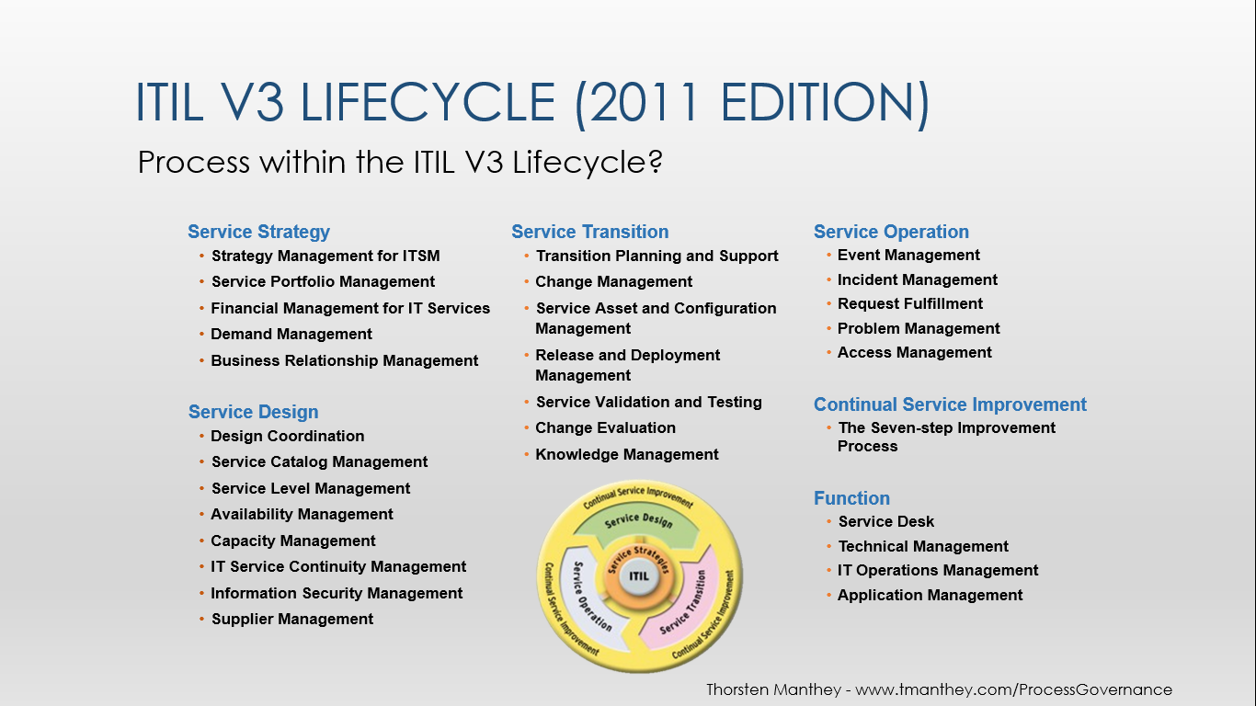
Figure 15: ITIL® V3 Lifecycle
  - Guiding Principles Overview
Each process will have a set of Guiding Principles. An effective Guiding Principle states a fundamental belief of an enterprise/organization that can drive decision making.
Each principle also has a supporting rationale and implications.
RATIONALE
PRINCIPLE
IMPLICATION

IMPLICATION
Figure 16: Guiding Principles, Rationale, Implication

Principles
A fundamental rule or guideline, tied to business objectives and requirements, that establishes design and implementation constraints
Basic and overarching rules or directions upon which IT steering and control rely
Basic philosophies of an organization that guide decision-making or behavior
Viewed as a starting point for subsequent decisions (in this case, with respect to service management design and implementation)
A Guiding Principle example is “Systems will be centrally managed”

Rationale
A list of reasons identifying why the enterprise/organization should invest in implementing the principle
Highlights the value to the business/IT of implementing the principle, and therefore provides a basis for justifying all related activities
Provides a clarified reason or motivation for the principle, derived from business/IT directions and requirements
Highlights the business and IT benefits of implementing the principle
Helps those not involved in governance to understand the principle and apply it correctly to guide their delegated decision making activities and behaviors within the service management system
An example of the rationale is “Centralization of systems management reduces costs enabling economies of scale”

Implications
A list of expected outcomes that are required in order to meet the adoption of the principle
An outline of the key tasks, resources and potential costs to the business of implementing the principle
Highlights the implications, i.e. what has to happen, both in the business and IT to implement the principle
Provides clarifying examples of where the principle directly impacts decisions and behavior changes
Documents instances where immediate impacts will occur that must be addressed
Could include any significant area of impact such as relationships, costs, processes, tasks, organizational change, and systems (i.e., identifying what are constraints that go along with the principle or key prerequisites that need to be in place)
An implication example is “Technical Resources from individual business units will need to be reassigned to the centralized organization responsible for support and management of systems.”
- Continuous Process Improvement
The IT Service Management processes will require constant improvement to fulfill their goals and objectives and must make sure all activities add value to the outcome.
  - Reason for Improvement
Demands From: | With Regards To:
- End customer or Business  - Process receiver / Stakeholder  - Process supplier  - Executive / Manager  - Associate | - Reduced costs / budget  - Reduced lead-time  - Increased productivity, profitability, and efficiency  - Improved effectiveness and customer satisfaction  - Improved working conditions (associate satisfaction)  - Adjustment to organizational and/ or legal changes
Table 5: Improvement Motivations
  - Process Improvement Model
Every organization aims to realize its vision, mission, objectives and policies, which means that appropriate activities have to be undertaken.
A common Process Continuous Improvement Model, used by the industry today is described below.

Figure 17: Process Improvement Model
What is the Vision? The organization dictates what needs to be achieved, e.g., required Capability Maturity Model Integration (CMMI) process level and define Key Performance Indicators (KPIs) according to the objectives.
Where are we now? Process assessment based on CMMI, where are we today to be able to baseline the KPIs defined?
Where do we want to be? Set goals and maturity levels for each process to be reached within specified timeline, e.g., CMMI maturity level.
How do we get there? Identify what we have to do to reach the Business Objectives and required CMMI Process level by analyzing the process as well as the enablers.
Did we get there? Measure the Process KPIs and perform Self Assessment. Have we reached out objectives?
Keep the momentum going. Improve the process again and again; by performing “Continuous Process Improvement”.
  - Process Enablers
A Process enabler is a factor that can be adjusted to impact process performance. Processes are governed by their environment, and will not work optimally unless all six enablers are in alignment.
Process Enablers:
- Motivation and measurement - Performance assessment measures, and rewards
- Human resources - Training and skills
- Policies and rules – What are the rules to be followed
- Information Systems – Tools and systems used executing the process
- Process design - the sequence of the work, the actors involved, the timing of handoffs
- Facilities - the physical layout, equipment, tools
When trying to improve a process, look carefully at these enablers to ensure they support the process changes.
  - Small Improvement Steps
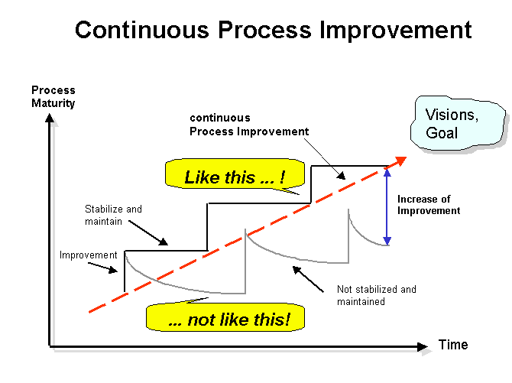

Figure 18: Many Small Improvements – Stable Process
Improve the process again and again; by performing “Continuous Process Improvement”. Several small process improvements are better than one big improvement. Small improvements can be stabilized and maintained more easily.
  - Deming Wheel
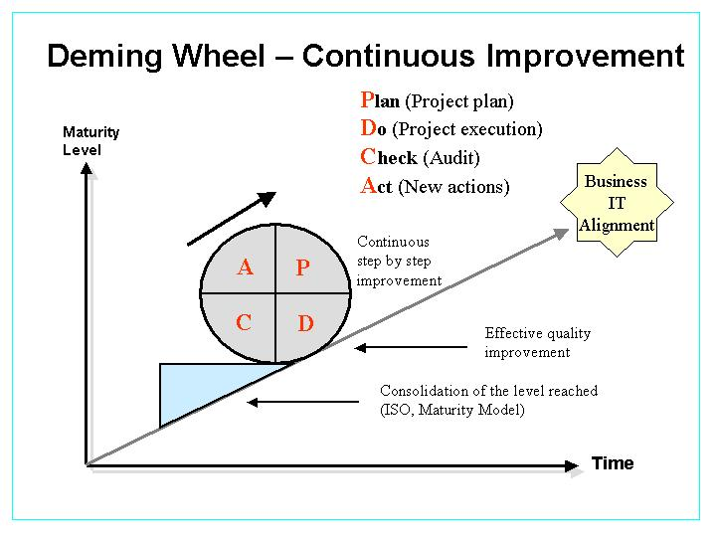

Figure 19: Deming Wheel – Continuous Step-by-Step Improvement
The Deming Wheel is a very useful method to utilize when continuously improving the process in small steps. The Deming wheel (P – D – C – A Method) can be applied as a Process Improvement and Problem solving tool when executing and fine-tuning the processes.

Plan
The Plan establishes goals for improvement including gap analysis, definition of action steps to close the gap and establishing and implementing measures to assure that the gap has been closed and benefits achieved.
- Plan how you are going to incorporate the needed improvements:
- Identify the reason for the improvement, stating it as an improvement goal
- Collect and analyze problem information (Method: e.g., ABC-Analysis)
- Identify the cause of the problem (Method: e.g., Cause-Effect Diagram)
- Develop solutions for the problem (Method: e.g.,. Brainstorming)
- Evaluate solutions and decide (Method: e.g., Efficiency Analysis)
- Update process documents and plans

Do
Do involve the development and implementation of a project to close the gap. It also covers the implementation or improvement of processes and establishment of the smooth operation of the process.
- Implement the improved process, execute and measure the KPIs.

Check
In the Check portion of the wheel there is a comparison of the implemented environment to the measures of success established in the Plan phase. The comparison determines if a gap still exists between the improvement objectives of the process and the operational process state. Gaps don’t necessarily require closure. A gap may be considered tolerable if the actual performance is within allowable limits of performance.
- Assess the measurements (KPIs) and report the results to decision makers. If the process is stable the improvement is concluded; if the process is not stable then continue with the next step under “act”.

Act
The Act stage includes the decision process to determine if further work is required to close remaining gaps, allocation of resources necessary to support another round of improvement. Project decisions at this stage are the input for the next round of the lifecycle, closing the loop as input to a subsequent Plan.
- Decide on changes needed to improve the process.

  - Process Measurements
A Critical Success Factor (CSF) is any event that must occur for the process to meet its goals and objectives. To measure the performance on a CSF, Key Performance Indicators (KPI) are established for each CSF. It is key that the KPIs are aligned with the CSF.
Critical Success Factors are supported by quantifiable, well-defined operational metrics and Key Performance Indicators so that continuous improvement can be managed.
Process measurements are used to obtain Key Performance Indicators (KPI) that supports the Service Level Agreement (SLA) and internal measures. They indicate the effectiveness, efficiency and agility (e.g. time to market) of the process. Key Performance Indicators can also be defined on a “chain of processes” linked together.
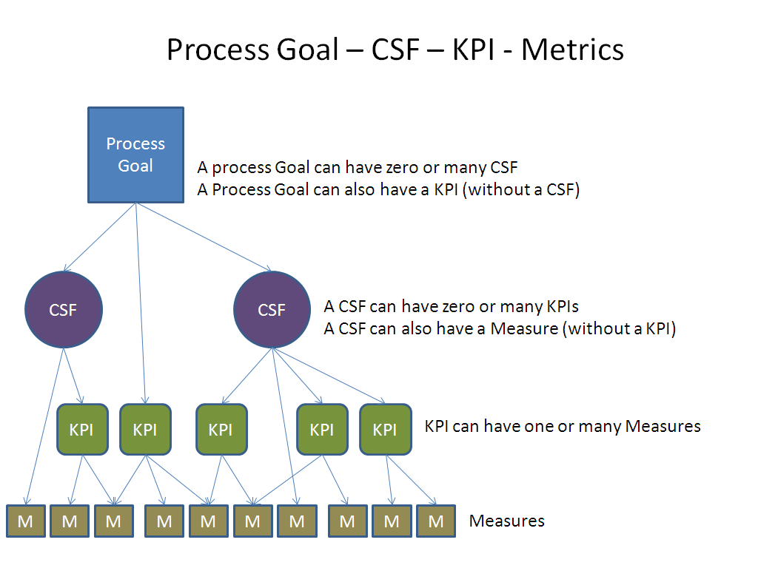

Figure 20: Critical Success Factors and Key Performance Indicators

Why Measure the Process
- To know if the process is stable
- To know if the process fulfills its goals
- To be able to improve the process
- To know if the process fulfills the Service Level Agreements (SLA)
- Validate (fulfillment of the strategic vision)
The defined measurement points in a process flow are indicated by using a triangle and a consecutive number inside the triangle.
The following table indicates what is recorded when defining a KPI for a process.
Measurement / KPI | Description / Definition
Name of measurement | Usually a mnemonic that indicates the nature of the measurement
Supports the following CSF | List of CSFs to which the measurement pertains
Owner of Measurement (e.g. Service Owner) | Owner role name or organization name
Objective of measurement (What do I want to know and why?) | The purpose of the measurement
Type of measurement (Compliance, Performance, Quality, Value) | Quality, Performance, Value, Compliance, etc.
Measuring formula (how to calculate) | Description of how the measure is obtained
Measuring points (start and end object, blue triangles in flow) | Where the measure is taken in the process. Specifically, where the process measurement begins and where it ends
Data source and location of data | Listing of the sources of the data collected to make the measurement
Goal and target of measurement | The range or value that constitutes service success
Frequency of measurement (daily, weekly, monthly) | Daily, weekly, monthly, hourly, etc.
Sample size of data (i.e. 100% or 50%) | Both the absolute number of samples and the percent of the environment sampled
Audience | A description of the population that will use the measures to make business or technology decisions
Constraints (conditions required for validity) | Conditions under which the measure may be considered valid
Upper or lower measurement /KPI limits | The valid boundary conditions for the measurement outside of which an error may be assumed to have occurred
Polarity (indicate if less or more is better) | Description of whether more (higher) or less (lower) is desirable
Table 6: Key Performance Indicators

Measurement Types

Four reasons to monitor and measure
To validate – monitoring and measuring to validate previous decisions
To direct – monitoring and measuring to set direction for activities in order to meet set targets. It is the most prevalent reason for monitoring and measuring
To justify – monitoring and measuring to justify, with factual evidence or proof, that a course of action is required
To intervene – monitoring and measuring to identify a point of intervention including subsequent changes and corrective actions.
The four basic reasons to monitor and measure lead to three key questions:
Why are we monitoring and measuring?
When do we stop?
Is anyone using the data?
To answer these questions, it is important to identify which of the above reasons is driving the measurement effort. Too often, we continue to measure long after the need has passed. Every time a report is produced the question should be asked: ‘Do we still need this?’

Four different types of measurements
Four different types of measurements can determine the health of a process ensure a balanced perspective.
A minimum of one or two measurements should be determined for each type of CSF.
Compliance – Are we doing it? / Are we following the rules?
Process compliance seeks to measure the percentage of process deployment across the IT organization. A process may have a good perceived value, good quality and speedy throughput but only be adhered to by a fraction of the IT organization. Is the process compliant, e.g., SOX?
Performance – How fast? / How many?
Performance measures gauge the average process throughput or cycle time (e.g., to capture the speed and performance of the stated process objective and output).
Quality – How well? / Number of errors?
Typically activity based and is established to measure the quality of individual or key activities as they relate to the objective of the end-to-end process.
Value – Does it matter? Are we adding value?
Value reports or surveys measure the effectiveness and perceived value of the process to the stakeholders and users.
- Process Documentation

The IT processes are based on the ITIL® framework, the industry standard of best practices for IT Service Management. It consists of a tiered process framework starting with a process, procedure and detailed work instructions on how to apply the process in a step-by-step approach including how to use the enabling support tool(s).
The process document describes the high level activities (process flow), controls, metrics, KPIs, roles and responsibilities.
Processes are mandatory if a product or a service is planned, negotiated, decided, procured, developed, produced, transported, stored, installed, implemented, tested, approved, repaired, upgraded, updated, or maintained.
  - Document Approval and Administration
Process changes that affect interfaces (e.g. inputs and outputs) to other ITSM processes must be vetted in the Process Managers Council (PMC).
With the approval, the “approver” has agreed to the content and form of the document.
By approving a process, the “approvers” (Process Sponsor, Process Owners and IT Managers) commit themselves to implement and execute the process according to its description.

Checklist for the Process Manager
After approval of the document:
- Indicate that the document has been signed and is approved in the electronic version of the document. A process is “electronically signed” when the date is inserted in the approval section, next to the name of the person who signed the document.
- Remove all “revision marks” in the document and update DRAFT to APPROVED on the title page of the document.
- Make sure the electronic document is stored and retained in according to the IT retention guidelines.
- Publish the document (PDF format) within the WorkNet structure under the ITSM Processes page
- Document Naming and Maintenance
It must be ensured that two documents cannot have the same unique name. Every physical file that is part of the formal process documentation must comply with the naming standard.
  - File Name and Uniqueness
The physical document file name to be seen in the explorer window must be named using the following convention in order to provide a unique identification for each document.
Convention | Example
<Name in characters> | Incident Management
<Document type>  Process, Procedure, Flow, Check-list etc. | Process
<Number>  Not required for process documents. To be used for Work Instructions, Flows and other types of documents where there is a possibility to have more than one document. | 1
Table 7: Unique Document Naming Convention
<Name in characters> <Document type> <Number> .docx
Example: Incident Management process.docx or Incident Management work instruction 3.docx
  - Document Version Control
The following structure must be followed for assigning version numbers for any document.
The version handling feature in SharePoint will be utilized to manage previous versions of the document / file. The version will be recorded within each document.
- V00 – major version changes
- R00 – minor revisions within one version
Version | Description
V00.R01 | First draft version of the document
V00.Rnn | nn = Subsequent draft revision number of the document draft
V01.R00 | First approved version
V01.R01 | First approved version plus small changes for minor release
V01.Rnn | nn = Subsequent revision number of the version 1 document
Vmm.R00 | Mmth approved version
Vmm.R01 | Mmth approved version plus small changes for minor release
Vmm.Rnn | nn = Subsequent revision number of the version mm document
Table 8: Draft and Approved Document Version Control
  - Information Security Classification Standard

Information Classification
Information Classification is the allocation of information assets into one of a series of categories and the application of specific controls based on those categories. The classification assigned to an information asset is based on the sensitivity, criticality, and value of the information and determines the appropriate level of protection that will be applied. We classify all information assets, whether generated internally or externally, under one of the following categories: Confidential, Limited Distribution, and Public. The default classification for information is Confidential.

Classification Responsibility
It is the responsibility of the owner of an information asset, or the originator or creator of a document, file, report, published work, computer tape or diskette, to properly classify and label an asset so that it is afforded sufficient protection when in storage (both physically and logically) and to help protect it from unauthorized access or disclosure.

Default Classification
Information assets that do not possess a classification marking or identifier are classified as Confidential by default and will be treated as such. A collection of information (e.g. data warehouse, repository, database, table, file, etc) will carry the highest classification of any of its data.

Information Classification Matrix
The below table provides definitions and classification levels for various types of information assets. The Business Owners will classify information using the classification matrix set forth in this policy based upon the actual sensitivity and confidentiality of the information being protected.
Classification Level | Description | Examples
Confidential | Encompasses all information that must be disclosed only to those individuals with a business need to know and the legal right to access it.  Unauthorized disclosure could have a serious financial, legal or operational impact. | - Covered Information  - Personally Identifiable Information (PII)  - Protected Health Information (PHI)  - Social Security Number  - Credit card information  - Personnel records  - Proprietary Corporate information  - Product designs, specs, confidential pricing metrics or business financial data  - Application code  - Merger and acquisition information  - Strategic business plans  - Encryption keys  - Account passwords  - Audit information containing any other Confidential Information
Limited Distribution  (Default) | Any information intended solely for use by workforce members when conducting our business.  Disclosure of this information requires discretion upon its distribution so only those with a business need-to-know have access to it. Limited Distribution information is often described as "Internal Use Only."  Differs from Confidential Information in that it does not include any individually identifiable information, nor does it include any proprietary company information that could cause serious harm to the company if disclosed in error. If released or disclosed without authorization, it may have a limited impact on the organization or internal operations. | - Internal communications  - Business practices  - Budget plans  - Company phone directory  - Company email address directory  - Contract information  - Internal policies  - Internal procedures  - Employee listings  - General security reports
Public | Public Information refers to any information that is released to the public by authorized management or is readily available to the public (such as through news services or the Internet).  If released or disclosed would have no impact on the organization, our customers or business operations. | - Advertisements  - Company announcements  - Marketing material  - Public web pages
Table 9: Information Classification Levels
  - Document Templates
Microsoft Word templates for process, work instructions and Vision flows are available to guarantee the same structure and same “look and feel” when documenting the processes.
The following document templates are located on WorkNet under the ITSM Document page
- Process Guide template
- Visio Flow template
- Visio Stencil
- ITSM Information Guide Template
- ITSM Glossary Template

Appendix A: Abbreviations and Acronyms
The Abbreviations, Acronyms, and Processes found within this document are defined below.

Document Specific Acronyms
Acronym | Meaning
CMM | Capability Maturity Model
CMMI | Capability Maturity Model Integration
COBIT | Control Objectives for Information Technology
CSF | Critical Success Factor
IT | Information Technology
ITIL® | Information Technology Infrastructure Library
ITSM | IT Service Management
KPI | Key Performance Indicator
P-D-C-A | Plan-Do-Check-Act
PMC | Process Manager Council
RACI | Responsible, Accountable, Consulted, Informed
ROI | Return on Investment
SLA | Service Level Agreement
SEPG | Software Engineering Process Group
SME | Subject Matter Executer
SOX | Sarbanes-Oxley Act of 2002
VOI | Value on Investment
Table 10: Abbreviations

Process Acronyms and Definitions
Note: The process acronym is a two to five letter character field, unique for each process and other identified documents.
Acronyms | ITIL Process Name and Description
ACM | Access Management – This process is responsible for allowing users to make use of IT Services, data, or other assets by establishing a registry of IT users’ identities and their associated access rights.
ARM | Architecture Management – The process which creates, maintains, promotes and governs the use of IT architecture models and standards, across and within a business's change programs. IT Architecture thus helps the stakeholder community coordinate and control their IT related activities, in pursuit of the business's common goals.
ASM | IT Asset Management - The process which controls all assets owned by the IT endeavor throughout their lifecycle and maintains accurate information about them in an Asset Register. The aspects of asset control under this purpose include inventory, contractual (licensing, maintenance), ownership and location
AVM | Availability Management - The process which enhances the availability of services by planning long-term service availability, measuring and monitoring service availability, and by formulating service availability requirements.
CFM | Configuration Management – The process which maintains the integrity of the configuration items (CIs) employed in, or related to, IT systems and infrastructure in either a development or operational context, and provides accurate information about CIs and their relationships. The definition of a configuration item is a component of the infrastructure that needs to be managed in order to deliver an IT Service. Primarily, this includes hardware, software, and related documentation. It may also include changes requests, service level agreements, procedures, and other items.
CHM | Change Management – The process which is responsible for the successful introduction of changes to an IT system or environment. Basically, a change is anything that alters the status of a configuration item (CI). This typically includes anything that adds to, deletes from, or modifies the IT infrastructure. The definition of a change is the addition, modification or removal of approved, supported or base lined hardware, network, software, application, environment, system, desktop build or associated documentation.
CMM | Compliance Management – The process which ensures adherence with laws and regulations, internal policies and procedures, and stakeholder commitments.
CPM | Capacity Management – The process which matches the capacity of the IT services and infrastructure to the current and future identified needs of the business. Capacity Management focuses on the design and planning of service capacities through to the operational aspects of service capacity and performance.
CSM | Customer Satisfaction Management – The process which determines whether - and how well - customers are satisfied with the services, solutions, and offerings from the providers of IT. The process aims to proactively predict what the customer satisfaction will be - and then to determine what must be done to maintain or, where appropriate, enhance satisfaction and customer loyalty.
CTM | Customer Transformation Management - The process which assists IT customers in the transformation of their business throughout the lifecycle from the genesis of transformation ideas through to the measurement and optimization of the benefits from implemented transformation. While this process primarily exists to support technology-based transformation, a customer might request assistance under this process for other kinds of transformation.
DM | Data Management – The process which ensures that all data necessary in providing and supporting business and operational services is available for use and is actively managed from creation/introduction until final disposal/destruction.
DMM | Demand Management – The process which understands the patterns of the customers' business behaviors and relate those patterns to the impact on the supply of IT services in order to synchronize the demand with the capacity of IT resources.
EVM | Event Management – The process which identifies and prioritizes infrastructure, service, business and security events, and establishes the appropriate response to those events, especially responding to conditions that could lead to potential faults or incidents.
ELM | Evaluation Management – This process is responsible for a) assessing a new or modified IT service to ensure risks are being managed before work proceeds and b) comparing actual with intended outcomes to determine areas needing improvement.
FAM | Facilities Management – The process which creates and maintains a physical environment that houses IT resources and optimizes the capabilities and cost of that environment.
FIM | Financial Management – The process which provides effective control of IT financial resources, including accounting, charging, and collection for IT services. This includes the forecasting, setting and control IT budgets, provision of financial information that enables business decisions, and compliance with legal, corporate and regulatory requirements on financial management.
IAM | Identity and Access Management – The process establishes and maintains a registry of IT user identities and their associated access rights for each service. The registry provides a key reference for the authorization or rejection, by the Security Management process, of service usage attempts.
INM | Incident Management – The process focuses on the restoration of a service affected by any real or potential interruption of the quality of that service.
IRI | IT Research and Innovation – The process identifies new developments in technology, methods and solutions which have potential business value, conducts research into their applicability and benefit, and promotes viable, innovative concepts in support of business objectives
IFS | Information Security Management – The process establishes and operates security controls and protections over all IT assets and services in order to conform to overall business security as well as IT-specific requirements. It includes activities to mitigate the risk posed by malicious outsiders and insiders, as well as to decrease vulnerabilities in the IT services, systems and processes that would make it easier for such malicious parties to succeed.
ITS | IT Strategy Management - The process sets the goals, and decides on areas of change for IT capability to support the business strategy. The IT strategy process should address long and short-term objectives, business direction and its impact on IT, the IT culture, communications, information, people, processes, technology, development, and partnerships.
ITSCM | IT Service Continuity Management – The process ensures that agreed-to IT Services continue to support business requirements in the event of a disruption to the business, based on the committed recovery schedule.
KWM | Knowledge Management – The process ensures that the organization's intellectual capital relating to IT is captured, shared, maintained and institutionalized in order to enable personnel to work effectively.
MSO | IT Governance and Management System Operation – The process runs the governance and management system under which the overall IT function performs its work of satisfying the business needs. This process does not direct what IT activities should be performed to reflect the priorities of the business, but rather oversees the monitoring and control of the collected IT projects and processes, making corrective adjustments where needed.
PBM | Problem Management – The process resolves problems affecting the IT service, both reactively and proactively. Problem Management finds trends in incidents, groups those incidents into "problems", identifies the root causes of problems, and initiates change requests (RFCs) against those problems.
PDM | Product Management – The process guides any IT product (such as an application, an infrastructure component, an IT service, documentation, or combination thereof) throughout its lifecycle from inception to retirement and is the ultimate owner of that product.
PJM | Program and Project Management – The process plans and oversees programs and projects in support of their objectives. Programs and projects are similar in that they both require planning and oversight. However, they are different in a number of ways. Projects are a temporary endeavor with a simple management structure, whereas programs are ongoing, have a more complex management structure (typically involving a steering committee), and are carried out by a number of projects. In addition, the success or failure of a program often affects the bottom line of a business.
POM | Portfolio Management – The Process decides on the set of IT investments, including both long-term and large-scale as well as short-term, limited-scope opportunities, based on the strategic intent and priorities of the business. This includes assessing all applications, services, and IT projects that consume resources in order to understand their value to the IT organization.
RDM | Release and Deployment Management – The process prepares and finalizes release packages that are fit for deployment so that optimal business value will be attained when deployment occurs. It spans the planning and direction of the rollout of software, hardware, and operational processes including related documentation, and operating procedures. The deployment portion of this process places releases and other desired changes into their target environments and activates them in order that the functionality and operational improvements they contain can create their intended value. The ‘other desired changes’ includes transferring the responsibility for any subset of an IT endeavor’s operations from ownership by one service provider to another, while maintaining service continuity.
RIM | Risk Management – The process identifies risks associated with the activities of the IT endeavor and takes measured, appropriate actions to mitigate those risks to the desired level of risk tolerance.
RQM | Request Fulfillment Management – The process receives service requests from users and routes each request to the appropriate process for handling. Some service requests are handled by the Request Fulfillment Process, whereas many others are routed to other processes for fulfillment. Request Fulfillment can be the contact management process for an implementation of an IT Service Desk (or equivalent).
SA | Solution Acceptance – The process verifies that the proposed solution - whether as individual artifacts or in its complete form - meets acceptance criteria at defined checkpoints
SAD | Solution Analysis and Design – The process creates a documented design from agreed-upon solution requirements that describe the behavior of solution elements, the acceptance criteria, and agreed-to measurements.
SCM | Service Catalog Management – The process provides an authoritative source of consistent information on all agreed-to services and ensures that it is widely accessible to those who are approved to view this information.
SDI | Solution Development and Integration – The process brings together all of the elements specified by solution design – regardless of whether they are to be created or acquired – for their customization, configuration, and integration.
SE | Service Execution – The process delivers operational services to IT customers, by matching resources to commitments and employing the IT infrastructure to conduct IT operations. This process is responsible for the scheduling, operation and execution of the IT-based services which have been committed to customers.
SIM | Service Improvement Management
SLM | Service Level Management – The process plans, co-ordinates, drafts, agrees, monitors and reports on Service Level Agreements (SLAs), and performs the on-going review of service achievements to ensure that the required and cost-justifiable service quality is maintained and gradually improved.
SMS | Service Marketing and Sales – The process understands the marketplace served by the providers of IT, identifies customers, markets to them, generates marketing plans for IT services and supports the selling of IT services. This process matches up customer wants and needs with IT service capabilities, and sells appropriate IT services.
SOT | Solution Test – The process validates that the solution and its features conform to design specifications and requirements, prior to the deployment of the solution, and verifies that selected interim work products meet specified requirements. Testing is performed throughout the entire lifecycle of the solution, including post-deployment.
SPCM | Service Pricing and Contract Administration – The process establishes a pricing mechanism for the IT entity to sell its services to internal or external customers and administers the contracts associated with the selling of those services.
SPM | Service Portfolio Management – The process provides proactive management of the IT services across the service lifecycle. This includes services in the concept design and transition pipeline as well as live services defined in the various service catalogs and retired services. It includes pieces of Product Management.
SQM | Stakeholder Requirements Management – The process captures, classifies, qualifies, promotes, and maintains requirements – from the business and for the management of IT activities – for IT services. This process also includes providing information on the status of all requirements throughout their lifecycle.
SR | Solution Requirements – The process provides a systematic approach to finding, documenting, organizing, and tracking a system's changing requirements so that an agreed-to understanding is reached as to the purpose of the solution.
SUPM | Supplier Management – The process manages interactions with suppliers and partners formally by selecting them based on their ability to meet identified requirements, and managing performance against the agreed upon commitments.
STG | Strategy Generation – The process responsible for the identifying and documenting the strategic direction for IT services and IT Service Management, defining its objectives and plan to achieve them.
SVM | Service Measurement – The process responsible for defining the metrics to be used to measure the degree of success in obtaining an IT Service’s objective.
SVR | Service Reporting – The process responsible for producing and delivering reports of achievement against Service Levels. Service Reporting should agree the format, content, and frequency of reports with Customer
SVT | Service Validation Testing – The process responsible for validation and testing of a new or changed IT Service. Testing ensures that the IT Service matches its design specifications and will meet the needs of the business
WFM | Workforce Management – The process provides the optimal mix of staffing (resources and skills) that is needed to provide the agreed-upon IT services at the negotiated service levels.
Table 11: Process Acronyms and Definitions

Source: Board Briefing on IT Governance, IT Governance Institute, 2003
This description comes from Clariteq's Workflow Process Modeling course, taught by Alec Sharp.
CMMI is a process improvement approach that provides organizations with the essential elements of effective processes that ultimately improve their performance. CMMI can be used to guide process improvement across a project, a division, or an entire organization. It helps integrate traditionally separate organizational functions, set process improvement goals and priorities, provide guidance for quality processes, and provide a point of reference for appraising current processes.
Activity Based Costing Analysis

