<Company Logo>

IT Service Governance Guide

DRAFT

|  |  |
| --- | --- |
| Document Owner:  Document Manager:  Author:  Date:  Version:  Classification: | Thorsten Manthey  Thorsten Manthey  Thorsten Manthey  2019-11-13  V01  Limited Distribution |

Document Management

Document Source

This document is maintained as an online document and can be found at: <http://www.tmanthey.com/ProcessGovernance>

Document Revision History

|  |  |  |  |
| --- | --- | --- | --- |
| Date | Revision | Description | Author |
| 01/01/2019 | V01 | Initial version | Thorsten Manthey |
|  |  |  |  |
|  |  |  |  |

Document Owners and Approvers

|  |  |  |  |
| --- | --- | --- | --- |
| Name | Role | Signature | Date |
|  |  |  |  |
|  |  |  |  |
|  |  |  |  |

Target Audience

The intended audience for this document is anyone within IT executing an IT process or delivering an IT service who requires information about the activities to be performed, e.g., a Subject Matter Expert (SME) or anyone who seeks detailed information of each step or tool utilization or implementation.

Ownership

The Document Owner has the accountability that the governance framework is followed and improved.

Any proposed service improvements and changes should be proposed to the Service Owner and if required in the Service Owner Council (SOC).

Feedback and Comments

Feedback and comments on the contents of this document can be submitted to the Document Manager.

Contents

Document Management 2

1. Introduction 6

1.1 Executive Summary 6

1.2 IT Governance 6

2. IT Service Governance 8

2.1 IT Service 9

2.2 IT Service Offering 9

2.2.1 Business Customer View 9

2.2.2 Technical IT View 9

2.3 Requestable Offering 10

2.4 IT Service Portfolio 10

2.5 IT Service Catalog 11

2.6 IT Service Request Catalog 11

2.7 Service Level Agreement 12

2.8 IT Service Measurements & Reporting 12

2.8.1 Why Measure 13

2.8.2 Measurement Usage 13

2.8.3 Measurement Types 13

2.8.4 Measurement and KPI Definition 14

2.8.5 Service Reporting 16

2.9 IT Services Across Organizations & IT Processes 16

3. Service Governance – Roles and Responsibilities 18

3.1 IT Service Roles 18

3.1.1 Strategic Service Delivery Executive (SSDE) 18

3.1.2 Business Relationship Manager (BRM) 19

3.1.3 IT Service Owner 20

3.1.4 Service Manager 21

3.1.5 IT Director or Line Management 22

3.1.6 Business Client/Customer 22

3.1.7 End User 23

3.2 Service Governance Structures 23

3.2.1 Service Owner Council (SOC) 23

3.2.2 Inputs to the Service Owner Council 23

3.2.3 Output from the SOC 24

3.2.4 IT Service Meetings 24

3.2.5 Input to IT Service Meetings 26

3.2.6 Output from the IT Service Meetings 26

3.3 Service Governance Matrix (RACI Matrix) 26

3.3.1 Accountability 27

3.3.2 Responsibility 27

List of figures

Figure 1: Types of Governance 8

Figure 2: IT Service Portfolio and Service Catalog 10

Figure 3: IT Service Catalog 12

Figure 4: Relationships among CSF, KPI and Metrics 14

Figure 5: Relationship between Process and Service 17

Figure 6: Organizational Relationships of the Governance Elements 25

Figure 7: IT Service Meetings 26

List of Tables

Table 1: Contents of a Service Key Performance Indicator 15

Table 2: Input to the Service Owner Council 23

Table 3: Output from the Service Owner Council 24

Table 4: Inputs to the IT Service Meetings 26

Table 5: Outputs from the IT Service Meetings 26

Table 6: IT Service RACI Matrix 30

Introduction

* Executive Summary

The purpose of this document is to present and describe the detailed concepts of an IT Service Governance framework.

The framework describes the structures that need to be put in place, the roles that need to be assigned with defined responsibilities and accountabilities and the meetings and council groups to be established in order to operate and govern the IT Services delivered by the IT organization.

This framework is intended to facilitate IT’s provision of quality IT Services to the business based on business needs, market requirements and IT capabilities and is complemented with the IT Process Management and Governance Guide.

The purpose of this framework is to:

Obtain a common view and understanding of IT Service Governance and the Service Governance Framework.

Identify linkages to other governance structures, e.g. Enterprise Architecture governance, Process Governance, Project Governance, etc.

Make sure that all IT Services are consistently described across the IT organization using a common standard definition set

Support the Strategic Service Delivery Executive, Service Owner, Service Manager, Business Relationship Manager, Process Sponsor, Process Owner, Process Manager, Service Owner Council (SOC), Process Manager Council (PMC), and Subject Matter Experts (SME) by providing guidelines to govern, develop, document, implement, execute, retire, measure, monitor and improve the IT Services

Provide clarity of the roles, responsibility and accountability to those involved in IT Service delivery, IT Process execution and IT governance.

Adhere to the principles and definitions set forth in the IT Service processes: Service Portfolio Management, Service Catalog Management, Request Fulfillment and Service Level Management.

Support the service improvement processes of Service Measurement, Service Reporting and Service Improvement

* IT Governance

IT Governance is the responsibility of the board of directors and executive management. It is an integral part of Enterprise Governance and consists of the leadership, organizational structures and processes that ensure that the organization’s IT sustains and extends the organization’s strategies and objectives. [1]

IT Governance involves the active distribution of decision-making rights and accountabilities among different stakeholders in an organization and the rules and procedures for making and monitoring those decisions to determine and achieve desired behaviors and results.

IT Service Governance

IT Service Governance is the integrated set of activities required to ensure the cost and quality of IT services valued by the customer. It is the man­agement of customer-valued IT capabilities through effective processes, organization, information and technology, including:

Aligning IT with business objectives

Managing IT services and solutions throughout their lifecycles

The primary objective of IT Service Governance is to ensure that the IT Services are aligned to the business strategic and tactical needs and actively support them. IT Service Governance is a structured way to identify, develop, document, implement, execute, govern, and continually improve IT Services.

IT Service execution is governed by the IT Management Team. The IT Management team has the responsibility and the executive authority and power to make decisions and resolve issues across the IT organization as related to the standardization of the IT Services.

IT governance must support and align with the governance of the corporation which must align with governance structures above the corporation, e.g., national laws, accepted standards, etc. The following figure depicts the nested structure and alignment of the governance structures that include the Process and Service Governance environments.

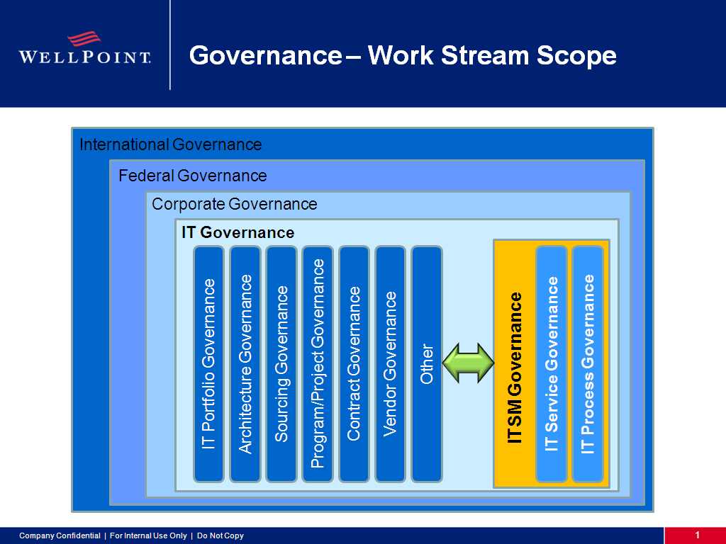

Figure 1: Types of Governance

* IT Service

An IT Service is one or more technical or professional IT capabilities which enable a business process and is the coordinated performance of one or more activities by one or more people on behalf of somebody else for the benefit of the corporate enterprise.

“A Service represents Value that the Customer wants and for which they are willing to pay”

An IT Service exhibits the following characteristics:

Fulfils one or more needs of the business

Supports the organization’s business objectives

Is perceived by the customer as a coherent whole or consumable product [2]

* IT Service Offering

### Business Customer View

A service offering describes a comprehensive service that IT is willing to provide.

Service offerings are used to publish and market IT Services to all employees and business units.

This is the “business customer view” of the IT Services Catalog and it is used by executives to understand how IT’s portfolio of Services map to business needs. The Service Offerings within the IT Service Catalog is a business description of the Services provided by IT and is used as a financial budgeting, demand planning and investment tool. At this level, the description of a Service answers the question from executives, “What is being offered by the IT organization?”

An IT Service Offering is a package of IT technology, information, processes, and procedures that is provided by the IT organization to meet the needs of its business users. Service Offerings are generally available to the entire user community and address general user needs. An example of an IT Service Offering is the corporate email service or the time recording service.

### Technical IT View

A subset of IT Service Offerings is categorized as Technical Services that are not visible to the Business but are used by IT associates to enable Service fulfillment. An example of this kind of service is standardized Servers, i.e., Platform Standardization. These services are Service Offerings but with limited or no visibility by the business.

* Requestable Offering

A Requestable Offerings is an actionable item that can be selected from a catalog and is supported by operational fulfillment activities. One or many Requestable Offerings may be associated with an individual Service Offering.

An example of a Requestable Offering would be the request to gain access to the corporate financial system to alter receipts or disbursements.

Requestable Offerings are considered the “end user view” of the IT Service Catalog and is used by employees and staff to submit IT Requests for the Services they require.

This is used for ordering services, submitting service requests, and checking on the status of requests. At this level, the Service description answers the question from end users, “If I request this service, what will I get and when will it be delivered to me?”

* IT Service Portfolio

The IT Service Portfolio describes the IT services in terms of business value. It articulates business needs and IT’s response to those needs. The service portfolio represents all the IT services presently engaged or being released in various phases of the service lifecycle. Figure 2 shows the relationship among the Service Portfolio, the Service Pipeline and the Service Catalog.

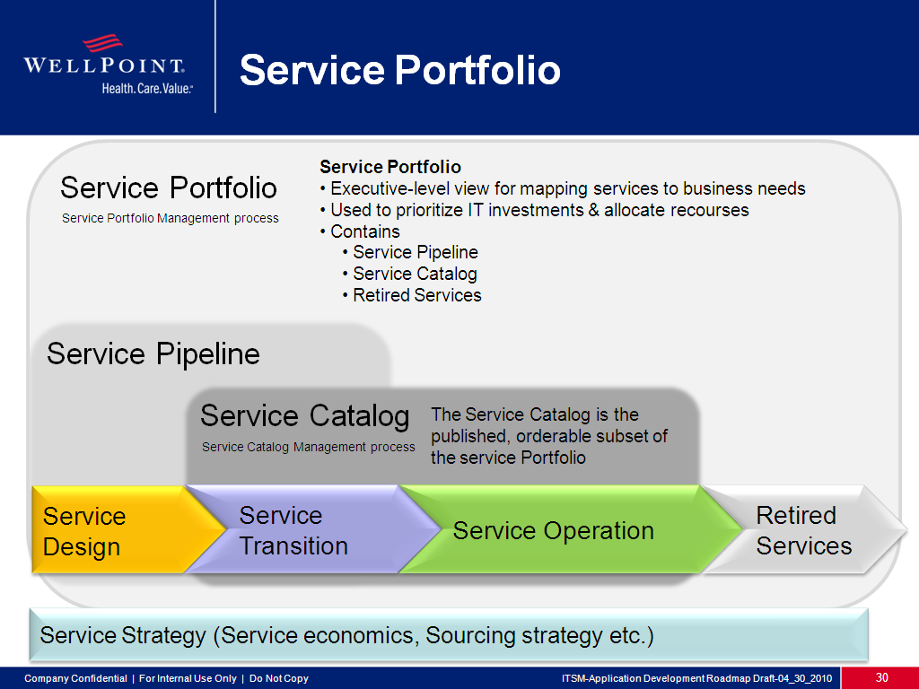

Figure 2: IT Service Portfolio and Service Catalog

* IT Service Catalog

The IT Service Catalog contains all services offered for delivery by the IT service provider. Portions of it can be used as a means of communication to the customers, but there are also sections that describe details (usually not published outside the delivery organization) of how each service is provided. ITIL defines Service Catalogue thus: "A database or structured Document with information about all Live IT Services, including those available for Deployment. The Service Catalogue is the only part of the Service Portfolio published to Customers, and is used to support the ordering and delivery of IT Services. The Service Catalogue includes information about deliverables, prices, contact points, ordering and request processes.”

The service catalog contains at least the following information:

Descriptions written in business terms familiar to the business or requestor community;

Interactive forms with pricing and categorization that describes the performance/cost alternatives;

Components, prerequisites, recommended accessories;

Authorization, escalation, and notification policies;

Delivery processes for optimal quality, speed, efficiency;

Internal and external cost structures and pricing;

Service level and operating level standards; and

Reporting on demand, usage, and customizations.

* IT Service Request Catalog

The IT Service Request Catalog is an actionable online tool used for submitting requests for IT Service and checking on the status of previously submitted service requests. The Service Request Catalog uses the information contained in the Service Catalog and the scheduling information from development management to answer the question from the end users:

* + 1. “If I request this IT Service, what will I get and when should I expect delivery?”

The end user view of the IT Service Catalog is the IT Service Request Catalog, which is used by any employee and external service providers to see the requestable IT Services available to them and to facilitate the submission of requests for the IT Services they require.

The Service Pipeline referenced in Figure 2 above is the document that describes where any service is in its lifecycle from proposal to retirement. The Service Pipeline will be created and maintained by the Service Owner Council and will be created with the transition to the documentation specialist.

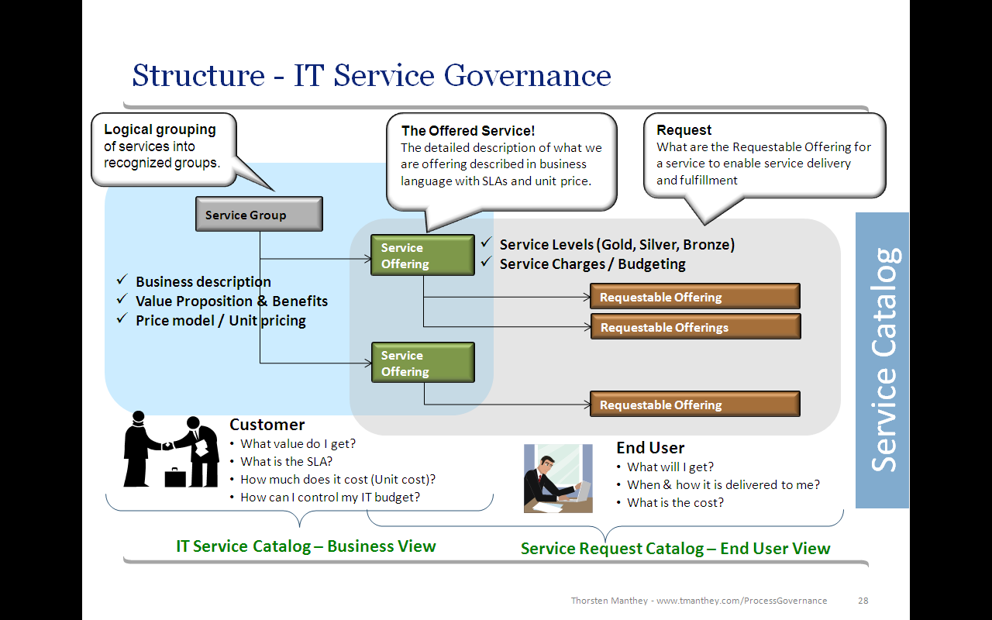

Figure 3: IT Service Catalog

* Service Level Agreement

A Service Level Agreement (SLA) is a formally negotiated and enforceable agreement between IT and the business. It is a “contract” that exists between the IT Service provider and the consumers of its Service Offerings. The SLA records the common understanding about the IT Service, priorities, responsibilities, guarantees etc. For example, it may specify the levels of availability, performance, cost, response and delivery times or other IT Service attributes.

A Service Level for an IT Service describes the different commitments that IT is making to the business regarding this IT Service. It outlines the key IT Service level metrics and their targets. It also defines the responsibilities and constraints agreed to by the consumer of the service, for example, the loads to be placed on the service, the number of supported concurrent users of the service, etc.

* IT Service Measurements & Reporting

IT Service measurements are created and instituted to ensure Critical Success Factors (CSF) are maintained for the Service Offerings. A CSF is any event that must occur or environmental configuration that must be in place for the IT Service to meet agreed goals and objectives. To measure the status of a CSF, Measurements and Key Performance Indicators (KPI) are established. It is imperative that the Measurements and KPIs accurately define and reflect the status of the CSF.

Measurements are used to support and report on the SLAs and internal IT Service measures. They indicate the effectiveness, efficiency and agility (e.g., time to market) of the IT Services and IT Processes.

### Why Measure

To know if the IT Service output fulfils the SLA or if the SLA has been breached

To know if the IT Service is achieving its goals

To be able to recognize service performance trends and proactively improve or more quickly move to bring the IT Service back into compliance

Validate fulfillment of the strategic vision for the service or component

To understand and manage customer satisfaction levels

### Measurement Usage

Measurements can be used for different reasons, the most common usages are:

Validate – Fulfillment of Strategy and Vision. Are we going in the right direction?

Justify – Reach Targets. Have we reached our target and goal?

Direct – Facts to Drive Change. Are we managing by facts not by feeling?

Intervene – Correction & Actions. Identify trends, what is broken and needs action?

The four basic reasons to monitor and measure lead to three key questions:

Why are we monitoring and measuring?

When do we stop?

Who is using the data?

To answer these questions, it is important to identify which of the above reasons is driving the measurement effort. Too often, we continue to measure long after the need has passed. Every time you produce a report you should ask: ‘Do we still need this?’

### Measurement Types

Four different types of measurements are required to determine the health of an IT Service and ensure that a balanced perspective is represented when establishing measurements.

A minimum of one or two metrics should be determined for each type of measurement to be more balanced:

* + 1. Compliance – Are we using the service? Are we following the rules?
    2. IT Services compliance seeks to measure how effectively a given service has been deployed and is being used across its intended user set. A service may have a good perceived value, good quality and speedy throughput but only be used by a fraction of its intended user set. Measures must also be put in place to ensure that the service is in compliance with government, industry and corporate regulatory measures (for example, Sarbanes Oxley (SOX), HIPAA and corporate policies.)
    3. Performance – How fast? How many?
    4. Does the IT Service deliver the required quantity within the required timeline? These would capture measures such as the average throughput or cycle time (e.g. to capture the speed and performance of the stated objective and output).
    5. Quality – How well? Are the numbers of errors acceptable?
    6. To measure the quality of individual or key activities as they relate to the objective of the service. What is the quality and number of Service level breaches generated by the IT Service?
    7. Value – Does it matter? Are we adding value?
    8. To generate reports or surveys that measure and accurately represent the effectiveness and perceived value of the IT Services to the stakeholders, the end users and the business.

### Measurement and KPI Definition

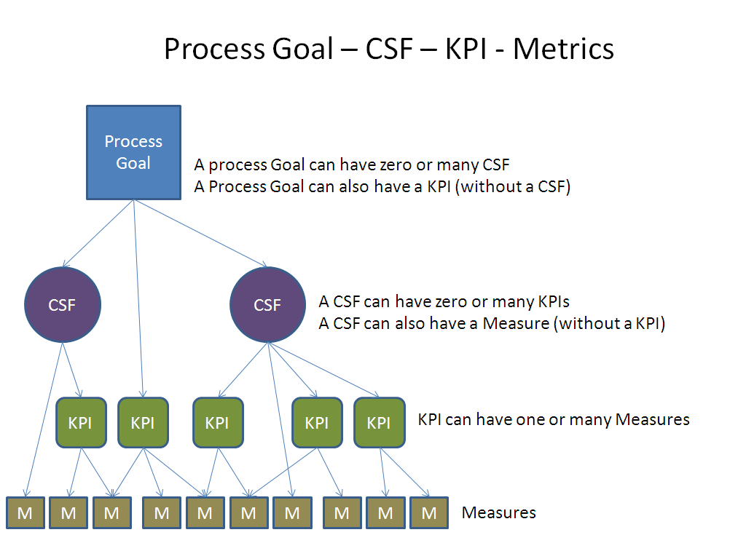

Figure 4: Relationships among CSF, KPI and Metrics

A Critical Success Factor (CSF) is any event that must occur for the service to meet its goals and objectives. To measure the performance on a CSF, Key Performance Indicators are established for each CSF. It is key that the KPIs are aligned with the CSF.

Service measurements are used to obtain Key Performance Indicators (KPIs) that support the SLA and internal measures. They indicate the effectiveness, efficiency and agility (e.g. time to market) of the Service. Key Performance Indicators can also be defined on a “chain of processes or services” linked together.

The following table indicates what is recorded when defining a KPI for a service.

| Measurement / KPI | Description / Definition |
| --- | --- |
| Name of measurement | Usually a mnemonic that indicates the nature of the measurement |
| Supports the following CSFs | List of CSFs to which the measurement pertains |
| Owner of Measurement (e.g., Service Owner) | Owner role name or organization name |
| Objective of measurement | The purpose of the measurement – what is being measured and why |
| Type of measurement | Quality, Performance, Value, Compliance, etc. |
| Measuring formula | Description of how the measure is obtained |
| Measuring points | Where the measure is taken in the process. Specifically, where the process measurement begins and where it ends |
| Data source and location of data | Listing of the sources of the data collected to make the measurement |
| Goal and target of measurement | The range or value that constitutes service success |
| Frequency of measurement | Daily, weekly, monthly, hourly, etc. |
| Sample size of data | Both the absolute number of samples and the percent of the environment sampled |
| Audience | A description of the population that will use the measures to make business or technology decisions |
| Constraints | Conditions under which the measures may be considered valid |
| Upper or lower measurement /KPI limits | The valid boundary conditions for the measurement outside of which an error may be assumed to have occurred |
| Polarity | Description of whether more (higher) or less (lower) is desirable |

Table 1: Contents of a Service Key Performance Indicator

### Service Reporting

Reporting is essential to successful IT Service execution and will serve to inform and establish accountability for actions required when improving IT Services and IT Processes. The frequency of the reports depends on the organization and type of report.

There are four constituencies that will receive reports on IT Service Delivery performance.

* + 1. Business Customer – This is the consumer of the IT Services and they will receive regular reports on Service Level achievements and value received from the IT organization.
    2. Internal IT – This is the service support staff and they will receive nearly real-time reports on IT Service performance, IT Service effectiveness and IT Service efficiency to identify areas for improvements.
    3. Senior Management – These are the sponsors and ultimate customers of the IT Services and they will receive high level reports on cost and IT Service quality to drive future IT spending and strategic decisions.
    4. External Service Provider – These are the external providers that are integrated with the IT organization delivering IT Services and they will receive the reports they need to be informed about their effectiveness in regard to IT Service delivery.
* IT Services Across Organizations & IT Processes

IT Services have been designed and implemented to be independent of the IT organization structure and the underlying IT Processes as much as possible. Organizational changes should have minimal impact on IT Service delivery and IT Service changes should be made in a way that minimizes the impact on the organizational structure and IT Processes undergirding the IT Service.

IT Processes have been designed and implemented to enable efficient and effective IT Service delivery. The focus on process quality has been on optimizing the IT Process execution to deliver business value and not the optimizing of the organizational support structures or the optimizing of the IT Process activities themselves.

Each IT Service will have a different “footprint” across the organization and is enabled by a different mix of IT support processes. It is essential that all IT Process improvements and organizational changes provide improvements in IT Service delivery.

As depicted on the graph below, both IT Services and IT Processes span across the IT organization, creating a three level matrix structure with the underpinning level being the IT organization. The challenge of the organization is to govern all three levels efficiently and effectively. The IT Process and IT Service governance frameworks focus on addressing these challenges.

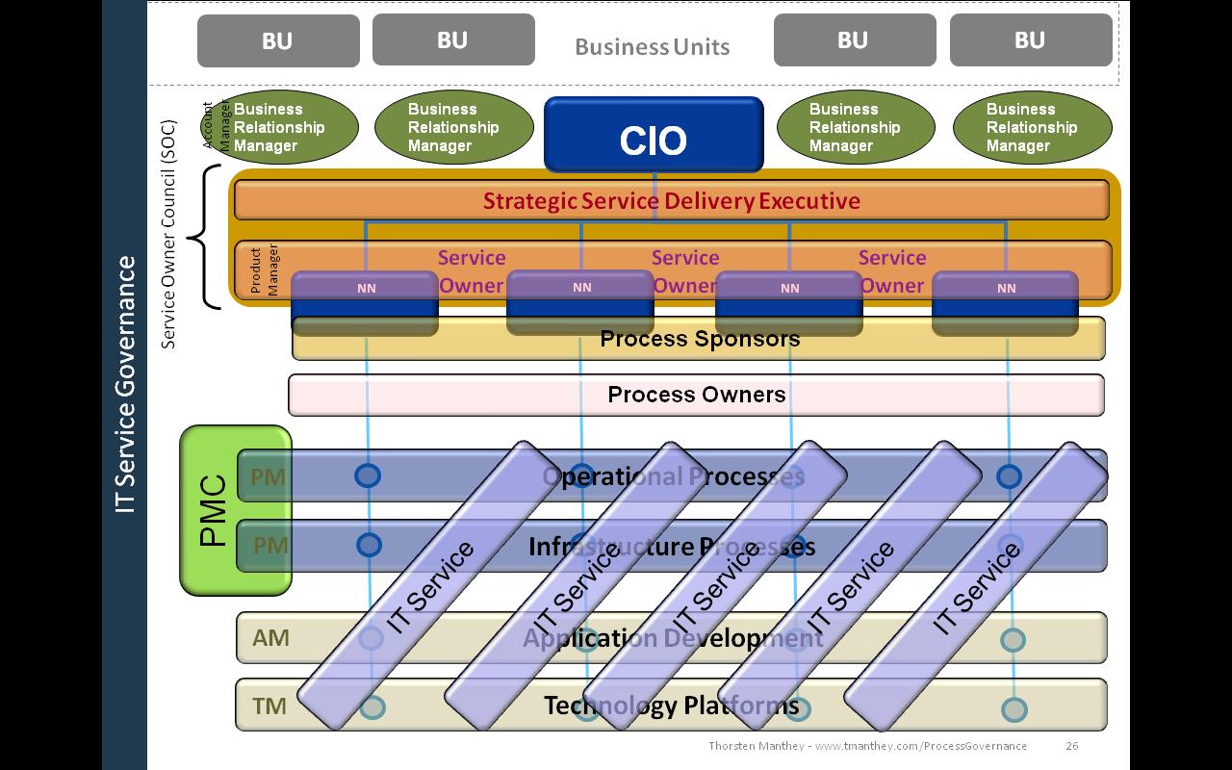

Figure 5: Relationship between Process and Service

Service Governance – Roles and Responsibilities

* IT Service Roles

Roles to govern the IT Services within the IT organization must be defined and assigned to individuals within the IT organization. Each individual assigned must have authority and empowerment to execute the role in an efficient and effective manner.

### Strategic Service Delivery Executive (SSDE)

The Strategic Service Delivery Executive is accountable for the planning of overall IT Services offered to the business and ensuring future IT Service needs are captured and that solutions are designed and provided in a timely and cost effective manner. The SSDE is responsible for the IT Service strategy and ensuring it is aligned with the business as well as both the overall IT strategy and IT architecture.

This is a senior person within the IT organization, usually reporting directly to the CIO, having authority to directly influence all aspects of IT Service delivery.

The Strategic Service Delivery Executive is accountable for the following:

Ensuring IT Service outcomes and IT Service delivery quality

Initiating and managing a Continuous Service Improvement Program (CSIP) for IT Services

Integrating the IT Service Delivery structure to enhance value and enablement within the client business processes

Support the Business Relationship Manager (BRM) and the Service Owners in the negotiation of realistic Service Level Goals with the business

Forecasting IT Service needs based on business requirements

Establishing IT Service pricing and chargeback processes and algorithms

Approving IT Service improvements that are aligned with IT Service strategy

Working with Business Relationship Managers to ensure current IT Services meet business needs and are relevant to the defined IT Services offerings

Creating and maintaining a strategic roadmap for future IT Services

Defining IT Service Offerings (based on the 4Ps - People, Processes, Products (technology, functionality, services) and Partners to deliver quality IT services with measurable results to fulfill business needs, meet regulatory requirements and improve operational efficiencies

Being accountable for the Service Levels, measurements, Service Offerings, pricing and internal IT cost allocations

Balancing the design of IT Service Offerings between quality and cost based on business needs, IT capabilities and the completeness of IT Services

Chairing the Service Owner Council (SOC) meeting

Assigning Service Owners

Ensure Service Portfolio Management, Service Catalog Management and Service Level Management processes are executed consitently across the organization

Typical skills required for a Strategic Service Delivery Manager:

Ability to align IT service offerings with business strategy, via an acute understanding of business needs and the ability to translate those needs into technology solutions or components that IT is able to provide

Company’s specific industry knowledge

Comprehensive knowledge of Company’s competitors

IT Service knowledge and process knowledge

Familiarity with and acceptance within the IT organization

Seniority and credibility within Company

### Business Relationship Manager (BRM)

The Business Relationship Manager is responsible for the relationship between IT and the business. The BRM works with the business units to understand specific IT Service requirements and negotiate on their behalf Service Level Agreements. This can be compared to being an “Account Manager” for a Business Unit.

The Business Relationship Manager is a business focused person within the IT organization with sound understanding of the business processes, business priorities, IT Services, IT and Business strategies and the IT chargeback system.

The Business Relationship Manager is accountable for the following:

Establishing and maintaining customer contacts and, in partnership with the SLM Process Owner, conduct Service Level review meetings with the business

Creating customer facing and business relevant IT Service reporting based on accepted SLAs

Capturing, documenting and representing to IT business needs for existing IT Services, for IT Service improvements or for new IT Services

Providing and explaining, on behalf of IT, chargeback information to the client

Representing the business in negotiations and issue resolutions with IT

Supporting the business with annual IT Service budgeting and IT Service utilization projections

Capturing IT Service improvement requests and communicating this information to both the IT Service Owner and the Strategic Service Delivery Manager.

Managing the business Service Requests from identification to implementation to usage to sun setting and reporting status to both IT and the business

Typical skills required for a Business Relationship Manager:

Business focused

Comprehensive understanding of Company’s business processes

Company’s specific industry knowledge including regulatory requirements

IT Service knowledge

Resource management and planning

IT Chargeback and cost model skills

Knowledge of Business and IT strategies

### IT Service Owner

The IT Service Owner acts as the Single Point of Contact (SPOC) for any operational matter regarding the IT Service and is accountable for IT Service delivery quality. This can be compared to being a “Product Manager” for an IT Service.

This is an executive level person within the IT organization having authority, knowledge, skills and staff to influence the IT Service delivery enabled by IT Process execution.

Each IT Service Owner is accountable for the following:

Providing service execution oversight, regardless of where the technology, IT Process or professional capabilities reside[3]

Maintaining, tracking, and coordinating Continuous Service Improvement Program (CSIP) for the IT Services within their purviews

Managing and implementing oversight of approved changes to the IT Service

Participating in IT Service Assessments and IT Service Audits

Overseeing the provision of IT Service Measurement, Monitoring and Reporting of formally agreed information to the Business Relationship Managers

Communicating to IT Leadership and Business Relationship Managers on IT Service initiatives and improvement progress and performance issues relating to the services they own

Some of the logistical activities of the position would include:

Attending Service Owner Council (SOC) meetings

Attending relevant Process Manager Council (PMC) meetings as required

Acting as a key Stakeholder of the IT Processes which enable or support the IT Service

Update of the IT Service Portfolio, IT Service Catalog and IT Service Request Portal with agreed IT Service updates

Participate in the execution of the Service Portfolio Management, Service Catalog Management and Service Level Management processes

Typical skills required for a Service Owner:

Understand Company’s business processes, specifically where and how the service he or she owns plays a role in the company’s operations

Possess Company specific industry knowledge as well as pertinent regulatory activities

IT Service knowledge, specifically with regard to his or her Service Offerings as they are currently defined with respect to direct and complementary interactions / impacts to other services / processes of the particular service.

Resource management and planning

IT Chargeback and cost model skills

### Service Manager

The Service Manager is responsible for the service development, documentation, execution and improvement and is the repository of service and process knowledge. The Service Manager is the champion for the Service and leads and co-ordinates the providers of service components and makes sure the service information is published and communicated.

He/She is a champion for appropriate service usage, and ensures standardization, consistency and harmonization of these activities. He/she is the custodian of service related documentation and training material.

Some of the activities would include:

Continuous reporting on defined service Key Performance Indicators (KPIs) and compliance reporting e.g. Sarbanes-Oxley (SOX).

Continuous service improvements

Monitors and measures the usage, market penetration, quality and content of the delivery/output of the service

Regularly reviews and adjusts the service in concert with the SMEs and BRMs to maintain efficiency and effectiveness of the service and user satisfaction with the service

Attending relevant Process Manager Council (PMC) meetings as required

The Service Manager participates in the Service Owner Council (SOC) when requested as the Subject Matter Expert for the service.

The Service Manager is responsible for the implementation and delivery of the service. The Service Owner assists (as he/she is accountable for the implementation and delivery quality) to ensure consistency across the organization.

### IT Director or Line Management

The IT Director or Line Managers within the IT organization are accountable for the following:

Taking on the role of Service Owner as assigned

Identifying, justifying, acquiring and managing IT Process execution staff and IT Service delivery staff within their own organizations

Identifying, quantifying and negotiating IT Service and IT Process related performance goals for their services and their foundation processes

Ensuring strategic alignment with the Strategic Service Delivery Manager’s directives

Providing funding and time for the training of the service support staff

Typical skills required for IT Director

Strong leadership skills

Financial management skills and including departmental budgeting

Identify, prioritize and set the vision for IT projects

Ability to set individual goals and establish the direction for the department as it aligns with the Company’s IT strategy

A thorough, broad based understanding of technologies

Desire and ability to maintain a personal presence in the IT marketplace to ensure awareness of innovation and leading practice technology

Communication skills to represent the activities of the service teams to the IT marketplace and to represent the advances and activities of the IT marketplace to the Company’s IT organization

### Business Client/Customer

The business clients represent their business units (BU) and interact with the Business Relationship Managers (BRM) and the SLM Process Owner at regular meetings where current IT Service Levels, improvements, measurements, updates to Service Level Agreements, IT Service cost and future IT Service needs are discussed, follow-on actions are assigned and progress is tracked.

The business client pays[4] for the IT Services delivered.

### End User

The end user, inclusive of business users and IT associates, are employees and clients, using and consuming the IT Services.

* Service Governance Structures

### Service Owner Council (SOC)

The Service Owner Council oversees coordination among the IT Services and identifies opportunities for IT Service improvements based on feedback from the Business Relationship Managers and IT Service measurements from the Service Level Manager.

The SOC agenda includes discussion of IT Service measurements, status of IT Service improvements based on business needs and coordinates the work required based upon business priority and IT capabilities.

Future IT Service requests from the business are evaluated and analyzed.

IT Service changes are approved by the SOC.

Meeting frequency: Quarterly

Chaired: Strategic Service Delivery Manager

### Inputs to the Service Owner Council

| Input | From |
| --- | --- |
| New IT Service Requirements | Strategic Service Delivery Manager  Business Relationship Manager |
| Major IT Service Changes | IT Service Meeting (Service Owner) |
| IT Service Integration Requirements / Challenges | Service Owners |
| Third party and sourcing vendor improvement requirements | Strategic Service Delivery Manager  Process Manager Council |

Table 2: Input to the Service Owner Council

### Output from the SOC

| Output | To |
| --- | --- |
| New IT Services analyzed and prioritized | IT Service Meeting |
| New IT Process Requirements | Process Manager Council / Process Owner / Process Manager |
| Consolidated IT Service Reporting | Business Relationship Manager |
| SLA Requirements / IT Service Improvements | IT Service Meetings |

Table 3: Output from the Service Owner Council

### IT Service Meetings

IT Service Meetings are held for each Service offering. The IT Service Meetings are attended by all Business Relationship Managers utilizing the IT Service, the SLM process owner, the Service Manager and the Service Owner to discuss opportunities in IT Service delivery quality based on short and long term business needs.

Upcoming IT Service Level changes based on business requests are communicated between the Business Relationship Managers and the Service Owners.

Major IT Service changes or updates agreed in this forum must be forwarded to the Strategic Service Delivery Manager for approval before implementation.

Meeting frequency: Monthly

Chaired: Service Owners

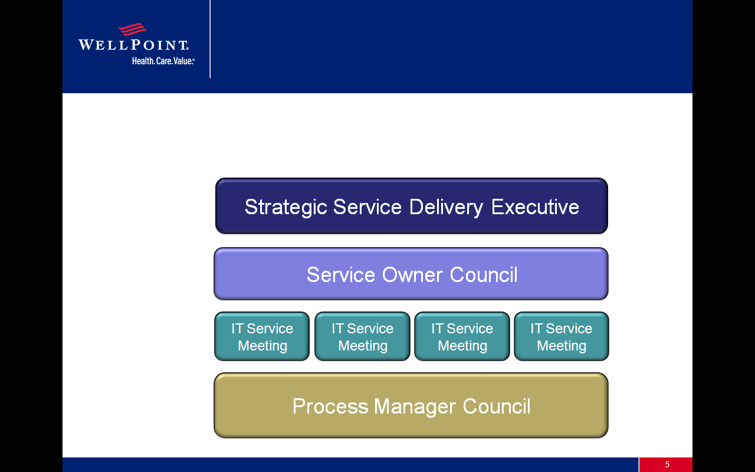

Figure 6: Organizational Relationships of the Governance Elements

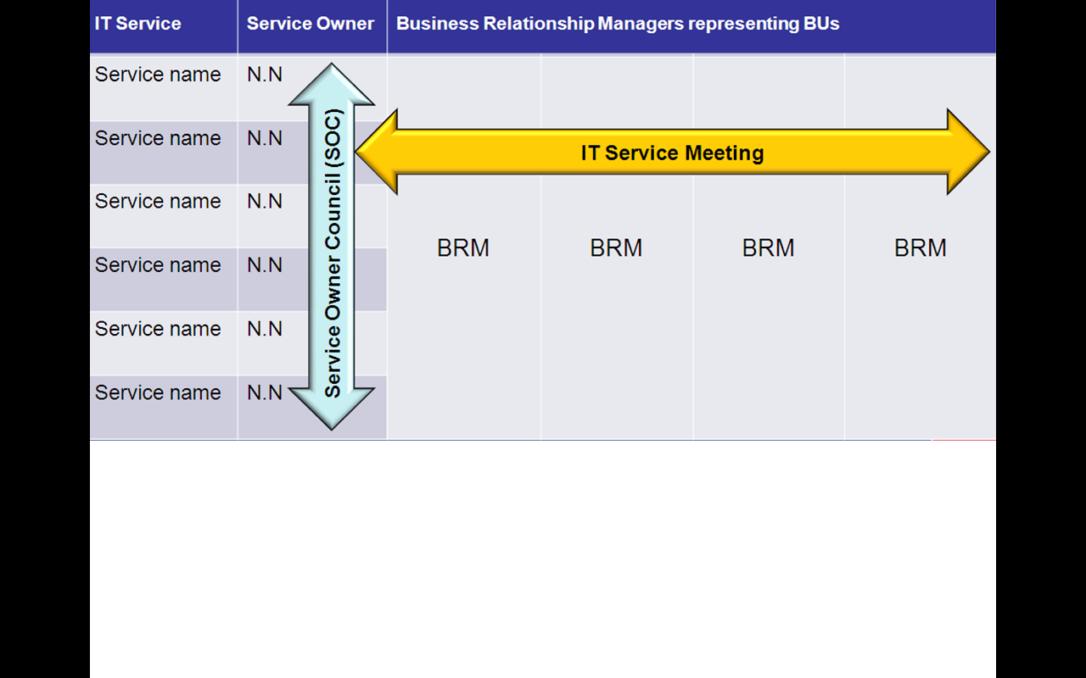

Figure 7: IT Service Meetings

### Input to IT Service Meetings

| Input | From |
| --- | --- |
| New IT Services Analyzed and prioritized | Service identification from the SPM process and prioritization from the SOC |
| Business / Client feedback on IT Service delivery | Business Relationship Manager and Service Level Manager |
| IT Service Integration Requirements / Challenges | Individual Service Owners |
| SLA Requirements / IT Service improvements | SOC |

Table 4: Inputs to the IT Service Meetings

### Output from the IT Service Meetings

| Output | To |
| --- | --- |
| Major IT Service change request | SOC for review and approval and SPM for implementation |
| Consolidated IT Service Reporting | Business Relationship Manager and Service Level Manager |
| IT Service Catalog Updates | Business Relationship Manager |
| IT Service Request Portal Updates | Business Relationship Manager |
| Third party and sourcing vendor improvement requirements | SOC |
| IT Process Improvement Requirements | PMC |

Table 5: Outputs from the IT Service Meetings

* Service Governance Matrix (RACI Matrix)

The levels of responsibility defined in the RACI model are as follows:

Responsible – Primary role(s) that does the work

Accountable – Makes sure the work is done adequately

Consulted – Asked for input

Informed – Told about the work

It is essential that everyone in the organization understand the difference between accountability and responsibility.

### Accountability

Those with an “A” in the matrix hold accountability for the output of the service and its quality. The role must ensure that the service is delivered according to SLA. This role may engage other resources to perform the execution, but is ultimately accountable for the result, quality and customer satisfaction.

### Responsibility

Those with an “R” in the matrix hold responsibility for delivery of the service and are engaged to perform one or several tasks. These roles “report” to the role accountable for the completion of the execution. One main role is Responsible to perform a task. When other groups or organizations also have responsibility for the delivery of parts of the service, they are considered as having secondary responsibility and as such are given a designation of “r” on the RACI Matrix. An example would be of a service that is comprised functions provided by both IT and one of its service providers. The Company holds the primary responsibility (R); the service provider has secondary responsibility (r).

| Task | Strategic Service Delivery Manager | Business Relationship Manager | Service Level Manager | Service Owner | Service Manager | IT Director / Line Manager |
| --- | --- | --- | --- | --- | --- | --- |
| Successful execution of the Service program including stewardship of the Service budget | A | I | I | C | R | C |
| Management and control over defined projects within a service | C | I | I | A | R | C |
| Defining, developing and communicating Service policies | A | r | C | R | C | I |
| Communication to the IT Leadership Team on progress and challenges in regards to IT Services | A | I | C | R | r | I |
| IT Service outcome and IT Service delivery quality | A | C | I | R | r | I |
| Service execution regardless of where the technology, IT Process or professional capabilities reside | I | I | I | A | R | I |
| Initiation of Continuous Service Improvement Program (CSIP) for IT Service | A | C | C | R | r | I |
| Maintenance and execution of Continuous Service Improvement Program (CSIP) | I | C | R | A | r | C |
| Manages and implements approved changes to the IT Service | I | I | r | A | R | C |
| IT Service Assessments and IT Service Audits | A | I | I | R | r | C |
| IT Service Measurement, Monitoring and Reporting of any relevant information needed by the Business Relationship Manager | I | I | r | A | R | C |
| Communication to IT Leadership and Business Relationship Managers on IT Service initiative progress and performance issues | C | I | r | A | R | r |
| Integration of the IT Service with the business process | A | C | I | R | r | I |
| Update the IT Service Portfolio, IT Service Catalog and IT Service Request Portal with agreed IT Service updates | A | C | C | r | R | I |
| Chair for IT Service Meetings with Business Relationship Managers | I | I | I | A/R | I | I |
| Ensure current IT Services meet business needs and definition of these IT Services | A | C | C | R | r | I |
| Define roadmap for future IT Services | A/R | C | I | C | C | I |
| Establishment of Service Levels, measurements, resources, pricing and internal IT cost allocations | A/R | C | C/r | I | C | C |
| Designs IT Service options between quality and cost based on business needs and IT capabilities | A/R | C | C | C | C | C |
| Chairs the Service Owner Council meeting | A/R | I | I | I | I | I |
| Customer contacts and continuous Service Level review meetings with the business | I | A/R | r | I | I | I |
| Creation of customer facing and business relevant IT Service reporting based on agreed SLAs | C | A/R | C/r | r | r | C |
| Capture new IT Service requirements and business needs for IT Service improvements or potentially new IT Services | I | A/R | C | I | C | I |
| Establish and agree realistic Service Levels with the business | A | R | C/r | C | C | I |
| Establish IT Service pricing and chargeback information | A | R | C | C | I | I |
| Provide chargeback information to the client | I | A/R | C | I | I | I |
| Support the business with annual IT Service budgeting and IT Service utilization | C | A/R | C | I | I | I |
| Capture IT Service improvement request and provide this information to the Service Owner and the Strategic Service Delivery Manager | I | r | A/R | I | I | I |
| Take on the role of Service Owner | C | C | I | I | I | A/R |
| Determine staff assignment for Process Managers, IT Process execution and IT Service delivery within own organization | I | I | I | I | I | A/R |
| Quantifies IT Service and IT Process related performance goals | C | I | C | R | I | A |
| Ensures strategic alignment with Strategic Service Delivery Managers directives | C | I | C | I | I | A/R |
| Supports funding and time for training for staff | I | I | I | C | I | A/R |
| Approval of IT Service improvements aligned with IT Service strategy | A/R | I | C | C | I | I |

Table 6: IT Service RACI Matrix

(This page was intentionally left blank)

1. Source: Board Briefing on IT Governance, IT Governance Institute, 2003
2. ITIL® Version 3
3. Given that many of the processes and services will be provided by organizations under contract to the company, this oversight may extend beyond the organization.
4. It is to be decided by the IT organization if and when chargeback for IT Services will occur.