<COMPANY>

COMPANY LOGO

ITSM Change Management Program

DRAFT

Document Owner:  Author:  Date:  Version:  Classification: | Thorsten Manthey  Thorsten Manthey  2014-10-13  V1  Open

Document Revision History
Date | Revision | Description | Author

Document Owners and Approvers
Name | Role | Signature | Date

Contents
1. Introduction 4
1.1 Goals & Objectives 4
1.2 Organizational scope 4
2. Change Management Phases 5
2.1 Phase 1 – Preparing for Change 5
2.2 Phase 2 – Managing Change 5
2.3 Phase 3 - Reinforcing change 5
3. Change Management Approach 6
3.1 Structured Approach 6
3.2 Change Management Strategy 6
3.3 Individual Change Management 7
3.4 Change Management Program 7
3.5 ADKAR Model 8
3.5.1 Communication Roles 8
3.5.2 Communication Activities 9
4. Communication and Training Plan 10
4.1 Consolidated Approach 10
4.2 Communication 10
4.3 Presentation 10
4.4 Training 10
5. Engagement Model 12
6. Appendix A - Evaluation & Assessment of Program 13
6.1 Critical Success Factors 13
6.2 KPI 13
6.3 Statistical Tracking 15

- Introduction
This document describes the IT Service Management (ITSM) change management program and the activities required to implement a successful program.
The program defines the process, its required output and what to whom, when, and how communication and training should be performed.

Goals & Objectives
The overall goal of this Change Management program is that all employees (IT and Business) and our partners are well informed about the IT Service Management (ITSM) program and how it will affect them.
It also ensures that our employees and partners have sufficient skills and knowledge at the right time to embraces the “new way of working”.
Realizing that what employees hear and what managers say is not always the same is the first step to understanding that change management cannot be reduced to a set of generic activities or steps. Change management requires attentiveness, insight and a results-orientation to be successful.

Organizational scope
- The complete IT Infrastructure organization including our partners.
- End Users and third parties relevant to specific functions, processes and services.

- Change Management Phases

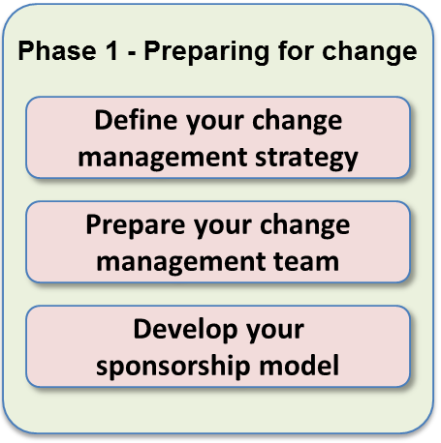
Phase 1 – Preparing for Change
The first phase of the Change Management process is aimed at getting ready. It answers the question: "how much change management is needed for this specific program/project?" The first phase provides the situational awareness that is critical for effective change management.
Outputs of Phase 1:
- Change assessment (size and attributes)
- Change management team structure
- Sponsor assessment, structure and roles
- Change management strategy

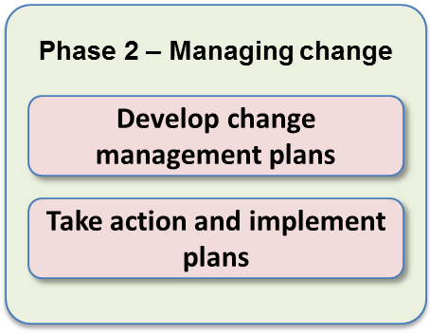
Phase 2 – Managing Change
The second phase focuses on creating the plans that are integrated into the program/project activities - what people typically think of when they talk about change management. There are typically six plans that should be created to help individuals move through the ADKAR Model
Outputs of Phase 2:
- Communication plan
- Sponsor roadmap
- Training plan
- Coaching plan
- Resistance management plan
- Transition plan

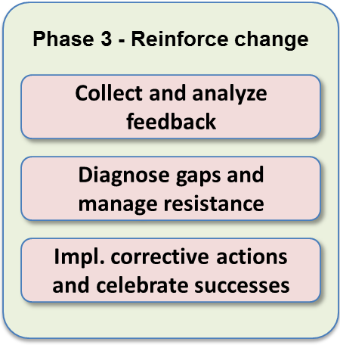
Phase 3 - Reinforcing change
The third phase helps project teams create specific action plans for ensuring that the change is sustained. In this phase, project teams develop measures and mechanisms to see if the change has taken hold, to see if employees are actually doing their jobs the new way and to celebrate success.
Outputs of Phase 3:
- Reinforcement mechanisms
- Compliance audit reports
- Corrective action plans
- Individual and group recognition approaches
- Success celebrations
- After action review
- Change Management Approach

Structured Approach
Change Management requires a structured approach, just like Project Management with different phases and defined deliverables.
The three phases in the Prosci® methodology are:
- Preparing for change
- Managing change and
- Reinforcing change.

In the first phase, Preparing for change the focuses is on “How much change management is needed for this specific program/project”? In this phase the change management strategy is developed.
The second phase, Managing change is where many of the change management plan are developed and implemented. Plans like, communication plan, sponsor roadmap, training plan, resistance management, transition plan and so on.
In the third phase, Reinforcing change, project teams create specific action plans to ensure that the change is sustained. This is also where measures and mechanisms are defined to see if the change has taken hold are created.

Change Management Strategy
A change management strategy is developed to get an understanding of the change itself and how people will be impacted.
This is the first phase where we should ask “How much change management is needed for this specific program/project”?
The Change Management strategy document includes a number of sections.
- Change Characteristics Assessment
The initial section describes the change characteristics of the program including the scope of the change – department, division or is it the whole company.
What type of change is it – Policy, process, technology, merger or acquisition.
The amount of change – incremental improvement or total reengineering.
- Organizational Attributes Assessment
The second section of the change management strategy is to assess the organizational attributes. What kind of leadership style exists? Is there capacity for change or is the organization change saturated?
Is there any history of past changes and their success or failure? What is the position of middle management, are they supportive or not?
- Proposed sponsorship model, project team and steering committee
The third section is all about the project organization and sponsorship. Are there multiple sponsors, who are the members of the steering committee, what project structure has been defined? Is there a program manager?
This is to understand the reporting structures, sponsorship and the governance of the project.
- Proposed change management team
The fourth section of the people change management strategy is to define the change management team and how it is related to the project organization. For example, are the change management resources full time or part time engaged on the project? Do they report to the Program manager or directly to the steering committee?
- Risk assessment of the change
There is also a section covering a risk assessment of the change, is this s high risk change that is disruptive or a low risk change with little resistance.
- Recommendations for special tactics
The last section identifies special tactics for special circumstances, which are key identified groups requiring special attention.
For example, is there a group that is known for resistance to changes or are the cultural differences that must be addressed for an international change effort.

Individual Change Management
“How one person makes a change successful?”
Effective people change management requires both an organizational and individual change management approach. Organizations don't change, individuals do.
No matter what type of a program or project, the success ultimately lies with each employee and our partners doing their work differently, multiplied across all of the people impacted by the change. Effective change management requires an understanding for and appreciation of how one person makes a change successfully. Without an individual perspective, we are left with activities but no idea of the goal or outcome that we are trying to achieve.

Change Management Program
“What tools we have to help individuals make changes successfully”
While change happens to one person at a time, there are processes and tools that can be used to facilitate this change. When there is a change management perspective, a process emerges for how to scale change management activities and how to use the complete set of tools available for project leaders and managers.

ADKAR Model
The first step in managing any type of change is to understand how to manage change with a single individual. The model of individual change to be used for the ITSM Program is ADKAR - an acronym for Awareness, Desire, Knowledge, Ability and Reinforcement.
In essence, to make a change successfully an individual needs:
- Awareness of the need for change
- Desire to participate and support the change
- Knowledge on how to change
- Ability to implement required skills and behaviors
- Reinforcement to sustain the change
It is imperative to communicate a message that will be understood and acknowledged by the employees and our partners at the right time.
No step in the ADKAR model can be circumvented or addressed in a different order. The content of the communication and training depends on the maturity of the organizations awareness, desire, knowledge and ability to deal with the change.

Communication Roles
The primary “senders” contribute differently to the success of the change within the different ADKAR elements. For example the CIO and VPs plays a key role of building awareness and desire as well as reinforcement.
When defining who should communicate what message and in which format the below table will help design the communication plan at the different stages of the IT Service Management Program.

Roles | ADKAR Elements
 | A | D | K | A | R
CIO / VP IT Operations  (e.g. NN, NN, NN) | X | X |  |  | X
ITSM Program Sponsor  (e.g. NN) | X | X |  |  | X
Program/Project Managers  (e.g. NN, NN, NN, NN) | X
Director  (e.g. NN, NN) | X | X | X |  | X
Manager / Team Leads  (e.g. NN, NN) | X | X | X | X | X

Communication Activities
Each communication activity plays a different role in the change and communication process.
For example, communications are instrumental in building awareness of the need for change and sponsorship is a primary activity for creating awareness, desire and reinforcement. Therefore these types of communications should be performed early in the change initiative as well as at the end during reinforcement.
Mapping of change management activities to the ADKAR elements.

Activities | ADKAR Elements
 | A | D | K | A | R
Communications / Presentations  (e.g. News Letter, Web page, Emails, IT employee meetings, Lunch & Learn etc.) | X | X |  |  | X
Management Sponsorship activities  (e.g. Communications / Presentations / Town halls etc.) | X | X |  |  | X
Coaching by a Manager, Team Leads etc.  (e.g. Coaching sessions of tool & process, employee team meetings, process training etc.) | X | X | X | X | X
Training  (e.g. Online, virtual live in person, classroom etc.) | X |  | X |  | X
KPI Reporting & Statistics Communications  (e.g. program status, celebrations of accomplishments etc.) | X |  |  |  | X

- Communication and Training Plan

Consolidated Approach
These plans can be separate plans or combined. The communication and training plan list all the different communication and training activities.
The plan captures how training / communications relate to each of the ADKAR elements, how it is provisioned, a description and the objectives of the communication and training.
The plan includes all the required details for development and execution.
The training and communication plan become a permanent record of what will be performed and also the training and communications completed, to whom and when it was delivered.
The plan will be “living document” during the lifecycle of the program/project and continuously updated and improved based on feedback and requirements. The consolidated view will enable a consistent message to the organization and provide a mechanism for synchronized activities.

Communication
Communications are planned ongoing or ad-hoc and contribute significantly to build the awareness and provide reinforcement during and beyond the project.
Communications can consist of in person meetings, Web meeting, IT employee meetings, computer based recorded sessions, emails, new letters, posters, screen savers, marketing gadgets, presentations, web pages, lunch & learn, and much more.

Presentation
A number of standard presentations focusing on the organization and program/project related topics should be available for all IT employees and partners to read when convenient. This can be used as reinforcement or on-boarding for a new employee or partner.
Examples of some standard presentations would include:
- Program/Project related presentation (scope, value, benefits, timeline etc.)
- Q&A and FAQ documentation
- Management overview presentation
- On-boarding presentation
- Process overview presentations
- Service overview presentations
- Technical/tooling presentations

Training
The training strategy for the ITSM program will be defined in the communication and training plan. The training strategy will drive the development of different training classes and how they are delivered e.g. online, virtual instructor led or in-class delivery and if the training is required or optional.
Also the training strategy will identify if tracking of completion in e.g. an LMS if required or if quizzes and testing will be part of the training to validate knowledge.
There are three main types of training during the execution of the program:
- General overview training
- ITIL training (Process)
- Tool training (Process)
- Service training (Specific for each service launched)
The goal of the training is to have a “just-in-time” educated workforce.
The objective for the organization is to have a knowledgeable organization but not necessarily everyone ITIL certified or trained in all aspects of our tools, systems, processes or services.
Training is scheduled or ad-hoc, available online, via Web meeting or provided in live classroom setting.
Training will contribute significantly to building awareness and provide specific knowledge about how to execute IT processes and procedures and how to utilize our tools.
Specific process, tool and service training will be provided to each employee involved within a specific area if required.

- Engagement Model
The development, execution and follow up of the communication and training plan could be managed centrally in one consolidated communication and training plans.
- Preparing for Change
Develop the change management strategy. Identify the sponsors / stakeholders and provide a sponsor / stakeholder roadmap document.
- Execution
Develop and deliver communications and training to stakeholders based on the change management strategy.
- Measure & Feedback
Measure and collect feedback on how effective the sponsorship, training and the communication is. Identify areas for improvement and decide on actions to be taken.
- Take Action & Update Plans
Plan for actions decided and update the consolidated sponsor / stakeholder roadmap, training and communication plan with the new activities required.
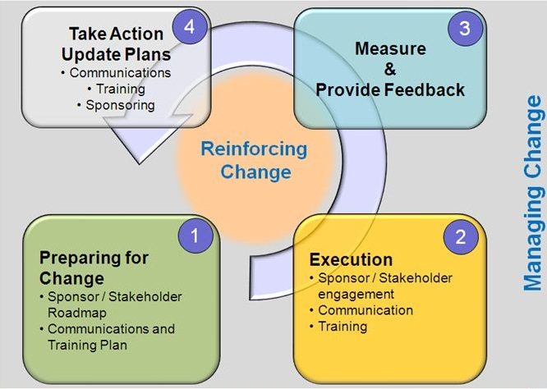
Figure: Consolidated Plans – Prepare, Manage and Reinforce Change
- Appendix A - Evaluation & Assessment of Program
The effectiveness of the change management program will be defined by Critical Success Factors (CSF) and measured by Key Performance Indicators (KPIs).

Critical Success Factors
The CSFs that have been defined are critical to the success of the implementation of the ITSM Program.
Name of CSF | Definition
People Change Management Funding | Sufficient funding for change activities, FTE, material, communication and training is made available.  Approve and promote communications and training to be distributed within the organization.
People Change Management resource hired | A dedicated people change management resource is hired to focus on change management activities for the ITSM program.
Sponsor support & Management  Walk-the-walk & Talk-the-talk | Visibility of executive management / sponsorship that promotes the program and change initiative. Without demonstrated commitment from management, a process initiative or change is severely constrained and will most likely fail.  Sufficient time must be allocated to sponsorship communications. Both by providing continuous communication as well as allowing employees to attend and absorb the communications.
Employee awareness and “sense of urgency” | Employees and partners must understand “why” we are doing this and why it is important. What is the risk of doing “nothing”?
Educated employees/  leadership | Have an educated work force to enable effective and efficient execution and quality service delivery.  Have educated leadership with a high level of process, tool and service knowledge.
Review & Feedback | Continuously review of the program must be planned for and actions identified and executed.
Celebration of successes | Funding available, time allocated and recognitions announced and celebrated.

KPI
The following KPIs will be reported quarterly.
Name of KPI | Definition | Objective | Goal
Funding  (CSF: Change Management Funding) | % of approved funding for a current year. | To indicate if the change management program is sufficiently funded and that management is “walking-the-talk” by providing sufficient resources. | - Green: > 80%  - Yellow: 50% - 80%  - Red: < 50%
Resource  (CSF: Change Management resource hired) | Approved funding for a people change management resource for a year. | To indicate if the change management resource has been assigned | - Hire in Q2 2014
Sponsorship  (CSF: Sponsor support & Management Walk-the-talk) | % of identified sponsors accepting their role | To make sure the sponsors are aware of their role and what is expected from them | - Green: > 90%  - Yellow: 60% - 90%  - Red: < 60%
Walk-the-walk & Talk-the-talk  (CSF: Sponsor support & Management Walk-the-talk) | % of identified sponsors actively supporting the change management effort | To make sure the sponsors are actively promoting and supporting the change | - Green: > 90%  - Yellow: 60% - 90%  - Red: < 60%
Awareness  (CSF: Employee awareness and “sense of urgency”) | % of employees understanding what we are trying to accomplish and have a positive view of the initiative and see the risk of doing nothing | To understand the change saturation and where additional change activities are required. | Understanding  - Green: > 70%  - Yellow: 50% - 70%  - Red: < 50%  Positive urgency  - Green: > 70%  - Yellow: 50% - 70%  - Red: < 50%
Knowledgeable employees  (CSF: Educated employees/  leadership) | % of identified employees with ITIL V3 Foundation certification within the IT Infrastructure organization. | To establish process and ITIL knowledge within the IT Infrastructure organization | - Green: > 70%  - Yellow: 50% - 70%  - Red: < 50%
Knowledgeable leadership  (CSF: Educated employees/  leadership) | % of IT Infrastructure management attending the ITIL Overview Presentation | To establish a base knowledge for IT Infrastructure management | - Green: > 70%  - Yellow: 50% - 70%  - Red: < 50%
Training evaluation score  (CSF: Educated employees/  leadership) | % of training evaluations with a score of 8 or higher (scale 1-10) | To ensure that the training provided has the right quality and content. | - Green: > 70%  - Yellow: 50% - 70%  - Red: < 50%

Statistical Tracking
Statistic | Definition
Lunch & Learn | # of lunch & learn over a year  # of employees attending lunch and learn
IT Infrastructure (ISG) employee meetings | # of IT Infrastructure (ISG) employee meetings where the ITSM program is mentioned
ITSM News Letter | # of newsletters distributed per year with ITSM program information
ITSM web page hits | # of web page hits per month on the ITSM web page
ITSM Email communications | # of Emails distributed per year with ITSM program information
All training classes should be followed up by an evaluation questionnaire to the targeted audience.

ADKAR: http://www.change-management.com/tutorial-adkar-overview.htm

