PROCESS GOVERNANCE

PROCESS MANAGER AND TECHNICAL REVIEW COUNCIL (PMTRC)

VERSION X.X

1. Meeting Name 3
2. Charter Effective Date and Duration 3
3. PMTRC Purpose 3
4. Scope of Requests and Topics 3
5. Council Composition 3
5.1. PMTRC Chair 3
5.2. Role Descriptions 4
.1 PMTRC Chair 4
.2 PMTRC Coordinator/Facilitator 4
.3 PMTRC Members 4
6. Meeting Information 4
6.1. Logistics Overview 4
6.2. Agenda and Meeting Calendar Location 4
6.3. Escalation thresholds 5
6.4. Meeting Agenda 5
6.5. Input, Activities and Outputs 6
7. Appendix 7
7.1. ITSM Governance High Level Workflow 7

Meeting Name
Process Manager and Technical Review Council.

Charter Effective Date and Duration
Effective on <Enter Date> with no planned expiration.

PMTRC Purpose
- A communication and escalation forum for process manager and technical reviews.
- To integrate, develop, maintain, and foster adoption of the best practices of ITSM processes and enabling technology using the ITIL, CMMI, COBIT and other best practice guidance and frameworks.
- To identify opportunities to improve process execution, technology integration to deliver optimized service delivery to ensure business success and a continual focus on customer experience.
- To look for opportunities that are shared by process areas and ensure that they are developed to benefit the ITSM program as a whole and to leverage process integration and technology enablement and automation.
- To govern operational and tactical changes and issue escalations, captured in a common CSI register, from process SMEs, process engineers, process stakeholders and technical analysts related to the ITSM processes and the ITSM Platform.
- Release schedule prioritization of operational/tactical items in the CSI register.
- To enforce and maintain standards (process, technology, organizational and document).
- To ensure decisions are vetted and approved/rejected by the correct audience and escalated to the Process Owner Architecture Council if a threshold is breached.
- To provide a structured meeting forum and facilitation of decision making and ensure proper communication and documentation is done for all decisions taken and escalations.
- To ensure agreed standards are followed and that proposed changes are feasible from both a technical, process, and organizational perspective.
- To ensure that the design/change proposed by the PMTRC meets the need of the customer.
- To address platform wide incidents, operational issues or conflicts that have been identified by the Process Managers/SMEs and technical analysts.

Scope of Requests and Topics
- Review and approve or deny suggested changes to the processes and ITSM platforms from an operational / tactical perspective from process SMEs or Process Managers.
- Control, authorize and prioritize operational/tactical changes to the ITSM Environments.
- Escalate to the next level (POAC) within the governance framework when required and when a threshold is breached.
- Enforce and maintain standards (process, technology, organizational and document) for the Environment.

Council Composition

PMTRC Chair
Name:
Email address:
Phone:

Role Descriptions

PMTRC Chair
- Facilitate the meeting and the voting process
- Enforce agenda timeframes
- Tiebreaker during voting
- Ensures the charter is reviewed annually

PMTRC Coordinator/Facilitator
- Ensure all the submitted agenda topics include the required information/material and is posted to the Collaboration Site
- Coordinate with meeting presenters and assign agenda time slots
- Finalize/freeze the agenda no less than 48 hours before the meeting. Ensure time slots for voting are included
- Send out a review reminders to participants 48 hours before the meeting
- Attendance recording
- Write structured meeting notes for each agenda topic with voting results
- Records action points and follows up on completion and status
- Update the meeting agenda with the voting result/notes on the Collaboration Site

PMTRC Members
- Participate in scheduled PMTRC meetings
- Review the proposed changes and CSI register
- Vote and represent their organization, process, technology or platform in the decision-making process
- Communicate decisions or direction to their organization or function
- Ensure process is in compliance with Saipem ITSM standards and policies
- Process Champion of the process they represent
- Tool/Platform Champion of the tool/platform they represent
- Review and prioritize suggested process, tool and platform changes
- Authorize changes for submission if the threshold is not breached for escalation to the POAC
- Representing the process, tool and platform during the next level in the governance framework if required

Meeting Information

Logistics Overview
- Meeting Frequency: Every X weeks
- Chair:
- Coordinator:
- Dial-in Instructions:

Agenda and Meeting Calendar Location
- Repository of Documents: Meeting agendas will be located in the Site:
<Enter Link>
- At least 48 hours before a governance meeting takes place all the supporting material shall be available at this location for participants to review in advance
- Meeting agenda will be emailed prior to each meeting including a link to the Collaboration Site
- The Collaboration Site should include notes and voting result from earlier conducted meetings

Escalation thresholds
Escalation thresholds for the Process Manager and Technical Review Council (PMTRC) to the Process Owner and Architecture Board (POAC) are defined below. When any of the following thresholds are breached escalation to the POAC is required.
- Strategic process impact changes
- Strategic tooling/platform impact changes
- Organizational or staffing changes required
- Any customization of the tool or platform
- New tools or technology requested
- Create, update, enhance, or retire applications or processes
- Any funding request > <Enter Dollar Amount>

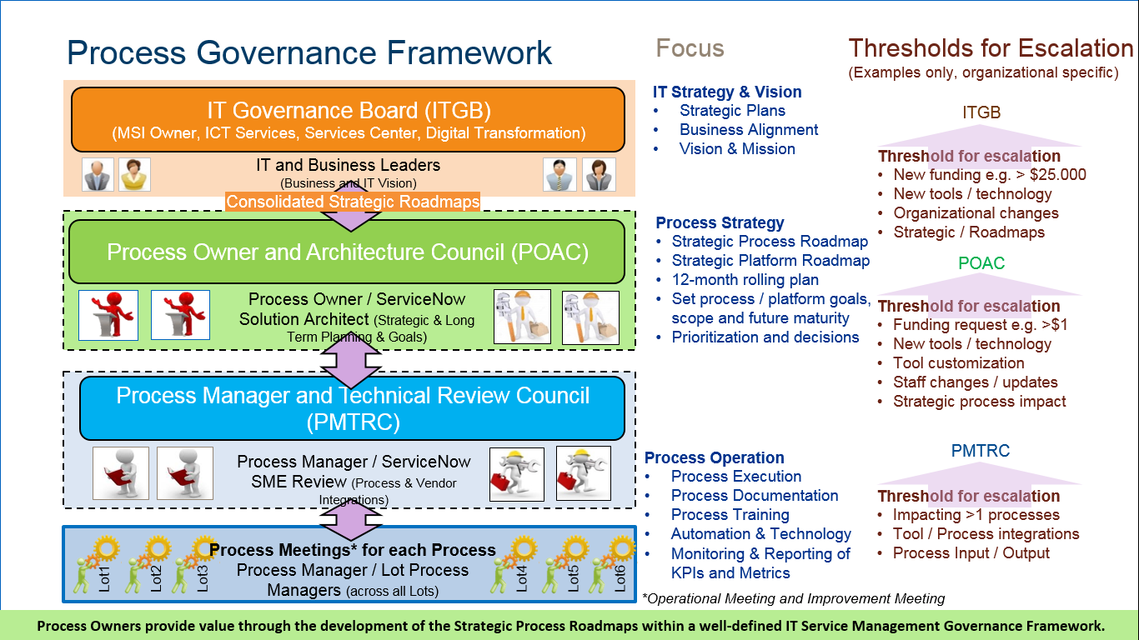

Meeting Agenda
- The agenda will be frozen 48 hours before the meeting takes place in order to ensure all participants have the necessary time to review the covered material. The agenda can be frozen at an earlier point if the agenda is filled up and the duration of the meeting cannot be extended.
- Any PMTRC member can add a topic to the upcoming PMTRC meeting agenda by:
  - Contacting PMTRC Coordinator/Meeting facilitator and submitting required information.
  - Directly add topic and related material to meeting agenda on the Collaboration Site. The following items should be specified for each topic added to the PMTRC agenda:
    - Topic
    - Short Description
    - Presenter Name
    - Duration (in minutes and do not to include time for voting)
    - Specification if the topic will require the audience to vote (Y/N)
    - Supporting material/presentation – Request Review Package (see table below)
  - The following is the minimum to be included in the Request Review Package:
    - High level overview of the Request
    - Business Justification
    - Technical Specification
    - Feasibility and Risks
    - Estimated Effort
    - Resource need (Time and skills)
    - Estimated costs and funding source
    - Estimated Timeline

Input, Activities and Outputs

Governing Body | Inputs | Activities | Outputs
Process Manager Technical Review Council (PMTRC) | - Changes that impacting more than one of the processes  - Tool / Process integrations  - Process Input / Output modifications  - Tool configurations | - Identify Quick Wins  - Review and approve or deny configurations or enhancements to ServiceNow platform  - Identify, leverage, evaluate and incorporate approved best practice from all regions into the overall ITSM program  - Adhere to policy and process standards  - Identify, track and implement service & process improvement initiatives  - Coordination between process improvements and tool integrations | - Approved or Denied Configuration/ Enhancements  - Validated and Approved Practices (Policies, Processes and Procedures)  - Escalation to POAC  - Meeting Minutes & Actions

Appendix

ITSM Governance High Level Workflow

