11th Kyu (Juichikyu)
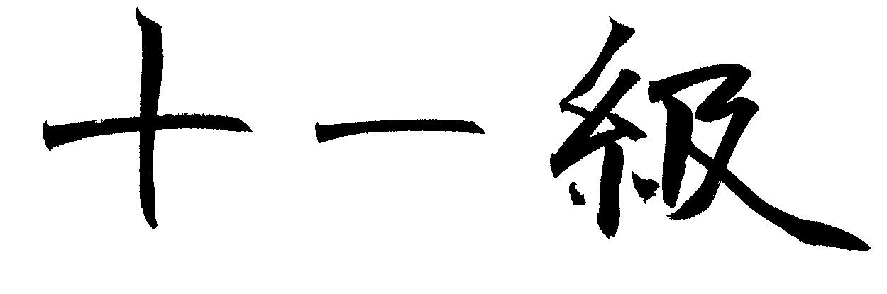
BELT
Youth Second White

Minimum age 5. Minimum number of classes 7.

BASICS
- Demonstrate shizentai (natural posture)
- Demonstrate adequate body control (tai sabaki) - changing direction and position while maintaining a balanced and controlled posture
  - Ritsurei - Standing bow
  - Zarei - Kneeling bow
  - Ayumi ashi - normal walking steps
  - Tsugi ashi - shuffling feet
- Referee commands – Define the following
  - Mate
  - Hajime

UKEMI: (Falling Techniques)
Must be able to proficiently demonstrate the following techniques
- Koho Ukemi - backward
- Yoko Ukemi - sideways
- Zempo ukemi - forward
- Zempo Kaiten Ukemi – forward rolling

TAICHI WAZA (Standing Techniques)
Must be able to proficiently demonstrate the following techniques
- O-Soto--Gari - Major outer reap
- O-Goshi - Major hip
- Ippon Seoi Nage – One arm shoulder throw

NE WAZA (Ground Techniques)
Must be able to proficiently demonstrate the following techniques
- Kesa Gatame - Scarf hold
- Yoko Shiho Gatame – Side hold
- Escape from Kesa Gatame

HISTORY & PHILOSOPHY
- Know how to spell Judo – J-u-d-o
- Define the word Judo – The Gentle Way
- Where was Judo founded - Japan

PERSONAL
- Good moral character
- Participate in class activities

10th Kyu (Jukyu)
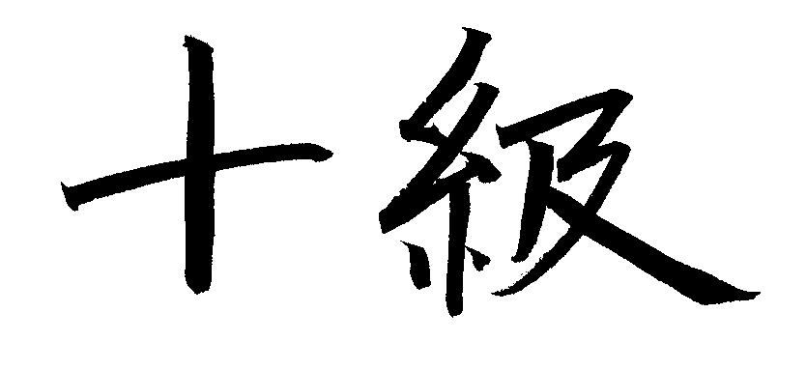
BELT
Youth Yellow

Minimum age 6. Minimum number of classes since 2nd white belt: 14

BASICS
- Be able to tie your own belt on your judogi
- Demonstrate shizentai (natural posture) and jigohontai (defensive posture).
- Demonstrate proper respect
  - Ritsurei - Standing bow
  - Zarei - Kneeling bow
- Demonstrate adequate body control (tai sabaki) - changing direction and position while maintaining a balanced and controlled posture :
  - Front and rear 90 Taisabaki – body pivot
  - Demonstrate uchikome (kuzushi and tsukuri) - entry and proper fitting of your body into the position used prior to executing a throwing technique.
  - Demonstrate the eight directions of kuzushi (happo no kuzushi)- forcing your opponent into an unbalanced position.
- Referee commands – Define the following
  - Osaekomi
  - Toketa
  - Soremade

UKEMI: (Falling Techniques)
Must be able to proficiently demonstrate the following techniques
- Koho Ukemi - backward
- Yoko Ukemi - sideways
- Zempo ukemi - forward
- Zenpo Kaiten Ukemi – forward rolling

TACHI WAZA (Standing Techniques)
Must be able to proficiently demonstrate the following techniques
- O-Goshi - Major hip
- Ippon Seoi Nage – One arm shoulder throw
- Koshi Guruma – Hip wheel
- O-Soto--Gari - Major outer reap

NE WAZA (Ground Techniques)
Must be able to proficiently demonstrate the following
- Kesa Gatame - Scarf hold
- Kuzure Kesa Gatame – Modified scarf hold
- Yoko Shio Gatame – Side locking four corner hold
- Escape from Kesa Gatame

HISTORY & PHILOSOPHY
- Name the founder of judo? Dr. Jigro Kano
- What year was it founded? 1882
- In what country was judo founded? Japan
- What was the name of the first judo school? Kodokan

PERSONAL
- Good moral character
- Participate in class activities

9th Kyu (Kukyu)
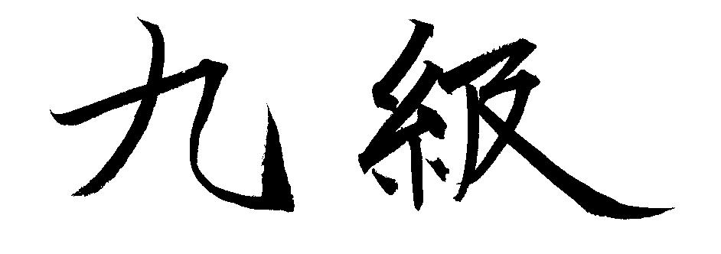
BELT
Youth SecondYellow

Minimum age 6 and attended at least 20 classes since attaining their yellow belt

BASICS
- Be able to tie your own belt
- Demonstrate shizentai (natural posture) and jigohontai (defensive posture).
- Demonstrate proper respectful movements
  - Ritsurei - Standing bow
  - Zarei - Kneeling bow
- Demonstrate correct body control (tai sabaki) - changing direction and position while maintaining a balanced and controlled posture :
  - Front and rear 90 Taisabaki – body pivot
- Be able to demonstrate the following:
  - Proper moving – Ayumi ashi, tsugi ashi
  - Demonstrate uchikome (kuzushi and tsukuri) - entry and proper fitting of your body into the position used prior to executing a throwing technique.
  - Demonstrate the eight directions of kuzushi (happo no kuzushi)- forcing your opponent into an unbalanced position.
- Referee commands – Define the following
  - Sonomama
  - Yoshi

UKEMI: (Falling Techniques)
Must be able to proficiently demonstrate the following techniques
- Koho Ukemi - backward
- Yoko Ukemi - sideways
- Zempo ukemi - forward
- Zempo Kaiten Ukemi – forward rolling

TACHI WAZA (Standing Techniques)
Must be able to proficiently demonstrate the following techniques :
- O-Goshi - Major hip throw
- Ippon Seoi Nage – Single arm should
- Koshi Guruma – Hip wheel
- O-Soto--Gari - Major outer reap
- De-Ashi Barai - Advanced foot sweep

NE WAZA (Ground Techniques)
Must be able to proficiently demonstrate the following techniques :
- Kesa Gatame - Scarf hold
- Kuzure Kesa Gatame – Modified Scarf hold
- Yoko Shiho Gatame – Side locking four corner hold
- Escape from Kesa Gatame
- Escape from Kuzure Kesa Gatame

HISTORY & PHILOSOPHY
Name 3 parts of a throw- off balance, entry, execution

PERSONAL
- Good moral character
- Participate in class activities
8th Kyu (Hachikyu)
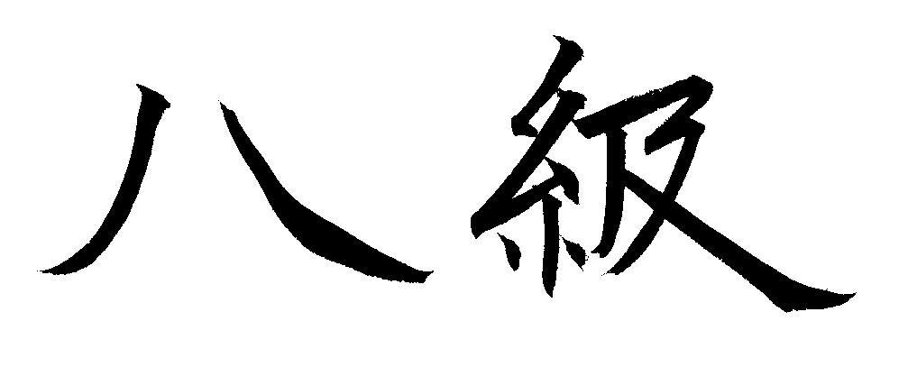
BELT
Youth Orange

Minimum age 7. Attended at least 20 classes since attaining their 2nd yellow belt.

BASICS
- Able to properly fold their judogi
- Demonstrate correct body control (tai sabaki) - changing direction and position while maintaining a balanced and controlled posture:
  - Front and rear 180 Tai sabaki – body pivot
- Ground movements
  - French fry
  - Crab
- Be able to demonstrate the following: .
  - Demonstrate uchikome (kuzushi, tsukuri, kake) both left (migi) and right (hidarai) - entry and proper fitting of your body into the position used prior to executing a throwing technique.
  - Demonstrate the eight directions of kuzushi (happo no kuzushi)- forcing your opponent into an unbalanced position.
  - Demonstrate shizentia (natural posture) and jigotai (defensive posture) both left (migi) and right (hidarai)
- Referee commands – Demonstrate the following and explain what it means
  - Ippon
  - Wazari
  - Yuko
  - Koka

UKEMI: (Falling Techniques)
Must be able to proficiently demonstrate the following techniques
- backward (koho ukemi).
- sideways (yoko ukemi).
- forward (zempo ukemi)
- forward rolling (zempo kaiten ukemi)

TACHI WAZA (Standing Techniques)
Must be able to proficiently demonstrate the following techniques
- De-Ashi Harai - Advancing foot sweep
- Hiza-Guruma – Knee wheel
- Tsurikomi Gosh – Lifting pulling hip
- Tai Otoshi – Body drop
- Ouchi Gari – Major inner reap

NE WAZA (Ground Techniques)
Must be able to proficiently demonstrate the following techniques
- Kata Gatame - Shoulder lock
- Kami Shiho Gatame – Upper four corner hold
- Escape from Yoko Shiho Gatame

SHIMI WAZA (Strangulation Techniques) – for judoka whose 13th birthday occurs during the calendar year
- Okuri Eri Jime – Sliding collar choke

HISTORY & PHILOSOPHY
Count 1-20

PERSONAL
- Good moral character
- Participate in class activities
7th Kyu (Shichikyu)
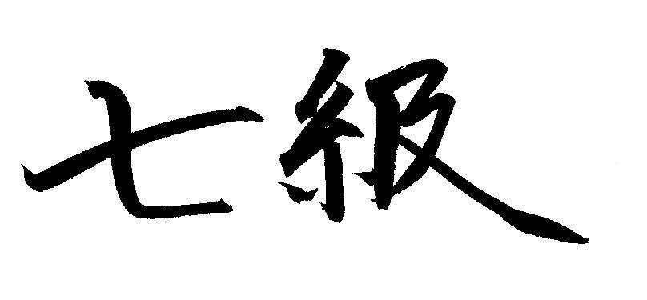
BELT
Youth Second Orange

Minimum age 7. Attended at least 20 classes since attaining their orange belt.

BASICS
- Able to properly fold their judogi
- Demonstrate Shizentai (natural posture) and jigotai (defensive posture)
- Ground movements
  - Crab backward
  - One turnover on Uki’s back
- Be able to demonstrate the following:
  - Proper moving – tai sabaki 180º
  - Demonstrate uchikome (kuzushi and tsukuri) - entry and proper fitting of your body into the position used prior to executing a throwing technique.
  - Demonstrate the eight directions of kuzushi (happo no kuzushi)- forcing your opponent into an unbalanced position.
- Referee commands – Demonstrate the following and explain what it means
  - Shido
  - Hansokumaki
  - Sonomama
  - Yoshi

UKEMI: (Falling Techniques)
Must be able to proficiently demonstrate the following techniques
- backward (koho ukemi).
- sideways (yoko ukemi).
- forward (zempo ukemi)
- forward rolling (zempo kaiten ukemi)

TACHI WAZA (Standing Techniques)
Must be able to proficiently demonstrate the following techniques
- O-Soto--Gari - Major outer reap
- O-Goshi - Major hip
- Tsurikomi Gosh – Lifting pulling Hip
- Tai Otoshi – Body drop
- Ouchi Gari – Major inner reap
- Morote Seoi Nage – Two arm shoulder throw
- One combination technique

NE WAZA (Ground Techniques)
Must be able to proficiently demonstrate the following techniques
- Kata Gatame - Shoulder lock
- Kami Shiho Gatame – Upper four corner hold
- One escape form Yoko Shio Gatame
- One escape from Kami Shio Gatame
- Demonstrate guard
- Demonstrate one guard pass

SHIMI WAZA (Strangulation Techniques) – for judoka whose 13th birthday occurs during the calendar year
- Okuri Eri Jime – Sliding collar choke
- Hadaka Jime – Naked hand choke

HISTORY & PHILOSOPHY
List jr. ranks in order

PERSONAL
- Good moral character
- Participate in class activities
6th Kyu (Rokyu)
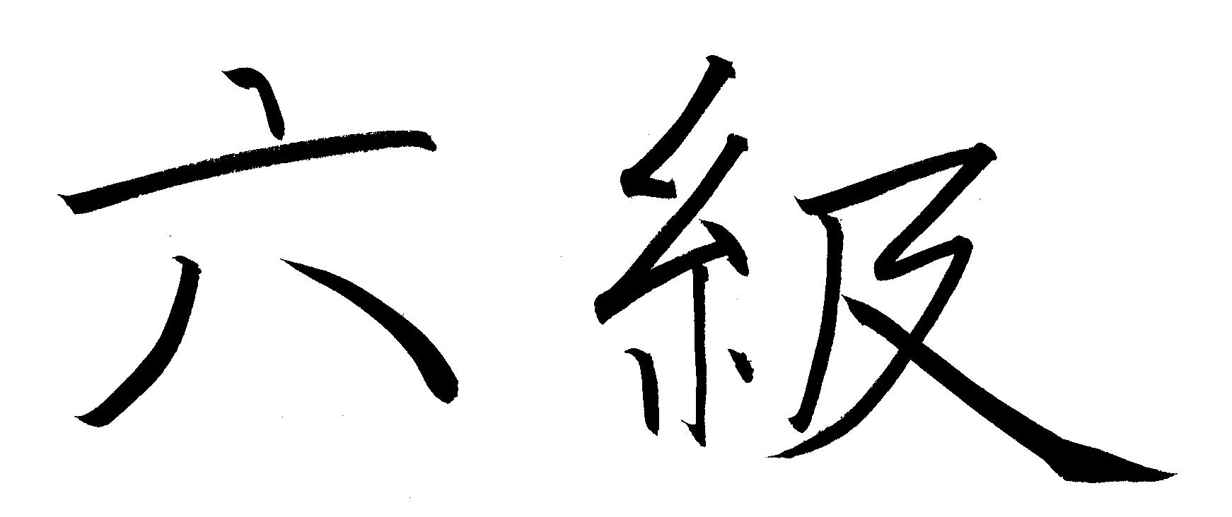
BELT
Youth Green

Minimum age 8. Attended at least 32 classes since attaining their 2nd orange belt.

BASICS
- Consistently has a clean judogi and helps keep the dojo maintained
- Demonstrate Shizentai (natural posture) and jigotai (defensive posture) both right (migi) and left (hadari) .
- Be able to smoothly demonstrate the following:
  - Proper moving
  - Demonstrate uchikomi (kuzushi, tsukuri, and kake) - entry and proper fitting of your body into the position used prior to executing a throwing technique.
  - Demonstrate the eight directions of kuzushi (happo no kuzushi)- forcing your opponent into an unbalanced position.
- Referee commands – Demonstrate the following and explain what it means
  - Provide 1 examples of how someone gets hansoku maki
  - State 2 penalties that will get you a shido

UKEMI: (Falling Techniques)
Must be able to proficiently demonstrate the following techniques
- backward (koho ukemi).
- sideways (yoko ukemi).
- forward (zempo ukemi)
- forward rolling (zempo kaiten ukemi)

TACHI WAZA (Standing Techniques)
Must be able to proficiently demonstrate the following techniques. .
- Harai Goshi – Sweeping hip
- Sode Tsurikomi Goshi – Sleeve pulling lifting hip
- Sasae Tsurikomi Ashi – Supporting foot lift pull throw
4) One nage waza to both left and right

NE WAZA (Ground Techniques)
Must be able to proficiently demonstrate the following techniques..
- Kuzure kami Shiho Gatame
- Tate Shiho Gatame – Vertical four corner hold
- One escape from Tate Shiho Gatame
- One escape from Kata Gatame
- Two turn over from uke stomach
- One Entry from uke legs
- One guard sweep

SHIMI WAZA (Strangulation Techniques) – for judoka whose 13th birthday occurs during the calendar year
- Kataha Jime – Single wing choke
- Okuri juji jime – Sliding collar choke
- One escape from Okuri Eri Jime

HISTORY & PHILOSOPHY
Name 3 parts of a throw English and Japanese - Off-balance – Kazushi, Entry – Tsukuri, Execution - Kake
List Jr ranks in order in Japanese

PERSONAL
- Good moral character
- Participate in class activities

5th Kyu (Gokyu)
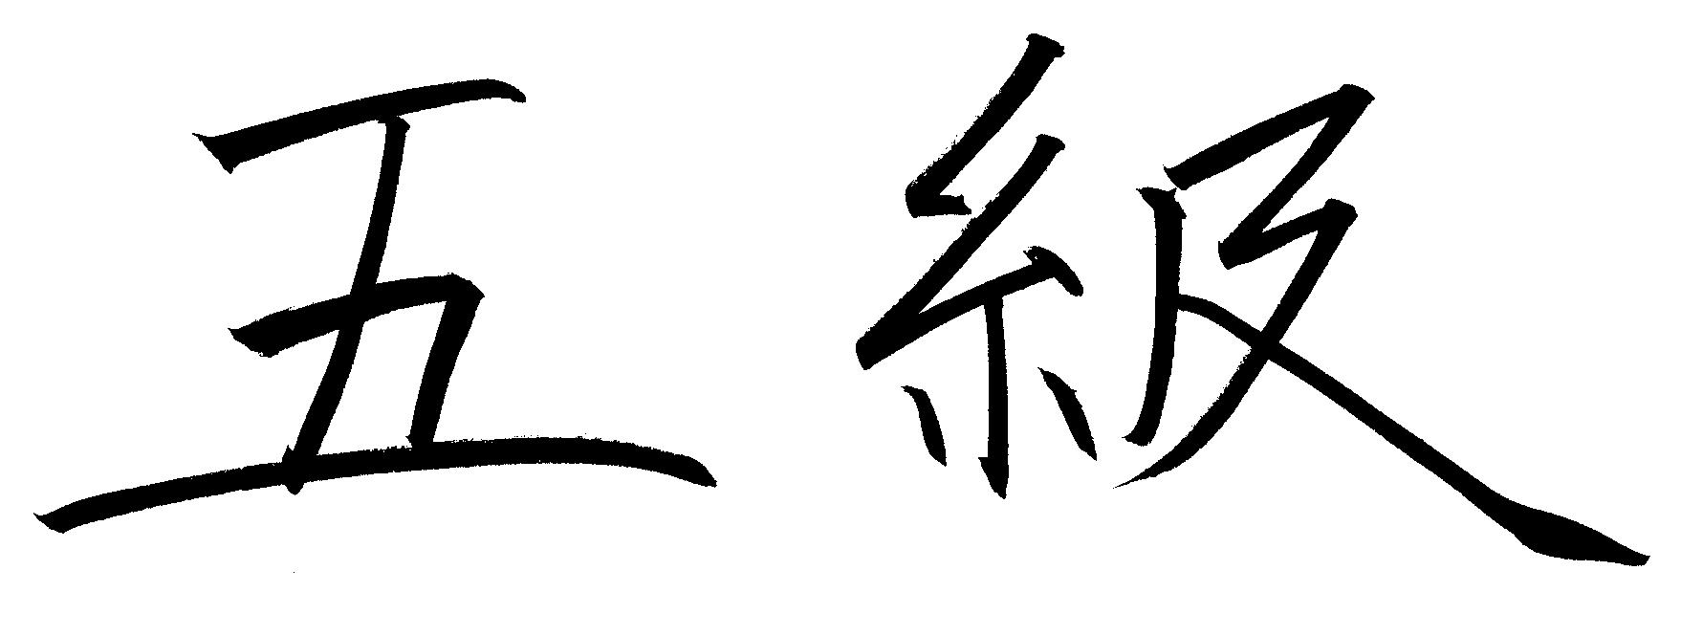
BELT
Youth Second Green

Minimum age 9. Attended minimum 40 classes since attaining their green belt.

BASICS
- Demonstrate care of judogi
- Demonstrate Shizentai (natural posture) and jigotai (defensive posture).
- Be able to demonstrate the following:
  - Proper moving
  - Demonstrate uchikome (kuzushi, tsukuri, and kake) - entry and proper fitting of your body into the position used prior to executing a throwing technique.
  - Demonstrate the eight directions of kuzushi (happo no kuzushi)- forcing your opponent into an unbalanced position.
- Referee commands – Demonstrate the following and explain what it means
  - Define hiki wake - Draw
  - Practice referee within the dojo

UKEMI: (Falling Techniques)
Must be able to proficiently demonstrate the following techniques
- backward (koho ukemi).
- sideways (yoko ukemi).
- forward (zempo ukemi)
- forward rolling (zempo kaiten ukemi)

TACHI WAZA (Standing Techniques)
Must be able to proficiently demonstrate the following techniques
- Harai Goshi – Sweeping hip
- Sode Tsurikomi Goshi – Sleeve lifting pulling hip
- Morote Seoi Nage – Two arm shoulder throw
- Sasae Tsurikomi Ashi – Supporting foot lift pull throw
- 1st nage waza to both left and right side
- 2nd nage waza to both left and right side

NE WAZA (Ground Techniques)
Must be able to proficiently demonstrate the following techniques
- Kuzure Kamshio Gatame – Modified upper four quarter hold
- Tate Shio Gatame – Vertical four quarter hold
- An escape from Kuzure Kami Shiho Gatame
- One turnover starting from uke’s side (uke face down)
- Two guard passes
- Tokui Waza _______________

SHIMI WAZA (Strangulation Techniques) – for judoka whose 13th birthday occurs during the calendar year
- Kata Juji Jime – Single wing choke
- One escape from Kataha jime
- One escape from Kata Juji Jime

HISTORY & PHILOSOPHY
Name judo’s two main principles
Mutual benefit and welfare
Maximum efficiency

PERSONAL
- Good moral character
- Participate in class activities
4th Kyu (Yonkyu)
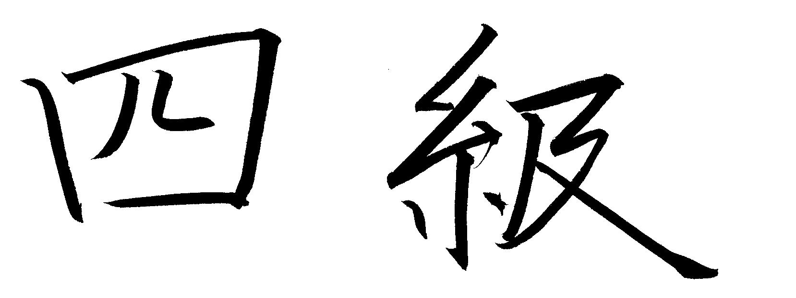
BELT
Youth Blue

Minimum age 10. Minimum 40 classes since attaining 2nd green belt

BASICS
- Demonstrate care of judogi
- Demonstrate Shizentai (natural posture) and jigotai (defensive posture).
- Be able to demonstrate the following:
  - Proper moving
  - Demonstrate uchikome (kuzushi, tsukuri, and kake) - entry and proper fitting of your body into the position used prior to executing a throwing technique.
  - Demonstrate the eight directions of kuzushi (happo no kuzushi)- forcing your opponent into an unbalanced position.
- Referee commands – Demonstrate the following and explain what it means
  - List five ways to get a shido
  - Practice referee within the dojo

TACHI WAZA (Standing Techniques)
Must be able to proficiently demonstrate the following techniques
- Ko Uchi Gari - Minor inner reap
- Uki Goshi - Floating hip
- Hani Goshi – Springing hop
- Hadari Okuri Ashi Harai – left side foot sweep
- Migi Okuri Ashi Harai – right side foot sweep
- Migi De Ashi Harai – right side advancing foot sweep
- Hadari De Ashi Harai – left side advancing foot sweep
- Two renraku waza
- Two kaeshi waza

NE WAZA (Ground Techniques)
Must be able to proficiently demonstrate the following techniques
- Osaekomi exercise – all holds- pin drill
- Two guard sweeps
- Tokui Waza – Nage Waza
- Tokui Waza – Osae Waza
- Tokui Waza – turn over
- Tokui Waza –Entry from leg

SHIMI WAZA (Strangulation Techniques) – for judoka age of 13 and older.
- Nami Juji Jimi - Normal cross choke
- Gyaku Juji Jimi - Reverse cross choke
- One escape from Nami Juji Jime
- One escape from Gyaku Jimi Jime

HISTORY & PHILOSOPHY
Explain judo’s two main principles
Mutual benefit and welfare
Maximum efficiency

PERSONAL
- Good moral character
- Participate in class activities
3rd Kyu (Sankyu)
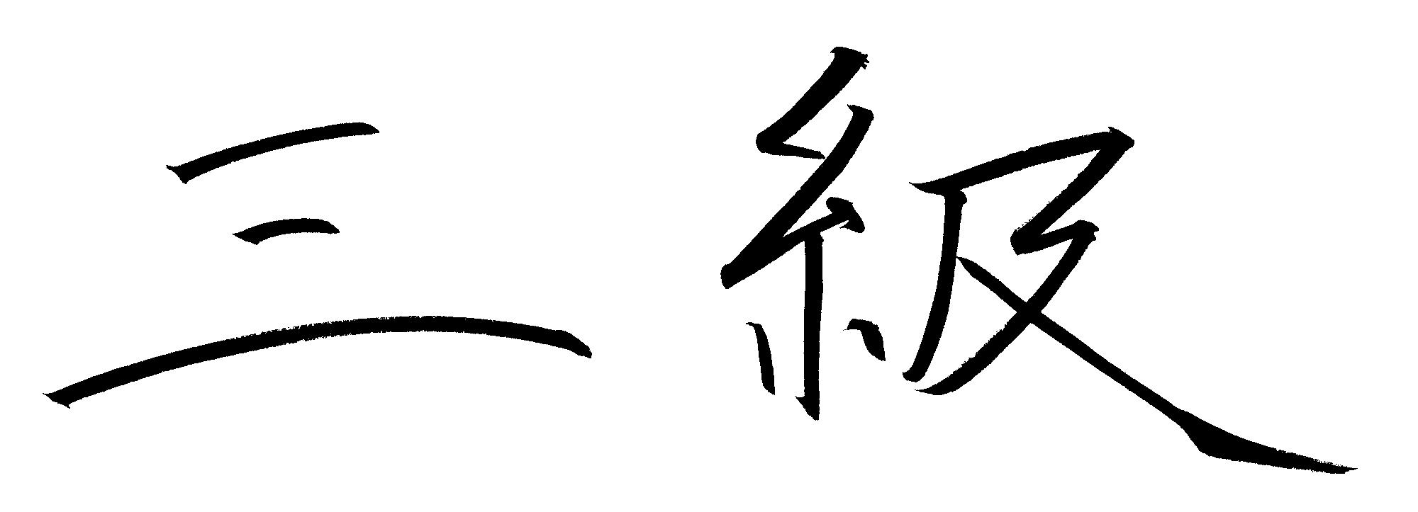
BELT
Youth Second Blue

Minimum Age 11. Minimum 52 classes since attaining blue belt

BASICS
- Must have knowledge and demonstrate the skills of the previous rank
- Must participate in a tournament or assist in the judo process (tournament, dojo, committees, etc.)
- Demonstrate care of judogi
- Demonstrate Shizentai (natural posture) and jigotai (defensive posture).
- Be able to demonstrate the following:
  - Proper moving
  - Demonstrate uchikome (kuzushi, tsukuri, and kake) - entry and proper fitting of your body into the position used prior to executing a throwing technique.
  - Demonstrate the eight directions of kuzushi (happo no kuzushi)- forcing your opponent into an unbalanced position.
- Practice referee within the dojo

TACHI WAZA (Standing Techniques)
Must be able to proficiently demonstrate the following techniques
- Uchi Mata – Inner thigh
- Harai Tsuri Komi Ashi – Lifting pulling foot sweep
- Tomoe Nage – Stomach throw
- Tsubame Gaeshi – Swallow counter
5) Hane Goshi – Springing hip

NE WAZA (Ground Techniques)
Must be able to proficiently demonstrate the following techniques
- All Osae Waza – examiner picks 3 osae waza – demonstrator show how to hold and how to escape
- Two ways to pass ½ guard

SHIMI WAZA (Strangulation Techniques) – for judoka age of 13 and older
- Morote Jime – Two hand choke

HISTORY & PHILOSOPHY
Name the 3 USA world gold medalists

PERSONAL
- Good moral character
- participate in class activities
- Contribute to some aspect of our program, the state program, or a community program
2nd Kyu (Nikyu)
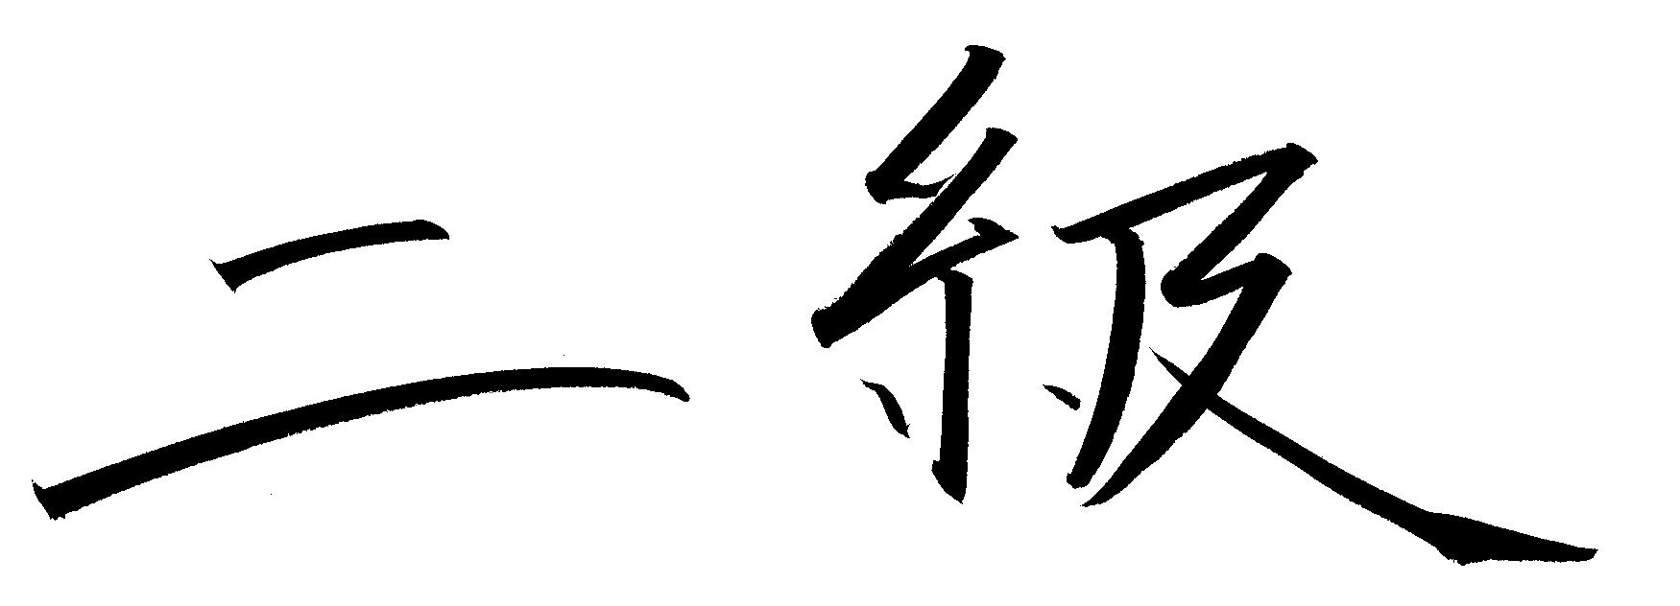
BELT
Youth Purple

Minimum age 12. Minimum 52 classes since attaining 2nd blue belt.

BASICS
- Must have knowledge and demonstrate the skills of the previous rank
- Must participate in tournaments or assist in the judo process (tournament, dojo, committees, etc.)
- Must perform the first and second set of moves from Naga No Kata

TACHI WAZA (Standing Techniques)
Must be able to proficiently demonstrate the following techniques
- Uchi Mata – Inner thigh
- Ko Soto Gari – Minor outer reap
- Tsubame Gaeshi – Swallow counter
- Harai Tsurikomi Ashi – Lifting pulling sweeping
- Ushiro Goshi – Back hip throw
- Kata Guruma – Shoulder throw
- Soto Maki Komi – Outer wraparound throw
- Osoto Gaeshi – Major outer reap throw counter
- Ouchi Gaeshi – Major inner reaping throw counter

NE WAZA (Ground Techniques)
Must be able to proficiently demonstrate the following techniques
- All Osae Waza – examiner picks 3 osae waza – demonstrator show how to hold and how to escape

SHIMI WAZA (Strangulation Techniques) – for judoka age of 13 and older
- Sode Guruma Jime – Sleeve wheel choke
- In the event the judoka has not learned shimi waza, the following needs to be performed
  - Nami juji jime
  - Kata juji jimi
  - Hadaka jimi
  - Okurieri jimi
  - Gyaku Juji Jimi - Reverse cross choke
- Morote Jime – Two hand choke
- One escape from Nami Juji Jime
- One escape from Gyaku Jimi Jime
- One escape from Kataha jime
- One escape from Kata Juji Jime

HISTORY & PHILOSOPHY
Name the divisions of throwing techniques – tachi waza, sutime waza
Name the divisions of standing throwing techniques – te waza, ashi waza, koshi waza
Name the divisions if sacrifice techniques – yoko sutime waza, ma sutime waza

PERSONAL
- Good moral character
- Participate in class activities
- Contribute to some aspect of our program, the state program, or a community program
1st Kyu (Ikkyu)
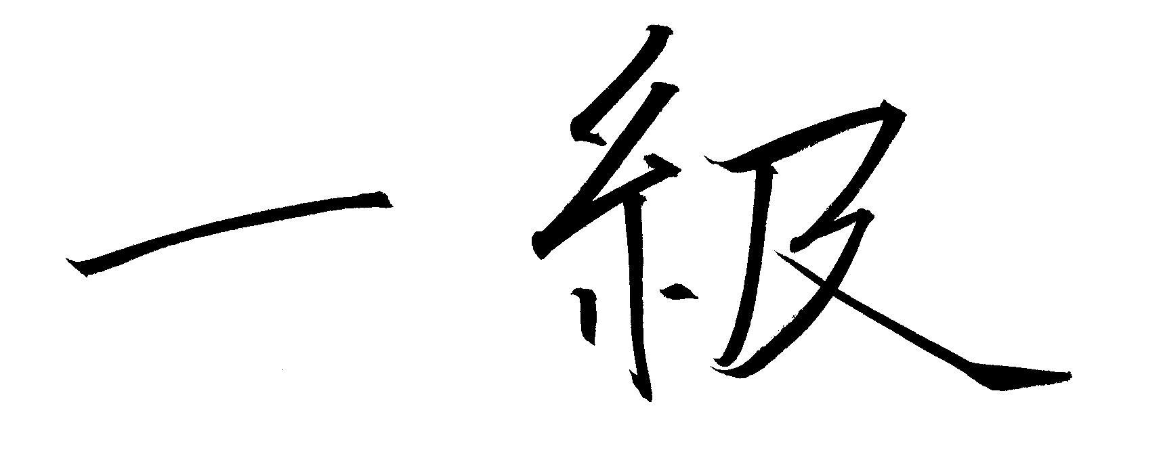
BELT
Youth Second Purple

Minimum age 13. Minimum 52 classes since attaining purple belt.

BASICS
- Must have knowledge and demonstrate the skills of the previous rank
- Must participate in tournaments or assist in the judo process (tournament, dojo, committees, etc.)
- Must perform the first, second, and third series of moves from Naga No Kata)

TACHI WAZA (Standing Techniques)
Must be able to proficiently demonstrate the following techniques
- Uki Otoshi – Floating drop
- Uki Waza – Floating throw
- Ashi Guruma – Leg wheel
- Hikikomi Gaeshi – Sumi Gaeshi -
- Uchimata Sukashi – Inner thigh reaping throw slip
- Utsuri Goshi – Hip switch
- Oguruma – Large wheel

NE WAZA (Ground Techniques)
Must be able to proficiently demonstrate the following techniques
- Must know all hold down techniques

SHIMI WAZA (Strangulation Techniques)
- One escape from Nami Juji Jime
- One escape from Gyaku Jimi Jime
- One escape from Kataha jime
- One escape from Kata Juji Jime

KANSETSU WAZA (Arm Lock Techniques) – for judoka above the age of 16. You may start teaching it 6 months before their birthday
- Juji Garami – Entangled arm lock
- Juji Gatame – Cross arm lock
- Ude Gatame – Arm lock
- Hiza Gatame – Knee lock
- Hara Gatame – Stomach lock
- Ude Garami - Entangled arm lock
- Waki Gatame – Arm pit lock

HISTORY & PHILOSOPHY
TBD

PERSONAL
- Good moral character
- Participate in class activities
- Contribute to some aspect of our program, the state program, or a community program

When the judoka achieves the age of 14, he/she can become an adult sankyu

USJF GENERAL EXPERIENCE AND TIME REQUIRMENTS:
JUNIOR RANK CHART FOR KONAN SYSTEM

PROMOTION TO THE RANK OF: | MINIMUM AGE | MINIMUM CLASSES ATTENDED | BELT COLOR
JUICHIKYU | 5 | 7 | 2nd WHITE
JUKYU | 6 | 14 | YELLOW
KUKYU | 6 | 20 | 2nd YELLOW
HACHIKYU | 7 | 20 | ORANGE
SHICHIKYU | 7 | 20 | 2nd ORANGE
ROKYU | 8 | 32 | GREEN
GOKYU | 9 | 40 | 2nd GREEN
YONKYU | 10 | 40 | BLUE
SANKYU | 11 | 52 | 2nd BLUE
NIKYU | 12 | 52 | PURPLE
IKKYU | 13 | 52 | 2nd PURPLE

No discounts should be given for junior rank.

At the rank of Junior Ikkyu, juniors should test for Senior Sankyu rank and then continue toward Shodan.

