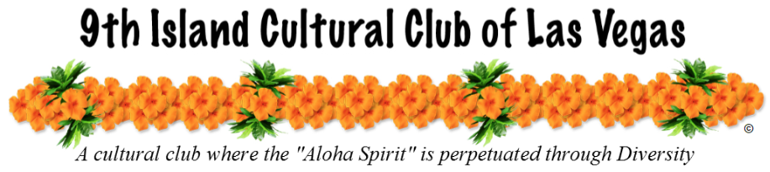

2021 Holiday Craft & Foodie Fair
Saturday, November 20th, 2021
9am – 3pm

Vendor Application

Business / Organization Name:
Contact Person:
Address:
City: | State: |  | Zip Code:
Phone: |  | Email:

Item |  | Qty. | Cost | Total
OUTSIDE (1 Stall) | Stall #: |  | $50
OUTSIDE (1 Stall) | Stall #: |  | $50
OUTSIDE Information Table | *Will be placed day of Fair |  | $10
**All Vendors will need to bring own tables, chair and tent**
TOTAL AMOUNT DUE: $
Vendor: Craft Vendor / Retail Vendor / Food Vendor (circle one)
Please list item & product you choose to sell:

Please make all money orders and checks payable to: 9thiccoflv
There will be a service charge of $20 for all returned checks.

Signature: _______________________________________ Date: _________________________

Please return this form no later than: November 6, 2021
9thiccoflv, 3007 Extravagant Ave., NLV, NV 89031
Pay online at: http://www.9thiccoflv.org
Or email to: 9thiccoflv@gmail.com
Any additional information contact (702) 706-8381

Thank you for your support!!

