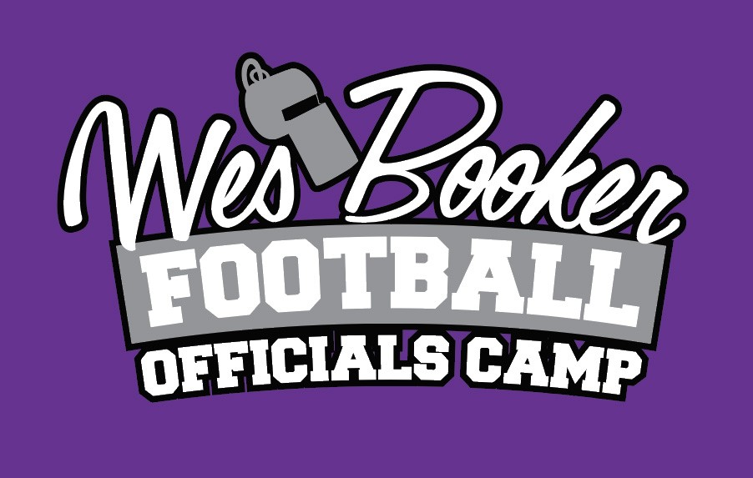
2021 SCHEDULE
WEDNESDAY, JUNE 9, 2021
7:00AM-8:45AM REGISTRATION
8:00AM-8:30AM CLINICIANS MEETING
8:45AM-10:15AM WELCOME/ASSIGNMENTS/CAMP RULES-RON STANDRIDGE
10:30AM-6:00PM ON FIELD ASSIGNMENTS/STATIONS (ROBINSON)
12:30PM-1:30PM LUNCH
6:30PM-9:00PM DINNER
GET IT RIGHT-BOB ARNONE
PROFESSIONALISM-KEVIN HOLMES/JORDAN CRADDOCK
COORDINATORS ROUNDTABLE
NFL OFFICIATING COORDINATOR-BUDDY HORTON
THURSDAY, JUNE 10, 2021
8:00AM-6:00PM ON FIELD ASSIGNMENTS (GREENBRIER)
12:30pm LUNCH
DINNER ON YOUR OWN
FRIDAY, JUNE 11, 2021
8:00 AM-8:55AM NCAA RULE CHANGES-STEVE SHAW
9:00AM-10:00AM STUMP THE REF-DAVID ALMAND
10:00AM-11:00AM CLOSING REMARKS/AWARDS/EVALUATIONS
REPLAY
WEDNESDAY, JUNE 9, 2021
10:OOAM-6:00PM REPLAY SESSION-CLASSROOM
THURSDAY, JUNE 10, 2021
10:OOAM-6:00PM REPLAY SESSION-CLASSROON/EQUIPMENT

