November 2018
Sun | Mon | Tue | Wed | Thu | Fri | Sat
 |  |  |  | 1  Second Quarter Begins | 2  Parent-Teacher Conference  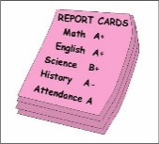 | 3
4 | 5 | 6 | 7 | 8  Quran Competition | 9 | 10
11 | 12 | 13  Annual Title 1 Meeting with Parents @ 8:30-9:00 AM | 14 | 15 | 16 | 17
18 | 19 | 20 | 21  Thanksgiving Break  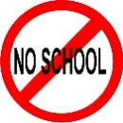 | 22  Thanksgiving Break | 23  Thanksgiving Break | 24
25 | 26 | 27 | 28 | 29 | 30
Please pay your monthly fees on time!

