February 2020
Sun | Mon | Tue | Wed | Thu | Fri | Sat
2 | 3  Semifinal Spelling Bee Kg-8th   | 4 | 5 | 6  Spelling Bee!  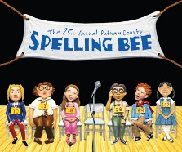 | 7  Bake Sale!   | 8
9 | 10 | 11 | 12  PTO Meeting   | 13 | 14  Bake Sale!  Game Night!   | 15
16 |   17  President Day!   | 18 | 19 | 20  Mid-Quarter Report Due  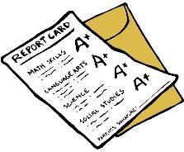 | 21  Bake Sale!  | 22
23 | 24 | 25 | 26 | 27 | 28  Bake Sale! | 29
Please pay your monthly fees on time!

