**Newsletter**

**Kindergarten Weekly News**

**Jan 13th – Jan 17th**

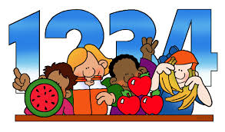

**Math**

Identify time to the hour



**Reading/ Writing**

“Finding Friends”

Full name

Letter “Tt” Sound and Shape

High frequency words

Popcorn words (**the**)

Rhyming



**Science/ Social studies**

Science- Unite B Chapter 1

Lesson 2: The Seasons

Social Studies- Unite 5-lesson 1: National Symbols

**At home Practice**

Reading skills to practice daily:

• Prediction

• Retelling

• Ask questions

• Read daily with your child

**Sight words**

popcorn word

**The**

Practice writing numbers Reading skills to practice daily: • Prediction • Retelling • Ask questions • Read daily with your child