**Newsletter**

**Kindergarten Weekly News**

**02/18 – 02/21**

**Dates to Remember**

**NO school-President day (Monday) 02/17/2020**

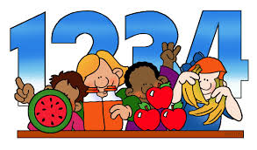

**Math**

Writing and ordering money amount to 10 cents



**Reading/ Writing**

Full name

Letter “Yy” Sound and Shape

High frequency words

Popcorn words (**is/there**)

Rhyming

rd

**Science/ Social studies**

Science- Unite B Chapter 3

Lesson 1: Day and night

Social Studies- Unite 3-lesson 1: Work

**Sight words**

popcorn word

**is**

**there**

**At home Practice**

Reading skills to practice daily:

• Prediction

• Retelling

• Ask questions

• Read daily with your child

Practice writing numbers Reading skills to practice daily: • Prediction • Retelling • Ask questions • Read daily with your child