**Newsletter**

**Kindergarten Weekly News**

**Jan 21st – Jan 24th**

**Dates to Remember**

No school (MLK day) 01/20/2020 Monday

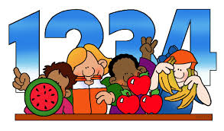

**Math**

Identifying Pennies and Counting Pennies



**Reading/ Writing**

Full name

Letter “Uu” Sound and Shape

High frequency words

Popcorn words (**have**)

Rhyming



**Science/ Social studies**

Science- Unite B Chapter 1

Lesson 3: Weather Matters

Social Studies- Unite 5-lesson 1: National Symbols

**At home Practice**

Reading skills to practice daily:

• Prediction

• Retelling

• Ask questions

• Read daily with your child

**Sight words**

popcorn word

**have**

Practice writing numbers Reading skills to practice daily: • Prediction • Retelling • Ask questions • Read daily with your child