The student athletes whose names accompany this letter are participating in the Tournament of Champions in Brunswick, GA, and Jekyll Island, GA, March 5-7, 2020. This is a GHSA sanctioned high school soccer tournament hosted by Brunswick High School. If you have any questions, feel free to contact me. Thank you.

Sincerely,

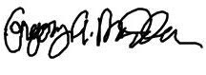

Gregory Andrew Madden
Tournament Director, Tournament of Champions
andrew.madden@glynn.k12.ga.us
912-223-2286
www.tocsoccer.com

