TEAM NAME: ______________ BOYS/ GIRLS/ BOTH

Tournament of Champions 2019
T-Shirt Pre Order Form

Please enter the number of shirts in the chart below and return via email no later than Monday, Feb. 24. When you receive your order, please make any mistakes known to andrew.madden@glynn.k12.ga.us / (912) 223-2286 as quickly as possible. I will try to have the shirts at your first game location. You can ask the volunteers at the gate when you arrive; they will be able to help direct you to where your shirts are located. Cash, checks, or a combination of the two are acceptable. Checks should be made payable to “The Tournament of Champions” or “TOC.” You can pay at pickup. Credit cards are only accepted on our website, which will have ordering closed MONDAY, FEB. 24. The shirts this year are all navy blue; there will be a short-sleeve performance shirt (moisture wicking material), as well as a short-sleeve and long-sleeve cotton shirt. Please be aware, all shirts are Adult Unisex Sizes.

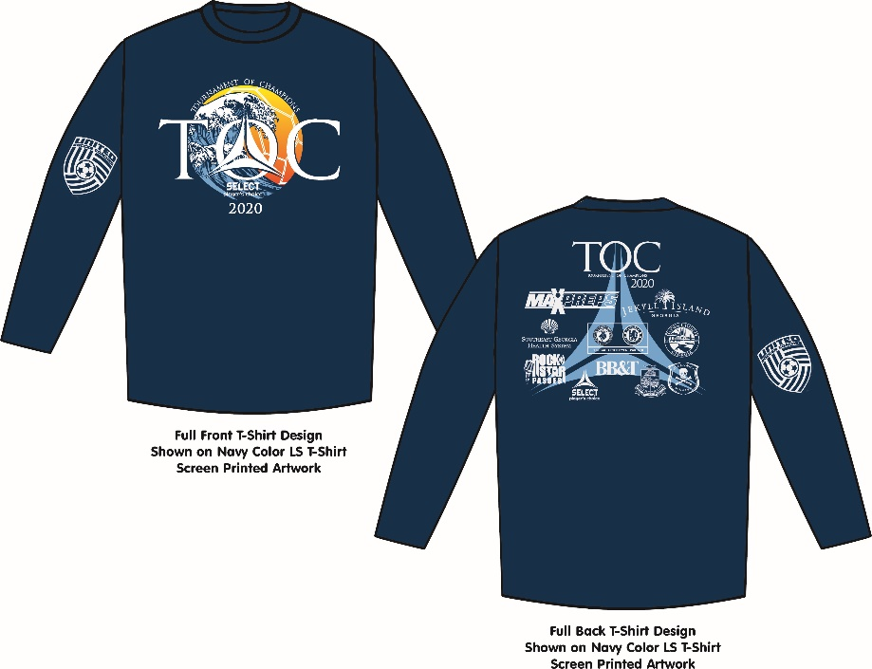

SHIRT TYPE | S | M | L | XL | XXL | TOTAL QTY.
Navy Performance SS
Navy Cotton SS
Navy Cotton LS

Short sleeves- $15
Long sleeves- $20

TOTAL PRICE = $

TOTAL GIRLS: $ / TOTAL BOYS: $

Delivery Information
Contact Name:
Phone Number:

