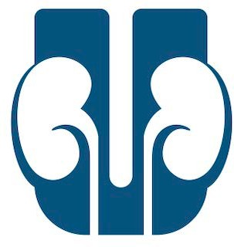
Faculty Questionnaire for UroResidency.com

Thank you for telling us about your program! With no in-person interviews or away electives, students are finding it difficult to learn about prospective residencies. At UroResidency.com, we hope to provide free information and resources for residencies and applicants alike. With your help, we can reach applicants and make the 2021 Urology match a success. We understand some fields may be left blank, these will not be displayed on your page!
Please complete this document and email your response to uroresidencymail@gmail.com. Attach any pictures of your program/residents/life you want to share alongside your submission! Feel free to insert any weblinks in your responses!

Name :

Residency Program :

Your Position :

Program Director :

Contact info(email or social media) :
Would you like to make contact info public for applicants?:

Survey
Are there any social media accounts you would like to promote? (personal/ program))

What aspects of your program make it unique that you would like to highlight for students?

Is there a public step 1 cut off? Does your program require Step 2 CK?

What is the rotation schedule like? Please feel free to attach images in the response.

What is the call schedule like?

How many sites do the residents train at during residency? What hospitals are involved?

Tell us about your location/city. What is it like living there?

Is there an emphasis on research or dedicated time?

What percentage of graduates go on to complete fellowships?

Are there any programs to promote resident wellness?

Advice in general for aspiring urologists in the Class of 2021?

Thank You!

