Front Till & Back Office
New Customer
Training Guide

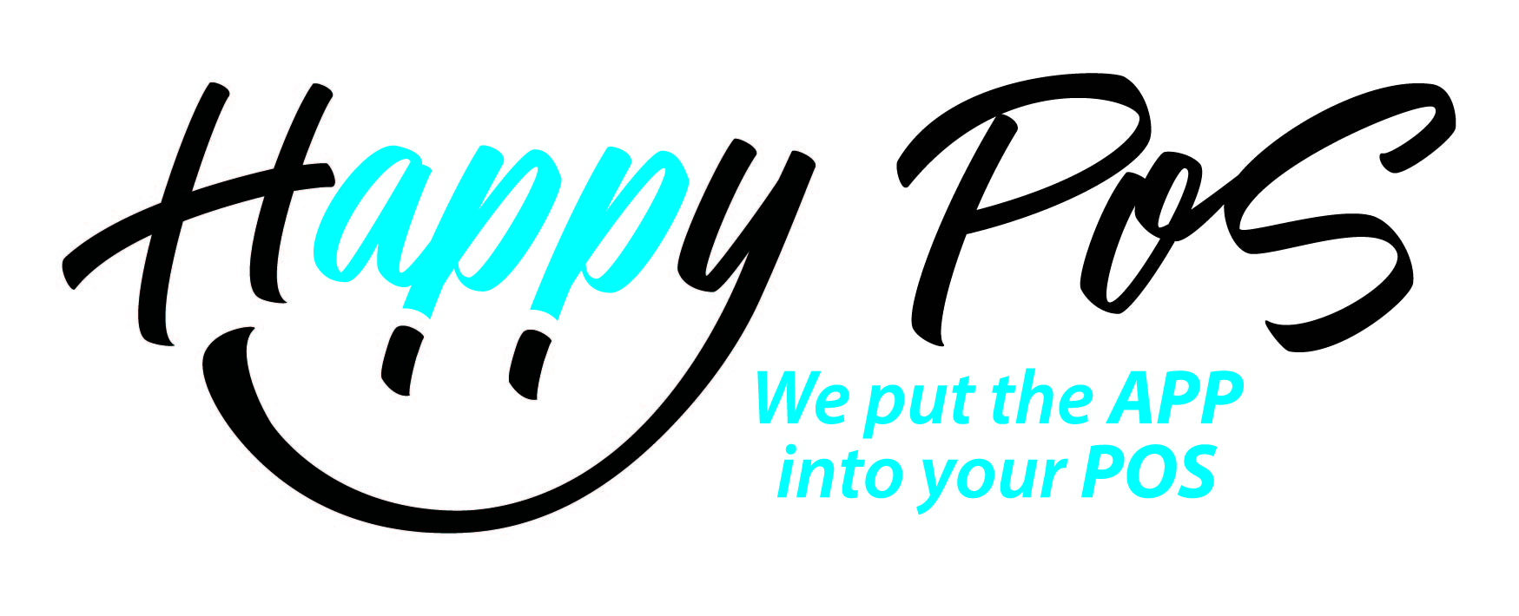

Vers 2.18

Welcome to the All New Till App
Till allocation should only need to ever be done once
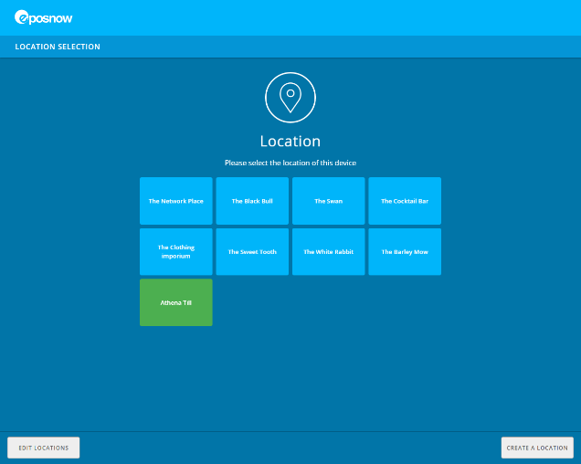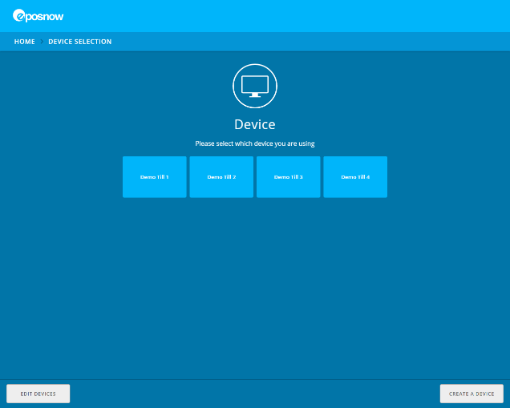
1st Select the location
2nd Select the device to be used on the till your working on
The next screen is the Clocking in/out and login screen
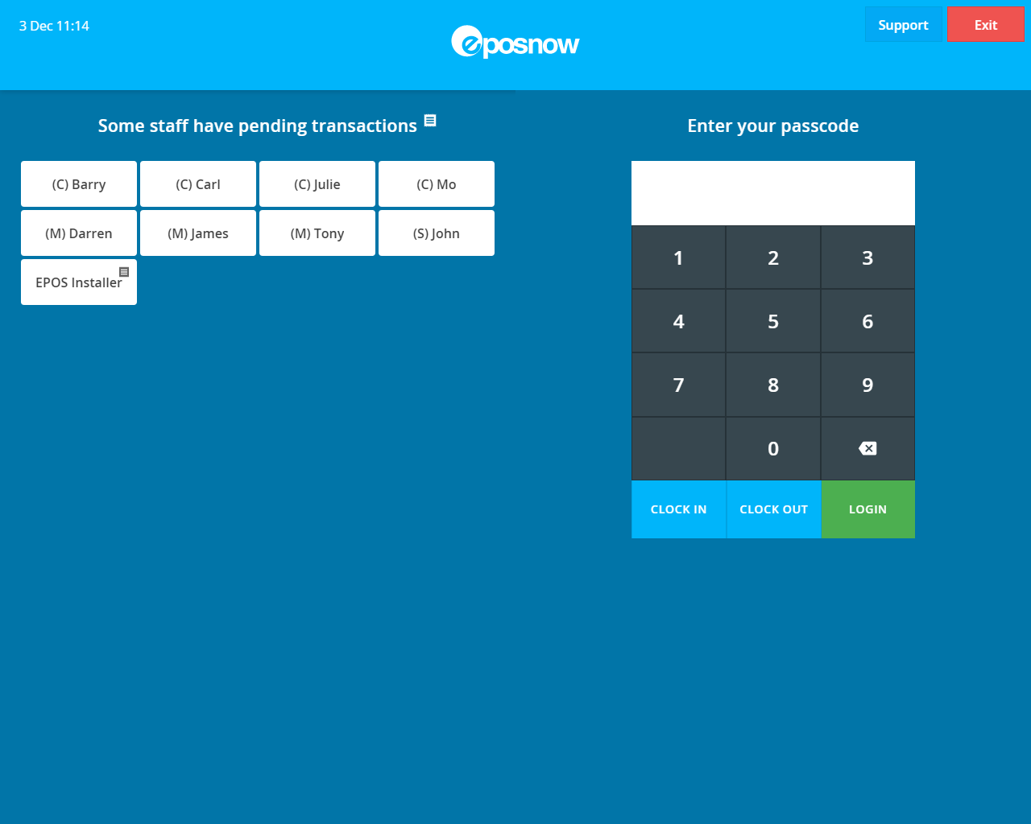

1st to clock in/out if using the till to track Hours worked, each staff member needs to select their name enter their pin number and tap ‘CLOCK IN’ at the bottom of the number keypad.
At the end of the shift each member of staff needs to press ‘CLOCK OUT’ in the same way.
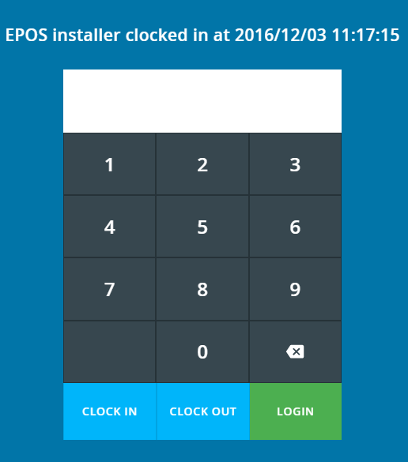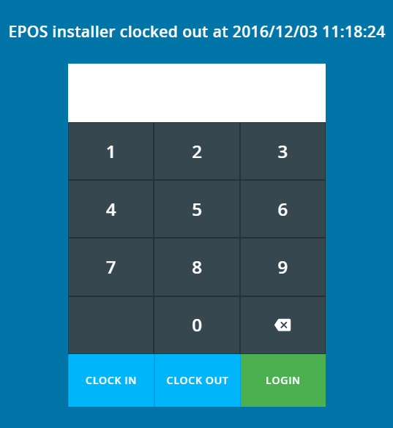
Clocked In Screen Clocked Out screen

- Swipe cards are also available to make logging into the till quicker, if a reader has been purchased
- If there is a swipe card reader the member of staff swipes their card and the till will log them in
- If there is no swipe card reader the staff member selects their name enters their pin number and taps LOGIN, the screen below is an example of what the staff member will see
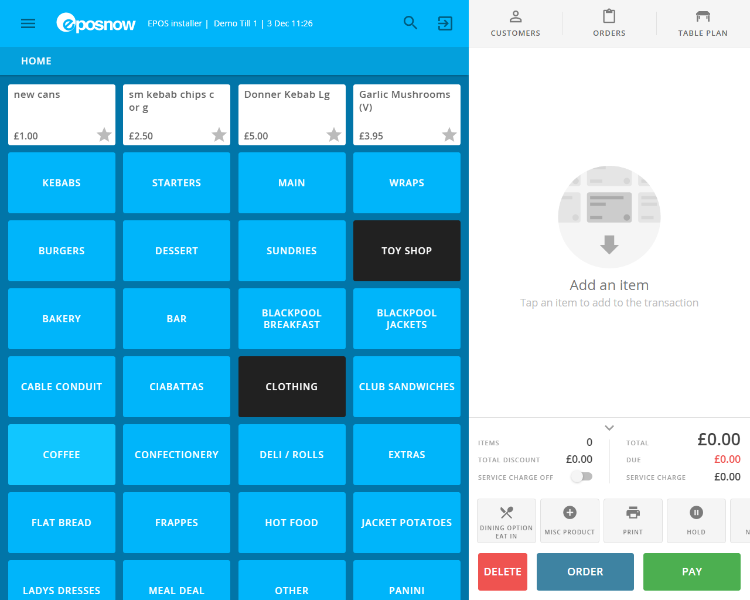

13
12
11
10
9
8
7
6
5
4
3
2
1
- Admin Bar
- Staff Member who is logged in
- Till Name
- Date and Time
- Search box to find products
- Log out Button
- Customer Data Base (not accessible in offline mode
- Held / Ordered / Pending / Complete transactions
- Table Plan if installed
- Category’s (Blue) Products (White) area (Button and Text Size can be Changed in Admin)
- The Customers Basket
- Action Panel (adjustable in Admin from 1 to 2 rows)
- Pay Panel
Any buttons with a is a ‘Best Seller’ product, which would have been set in the back office

In the ‘action panel’ the small down arrow will allow you to minimise this area, in here you can see a running total, any discount amount and service charge if there is one.
When items are added to the basket, they are added to the bottom of the list, NOT the top
Adding an item to the basket
- Find desired category, tap it, then find the product and tap it, it’s then added to the basket
- If a barcode scanner is attached scan the barcode and the item will be added
- Using the search option, you can search by name or barcode (if the barcode won’t scan)
Deleting an item from the basket (if allowed)
- Select the item in the basket to be deleted (Voided) and tap the button
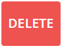
- To delete the entire basket, tap the button in at the bottom of the screen

- If the delete button is missing from the item or grey at the bottom of the till, you are not authorised to do that action and will need to get a colleague with the right access
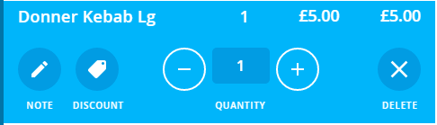
- To add a note to a product, tap the note button. There can be prepared buttons listed to save time typing
- To add a discount, tap the discount button (individual item discount)
- To change quantities of a product use the + or – buttons or tap in the number box and enter the amount on the popup keypad, if a minus number is selected this will become a refund.
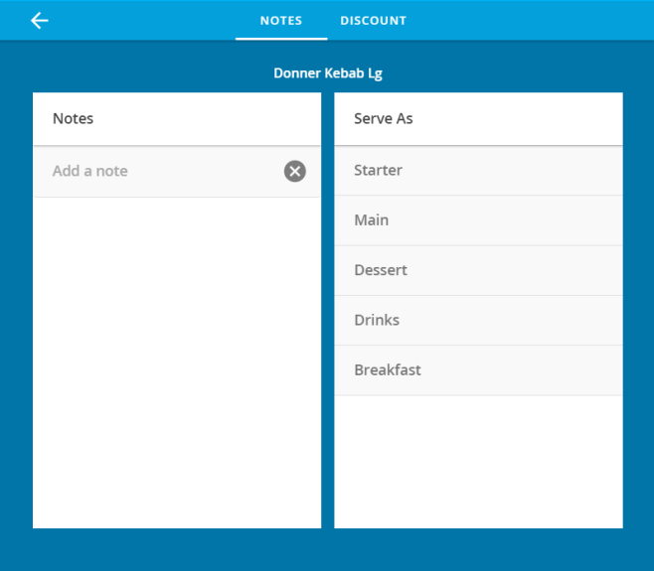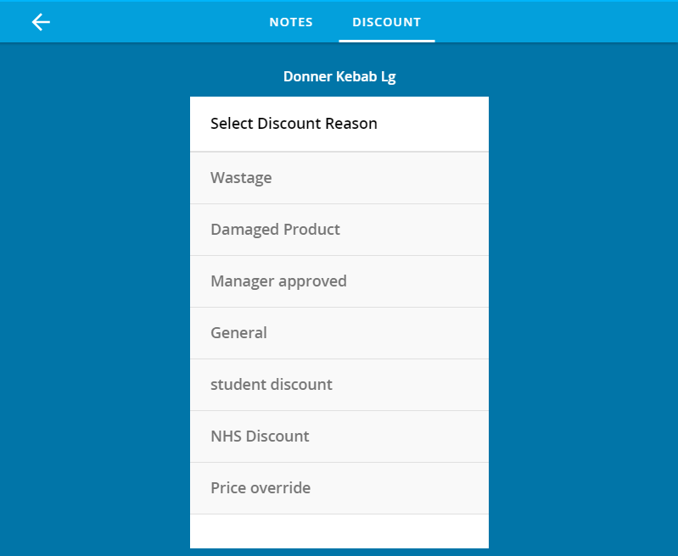
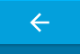Using the Back Arrow in both notes and discounts will stop the operation.
Take Payment
- To progress with a transaction, press the PAY button at the bottom of the screen
- Please note the buttons at the bottom of the screen may vary depending on installed apps i.e. the ORDER button in the example may say HOLD if the table planner is not installed
- Once the Pay button is pressed the screen on the left will change to the payment screen
- This screen has multiple functions available See Screen Shot 1
- To take a cash payment enter the amount given or use the tender amounts on the right of the panel, the bottom amount will always round up to the nearest pound from the total, if the exact money is given then press CASH
- To pay by credit or debit card process the transaction through the PDQ (card machine) and once completed and authorised, select the relevant button to complete the transaction
- The SHOW TENDERS button at the top will show what money has been processed if more than 1 payment method has been used See Screen shot 2
- Once the transaction is complete if any change is needed you will see this select confirm to complete See Screen Shot 3
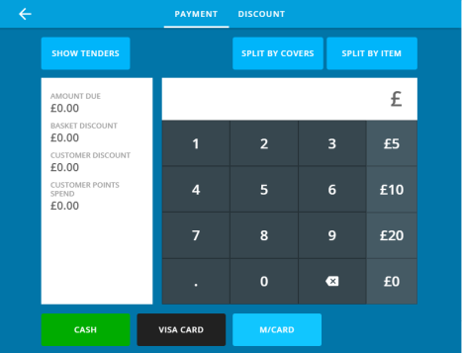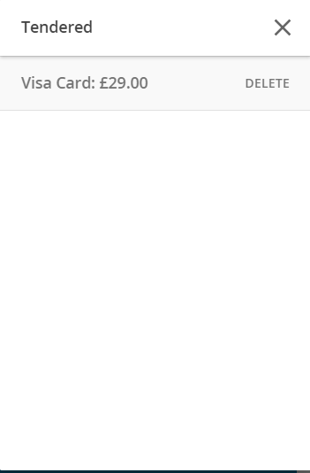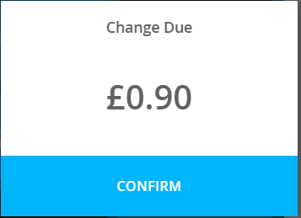
Screen shot 1 Screen shot2 Screen shot 3

To place a Transaction on HOLD
- At the bottom of the customers basket in the action bar use 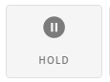or if the table planner is not installed the blue button next to PAY will say HOLD

- To retrieve a held basket use the 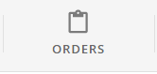 button, to be covered later
Split by Covers
- Split by Covers allows you to split the bill by however many people (Covers) you need i.e. half and half, select how many covers are needed and the screen will look like this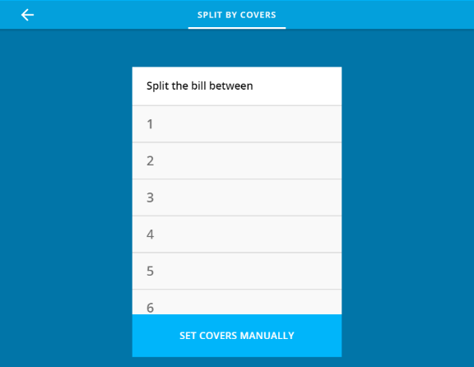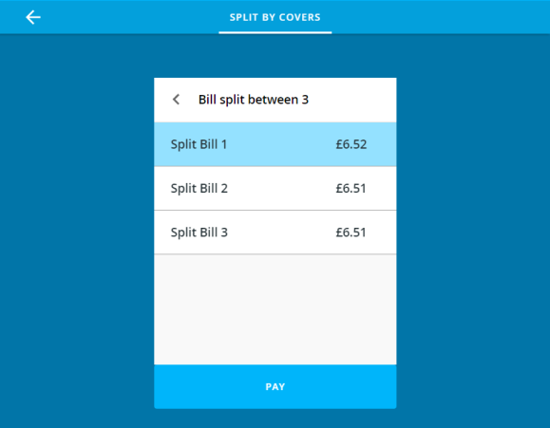
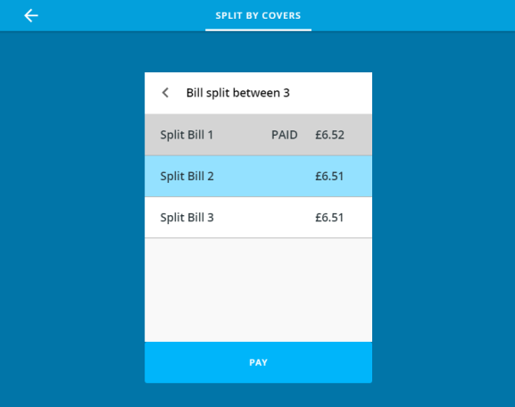
This screen show that the Split Bill 1 has been paid and the other 2 still need to be paid, each payment will produce its own receipt if turned on.
Split by Item
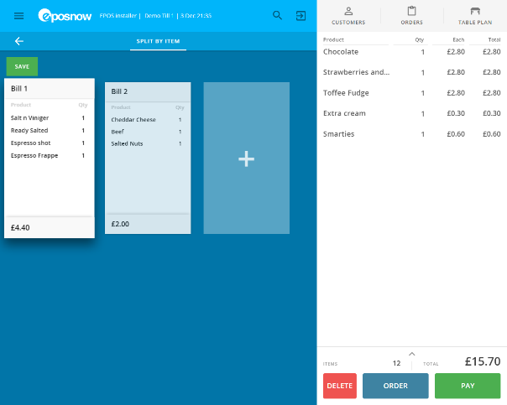
- Split by Item allows you to create separate bills if customers only want to pay for what they ordered. To do this highlight the bill needed or + to add more bills. Bill 1 is selected here, to add items from the right hand side tap them and they will move to that bill and be removed from the basket area so that they cannot be selected more than once.
Once all the items have been allocated, they will then show up on the right hand side of the screen. At this point make sure you select SAVE. Above Bill 1 you will be prompted that the bill has been split and can be found in ORDERS
- To retrieve held bills, select ORDERS and select HELD and the held bills will have the same date and time,
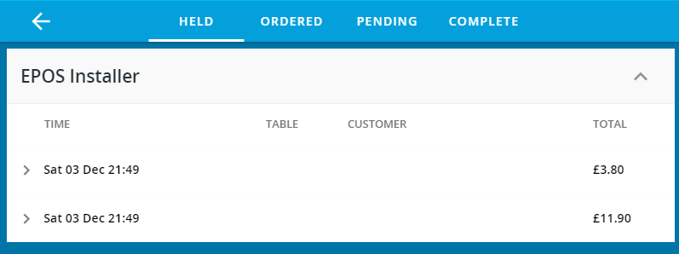

- Tap the arrow next to the bill you want to pay and it will open to show all the items on that bill, at this point you can UNHOLD or DELETE (VOID) the bill

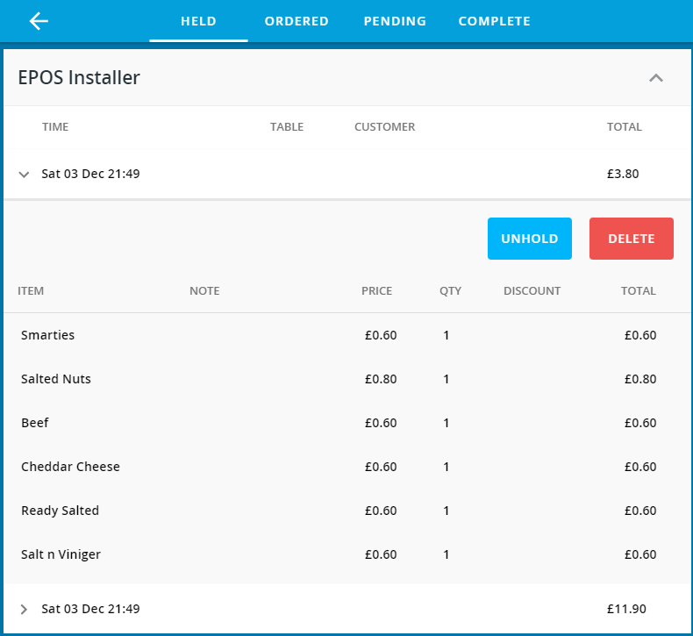

- Select UNHOLD and that part of the bill will return to the basket area complete payment as above
- Repeat until all bills are paid.

Customer Refunds
Make sure the correct Refund Reason is selected to prevent the return going back into stock if it’s not meant to
- A manual refund
- Select your product
- Change the quantity to minus 1 or however many to be refunded
- Select a refund reason
- Select Refund at the bottom
- Process the refund
- The till will print 2 receipts
- The 1st needs the customers details for the cashier to keep in the till
- The 2nd receipt is for the customer as proof of the refund
- Refund Policy Option
- Firstly a refund policy must have been setup in the back office
- Back office>>Setup>>Company>>Receipts
- Make sure refund policy is setup to allow a barcode to be printed at the bottom of the receipt
- To refund through the till enter or scan the Bar code and complete the refund
- Refund during a period when the till was opened but not closed
- Go to ORDERS Button
- Go to Completed and find the transaction and complete the refund
- And again 2 receipts
- To customise the reasons go to Back office>>Setup>>Company>>Refund Reasons>>Add Refund Reason>>Enter a description for the refund
- Return to Stock only needs to be checked if the item can be returned to stock if this is checked when the code is used the item will be automatically added back into stock
- If the item has a different price follow the same process and if there is any moneys to pay take payment or refund if needed
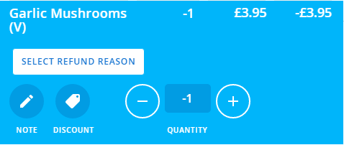

Credit Notes
Make sure Credit Notes App is installed from the back office. In the Appstore search for Credit Notes and install
- Select the item to be returned (or scan the barcode on the returned receipt)
- Select the reason why
- Press Refund option
- Press Credit and a pop up box will ask what type of customer
The customer will receive 3 receipts, the 3rd is a credit note bar code to makes it easy to find the refunded amount
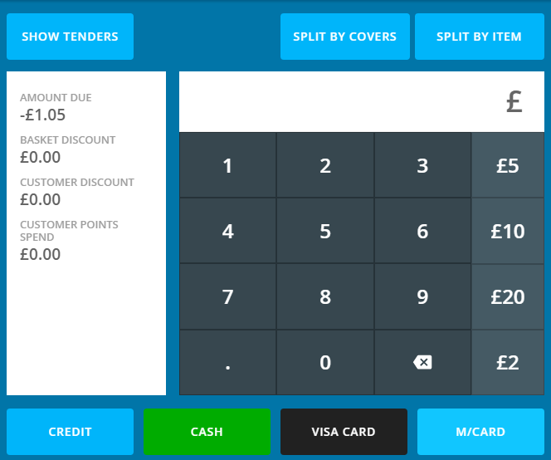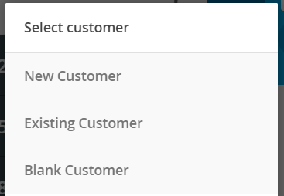
CUSTOMERS
- This button allows you to manage and add to your customer data base, manage credit limits, view invoices and get directions via Google Maps
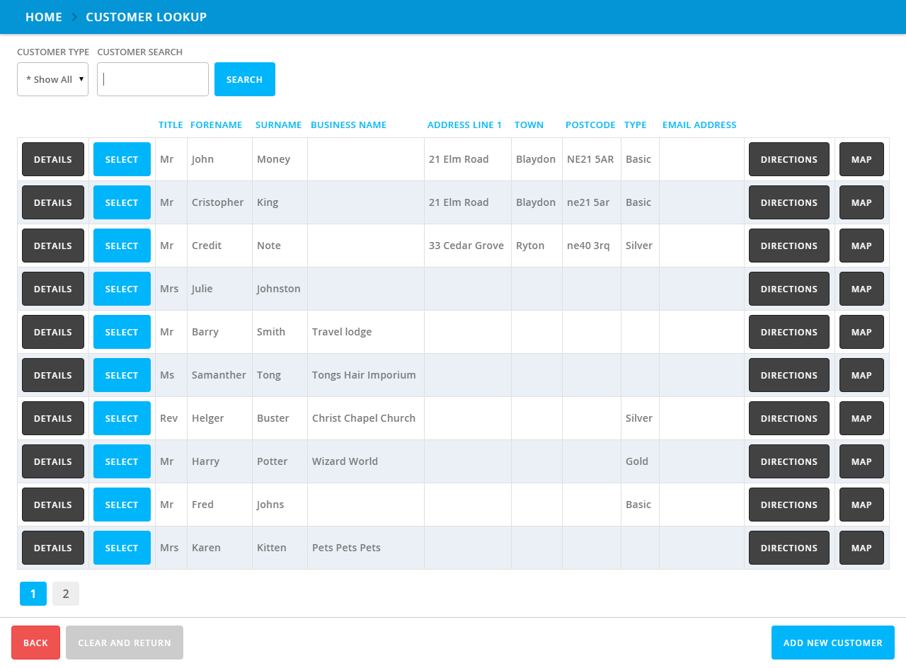
TABLE PLAN (Back Office Setup)
- To setup or amend a table plan this has to be done through the Back Office
- In the Back Office go to
- Setup
- Locations and Devices
- Scroll to the correct Location and select edit Table Plan
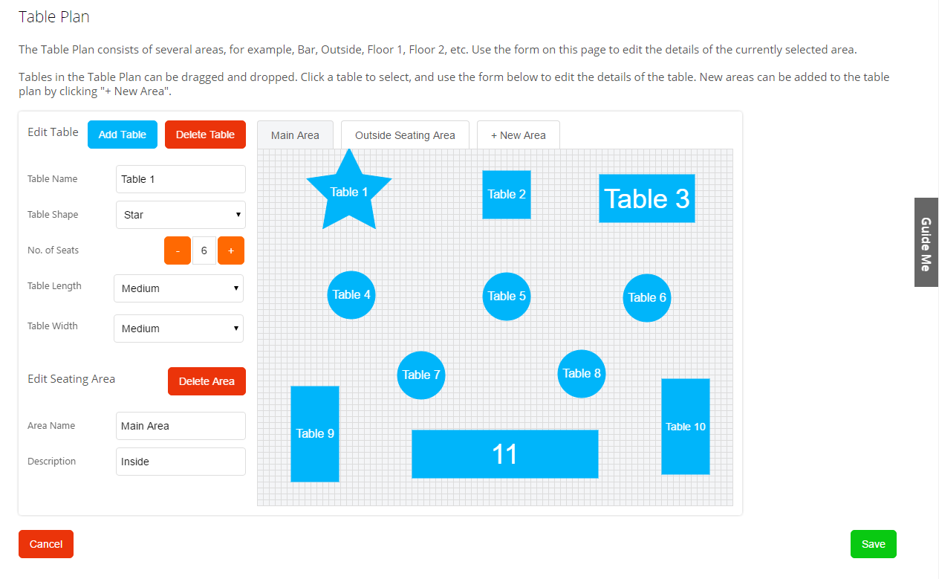
- To add a table select Add Table, to delete a table select delete table
- The tables can be moved around as you want by clicking and dragging the table
- To change the table name, enter it in the table name box
- To change the table shape, select it from the table shape drop down box
- To change the number of seats (covers) adjust this in No. of seats
- Table length and width determine the size of the table
- If you use the custom option, the minimum is 40 and the maximum size is 250
- To add a new seating area, use the +New Area tab at the top
- To rename the area use the edit seating are at the bottom
- make sure you press save button to save any changes
- Setup>> Company >> Company Details >> make sure the Set Covers on Table Plan tick box is ticked and press save at the bottom

Table Plan use on the Till
To add orders to the table there are 2 options
Install Table Timer from the App Store to get the time to display the time in the active table
Option 1 Take the order then add it to the table

- Take the order as normal through the till then at the top select the table
- From the table planner screen select the table to add the order to
- If you have activated the Service Stages section, you can also select the Cause from the drop down box to allow the system to monitor a customer’s waiting time
- Adjust the number of covers as required and select OPEN TABLE at the bottom, then select ORDER to place the order on the table.
- If you need to add another order to the same table, follow the same process but when you select the active table in the action bar select ADD BILL TO TABLE
- To add orders to the existing tab select it from the table plan and select TAKE ORDER which will return you to the till front to allow more items to be ordered. Items that have already been ordered will have under the Product and WILL NOT BE RE-ORDERD
- When you have taken the order on the till make sure you press ORDER and not PAY to allocate the order to the table
PLEASE NOTE: YOU CAN GO STRAIGHT TO TAKING A PAYMENT FROM THE TABLE PLAN SCREEN

Option 2 Select the table then add the order

- From the main till screen select the TABLE PLAN at the top
- The table plan will open, pick the table to be allocated
- ADD THE SERVICE STAGE AND ADJUST THE COVERS THEN OPEN TABLE
- You will be taken back to the main till and you will see at the top it will say the table number
- Take the order and use the ORDER button not the PAY button to place the order

Move from 1 table to another
- From the Till select TABLE PLAN and select the Table to Move
- At the bottom of the screen select 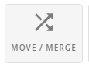then select the table to move 2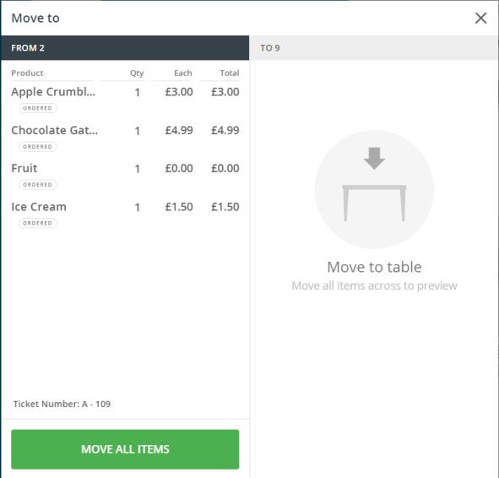 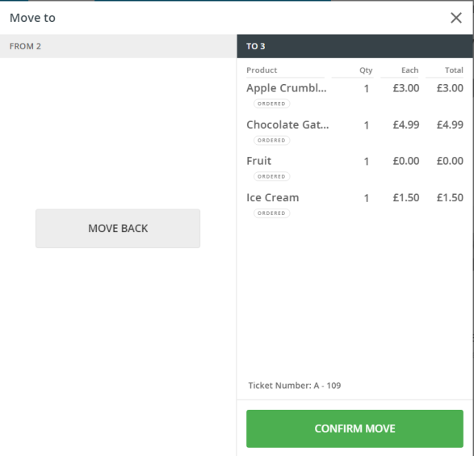
- Select MOVE ALL ITEMS and then Select CONFERM MOVE and it will move on the plan
- The Order will NOT be placed again.
Merge 2 tables together
- From the Till Select TABLE PLAN and select the Table to Merge
- At the bottom of the screen selectthen select the table to merge with
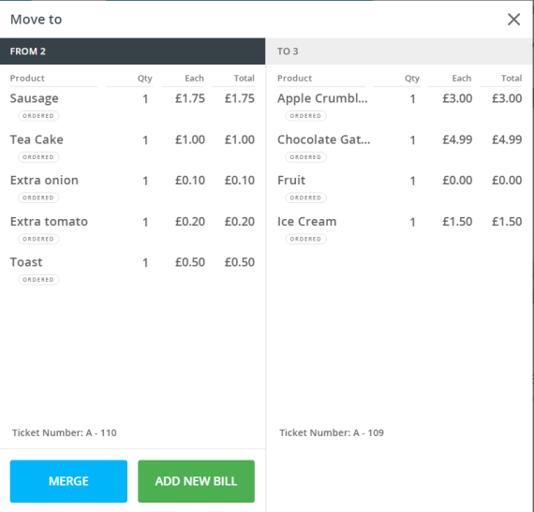
- As you can see above you have the option to MERGE or ADD NEW BILL
- Splitting the bill can be done when the customer comes to pay as shown before.

ORDERS
When you press the ORDERS button at the top of the till you can view HELD, ORDERD, PENDING and COMPLETED transactions, all 4 sections work in the same way
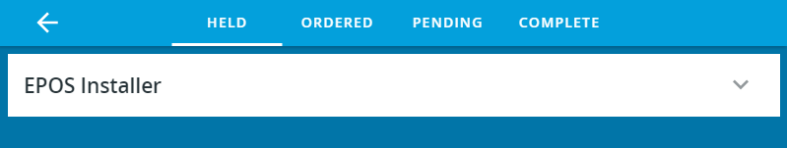
Pressing the down arrow will expand to show the transactions
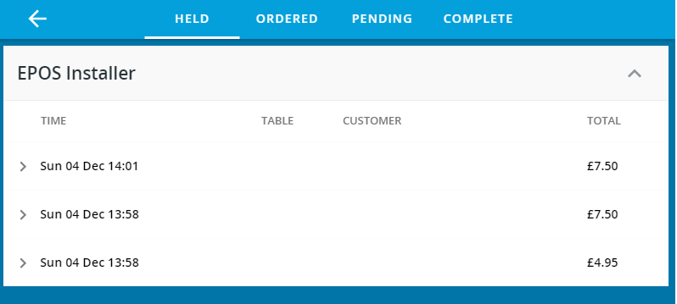
Selecting a transaction will open it
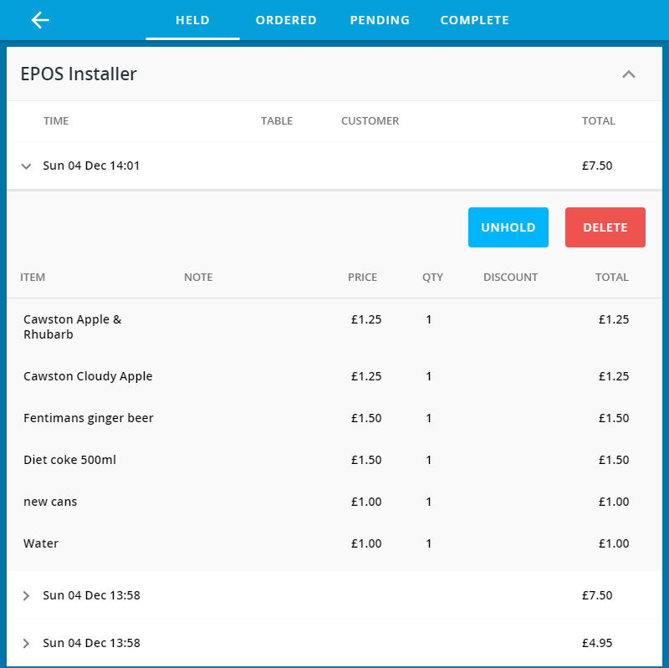
As you can see from above there are 2 options UNHOLD or DELETE (VOID)
If UNHOLD is selected the items are returned to the basket
If DELETE is selected the items can be deleted (if allowed) you will be prompted if you are not allowed

- To access the ADMIN BAR press depending on your access rights will determine what you will see, the admin bar will be down the left hand side of the screen.

Admin
Within the admin tab you can Adjust the tills Float, access the back office (NOT RECOMMENDED ON THE TILL USE A LAPTOP OR PC)
Change the Till Location i.e. you have taken the till to another store.
Close the Till (Internet Access is needed to Close the Till)
Edit Table Plan (this is a back office process NOT RECOMMENDED ON THE TILL)
No Sale (open the cash draw without having to make a sale) also in the Action Panel of the Till
Petty Cash (if you are using the Float as a Petty Cash draw as well) also in the Action Panel of the Till
Print
- Print Current
This will print a copy of whatever is in the customer’s basket at the time without any payments
- Print Previous
This will print a copy of the last completed Receipt
- Print Gift Receipt
This will print a copy of the last completed Receipt without the monetary values being displayed
- Print Historic
- This will allow you to print any receipt (Internet Connection Needed) it will show as a Copy

Stock
Stock Lookup -
This option allows you to search for stock per location
Send/Add Stock -
This allows you to move stock from 1 location to another if you have more than 1 or to
Receive Stock -
This shows you what stock has been moved where

Stocktake (Search) -
Stock Take Search
Stocktake (List) -
Stock Take List
Cloud Sync
This updates the till to make sure any and all changes made in the back office are up to date

Settings
This contains the controls to make the till customisable
- TILL
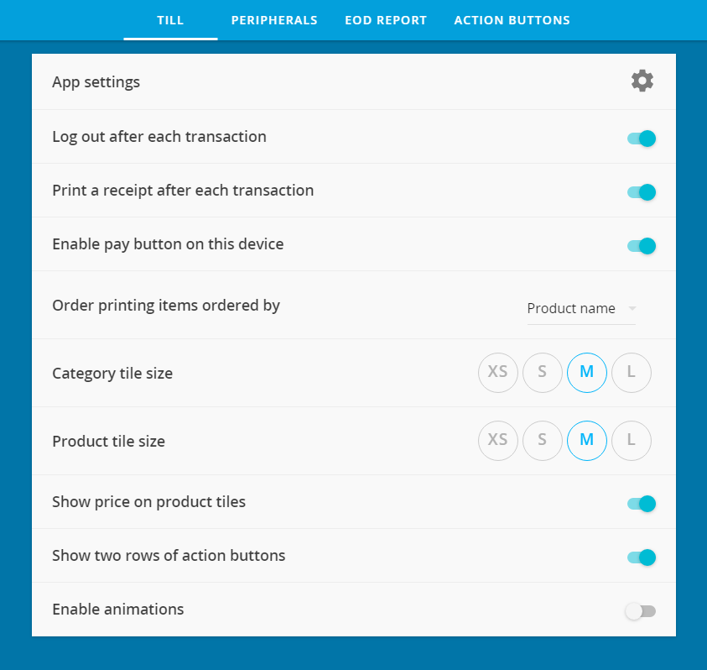

- PERIPHERALS
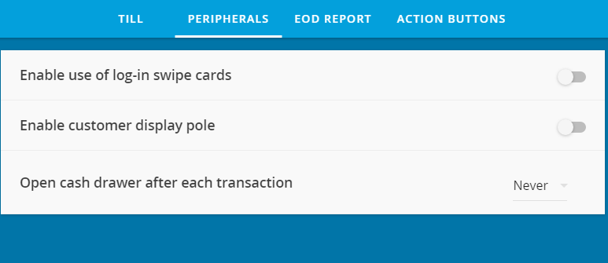

- EOD REPORT
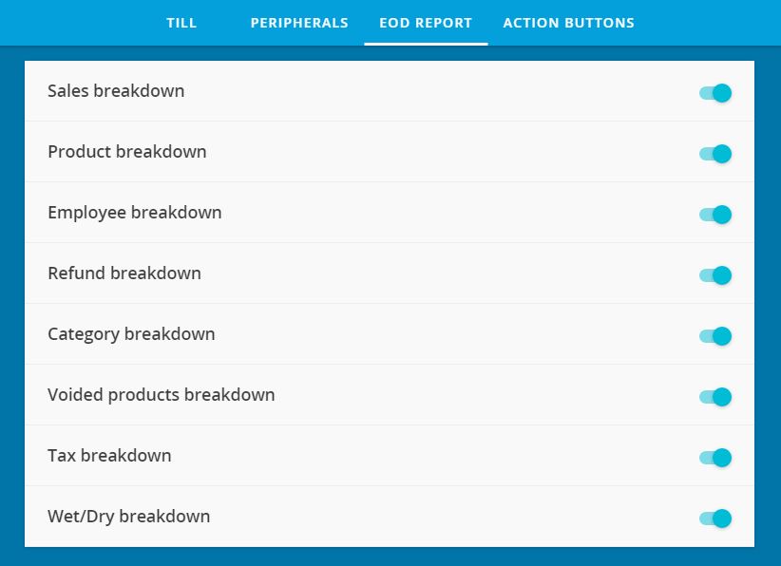
- ACTION BUTTONS (if apps installed)
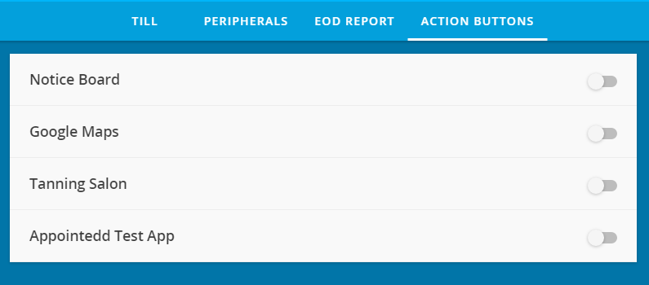

Turning these on will give you access to the Apps via the Action Panel on the Till

Apps
Here you will find any installed apps

INDEX

Page 2 - 2 Software overview and Locations and Devices
Page 3 - 3 Overview of the menu Structure in the Back office
Page 4 - 4 Locations and Devices, Staff and Roles
Page 5 - 5 Categories
Page 6 - 6 Products
Page 7 - 7 Popup Alerts, Variants & Sizes
Page 8 - 8 Multiple Choice Products, Misc Products
Page 9 - 9 Promotions, Multiple Choice Notes
Page 10 - 12 Master Products
Page 13 - 13 Stock Control, Add stock when it arrives, Stock Movement
Page 14 Add new stock no Purchase Order
Page 15 Stock Lookup from Till
Page 16 Add Customer via Back Office / Customer Type and Discount / Customer Specific Prices
Page 17 Customer Credits / Customer Limit / Customer Reports / Customer Invoices
Page 18 Customer Loyalty / Customer Loyalty Card (Loyalty App)
Page 19 Reports
Page 20 - 22 Corporate
Software
- Google Chrome or Safari Browser
- www.eposnowhq.com
- Left hand side is the navigation bar
- The right hand side will show the dashboard
- Setup tab allows the setup of your account
- Management tab allows you to add and manage your info
- Reporting tab is for all the types of reports
- Till will allow the till to be loaded (no advised if Till is live)
- Support tab gives online support and allows a ticket to be raised
- Check in the support tab to vote for new options

SETUP
- Company
- Locations
- Banking
- Restore Data
Management
- Products
- Stock Control
- Staff
- Customers
Reports
- Dashboard
- Transactions
- Sales
- Stock
- Customer
- Banking
- Accounting
- Auditing
- Scheduled Emails
Till Takes you to the Till in offline mode
Support
- Faqs
- Feature Vote
- Submit Ticket
- Videos
- Contact Us
- Printer setup
- Search
- Remote Support
Web Store Takes you to the Epos Now Internet Store
Apps Shows all installed apps and allows access to the App Store
Guide Me Opens the Guide me section under development

Locations and Devices
- Back office
- Setup
- Locations (IF LOCATION AREA IS AVAILABLE THE CORPORATE MODULE IS INSTALLED)
- Locations and Devices
- Add Location from the top right or edit if you need to change details
- Show Devices allows you to see what devices are allocated to what Location as well as un- assign the device if you need to move it to a new location.
- You can add as many locations as you like but you can only use as many devices as you have licences for
Staff
- Back Office
- Management tab
- Staff
- Staff will show all staff roles Locations and their roles Hourly rate password and swipe card if fitted
- To add a new staff member use Add Staff at the top right
Roles
- Back Office
- Setup
- Staff
- Roles
- Add Role at the top right to allow new Roles
- To Clock in from the till select member of staff enter there in and click clock/out as needed
- To amend a clock in time go to
- Back office
- Management
- Staff
- Hours
- Amend accordingly by selecting edit on the left of the name
- Clock in Type allows for different types of clocking in relevant to wages
- To edit or add a Clocking in Type go to back office, setup, company, clocking type
- To generate a report ref to hours worked
- Back office
- Reports
- Accounting
- Payroll
- Choose relevant dates
- To log in to use the Till Front select the member of staff enter pin login or swipe card

Categories
- Try to arrange the Categories into a logical order
- This is all done via the back office
- Management
- Products
- Categories
- Add Category or edit if needed
- When adding a new Category use the Order printer / Display to allocate which printer use the course option to arrange ‘starters, mains, desserts’ on the order printer
- Wet / dry is for reporting i.e. HOT Drinks are Dry because they are stored in the Dry Store.
- Nominal Code is used for Sage or Zero integration if needed.
- Show on till allows the Category on the till i.e. master products don’t show on the till
- Sub – Categories are added in the same way but the Parent Category needs to be selected and the reporting categories is for reports
Products
- Make sure you add the Categories first
- Adding a single unit product
- Back office
- Management
- Products
- Add New Product
- Name the Product show on till
- Description shows on the receipt
- Enter the cost price ex or inc VAT
- Enter Selling Price inc / ex vat
- VAT rate
- The Margin will be automatically worked out or you can adjust it and it will change the selling price
- You can also add a Take away price if needed
- RRP price is Optional
- Add a bar code if needed by typing or scanning it
- Tick Generate bar code if you don’t have one and need one
- Enter the Category where the product will live
- Enter the brand if needed (for reporting) other uses as well
- Enter the Supplier if needed for re-ordering though the Epos Now System
- Enter Product Order Code if needed for Suppliers
- Enter Article Code if exporting reports to Sage / Zero
- Ignore unit and volume of sale as this item is being sold as a whole item
- Enter the button colour if needed
- Enter Popup Note / Multiple Choice Note if needed
- Enter any other options needed
- Check or un-check sell on till if needed
- Enter how many units you have make sure this is divided by the number of locations your adding to
- Activate the item if needed by using the option Add Stock at the selected Location
- Pick which location it’s to be added to or all if all sites are going to stock it
- Pick the member of staff who is adding the item of stock
- Select Add or Add Another
- IF YOU ARE ADDING A SERVICE THIS WILL NOT NEED TO BE ACTIVATED
- To view the stock go to:
- Back Office
- Stock
- Stock Levels
- If this product is going to be part of a master product see the master product section

Popup Alerts
- Back Office
- Management
- Products
- Popup Alerts
- Add popup Note
- Add Name for the Popup Note
- Add the message you want to pop up such as “Have you checked age verification”
- Tick if the popup note is only to be displayed once per transaction
- Add or Add Another
- Go back into products or if needed for a full category add to that instead
- Till the box at the top Show Till details
- Find the product you want to add the popup note to and select
- Edit
- Under popup note from the dropdown tab add the popup note you want
Variants & Sizes (if Fashion module activated)
- Step 1 Create your product and add it to the till as normal
- Step 2
- Back Office
- Management
- Products
- Variants & Sizes
- Give name and click Add
- Under the add Items input each size or variant needed pressing Add after each one
- Once completed Press Save
- Step 3
- In the back office go back to Products find the product you want the variant / size to be added to
- Select Advanced and scroll to Product Matrix
- Select the variant / sixe from the drop down box next to Create all possible Variants
- Check or uncheck Auto Generate Barcodes as needed
- Check or uncheck Disable Sub-Category Creation, if this is un checked then a category will be created with the name of the product and all the product variants / sizes will be added
- If Disable Sub-Category Creation is checked then no Category will be created just the different variants / sizes.
- Also in this section you can generate just 1 variants / sizes by using Create single Variant
- The 3rd box will allow different colours of the Variant to be created
- To add edit or remove Colours go to Back office >> Management >> Products >> Colours >> Add Colour or Edit Colour
- YOU CAN EATHER CREAT THE VARIANT OR THE PRODUCT FIRST
- NEW APP RAPID EDIT works like a spread sheet
Multiple Choice Products
- Back Office
- Management
- Products
- Multiple Choice Products
- Add a Multiple Choice Product Group
- Give the Product Group a name
- A description
- And then in the lower section we need to pick what is being added to the group
- These are products already in the product section
- Add the relevant additional price if there is one
- To add this to your Product go to
- Back Office
- Management
- Products >> Products
- Find the Product that the Multiple Choice Product is to be added to and select
- Advanced
- Scroll down to Multiple Choice Products
- Add as many multiple products as you needed you can state which displays 1st / 2nd /3rd
- THIS CAN ONLY BE ADDED TO PRODUCTS AND NOT CATAGORYS
Misc Products
- Back Office
- Management
- Products
- Misc Products
- Add or edit as needed
- These products will show on the till when Misc Products under Products is selected
for quick entry of the Misc Product name
- Add the relevant VAT rate
- They Report in the Back Office >> Reports tab >> Sales >> Misc Products
Promotions
- Back Office
- Management
- Products
- Promotions
- Add or Edit Promotion
- Name the Promotion for the till
- Give it a description for reporting
- Location area is only available if you have the Corporate Module added
- Fill in the details of the Promotion as required
- In the box at the bottom you can add Products and Category’s to the promotion depending on the promotion being setup
- If you want points in a promotion you will need to purchase the Loyalty app
Multiple Choice Notes
- Back Office
- Management
- Products
- Multiple Choice Notes
- Add or edit Multiple Choice Note
- If adding give the note a name
- Decide if it’s going to popup by default or not
- Add each option for the note
- Select Save
- Multiple choice Notes can only be added to products
- In the Back Office
- Management
- Products
- Add or edit and in the multiple choice notes box select the multiple choice note needed.

MASTER PRODUCTS CREATION PROCESS (for stock monitoring & ordering)
Possible Category / Products flow chart Example
Category MP/Master Products
MP/Draughts
MP/Wines
MP/Bottled _Beer
MP/Spirits
MP/WW
Products MP/DR - Guinness = MP = Master Product DR = Draught
MP/DR - Grolsch = MP = Master product DR = Draught
MP/SP - Vodka = MP = Master Product SP = Spirits
MP/SP – Whisky = MP = Master Product SP = Spirits
MP/WW - Chardonnay = MP = Master Products WW = White Wine
MP/RDW - Melot = MP = Master product RDW = Red Wine
MP/RSW - Blossomhill = MP = Master Product RSW = Rose Wine

There may be an issue where you have Red White and Rose wines make sure when picking
The product names you can tell the difference i.e. RW could mean Red or Rose
STEP 1 Create Till Button
- Management
- Products
- Products
- Add Product
- Name (as you want it on the Till)
- Description auto fill can be changed
- Sale Price Inc. vat
- Category for reporting
- Brand / Supplier / Product Group / Popup Note / Multiple Choice Note (Optional)
- Button Colour is for the Till (Optional)
- Size (or Variant)
- If a value is selected, one of this product will be created for each of the possible variant
- Auto Generate Barcode for Variant (Optional)
- Till Order (Leave Blank for Alphabetical or 1 is First 2 second and so on)
- check Sell on Till
- do not add Stock
- Add or Add Another if another is needed

STEP 2 Creating a Master Product Category
- Management
- Products
- Categories
- Add Category
- Name E.g. MP/SP - Vodka (it’s advisable to have a main master category i.e. MP / Master Products)
- Pick Parent / Reporting Category as needed -this will help running reports
- Order Printer / Display not needed
- Course is needed only for reporting purposes
- Wet / Dry
- Button Colour and Till Order are not needed
- Nominal Code: (Used for accounting purposes)
- Show on Till needs to unchecked as this will not show on the till
- Popup Note not needed for mast product category
- Click Add or Add another if another Category is needed.
STEP 3 Create a Master Product (the important fields are as below)
- Back Office
- Management
- Products
- Products
- Add Product
- Name *
- Description auto fill can be changed
- Product Type if needed, if selected more options may need to be filled in
- Cost Price ex vat
- Sale Price Inc. vat **
- Margin will be calculated for if both cost and sales are input
- Optional Fields >> Take Away/Delivery Tax Rate / Take Away/Delivery Price: (including Tax) >> Recommended Retail Price (RRP)>> Barcode: (Separate multiple Barcodes with a comma)
- Category for reporting
- Brand if needed
- Supplier if needed
- Units of Sale ***
- Volume of Sale ****
- Not Needed Button Colour >> Popup Note >> Multiple Choice Note >> Product Colour >> Size or Variant >> Disable Colour and Variant Sub Category Creation >> Till Order
- Uncheck Auto Generate Barcode for Variants
- Uncheck Sell on Till
- Enter Stock amount to be added
- Selected Location to add the stock to from drop down box
- Select Staff Member adding Stock
- Select the Add or Add another Button if more are needed.
* The Name for a Master Product will not show on the till but make sure it has meaning i.e. MP/DR - San Miguel which means MP= Master Product / DR = Draught and name of product
** Sales Price can be worked out by using the Margin field or taking the till sale price * units i.e. £3.00 per pint * 88 = £264
*** Unit of Sales = Minimum measurement in which this product is used (e.g. half pints in a Keg)
**** Volume of Sale: (Master Products only) Volume of 'Unit of Sale' in this product (e.g. 176 half pints in a keg)
STEP 4 Link the Till Button to the Master Product
- Management
- Products
- Products
- Find the Product you want, not the Master Product : example Coffee
- Advanced
- Scroll Down to Master Products
- Select the Master Product Category from the drop down list
- In the second drop down box select the master product will auto populate with first option
- In Amount enter the amount to be removed from the master product
If you want to be warned of low stock on the right select advanced scroll to Stock Adjustment and enter the details required in Min / Max Stock tick Alerts if you want an email select a reason and staff member who is controlling the stock click Add
To make a button on the Till function as a Master Product when you’re selling the item as 1 of 1
- Back Office
- Management
- Products
- Find the Product entry you want to use
- Advanced
- Scroll to Stock Adjustment
- Enter the Current Stock Amount
- Set your min / max options
- Tick Alerts if you’re wanting alerts
- Select the Reason for adding the Stock i.e. New Stock or Stock Take
- Select a staff member who is adding the stock
- Select Add and the Save
- Add Stock to Different Locations if you have them
Stock Control
To View any stock with a low stock warning where setup
Go to the Back Office and Reporting Tab
You can view any low stock from the main dashboard and the Low Stock Items section which will show what may need to be re-ordered
To add a new Purchase Order
- Go to the Back Office
- Management Tab
- Stock Control
- Purchase Orders
- Add Purchase Order
- Select Show Products next to each Supplier to see stock levels and purchase order
Use the check box Show all suppliers and products to show all stock not just stock below minimum set levels
- Changing cost price will only effect cost price going forward not historic
- Create Purchase order
To add stock once it arrives
- Management Tab
- Purchase Orders
- View Details
- Edit / Receive
- Amend as required changes only effect moving forward not historic
- Press Save once checked and complete
Viewing Reports Dashboard will show the changes
Stock Movements
Back office >> management >> stock Control >> stock Movement’s
Add Stock Movements
Select >> From and to Locations
Front till stock control
Stock button at top
Stock cannot be accepted by a branch that is not receiving it

Add new stock no purchase order
Back office >> management >> stock Control >> Stock Movement >> Add Stock Movement
Do not select Branch from and to >> Select Other
Select store to add to
Add goods to stock
Stock Taking
- Back office
- Reports
- Stock
- Levels
- Select location
- Export stock sheet into whatever format is best for you.
- It may be a good idea to export as Excel file to allow adjustments to the stock sheet as required add in 2 new columns Actual Stock and Variance’s and use a formula such as Current stock minus Actual Stock : =Sum(A-B) will give the Variance.

- Do stock take
- Deale with variance’s from the Till go to stock
- Stock Take List
- Use Filter Boxes as required.
- Adjust stock accordingly click save
- In the back office via Stock
- Discrepancies >>
- Bar code scanner can also be used by doing this
- In the Till go to Stock
- Stocktake List then
- Use Stocktake Search
- Make sure you have your Barcode scanner in Fast Barcode scan and also make sure the check box is ticked
- Select Reason for the stock take and add notes if needed.

Stock Lookup from Till
- In the till go to Stock at the top
- Go to Stock Lookup
- Search using relevant fields including other stores if applicable
Add Customers
Back Office add
- Management
- Customers
- Customer Search
- Add Customer
- Credit Limit / Location if Global Account
- Additional Member
- Add Button
- Edit / Delete / View / Invoice

Customer Types & Customer Discounts
- Back Office
- Setup
- Customer Types
- Create Customer Type and relevant Discount
- Add customer type to a customer by going to
- Customer in back office
- Customer Search
- Find the Customer
- Select Details and amend Customer Type
- Only 1 Customer Type to 1 customer at any 1 time
- This will give a blanked discount on all purchases
- This discount will override Customer Specific Pricing
Customer Specific Prices
- Find the product in back office by going to Management
- Products >> products
- Search for product
- Advanced Button
- Scroll to Customer Specific Prices
- Select the Type and the actual price
- This is not a discount it’s a final price
- If you have a Customer Type setup with more than 0% then that discount will Apply

Customer Credit Completed Front Till

- Select the customer from the Customer Tab
- Press the Product button at the top admin section
- Select credit
- Select add button at bottom left screen
- Press Pay button bottom Right screen
- Take the payment on the left side of the screen
- If no credit left the outstanding will need to be paid by other means
Customer Limits Completed from Back office or Front Till
- Select Customer from the Customer Tab
- Select details next to the customer’s name
- Scroll to Credit Limit
- Enter Credit Limit
- To settle a credit account select customer from admin bar
Select Products and Credit from the Admin bar
and take payment
this will automatically reset any credit limit.
- If required don’t forget to remove any credit limit when not needed.
Customer Reports Completed from Back Office
- Reports Tab
- Customers
- Customer Reports will give customer info
- You can filter the reports at the top of the page by Debit or Credit status
Customer Invoices
- Management
- Customers
- Customer Search
- Find the customer you want
- Select Invoice on the right of their name
- Complete the invoice as required
- Export to Sage or Zero at the bottom also use mail chimp integration for mail shots

Customer Loyalty
- Make sure they have Loyalty Cards and Card Reader before activating
- Go to Epos now admin in the back office
- Search for customer
- Select the details button
- Scroll down to Modules to activate (Loyalty) Module
- Save
- Go to Setup
- Customer Details
- Go to Loyalty Points
- Fill in the relevant details
- Setup minimum points before they can spend
- Setup Points Value
- Setup how many points for pounds earned
- Save
Customer Loyalty Card
- From the Till Front go to the customer tab in the admin section at the top
- Find the customer and select details
- Scroll down to Card Number
- Swipe the card to be issues
- Save
- To setup a promotion go to:
- Back office
- Management
- Promotions
- Add Promotions Tab at the top
- In the Type drop down field you will see 2 new options with the Loyalty option
- Points (Bonus)
- Points (Multiple)

We offer over 50 different reports
Dashboard
- Back office
- Reports
- Dashboard
- 6 dashboards per user accounts only
- By selecting edit next to the dashboard name you can customise it.
- You cannot customize the 4 main widgets
  - Total Sales
  - Total Transactions
  - Low Stock Items
  - Operating Margins
- All other widgets can be customised
  - Reporting Section
  - Transactions
  - Sales
  - Stock
  - Customer
  - Banking
  - Accounting
  - Auditing
  - Scheduled Emails

CORPORATE MODULE
Setup Locations CORPORATE MODULE
- Setup High Level Area Parent Location
- Back office
- Setup
- Locations
- Locations and devices
- Location Areas
- Give it a name
- Description
- Email
- add location
- Add midlevel locations
- Name the area
- Description
- Email
- Reporting Area i.e. Parent Location
- Add low level Locations
- Name the area
- Description
- Email i.e. midlevel Location
Setup Areas to actual locations
- Setup
- Locations and Devices
- Edit the locations and make sure Location Area is correctly selected

Setup Location account access
- Select user name at very top right of the back office
- Select users
- Add additional login
- Limitations number of devices purchased * 2+1
- Give the login a name
- Give it a password
- Select location area allowed access and setup access rights
- Select Add
- Repeat as required
Location Specific Prices

Back office
- Management tab
- Product
- Find product
- Advanced
- Scroll to Location Area Specific Prices
- Find location from drop down box
- Add both eat in and eat out price
Location Specific Promotions
- Management tab
- Promotions
- Edit or add promotion
- Select location required or location area
Location Specific Products
- Management Tab
- Products
- Product Groups
- Add Product Group
- Name the Group
- Scroll to the bottom and from drop down box select items for the group
- Select Add at the very bottom
- Go to Setup
- Locations
- Location Areas
- Select Location and Product Group
- Add from drop down box and then save at the very bottom once complete
Location Specific Receipts
- Management Tab
- Receipts
- Scroll to the bottom Location Area Receipts
- Add Receipt
- Select Location and complete details for receipt
Location Specific Customers
- Click on user name in the top right of the Back office as if adding a new user
- Select users
- Select / Un-Select Customer Access Rights
If adding a customer via the back office
go to Management >> Customers >> Customer Search >> Add Customer
and make sure Sign up Location is selected.

