Powering California:
Assessing California’s Energy Future

________________________________________________________________________________________________

The Energy Supply and
Demand Landscape
Synthesizing Research on California’s Energy Supply and Demand

Balancing Fiscal, Energy, and
Environmental Concerns
Analyzing the Policy Options for California’s Energy and Economic Future



A Research Study
Published by:
The Communications Institute
With support from
University of Southern California
School of Policy Planning and Development
Keston Institute for Public Finance
and Infrastructure Policy
Center on Energy Economics and Public Policy
University of Wyoming

This research is presented in the public interest by The Communications Institute in association with our academic partners and is part of the Institute’s commitment to expanded use of economic analysis in public policy decision making. The Institute’s goal is to provide policy makers at all levels with the knowledge to make better decisions that benefit the public.

The study is part of the ongoing research and educational programs provided by the Institute in association with others institutions since 2003 including those from University of California, the RAND Corporation, University of Southern California, Arizona State University, Sandia National Laboratories, Lawrence Livermore National Laboratory, Stanford University, University of Pennsylvania, University of Wyoming, Penn State, and University of Arizona.

Cover Design by Dean Swartz

Copyright © 2011 The Communications Institute

All rights reserved. No part of this book may be reproduced in any form by any electronic or mechanical means without permission in writing from The Communications Institute.

Published by
The Communications Institute
Los Angeles, California

9536 Topanga Canyon Boulevard
Chatsworth, CA 91311-4011
(818) 349-5555
www.communicationsinstitute.org
www.poweringcalifornia.org

To order additional copies or for additional information
Contact the Institute by phone or email
research@tci1.org or call (818) 349-5555.

Preface

Energy is the currency of the world. For decades, energy supply and demand have shaped the world politically and economically. The significant increase in oil prices over the past few years has dramatically demonstrated the impact of energy costs on consumers as well as on every sector of our economy. More recently, the September 2011 blackout of large portions of southern California caused by mistake at a transmission office in Arizona demonstrates the hazards caused by the fact that an increasing proportion of California’s electricity is imported from outside the state.

And not just electricity: more of the crude oil that powers California is coming from sources outside the United States as well. The California Energy Commission reported in 2010 that oil imported into California from other nations increased by 86% over the last quarter century—from 40 million barrels per year to approximately 280 million barrels per year in 2009. One key reason: California’s within-state oil production during the same time period has dropped by more than half, from 425 million barrels per year in 1985 to approximately 200 million barrels per year in 2009. In addition to its obvious impact on California’s energy security and energy prices, imported oil also means less revenue and fewer jobs for Californians.

The California energy picture is hardly all negative, however. Even though California is just one of 50 U.S. states, the actions by the state’s executive and legislative branches of government dealing with energy, conservation, and improvement of air quality have vaulted the state into a worldwide leadership role. The conservation efforts undertaken in California, in particular, have been extremely effective in reducing energy consumption. On a national level, Professor Joseph Kalt, a Harvard University economist, observes that the United States would require 75% more energy than it now has available to meet the country’s energy demand if the nation had not undertaken the conservation policies initiated primarily in California during the 1970s.

The Wrong Energy Debate

All of this is encouraging. And yet, as challenging as energy issues have been since the oil crisis of the late 1970s, they are bound to be even more contentious—and of greater consequence—in the future. For in California as elsewhere, the availability and price of energy affects every aspect of daily life for families and businesses alike. Put simply, modern life cannot function without adequate energy. And if that energy is unavailable or too costly, the resulting higher prices filter through the system down to consumers in the form not just of more expensive gasoline and higher electric bills, but of more costly food, household products, and health care as well.

Unfortunately, while there is periodic recognition of this relationship, the public debate over energy increasingly has been framed by other concerns over the past decade—primarily, environmental protection and climate change. Make no mistake: these are extremely important issues for public discussion. As the Deepwater Horizon oil spill in the Gulf of Mexico during April to June of 2010 clearly demonstrated, energy production, badly managed, can cause grave environmental damage. And the pollution that results from energy use is of essential—and ongoing—concern as well.

This perspective has led a number of organizations to spend millions of dollars and years of work preparing studies aimed at constructing a more environmentally friendly energy future. Invariably, these studies cast traditional fossil-fuel-based energy in a highly negative light and so craft a future built heavily if not primarily upon renewable resources and alternative energy sources. Although well-intentioned (for the most part), such studies tend to paint the future in terms of possibilities rather than realities or even likelihood. For it is indeed possible that a largely renewable energy portfolio can be developed. But as policymakers and interested observers, our interest should go beyond what is theoretically possible to what is realistically achievable—what, in fact, is most likely to come about. As the brewing Solyndra scandal demonstrates, even the best intentions in the world combined with billions of dollars do not necessarily equate to a workable and sustainable energy solution.

And so, for the past decade or so, the public debate on energy has essentially been the wrong debate. The issue isn’t whether we should strive to use more environmentally friendly energy sources. Of course we should. We should be undertaking aggressive research and development to make every reasonable alternative source more realistic and more affordable. And the issue isn’t whether these more environmentally friendly energy sources are a good thing. Of course they are. A solar-powered economy, a hydrogen-powered economy, a nuclear fusion-powered economy: all of these, without dispute, would be energy utopias. That isn’t the question. Nor is the question one of whether, in theory, we could realize these dreams. The real questions are: To what extent can we achieve these energy dreams in practice, what will it cost, and in what time frame?

Re-Framing the Energy Debate

The goal of the Powering California study is to re-frame the public energy debate into one that is, at once, more realistic and more constructive. Our purpose is to define an energy future that is not only more environmentally friendly, but one that is both technologically feasible and economically affordable. For only if all three criteria are satisfied can the proposed future be achieved.

We do not take that entire journey in this initial pair of reports, but we set off down that road. In so doing, we gird ourselves in the same way that any wise traveler does: by collecting and employing an accurate map of the landscape that we propose to travel. We resist indulging in “best cases” or mere possibilities but, in the spirit of that famous L.A. cop Joe Friday, we desire simply, “just the facts.” And those facts are of three types:

- How much energy will California need in the near- and mid-term future?
- How much energy will be supplied (produced and imported) in California under the most realistic scenarios?
- And what will it cost?

Another related but important question turns on the economics of the energy sector. Specifically: could the accelerated development of California’s indigenous energy supplies speed the growth of California’s economy, add jobs to our state, and enhance state tax revenues? Such questions are particularly important as California struggles to emerge from one of its most difficult fiscal crises in memory. Answers to these and other vital questions will illuminate our understanding in these key areas. But more than that, they also will help us to make more informed, more intelligent, and—ultimately—more beneficial public policy decisions for our people, for our businesses, and for our state.

Powering California Content

The two sections in Powering California are intended to address the key questions just set forth:

- Powering California: The Energy Supply and Demand Landscape. This study synthesizes the outstanding research and analysis currently available from leading academic, research, and government organizations that have studied the energy past and future of both California and the United States as a whole. Among the research reviewed were:
- United States Energy Information Administration’s Annual Energy Outlook.
- California Energy Commission’s California Energy Demand Forecast.
- California’s Energy Future by the California Council on Science and Technology.
- California Energy Demand Scenario Projections to 2050 (University of California Davis).
- Meeting California’s Long-Term Greenhouse Gas Reduction Goals produced by Energy and Environmental Economics, Inc. (E Three).
- California’s Uncertain Oil Future by the Los Angeles Economic and Development Commission.
- Prudent Development: Realizing the Potential of North America’s Abundant Natural Gas and Oil Resources, by the National Petroleum Council.

- Powering California: Balancing Fiscal, Energy, and Environmental Concerns. This second report is an in-depth, original study that examines California energy supply and demand picture from now through 2025. It evaluates various options to meet future demand while accommodating environmental concerns. This study was based upon a similar research study in Arizona called Powering Arizona. As a result, the current study was made possible, in part, through the support of Thomas R. Brown Foundations that created the economic model upon which this study is based.

Combined, these two reports provide a valuable, even unprecedented look at California’s energy past and future. But they do so in a way that is not only mindful of, but oriented toward, the economic costs and benefits of the respective energy paths. It is therefore hoped that these reports will serve to both enlighten and broaden the minds of those whose responsibilities include shaping the policies that govern California’s energy future, and to create policies that are not only beneficial, but technologically and economically achievable as well.

Jack H. Knott, Ph.D. John E. Cox, Jr.
Chairman of the Board of Trustees President
The Communications Institute The Communications Institute
Dean, School of Policy, Planning, and
Development
University of Southern California

Acknowledgements
_________________________________________________

These reports benefit greatly from the work of The Communications Institute over the years with such leading institutions as the University of Southern California, the California Institute of Technology (Caltech), Penn State, the energy program at Harvard University John F. Kennedy School of Government, several of the United State Energy Laboratories, and the RAND Corporation. These educational programs cosponsored by these and other institutions have been designed to help policymakers, leaders in all sectors, and the news media to better understand the difficult energy choices facing our state and our nation through more objective analysis made possible by economics and engineering.

The Powering California project and related educational programs have been made possible through the contributions of a number of leading experts around the nation. We are fortunate to have had the services of Dr. Timothy Considine, Ph.D., Director of the Center on Energy and Economics at the University of Wyoming, who directed the research in the “Balancing Energy, Fiscal, and Environmental Concerns” component of Powering California. Dr. Considine has extensive experience with this type of studies, having conducted pioneering energy research for many organizations around the world, including the State of Israel and the World Bank. He is recognized as a leading energy research economist. We hope that this study provides valuable information in the consideration of these issues of incredible importance to the state and its tens of millions of residents.

We want to acknowledge the contribution of Richard G. Little, Director of the Keston Institute for Public Finance and Infrastructure Policy at the University of Southern California (USC), for his contribution to research study and related educational programs. Dr. Little manages the Keston Institute, which focuses on research and dissemination activities aimed at informing the discussion of infrastructure issues critical to California and the nation. Prior to joining USC, he was Director of the Board on Infrastructure and the Constructed Environment of the National Research Council (NRC), where he developed and directed studies in building and infrastructure research.

This report also was developed with the assistance of Dr. Craig F. Smith, Ph.D., Former Deputy Associate Director of the Energy Directorate at Lawrence Livermore National Laboratory (LLNL). He is currently the LLNL Chair Professor of Physics, Naval Post Graduate School, in Monterey, Calif. Dr. Smith is a scientist and engineer with 30 years’ experience in energy, environmental, defense, and information sciences. He is experienced in planning, organizing, and managing multi-disciplinary projects, and in leading technical organizations around the world. He received his Ph.D. in Nuclear Science and Engineering at UCLA.

We also want to recognize the assistance of Kevin R. Hopkins, Senior Contributing Editor to Bloomberg Businessweek’s special projects division, who received his graduate education in economics and mathematics at UCLA and the University of Missouri. He also served as Director of the White House Office of Policy Information and Research Counsel for the White House Office of Science and Technology Policy in Washington, D.C., and was a Senior Fellow at the Hudson Institute, a public policy research center, where he directed numerous large-scale economic research studies for agencies and departments of the U.S. government.

Finally we want to thank Dr. Mark Schniepp, the principal of California Economic Forecast for his research that contributed to this report. Dr. Schniepp has long been associated with the UCSB Economic Forecast as the Director and Chief Economist. He is well known in California for his economic and forecasting analysis and commentary on regions of California. Special areas of expertise include regional economic analysis; economic evaluation of regions using local indicators, and longer term forecasting of California Counties. Dr. Schniepp also served as the Senior Economist for the California State Controller's Office. He is a consulting economist to the California Department of Transportation, and to the UCLA Anderson Forecast.

The Energy Supply and
Demand Landscape
________________________________________________________________________________________________
Synthesizing Research on California’s Energy Supply and Demand

Kevin R. Hopkins
Director of Research
The Communications Institute

With Editorial Support and Analysis by:

Craig R. Smith, Ph.D.
Research Professor, Department of Physics,
Naval Postgraduate School
Former Deputy Associate Director, Energy Directorate,
Lawrence Livermore National Laboratory


A Research Study

Table of Contents

Executive Summary 1
List of Tables 3
List of Charts 4
- Introduction 5
1.1 The Research Approach 5
1.2 A Library of Comprehensive Studies 6
1.3 Addressing Key Energy Questions 7
1.4 Acknowledgements 7
2. Energy Demand 8
2.1 Determinants of Energy Demand 8
2.2 Overall Energy Demand 13
3. Energy Supply 18
3.1 California Energy Supply Overview 18
3.2 Future U.S. Energy Supply 21
3.3 Future California Energy Supply 27
3.4 The Role of Renewables in Energy Supply 29
3.5 Energy Supply in Alternative Scenarios 31
4. Energy Prices 39
4.1 Energy Price Overview 39
4.2 Price Variations by Scenario 40
5. Economic Impacts 42
5.1 The Energy-Economic Relationship 42
5.2 Economic Consequences for California: The Considine Study 46
6. Conclusions 50
6.1 Determinants of Energy Demand 50
6.2 Future Energy Demand Levels 51
6.3 U.S. and California Energy Supply 51
6.4 Energy Prices 53
6.5 Economic Impacts 43
7. References 55

Executive Summary

This report synthesizes the results of a number of high-quality, recent studies that explore future energy supply and demand in both California and the nation. These studies were conducted by leading academic institutions, research organizations, and the United States Department of Energy. It is interesting to find agreement from this large variety of research on California’s energy future regarding the critical supply and demand issues. The research for this study is based in part upon the following:

- United States Energy Information Administration’s Annual Energy Outlook.
- California Energy Commission’s California Energy Demand Forecast.
- California’s Energy Future by the California Council on Science and Technology.
- California Energy Demand Scenario Projections to 2050 (University of California Davis).
- Meeting California’s Long-Term Greenhouse Gas Reduction Goals produced by Energy and Environmental Economics, Inc.(E Three).
- Powering California: Balancing Fiscal, Energy, and Environmental Concerns (Center for Energy Economic & Public Policy, The University of Wyoming)
- California’s Uncertain Oil Future by the Los Angeles Economic and Development Commission.
- Prudent Development: Realizing the Potential of North America’s Abundant Natural Gas and Oil Resources, by the National Petroleum Council.

The main purpose of the report is to establish a factual foundation for reasoned public debate on this vital issue, and to better understand the key parameters governing California’s ability to meet future statewide energy needs in the face of continued growth in the state’s population and economic output.

The principal findings from this research effort were as follows:

- Energy Demand. California’s population and economic output are expected to continue growing in coming decades, at roughly historical levels, thereby putting continued upward pressure on California’s energy resources. As a result, even with expanded efficiency improvements, energy demand will increase significantly in California for the foreseeable future, with demand likely to grow by an average of 1.0% or more per year.

- Conservation. Conservation has been vital to California’s energy economy. Without the past quarter-century’s improvements in conservation and energy-efficiency, energy consumption in the state would be much higher than it otherwise is. And because of the growing demands on the state’s energy resources, continued conservation and energy-efficiency will be even more important in the future.

- Energy reserves. California has abundant energy reserves. The state is one of the nation’s top producers of crude oil, with output accounting for more than one-tenth of the U.S. total and with 17 of the nation’s 100 largest oil fields located in California. The state also possesses substantial natural gas deposits, primarily in the Central Valley and along the Pacific Coast. Finally, California’s hydroelectric and nuclear energy resources are among the most significant in the United States.

- Oil and gas. Oil and natural gas currently satisfy the vast majority of California’s energy needs—nearly 63%. The usage of energy varies by sector, however. Transportation—California’s largest energy-consuming sector—is dependent upon crude oil for some 96% of its energy supply. Some 84% of the industrial sector’s supply and some 60% of the residential sector’s comes from oil and natural gas, with most of the remainder coming from electricity.

- Future energy supplies. Total U.S. energy supplies are expected to grow by some 25% over the next quarter century. However, even if California’s energy supplies were to grow by the same percentage, they would fall well short of the nearly 34% projected increase in the state’s population and the projected 57% increased in statewide economic output, leaving significant gaps to be filled by either increased in-state production, greater imports, increased contributions from renewables, or even greater improvements in conservation and efficiency.

- Imports. California’s in-state crude oil production has declined by 47% over the past quarter century. In addition, in-state production of natural gas has fallen, to the point that California’s natural gas output now accounts for less than 2% of total U.S. production and satisfies less than one-fifth of state demand. California’s in-state electricity production also falls far short of statewide demand. As a result of these factors, two-thirds of California’s oil, gas, and electricity now must be imported.

- Renewables. Renewables play a significant role in California’s energy economy, with more than 24% of the state’s energy and 28% of the state’s electricity provided by renewable resources (mostly hydroelectric power). However, although the use of renewables will continue to grow, these sources are likely to meet only a minority of California’s energy needs over the next 20 to 30 years. In 2035, for instance, 14.8% of the state’s electricity is expected to come from hydropower and 13.7% from geothermal power, but only 0.6% from biomass, 0.7% from solar, and 4.4% from wind.

- Bridging the gap. Renewable energy and other new energy technologies at some point in the future are likely to play a dominant role in California’s energy economy. However, given the continuing growth in California’s population, the consequent increase in the state’s energy demand, and the relatively slow growth in renewables’ contributions, oil and natural gas will continue to be called upon to fill the majority of California’s energy needs for at least the next few decades.

- Policy changes. Although research and development of new energy technologies—for oil and natural gas as well as for renewables—remains vital, no public policy levers appear able to fundamentally change California’s near- and mid-term energy picture in a dramatic way. Indeed, the most powerful policy levers are those aimed at increasing the in-state supply of oil and gas, primarily from offshore reserves.

- Energy and the economy: California is in the midst of serious financial challenges. Plentiful and affordable energy will be critical to overcoming these challenges and to supporting continued economic growth in all sectors. In addition, increasing in-state energy production will significantly boost job creation throughout the state and increase state tax revenues. New energy-development technologies, like horizontal drilling, can allow the state to achieve these important goals—particularly in ecologically sensitive offshore areas—even while providing continued protection to the environment.

It is to the greater understanding of these vital issues and of the necessary public responses to the challenges they raise that this report is dedicated.

List of Tables

Table 1. California Electricity Demand, 2025 and 2050: Five Scenarios (UC Davis) 15

Table 2. California Natural Gas Demand, 2025 and 2050: Five Scenarios (UC Davis) 16

Table 3. Summary of California Energy Consumption by Sector, 2009 21

Table 4. Energy Price Changes by Energy Type Under Three Scenarios, 2035 39

Table 5. Energy Price Changes by Sector Under Three Scenarios, 2035 40

Table 6. Energy and Economic Impacts of Differing Growth Scenarios, 2035 43

Table 7. Economic Effects of Three Different Energy Scenarios (Considine) 47

List of Charts

Chart 1. California Population Growth 2005 – 2050: Three Scenarios (UC Davis) 9

Chart 2. California GSP 2005 – 2050: Three Scenarios (UC Davis) 11

Chart 3. Current California Energy Supply by Type 19

Chart 4. Current California Energy Supply by Source 20

Chart 5. EIA Economic Growth Assumptions, 2009 – 2035 22

Chart 6. US Crude Oil Supply, 2009 – 2035 23

Chart 7. US Natural Gas Supply, 2009 – 2035 24

Chart 8. US Coal Supply, 2009 – 2035 25

Chart 9. US Electricity Supply, 2009 – 2035 25

Chart 10. US Nuclear Power Supply, 2009 – 2035 26

Chart 11. Total US Energy Supply, 2009 – 2035 26

Chart 12. Relative Growth in Renewables, 2009 – 2035 29

Chart 13. Renewables Contribution to California Energy, 2035 31

Chart 14. Effect of OCS Policies on US Oil & Gas Imports 35

Chart 15. Additional Property Tax Revenues for Santa Barbara County from Enhanced Leasing 48

Chart 16. Additional Oil & Gas Royalties for Santa Barbara County from Enhanced Leasing 48

- Introduction

Among all public policy topics, energy is one of the most widely studied. There are many reasons for this fact. One, of course, is that energy is a central facet of all people’s lives—and of the operation of every company, every organization, and every governmental unit. Second is that energy production and supply are concrete, easily quantified commodities with discrete uses and flows, and therefore more easily studied than many public policy areas where inputs, processes, and outputs are more qualitative and harder to measure. Third, energy-related events and discussion are frequently in the news, making energy a prime topic for public interest and private funding. Finally, the direct connection between energy and economic prosperity at the local, national, and global levels is widely appreciated.

But perhaps the most important reason for the vast number of studies of energy is simply that our future—as a people, as a country, and as a global society—depends on it. Modern life and modern technology are very energy-intensive, and these lifestyles cannot be preserved, much less enhanced, unless sufficient energy is available at a reasonable cost. Indeed, careful analysis of many other major public policy issues—including economic growth, employment, budget and taxes, and the environment—turns at least to some degree on matters of energy.

1.1 The Research Approach

In light of the above, one might well ask: if there already have been so many studies of the energy topic, why conduct yet another one? There are three reasons for doing so:

- Identifying relevant studies. The current study has a very specific purpose: to assess California’s future supply of and demand for energy. As in any predictive undertaking, conducting such as analysis requires comprehensive data sets and sophisticated analytical methods. Although there have been scores of major energy studies over the past couple of decades, only a few such studies have been constructed in a way that permits (or explicitly incorporates) the needed forecasting. Therefore, the first purpose of the current research project is to identify those previous studies that best support this goal.

- Synthesizing what we know. As discussed below, a number of studies qualify in this regard—and each comes to distinct and specific conclusions. The data and methods used to arrive at these conclusions vary from study to study, and so an important first step in extracting the knowledge from this body of work is to inventory, assess, and synthesize the conclusions from these previous studies. This collection of conclusions not only will provide an excellent foundation for future analysis, but they also will create a “reality check” against which the findings of any new studies can be tested.

- Focusing on the target questions. As also discussed below, the current research project attempts to answer some very specific questions. Some of these questions are addressed in existing studies, while others are not. The current project therefore seeks, in the first order, to fill in some of these knowledge gaps. It further attempts to set forth a comprehensive economic model in which all of the key questions can be assessed in a consistent and comparable manner.

1.2 A Library of Comprehensive Studies

As it happens, among all of the energy studies that have been conducted to date, there are several that meet the qualifications noted above—research work that is widely cited, although not often analyzed in depth. Two of the most important of these research sources are data from: (1) the California Energy Commission (CEC), especially its May 2011 “Updated California Energy Demand Forecast 2011-2022”; and (2) the U.S. Energy Information Administration (EIA) of the U.S. Department of Energy, particularly its “Annual Energy Outlook 2011.” While these data sources are certainly not without their flaws, they do offer uniquely comprehensive views of the entire U.S. and/or California energy ecosystems, something that few other energy-related studies or data sets provide.

In addition to these more comprehensive state and Federal government resources, there is also a handful of private, academic, or other public research studies that look at either the national and/or California energy systems in a relatively comprehensive fashion. Some of the more informative of these studies used in the current assessment are:

- “California Energy Demand Scenario Projections to 2050,” a November 7, 2006, report from the Institute of Transportation Studies at the University of California at Davis.

- “California’s Uncertain Oil Future,” a March 2008 study undertaken by the Los Angeles Economic Development Corporation.

- “California’s Energy Future—The View to 2050,” a May 2011 study prepared by the California Council on Science and Technology

- “Meeting California’s Long-Term Greenhouse Gas Reduction Goals,” a November 2009 report from Energy and Environmental Economics, Inc. (E Three), a private research group.

- “Outlook for Crude Oil Imports into California” (July 12, 2007) and the follow-on “Crude Oil Import Forecast & HCICO Screening,” (May 11, 2011), a pair of reports by the Transportation Committee Workshop of the Fuels and Transportation Division of the California Energy Commission.

- The companion section to this report, “Powering California: Balancing Fiscal, Energy, and Environmental Concerns,” a September 2011 study led by Dr. Timothy Considine of the Center for Energy Economics & Public Policy at the University of Wyoming.

The focus of the current survey, as noted, is California’s current and future energy demand, prices, and supply. While environmental questions are vital—and while any U.S. or California energy future should include the essential principles of energy efficiency and environmental protection—those questions are not the focus of this report.

1.3 Addressing Key Energy Questions

The intent of the current survey is to review and synthesize the findings from the studies identified above in a systematic fashion and, where possible, apply them to the California energy landscape, in particular to shed light on the following key questions:

- What are the determinants of future energy demand in California and how will these determinants unfold over the coming years and decades?

- What will be the resulting mid- and long-term demand for energy from various sources within California?

- What will be the future course of energy supply in California?

- What level of contribution will renewable energy resources make to California’s energy future?

- What will be the future course of energy prices in California?

- What will be the economic consequences of various future energy scenarios?

It is to the greater understanding of these vital questions in the public policy sphere that this report is dedicated.

1.4 Acknowledgements

The author would like to thank Dr. Craig F. Smith of the Naval Post Graduate School for his contributions and analysis and John E. Cox and staff of The Communications Institute for their intelligent guidance and direction of this study. It is also important to thank Dr. Timothy Considine for his insightful research upon which part of this report was based, and the Thomas R. Brown Foundations, whose generous financial contributions made possible some of the work on which this report was based.

- Energy Demand

  - Determinants of Energy Demand

Future demand for energy in any geographic region is determined by a number of key factors—some largely independent of the future supply of energy and some intrinsically dependent on that supply. Of course, these distinctions are not absolute—the values of even the most seemingly external variables bear at least some dependencies on the rest of the system—but it is still worth cataloguing them in order to identify general relationships.

2.1.1 Population

Perhaps the most important influence on the future demand for energy is the size of the population requiring that energy: simply put, all else being equal, a larger population will require more energy. Beyond factors such as weather and natural geographic characteristics (e.g., the amount of sunshine, the density of the population), the total number of people living in the state is one of the most reliably predictable variables influencing the demand for energy. To be sure, even population levels can depend on certain “within the system” factors: for instance, over the recent decade, due to unexpectedly difficult economic circumstances, California has experienced a significant exodus of residents (although more people still have entered California than have left the state). However, little of this population higher-than-usual out-migration was due to energy supply concerns per se; therefore, it is reasonable to treat population level as an “exogenous” variable that helps to determine energy demand, but that is not substantially influenced by it in a direct way.

Obtaining estimates of California’s future population levels is a fairly straightforward matter, as there are a several reputable forecasts for California’s future population growth as well as historic assessments that can form the basis for projections. Let us begin, therefore, with previously published projections of population trends. According to the U.S. Census Bureau, California’s population grew from 23.7 million in 1980 to 36.8 million in 2005—an increase of 55%, or an average growth rate of 1.8% per year. By comparison, over the same time, the population of the United States rose from 228.5 million in 1980 to 295.7 million in 2005—an increase of 29%, or an average annual growth rate of 1.0%. In other words, for the quarter century up to 2005, California’s population grew at a rate nearly twice that of the United States as a whole—and, as discussed in what follows, California’s energy demand followed suit.

How fast is California’s population expected to grow in the future? Two forecasts tell the story. The California Energy Commission (CEC), in its May 2011 “Updated California Energy Demand Forecast 2011 – 2022,” projects that California’s population, which reached 38.0 million in 2010, will rise to 42.8 million by 2022. For that 12-year period, this represents a growth rate of 13%, or 1.0% per year—a slowdown to the historical U.S. population growth rate. The California Department of Finance projects a slightly higher annual growth rate of 1.2% per year, which would cause California’s population to reach 49.2 million by 2030.

Over the longer term, a November 7, 2006, study by researchers at the University of California at Davis, entitled “California Energy Demand Scenario Projections to 2050,” projects that, in its baseline scenario, California’s population will reach 45.9 million by 2025 and 54.8 million by 2050. These population levels represent growth rates over their respective timeframes of 21% and 44% as compared to 2010 population levels, or an average annual growth rate of 1.3% for the first 15-year period (2010 to 2025), slowing to an annual growth rate of 0.7% for the second 25-year period (2025 to 2050).

The UC Davis study goes further, however, by defining low-growth and high-growth population scenarios (see Chart 1). In the low-growth scenario, California’s population stagnates, reaching only 44.8 million by 2050. In the high-growth scenario, which assumes a speed-up of in-migration and an increase in birthrates, California’s population reaches 48.8 million by 2025 and 70.0 million by 2050. These population levels translate into an average annual increase of 1.7% for the first 15-year period, close to the growth rate for the previously mentioned 25-year period, thereafter falling only slightly to 1.5% per year for the subsequent 25-year period.

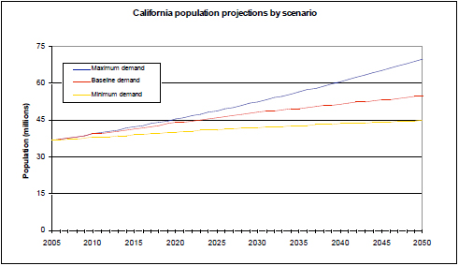
Chart 1. California population growth 2005 – 2050: Three Scenarios (UC Davis)

Closely related to population growth and clearly linked to future energy demand is the size of California’s motor vehicle fleet. As the Los Angeles Economic Development Corporation (LAEDC) expresses it in a March 2008 report entitled “California’s Uncertain Oil Future,” “as the population rises, so will the number of light-duty vehicles (LDVs)—cars, light trucks, and sport utility vehicles—on the roads of California.” According to the California Energy Commission, the number of LDVs is expected to rise from 25.6 million in 2005 to 37.2 million in 2030, a 45% increase. At the same time, the average number of LDVs per person statewide will increase slightly, rising from 0.70 to 0.76 per person. And despite the fact that fuel-economy will improve—in the best-case scenario, Californians will travel almost 50% further on every gallon of gasoline by 2030—the number of miles traveled on the state’s roads and freeways will approach 490 billion by 2030, up from 320 billion in 2004.

Conclusion. While California’s population growth rates are expected to slow sharply in the near- and mid-term, in at least one reasonable scenario they could remain close to the relatively high growth rates of the past 25 to 30 years. Hence, while California may expect some relief in pressures on energy demand growth from slower population growth, this result is far from certain. Moreover, even with relatively conservative forecasts, California’s population is still likely to grow by at least 1.0% per year for the foreseeable future, suggesting that energy demands will grow as well. This relationship can be seen clearly in motor vehicle fuel demand, as the number of vehicles and miles driven will expand in direct relationship with the number of residents of the state.
2.1.2 Economic Output
As noted, population growth rates can be assumed to be largely exogenous to the energy demand model—that is, they establish a course that, for the most part, is independent of the level of energy usage. The same is not true of economic output and economic growth rates, however. On the contrary, economic output is directly and inextricably linked to energy usage: in general, the higher the energy usage, the higher economic output can be. And vice versa: the lower the energy usage, the lower economic output will be.

California historically has altered this equation somewhat through significant gains in energy efficiency. Harvard University’s Joseph P. Kalt has noted that California’s energy usage would be some 75% greater now were it not for the energy efficiencies that the state has achieved over the past generation. Nevertheless, as strong as they are, energy efficiencies alter the trajectory but not the direction of the effect: to at least some noteworthy degree, increased energy use is associated with increased economic output, and vice versa.

In looking at forecasts for California’s economic output and economic growth, it is also important to understand that they are typically generated by multivariate econometric models. These models depict with a relative degree of statistical accuracy the relationship among different time series of economic variables. While causation sometimes can be established, there is inevitably an associative quality to the models that implies not just a dependent but an interdependent relationship among variables.

Consider, for instance, the relationship among energy usage and economic output. If the economy slows, there will be less economic activity, and so energy use will diminish. On the other hand, if energy supply and hence energy usage is constrained, economic activity will be constrained, and economic output will fall or at least rise more slowly. To the equations of econometric models, the numbers underlying these two sets of events may look essentially identical. But even if the model can be specified in a way that yields some indications of causality, there still will be something of an iron relationship between the two variables: assuming only marginal changes in energy efficiency, a given time-path of energy usage will be associated with a specific time-path of economic output, and vice versa. The implications of this relationship will be spelled out in the discussion of macroeconomic effects toward the end of this report.

For the moment, however, let us consider the economic output projections themselves. Historically, according to the California State Bureau of Economic Analysis, California’s Gross State Product (GSP) rose from $328.2 billion in 1980 to $1.43 trillion in 2005—an increase of 335% over the 25-year period, or an average of 6.1% per year.

For the future, according to the CEC, the California economy is expected to continue to grow as well, with consequent influences upon energy demand. The agency posits three economic-growth scenarios that result, respectively, in: (1) low energy demand (“low-demand”); (2) moderate energy demand (“mid-demand”); and (3) high energy demand (“high-demand”). The results of its projections according to these three scenarios are as follows:

- For the low-demand scenario, California’s GSP will grow from $2.00 trillion in 2010 to $2.74 trillion in 2022, an increase of 37% over the 12 years, or an average growth rate of 2.7% per year.
- For the mid-demand scenario, California’s GSP will grow from $2.00 trillion in 2010 to $2.84 trillion in 2022, an increase of 42% over the 12 years, or an average growth rate of 3.0% per year.
- For the high-demand scenario, California’s GSP will grow from $2.00 trillion in 2010 to $2.98 trillion in 2022, an increase of 49% over the 12 years, or an average growth rate of 3.4% per year.

Similarly, in its similarly constructed multi-scenario projections, the UC Davis study offers these forecasts (see Chart 2):

- For its low-demand scenario, California’s GSP will experience a reduction from $2.00 trillion in 2010 to $1.77 trillion in 2025 and then a rebound to $2.35 trillion by 2050, representing annual increases in economic growth of negative 0.8% for the first 15-year period and 1.1% for the second 25-year period.

- For its baseline or mid-demand scenario, California’s GSP will grow from $2.00 trillion in 2010 to $2.53 trillion in 2025 and further to $4.99 trillion by 2050, representing annual increases in economic growth of 1.6% for the first 15-year period and 2.8% for the second 25-year period.

- For its high-demand scenario, California’s GSP will grow from $2.00 trillion in 2010 to $3.05 trillion in 2025 and further to $7.68 trillion by 2050, representing annual increases in economic growth of 2.9% for the first 15-year period and 3.8% for the second 25-year period.

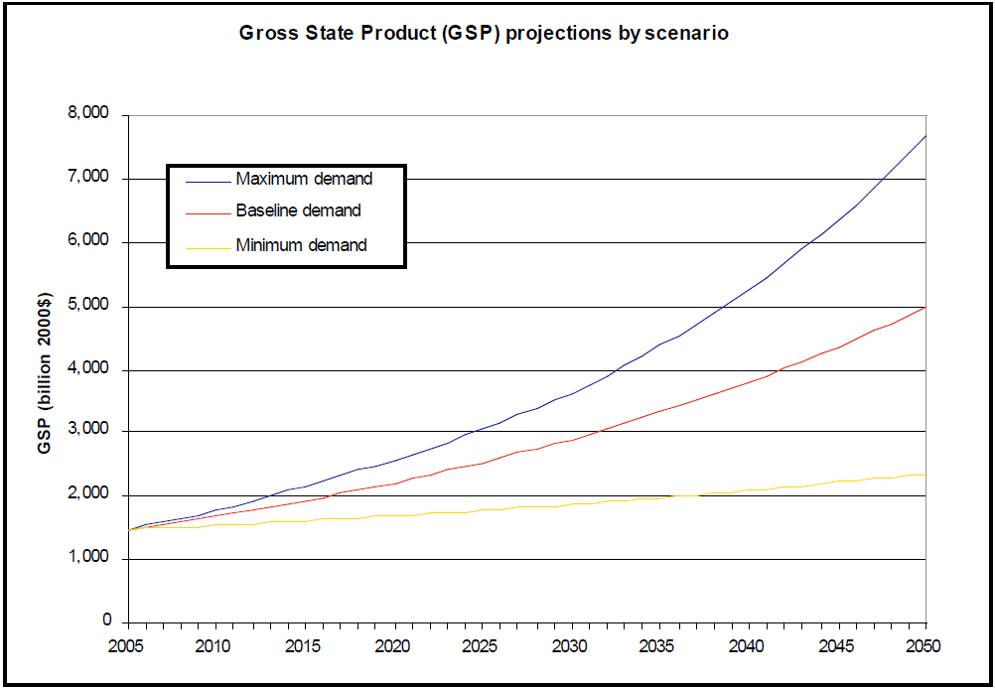
Chart 2. California GSP 2005 – 2050: Three Scenarios (UC Davis)

Conclusion. Even in the most optimistic growth scenario, the rate of expansion of California’s economy is expected slow substantially over the coming decades. Nevertheless, in the likeliest scenario, California’s economy is expected, on average, to grow faster than its population levels, thereby continuing to put upward pressure on the state’s energy demand.
2.1.3 Employment

Employment levels are directly related to economic activity: in general, the more an economy produces, the more people who are required to produce it, and hence the higher employment levels will be. At the same time, employment and energy demand are also related: in general, employed people tend to consume more energy than those who are not employed, in part because they can afford it, and in part because they engaged in activities (living in larger homes, driving more miles) that result in the greater consumption of energy. In addition, the economic activity itself increases energy usage.

Economic statistics bear out this principle. Historically, according to the California Employment Development Department, employment in California grew from 10.9 million in 1980 to 16.7 million in 1985, an increase of 53%, or an average of 1.7% per year—just below the population growth rate for that period. The employment growth rate was substantially lower than the economic growth rate during this time, suggesting that the majority of the growth in economic output was due to productivity increases rather than primarily to an increase in the number of people working.

For the future, the CEC sets forth three scenarios by which employment levels will grow in California:

- For the low-demand scenario, California’s employment levels will grow from 13.8 million in 2010 to 15.9 million in 2022, an increase of 14% over the 12 years, or an average growth rate of 1.1% per year.

- For the mid-demand scenario, California’s employment levels will grow from 13.8 million in 2010 to 15.7 million in 2022, an increase of 15% over the 12 years, or an average growth rate of 1.2% per year.

- For the high-demand scenario, California’s employment levels will grow from 13.8 million in 2010 to 16.6 million in 2022, an increase of 20% over the 12 years, or an average growth rate of 1.6% per year.

Conclusion. California’s employment growth will roughly parallel the growth of population in the state, but likely will be either somewhat or substantially lower than the economic growth rate (depending upon the scenarios used)—suggesting that in the future, as in the past, growth in economic output will be driven more by increases in productivity than by increases in employment. This projection also suggests that the level of economic output, more than the employment levels, will determine the course of the state’s energy demand. Nevertheless, even with these limitations, employment growth will serve to put additional pressure on energy demand over the coming years and decade.

    - Household Income

Household income affects energy demand in much the same way as unemployment does: the higher the levels of household income, the higher energy demand is likely to be. And, as with economic growth and employment levels, household income has been increasing in California over time. From 1980 to 2005, the U.S. Census Bureau says, the median California household income grew (in nominal terms) from $21,200 per year to $51,185 annually, for an increase of 142%, or 3.6% per year. Because employment levels grew only about one-third this fast, this suggests that wages earned by Californians were growing substantially over this period.
For the future, according to the CEC, household income in the state is likely to progress according to one of three scenarios:

- For the low-demand scenario, California’s average household income will grow from $42,386 in 2010 to $53,876 in 2022, an increase of 25% over the 12 years, or an average growth rate of 1.9% per year. (Note that the base used for this calculation by the U.S. Census Bureau, referenced above, differs slightly from that used by the CEC.)

- For the mid-demand scenario, California’s average household income will grow from $42,386 in 2010 to $55,631 in 2022, an increase of 31% over the 12 years, or an average growth rate of 2.3% per year.

- For the high-demand scenario, California’s average household income will grow from $42,386 in 2010 to $56,775 in 2022, an increase of 34% over the 12 years, or an average growth rate of 2.5% per year.

Conclusion. Average household income will grow slightly faster than employment levels over the next dozen years, but somewhat less than the growth levels in overall economic output in the state. Still, as with the other economic variables, increasing income will continue to put upward pressure on energy demand.

Overall conclusion. While the primary factors affecting the demand for energy in the state of California over the next 12 to 40 years are likely to become neither more intense nor influential than they have been, nor are they likely to wane. As a result, the annual growth rate in energy demand is likely to be just as pronounced in the near- to mid-term future as it has been over the recent decade. It is to that question that we next turn.

  - Overall Energy Demand

    - Current California Energy Demand

According to the EIA, as of 2009, Californians were using 217 million Btu of energy per capita each year. That sounds like a great deal of energy use—and it is. However, although California has long had a reputation as an “energy hog,” the facts tell a somewhat different story. The state actually ranks 47th out of 50 states in per capita energy usage. Wyoming and Alaska, ranked #1 and #2, respectively, use almost four times as much energy per capita as California does. In fact, California’s per capita energy use is almost 30% lower than the U.S. average.

Considered in the aggregate, Californians used 8,006 trillion Btu of energy in 2009, representing 8.6% of total U.S. energy consumption, despite having 12.4% of the total U.S. population. The relative degree of petroleum consumption in California is only slightly higher, with California accounting for 9.6% of all U.S. petroleum usage. For motor-vehicle gasoline, not surprisingly, California’s energy usage is relatively higher, with the state accounting for 10.9% of the U.S. total. While California’s natural gas consumption is similarly 9.6% of the U.S. total, California’s coal usage is markedly lower, representing just 0.2% of all coal consumed in the United States. Finally, at 885.7 trillion Btu, California’s 2009 retail electricity consumption was 7.2% of the U.S. total.

By sector, California consumed the following shares of U.S. energy in 2009:

- Residential sector: 7.3% of the U.S. total.
- Commercial sector: 8.2% of the U.S. total.
- Industrial sector: 6.2% of the U.S. total.
- Transportation sector: 11.6% of the U.S. total.

Conclusion. California’s current energy consumption, while substantial in absolute terms, is well below the U.S. average on a per capita basis. California therefore cannot be fairly accused of “over-consuming” energy when compared with other U.S. states.

2.2.2 Future California Energy Demand

According to a November 2009 study by the research group Energy and Environmental Economics, Inc. (E Three), entitled “Meeting California’s Long-Term Greenhouse Gas Reduction Goals,” total California energy use will grow from 6.10 quadrillion Btu (quads) in 2008 to 9.93 quads in 2050, using its baseline forecast. This represents an increase of 63% over the 42-year time period, or an average annual increase of 1.2%. Note that the growth in energy usage is identical to the 1.2% projected population growth rate of 1.2% per year through 2025, discussed above, but considerably higher than the 0.7% growth rate per year from 2025 to 2050 that was projected in the UC Davis study discussed previously. However, the projected growth in energy usage is well below the projected growth rates of the state’s economic output, suggesting continued efficiencies in the state’s use of energy.

The E Three study similarly projects that California’s electricity usage will grow from 0.90 quads in 2008 to the baseline forecast of 1.54 quads in 2050. This represents an increase in electricity usage of 71% over 42 years, or an average of 1.3% per year—only marginally above the increase in overall energy usage. Likewise, consumption of natural gas and allied fuels is expected to grow from 2.56 quads to 3.22 quads over this time—a 42-year growth rate of 26%, or an average 0.5% per year. By contrast, liquid petroleum fuel usage is projected to rise from 2.64 quads in 2008 to a nearly double 5.17 quads in 2050—a 42-year growth of 96%, or an average of 1.6% per year.

Broken out by sector, the 42-year and average annual average growth rates are as follows:

- Residential sector: a total growth in energy usage of 69%, or an average of 1.3% per year.
- Commercial sector: a total growth of 68%, an average, likewise, of 1.3% per year.
- Industrial sector: a total growth of 2%, an average of 0.0% per year (a figure that appears to be an anomaly, as judged by the Davis study, below).
- Transportation sector: a total growth of 98%, an average of 1.6% per year.

The UC Davis study, cited earlier, provides another viewpoint, examining changes in various forms of energy usage in these four sectors according to five demand scenarios: maximum demand, baseline demand/low-efficiency, baseline demand/nominal efficiency, baseline demand/high efficiency, and minimum demand. The study’s findings, covering the period 2005 to 2050, are as following (see Tables 1 and 2):

- Residential sector: (1) Electricity: a baseline growth of 34% (annual average of 0.7%), ranging from 128% (1.8%) for the maximum-demand scenario to a negative 34% (annual average of negative 0.9%) for the minimum-demand scenario. (2) Natural gas: a baseline growth of 23% (annual average of 0.5%), ranging from 111% (1.7%) for the maximum-demand scenario to a negative 36% (negative 1.0%) for the minimum-demand scenario. (Significantly, almost all of the projected growth in residential electricity usage is due to population growth, with electricity use per single-family household growing by only 4% over the 45-year period in the maximum-demand scenario, falling by 10% in the baseline scenario, and falling by 36% in the minimum-demand scenario. Similar patterns hold for natural gas usage.)

- Commercial sector: (1) Electricity: a baseline growth of 56% (annual average of 1.0%), ranging from 115% (1.7%) for the maximum-demand scenario to a negative 5% (negative 0.1%) for the minimum-demand scenario. (2) Natural gas: a baseline growth of 43% (annual average of 0.8%), ranging from 113% (1.7%) for the maximum-demand scenario to a 3% (0.1%) for the minimum-demand scenario.

- Industrial sector: (1) Electricity: a baseline growth of 86% (annual average of 1.4%), ranging from 284% (3.0%) for the maximum-demand scenario to a negative 37% (negative 0.7%) for the minimum-demand scenario. (2) Natural gas: a baseline growth of 52% (annual average of 0.9%), ranging from 219% (2.6%) for the maximum-demand scenario to a negative 53% (negative 1.7%) for the minimum-demand scenario.

- Transportation sector: the study provides no comparable data on the transportation sector.

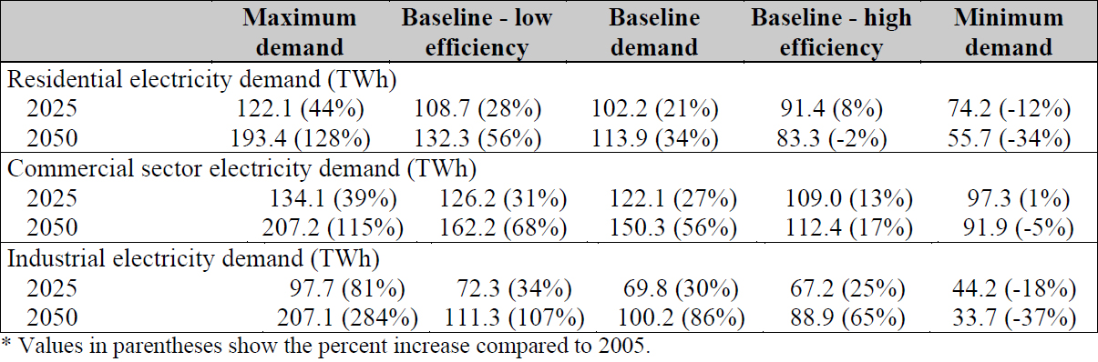
Table 1. California Electricity Demand 2025 and 2050: Five Scenarios (UC Davis)

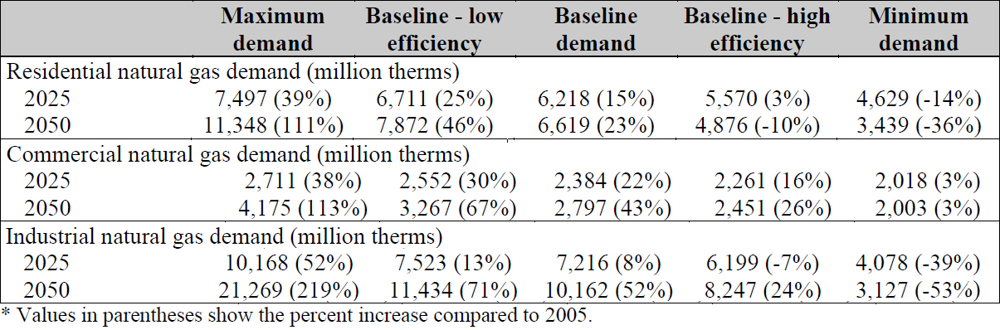
Table 2. California Natural Gas Demand 2025 and 2050: Five Scenarios (UC Davis)

The California Council on Science & Technology, in a May 2011 report, primarily focused its research efforts on assessing ways of reducing greenhouse gas emissions. However, in analyzing data regarding future energy demand, the study’s authors came to a similar conclusion to that above: “By 2050,” they wrote, “California’s population is expected to grow from the 2005 level of 37 million to 55 million. Even with moderate economic growth and business-as-usual (BAU) efficiency gains, [California] will need roughly twice as much energy in 2050 as we use today.”

Finally, the CEC study looked at growth rates in electricity use for mid-, high-, and low-demand scenarios, but only for the period 2010-2022. Still, their findings are instructive. The CEC projects:

- Total electricity consumption: an annual growth rate of 1.3% in the mid-demand scenario; 1.5% in the high-demand scenario; and 1.1% in the low-demand scenario.

- Residential sector: an annual growth rate of 2.0% in the mid-demand scenario; 2.3% in the high-demand scenario; and 1.8% in the low-demand scenario.

- Commercial sector: an annual growth rate of 1.2% in the mid-demand scenario; 1.4% in the high-demand scenario; and 1.1% in the low-demand scenario.

- Industrial sector: an annual growth rate of 0.6% in the mid-demand scenario; 1.2% in the high-demand scenario; and 0.5% in the low-demand scenario.

Finally, the companion study by Dr. Timothy Considine points out that energy demand will grow—even as California makes significant progress in improving energy-efficiency. “Despite considerable energy-efficiency improvements,” the report says, “California will continue to need more energy in the future while it confronts the fiscal challenges that threaten the state’s economy. In other words, while energy-conservation activities will reduce future needs for additional energy supplies, it is unlikely to fully offset additional energy requirements from economic and population growth.”

Conclusion. Regardless of the scenario and sector examined, the clear conclusion is that California will require significantly more energy in the future, with annual energy demand growth averaging in the range of 1.0% or more in most scenarios, in most sectors, and for most energy types. This growth rate roughly parallels the projected growth in California’s population, confirming the projection that California’s energy needs will rise roughly in concert with its population.

Only in the low-demand scenarios does energy demand rise more slowly (or even fall), but as noted in previous sections, these slower energy-growth scenarios are associated with significantly lower or even negative economic growth, as well as with somewhat slower income and employment growth, over the indicated timeframes. Note, in particular, that these increases in energy needs will take place even if California continues to make progress on its already impressive energy-efficiency achievements.

- Energy Supply

  - California Energy Supply Overview

    - Statewide Energy Resources

California has abundant energy reserves. As the EIA writes, “California is rich in both conventional and renewable energy resources. It has large crude oil and substantial natural gas deposits in six geological basins, located in the Central Valley and along the Pacific coast… Seventeen of the Nation’s 100 largest oil fields are located in California, including the Belridge South oil field, the third largest oil field in the contiguous United States. In addition, Federal assessments indicate that large undiscovered deposits of recoverable oil and gas lie offshore in the federally administered Outer Continental Shelf (OCS), which in 2008 was reopened for potential oil and gas leasing. California’s renewable energy potential is extensive. The State’s hydroelectric power potential ranks second in the Nation behind Washington State, and substantial geothermal and wind power resources are found along the coastal mountain ranges and the eastern border with Nevada. High solar energy potential is found in southeastern California’s sunny deserts.”

California’s petroleum resources are especially extensive. Again, the EIA notes that “California is one of the top producers of crude oil in the nation, with output accounting for more than one-tenth of total U.S. production. Drilling operations are concentrated primarily in Kern County and the Los Angeles basin, although substantial production also takes place offshore in both State and Federal waters… A network of crude oil pipelines connects production areas to refining centers in the Los Angeles area, the San Francisco Bay area, and the Central Valley. California refiners also process large volumes of Alaskan and foreign crude oil received at ports in Los Angeles, Long Beach, and the Bay Area. California ranks third in the United States in petroleum refining capacity and accounts for more than one-tenth of total U.S. capacity. California’s largest refineries are highly sophisticated and are capable of processing a wide variety of crude oil types and are designed to yield a high percentage of light products like motor gasoline. To meet strict Federal and State environmental regulations, California refineries are configured to produce cleaner fuels, including reformulated motor gasoline and low-sulfur diesel.”

There are downsides to California’s energy-resources picture, however. The EIA explains that “crude oil production in California and Alaska is in decline and California refineries have become increasingly dependent on foreign imports. Led by Saudi Arabia, Iraq, and Ecuador, foreign suppliers now provide more than two-fifths of the crude oil refined in California; however, California’s dependence on foreign oil remains less than the national average.” Moreover, “California natural gas production typically accounts for less than 2% of total U.S. production and satisfies less than one-fifth of state demand.” And, “due to high electricity demand, California imports more electricity than any other state.”

By contrast, in terms of renewable energy resources, California’s energy-supply situation is more positive. “California,” the EIA notes, “is one of the largest hydroelectric power producers in the United States, and with adequate rainfall, hydroelectric power typically accounts for close to one-fifth of State electricity generation. California’s two nuclear power plants account for about 17% of total generation… California leads the Nation in electricity generation from non-hydroelectric renewable energy sources… California is the top producer of geothermal energy in the nation with more than 2,500 megawatts of capacity. A facility known as ‘The Geysers,’ located in the Mayacamas Mountains north of San Francisco, is the largest complex of geothermal power plants in the world, with more than 700 MW of installed capacity. California is also a leading producer of wind energy and holds nearly 10% of the nation’s capacity. The world’s largest solar power facility operates in California’s Mojave Desert.”
    - California’s Energy Supply

California’s current energy portfolio bears both similarities to and differences from the energy portfolios of other states. Like most other states, California obtains the majority of its energy from oil and natural gas. California, however, receives a much higher proportion of its energy from renewable resources (most hydroelectric power), and a much lower percentage (almost zero) from coal, which is a dominant resource in many other states. It total, according to the most recent data from the EIA, California’s current energy supply can is as follows (see Chart 3):

- Crude oil, 50.9%
- Natural gas, 11.9%
- Nuclear power, 12.8%
- Coal, 0.0%
- Renewables, 24.4%

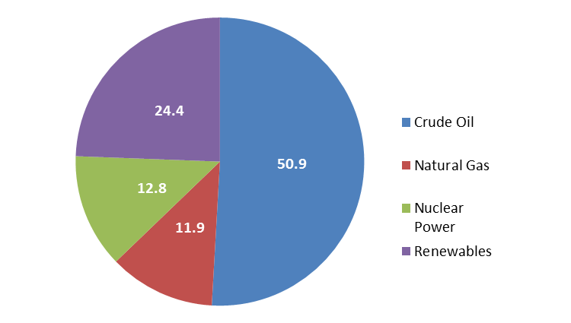

Chart 3. Current California Energy Supply by Type

Looked at in terms of in-state production versus imported energy, however, the breakouts are markedly different (see Chart 4):

- 17% from domestically produced crude oil.
- 4% from domestically produced natural gas.
- 4% from nuclear power.
- 8% from renewables (primarily hydroelectric power).
- 67% from imports (primarily crude oil, natural gas, and electricity).

In an October 2011 study, the California Council on Science and Technology concluded that nuclear power could play a much more significant role in California’s mid- to long-term energy future, although the report did not provide specific estimates. The report emphasized that “there are no technical barriers to large-scale deployment of nuclear power in California” but that there are “legislative barriers and public acceptance barriers that have to be overcome to implement a scenario that includes a large number of new reactors.” Researchers speculated that loan guarantees for nuclear power would be required until the financial sector was convinced of its viability, but that generation costs should be less than for solar.
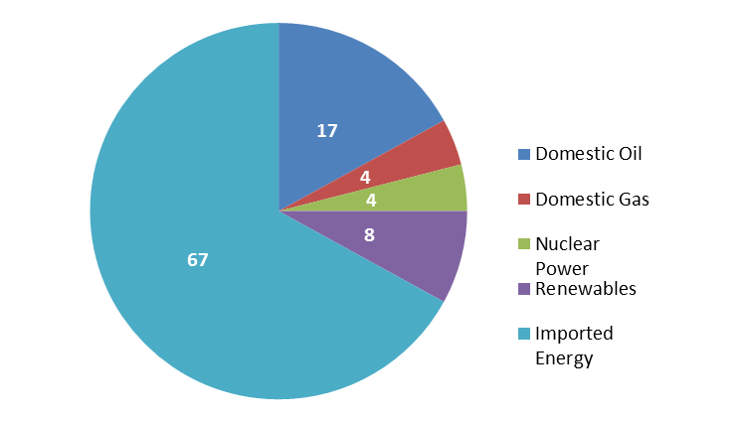
Chart 4. Current California Energy Supply by Source

Conclusion. California has an incredibly rich array of energy resources at its disposal, primarily petroleum and natural gas resources. It also possesses significant renewable energy resources, primarily hydroelectric resources. However, California now imports for two-thirds of its energy resources to supply its population’s energy needs.

    - California’s Energy Supply by Sector

There are four principal energy-consuming sectors in California (as is true elsewhere): residential, commercial, industrial, and transportation. While the distribution is similar in many respects to that of other jurisdictions, there are a number of aspects of the matrix of resources by sector that are more or less unique to California (see Table 3).

One of the most obvious of these unique characteristics is that the largest end-user of energy in California, by far, is transportation. The transportation sector in 2009 used 3,203.8 trillion Btu of energy. Petroleum products accounted for 96.8% of the transportation sector’s energy resources, with ethanol constituting 2.6% and natural gas 0.6%. Of the total petroleum products used in transportation, 59.5% was gasoline, 17.9% was jet fuel, 14.2% was distillate fuel, and 7.8% was residual fuel oil.

The next largest energy-consuming sector in California is the industrial sector, which includes manufacturing, agriculture, and mining. The industrial sector used 1,426.5 trillion Btu of energy in 2009. Natural gas accounted for 55.6% of total industrial use in the state and petroleum 28.6%. Electricity was the next largest energy source in the industrial sector, constituting 11.4% of the sector’s energy supplies. Coal and renewables each were responsible for just 2.2% of energy used in this sector.

The third largest energy-using sector in California is the residential sector, which consumed 882.7 trillion Btu of energy in 2009. Natural gas provided 55.9% of the sector’s energy use, with electricity accounting for 34.7%. Renewables and petroleum provided only 5.8% and 3.5%, respectively, of the sector’s energy.

Finally, the commercial sector in California consumed 709.2 trillion Btu of energy in 2009. In an almost exact reversal of the residential percentages, 58.3% of this energy came from electricity and 35.9% was derived from natural gas. Petroleum accounted for 4.4% and renewables for 1.4%.

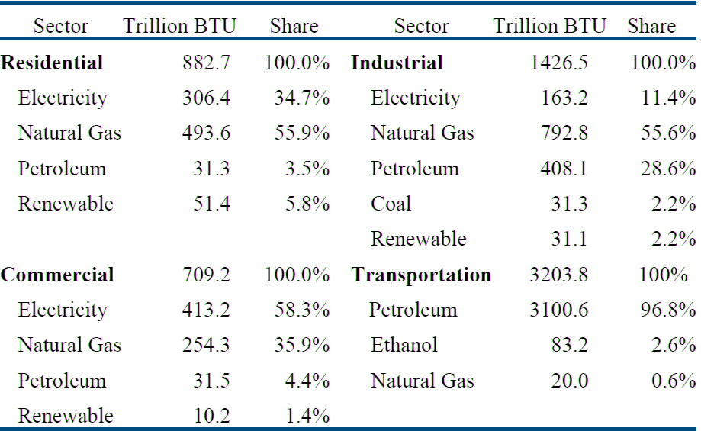
Table 3. Summary of California Energy Consumption by Sector, 2009

Conclusion. In general, California’s different economic sectors rely on differing combinations of energy resources. But one characteristic is clear: petroleum and natural gas account for the substantial majority of energy supplies consumed for all sectors except the commercial sector, where electricity represents the majority source. By contrast, renewables represent only a relatively small minority of each sector’s energy resources.

3.2 Future U.S. Energy Supply

The studies discussed above consider only energy demand and consumption patterns and generally ignore energy supply issues. Indeed, in its 2011 Annual Energy Outlook, the EIA provides one of the few comprehensive projections for future energy supply (with some data reported on a regional basis, but mostly for the United States as a whole). Even though these figures do not relate directly to California’s projected energy supply, the U.S. energy supply system is largely interconnected, and so even EIA’s national projections, as discussed below, are at least partially relevant to supply patterns in California.

The EIA considers three primary growth scenarios

- A baseline case in which U.S. economic output grows by an average of 2.7% per year from 2009 to 2035.
- A high-growth case in which U.S. economic output grows by an average of 3.2% per year over the same time period.
- A low-growth case in which U.S. economic output grows by an average of 2.1% per year over the same time period.
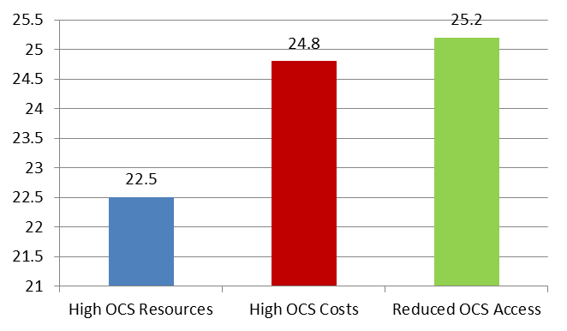
Chart 5. EIA Economic Growth Assumptions, 2009 – 2035

More recently, the National Petroleum Council (NPC), in a report commissioned by the U.S. Department of Energy and released on September 15, 2011, also investigated future U.S. energy supply. The draft report, entitled “Prudent Development: Realizing the Potential of North America’s Abundant Natural Gas and Oil Resources,” observed that, over the past five years, “significant technology advances have unlocked abundant natural gas and oil resources” in the United States. “These greatly expanded resources have already benefited our country economically.”

However, “the positive outcomes of increased North American natural gas and oil resources can only be realized if developed prudently…” Specifically, the report notes that “achieving the economic, environmental, and energy security benefits of North American natural gas and oil supplies requires responsible approaches to resource production and delivery. Development in different geographic areas, such as deepwater offshore basins or onshore areas with shale gas resources in populated areas, required different approaches and continued technological advances. But in all locales and conditions, the critical path to sustained and expanded resource development in North America includes effective regulation and a commitment of industry and regulators to continuous improvement in practices to eliminate or minimize environmental risk.”

The specific findings of the NPC report are also presented below.

    - Oil & Petroleum

In its baseline forecast, the EIA projects that total U.S. crude oil supply will decline from 14.7 million barrels per day (mbpd) in 2010 to 14.2 bpd in 2035, a decline of 3.3% from 2010 levels. Gross imports also are projected to decline, from 9.2 mbpd to 8.3 mbpd. The demand for these products will grow, however. The difference will be made up mostly by natural gas liquids, which will rise from 1.96 mbpd to 2.94 mbpd, and from renewables (ethanol and biodiesel), whose supply will nearly triple, from 0.89 mbpd to 2.94 mbpd.
In the EIA’s high-growth scenario, total crude supply rises from 14.7 mbpd in 2010 to 15.3 mbpd in 2035, an increase of 3.3% over the entire period. Gross imports remain stable at 9.2 mbpd while renewables supply increases by more than three times, from 0.89 mbpd to 2.71 mbpd. In the EIA’s low-growth scenario, total crude supply falls from 14.7 mbpd in 2010 to 13.2 mbpd in 2035, a decrease of 10.3%. Gross imports fall from 9.2 to 7.6 mbpd, while renewables grows by slightly less than three times, from 0.89 mbpd to 2.37 mbpd. Even in the high-growth scenario, however, renewables contribute to only 11.4% of needed energy supply. (See Chart 6.)

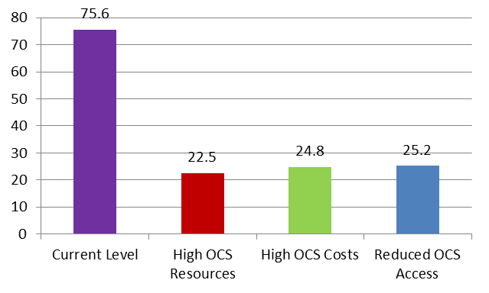
Chart 6. US Crude Oil Supply, 2009 – 2035 (million barrels per day)

The NPC’s report provides fewer details of its underlying model, but nevertheless comes to some clear conclusions. Specifically, the report notes that, “contrary to conventional wisdom, the North American oil resource base could provide substantial supply for decades ahead. Through technology leadership and sustained investment, the United States and Canada together now constitute the largest oil producer in the world. We have world-class resource basins, some of which are located in remote areas offshore and in the Arctic. Going forward, access to these resources depends upon responsible development practices being consistently deployed.” Indeed, the report notes, the U.S. is the third-largest oil producer in the world (after Russia and Saudi Arabia), with nearly double the production of Iran and China, the fourth- and fifth-largest producers.

As for the future, the NPC considers two scenarios: (1) in the 2035 limited scenario, oil production dips slightly from the 2010 level, but still remains approximately 7 million barrels per day; and (2) in the 2035 high potential scenario (with significant contributions from unconventional sources like oil shale, oil sands, and tight oil), oil production more than doubles to approximately 18 million barrels per day. Either is possible, but the actual evolution of supply, the organization says, depends heavily on the Federal regulatory environment.

On a slightly different score, Pulitzer Prize-winning economist Daniel Yergin, chairman of IHS Cambridge Energy Research Associates, recently addressed the oft-floated claim that the world soon will run out of oil. Writing in an article in The Wall Street Journal entitled “There Will Be Oil,” Dr. Yergin noted that, according to this school of thought, “the world is fast approaching (or has already reached) a point of maximum oil output” with “an unprecedented crisis just over the horizon.” However, he pointed out, this was the fifth time in recent decades when the world was said to be running out of oil. Most recently, that claim arose in the 1970s—and world oil output has increased by 30% since that time.
Over the next 20 years, global oil production is expected to increase by another 20%. Just in the years 2007 through 2009, for instance, for every barrel of oil produced in the world, 1.6 barrels of new reserves were added. Clearly, the world is not running out of oil—and will not be any time soon.
    - Natural Gas

In its baseline forecast, the EIA projects that total U.S. natural gas supply will rise from 24.1 trillion cubic feet (tcf) in 2010 to 26.6 tcf in 2035, an increase of 10.3% from 2010 levels. In the EIA’s high-growth scenario, total natural gas supply rises from 24.2 tcf in 2010 to 29.7 tcf in 2035, an increase of 22.6%. In the EIA’s low-growth scenario, total natural gas supply inches up from 24.1 tcf in 2010 to 24.4 tcf in 2035, an increase of just 1.2% over the 25-year period (see Chart 7).

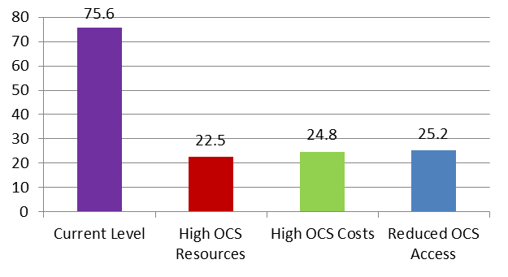
Chart 7. US Natural Gas Supply, 2009 – 2035 (trillion cubic feet)

By contrast, the NPC describes natural gas as “a very abundant resource,” declaring that “America’s natural gas resource base is enormous… Thanks to the advances in the application of technology pioneered in the United States and Canada, North America has a large, economically accessible natural gas resource base that includes significant sources of unconventional gas such as shale gas. This resource base could supply over 100 years of demand at today’s consumption rates.” Overall, the report notes, “the United States is now the number one natural gas producer in the world and together with Canada accounts for over 25% of global natural gas production.”

The future U.S. supply of natural gas has been growing as well: “New applications of technologies such as horizontal drilling and hydraulic fracturing have brought about [a] recent increase in natural gas production and the reassessment of the size of the U.S. recoverable natural gas resource base.” This resource base now “could support supply for five or more decades at current or greatly expanded levels of use.” These resources, the report concludes, “could allow natural gas to continue to play a central role in the North American energy economy into the next century.”

Shale oil reserves are a particularly promising potential source of natural gas. A September 29, 2011, report in The Wall Street Journal, notes that, because of the more intense development of shale gas, “U.S. natural gas production has surged by more than 25% in the last four years. Yet just a few years ago, government reports and long hours of expert testimony on Capitol Hill outlined the need for the U.S. to take action to address a growing shortage of natural gas. A crash program was called for to build receiving facilities to import foreign supplies of liquefied natural gas (LNG). Many receiving facilities were built at a cost of billions of dollars as investors bought into the government assessments. Today, these facilities are operating at less than 10% capacity.”

    - Coal

In its baseline forecast, the EIA projects that total U.S. coal supply will rise from 1.06 billion short tons (bst) in 2010 to 1.32 bst in 2035, an increase of 24.6% from 2010 levels. In the EIA’s high-growth scenario, total coal supply rises from 1.05 bst in 2010 to 1.36 bst in 2035, an increase of 30.2%. And in the EIA’s low-growth scenario, total coal supply grows from 1.06 bst in 2010 to 1.23 bst in 2035, a still-impressive increase of 16.9% over the 25-year period (see Chart 8).

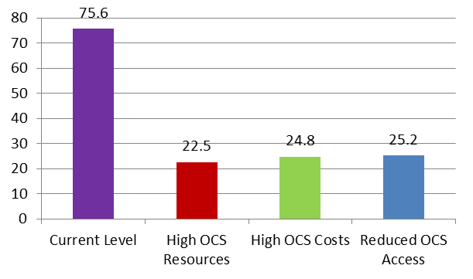
Chart 8. US Coal Supply, 2009 – 2035 (billion short tons)

    - Electricity

Again, in its baseline forecast, the EIA projects that total U.S. electricity supply from all sources will rise from 3.9 trillion kilowatt hours (tkWh) in 2010 to 4.6 tkWh in 2035, an increase of 17.0% from 2010 levels. In the EIA’s high-growth scenario, total electricity supply rises from 3.9 tkWh in 2010 to 4.9 tkWh in 2035, an increase of 25.5%. And in the EIA’s low-growth scenario, total electricity supply grows from 3.9 tkWh in 2010 to 4.3 tkWh in 2035, an increase of 9.1% during that 25-year period (see Chart 9).
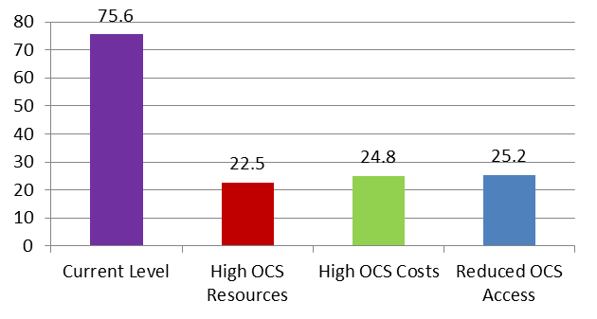
Chart 9. US Electricity Supply, 2009 – 2035 (trillion kWh)
3.2.5 Nuclear Power

Once more in its baseline forecast, the EIA projects that total U.S. production of nuclear power will rise from 8.4 quadrillion Btu (quads) in 2010 to 9.1 quads in 2035, an increase of 8.9%. In the EIA’s high-growth scenario, total nuclear power production rises from 8.4 quads in 2010 to the same 9.1 quads in 2035, an increase, again, of 8.9%. And in the EIA’s low-growth scenario, total nuclear power production grows from 8.4 quads in 2010 to 9.0 quads in 2035, an increase of 7.2% over the 25-year period (see Chart 10). Clearly, the growth in nuclear power generating capacity will be little influenced by overall economic performance.

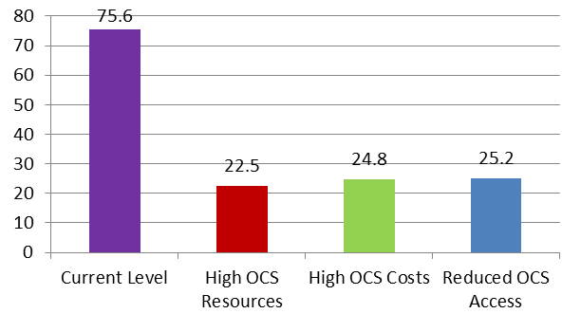
Chart 10. US Nuclear Power Supply, 2009 – 2035 (quadrillion Btu)

3.2.6 Total U.S. Energy Supply

Finally, again in its baseline forecast, the EIA projects that total U.S. energy supply from all sources will rise from 75.6 quads in 2010 to 94.6 quads in 2035, an increase of 25.1%. In the EIA’s high-growth scenario, total U.S. energy supply grows from 75.6 quads in 2010 to the same 100.3 quads in 2035, an increase, again, of 32.7%. And in the EIA’s low-growth scenario, total U.S. energy supply grows from 75.6 quads in 2010 to 89.1 quads in 2035, an increase of 17.7% over the 25-year period (see Chart 11).

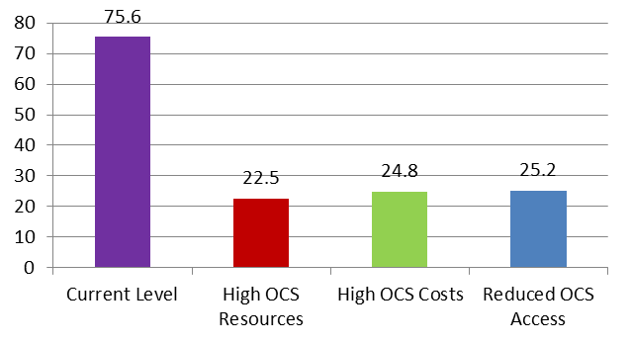
Chart 11. Total US Energy Supply, 2009 – 2035 (quadrillion Btu)

Conclusion. Total U.S. energy supply is expected to rise by a substantial 25.1% over the next 25 years. This is almost identical to the projected 25.5% increase in the U.S. population age 16 and above during the same period. However, even if California’s energy supplies were to grow by a comparable percentage, they would fall well short of the 33.7% increase in California’s population and the estimated 57.2% increase in California’s economic output during the same time period, as calculated using data from the California Energy Commission. As a result of these disparities, California’s energy supplies are likely to be under serious pressure to keep up with statewide energy demand. While the U.S. data indicate that some of this increased demand may be satisfied by renewable energy resources, if the projected U.S. experience is any guide, the vast majority of energy supplies in California during the near- and mid-term will continue to come from conventional energy sources, primarily fossil fuels.

  - Future California Energy Supply

Only a few studies look at the future supply of energy in California. The companion study by Dr. Timothy Considine is one, and its results will be referenced periodically throughout this report. But the study’s principal observation regarding California’s future energy supplies clearly demonstrates the pathway open to the state. “Outside Alaska,” Dr. Considine writes, “California has the largest untapped potential for additional oil and gas production in the United States. Offshore California contains more than 10 billion barrels of oil and nearly 12 trillion cubic feet of natural gas. Onshore, the Monterey Shale may contain more than 15 billion barrels of oil. At current market prices, these reserves are worth more than $2 trillion.”

A variety of other studies and reports examine elements of California’s future energy supplies. Most of these focus on petroleum supply specifically—and, in particular, the balance between domestically produced and imported crude oil.

    - The Historical Decline in Crude Oil Production

Rather than rising to meet demand, California’s (and the United States’) crude oil production has been declining in recent years. As the Considine study bluntly puts it, “in 1970, California produced 62% of its energy, yet by 2009 the state imported 67% of its energy needs.” A May 11, 2011, presentation by the California Energy Commission, entitled “Crude Oil Import Forecast & HCICO Screening,” along with an earlier CEC report, “Outlook for Crude Oil Imports into California” (July 12, 2007), go further, noting that:

- California crude oil production, at 613,000 bpd in 2010, had declined 47% over the previous 25 years (since 1985).
- Over the same time span, Alaskan crude oil production had declined by 65% and production in the rest of the United States by 48%.
- California’s onshore production fell from a peak of approximately 360,000 bpd in 1985 to less than half that (approximately 170,000 bpd) by 2009. Likewise, offshore oil production fell from peaks of just over 60,000 bpd in 1985 and nearly 100,000 bpd in 1995 to only about 40,000 bpd by 2009.
- This crude oil production decline was expected to continue into the future, despite sustained higher prices and significant drilling activity.
- As a result, foreign crude oil imports into California had increased by 16.1% per year between 1986 and 2006 and somewhat less thereafter, such that crude oil imports in 2010 were more than 71% greater than the levels of 2000 and more than five times greater than they were in 1985.

    - The Domestic/Imported Crude Oil Balance

The Los Angeles Economic Development Corporation, in its 2008 study referenced earlier, projects that, from 2005 to 2019, the consumption of crude oil by California refineries is expected to increase from 1.8 million barrels per day (mbpd) to 2.3 mbpd. The study forecasts that the sources of this oil will shift dramatically over this time period:

- Crude oil from Alaska’s North Slope (ANS) used in California will decline from 374,000 barrels per day (bpd) to zero.
- Crude oil pumped in-state will decline from 696,000 bpd to 423,000 bpd.
- The state’s reliance on imports will more than double over this time, rising from 737,000 bpd to 1.87 million bpd.

The LAEDC points out that “The decline of in-state production is particularly important because it means California will have to import an additional 273,000 bpd of crude oil even if demand were to remain constant—which it obviously will not do.”

    - The Implications of Rising Crude Oil Imports

The LAEDC notes two important implications of this substantial projected increase in crude oil imports into California, as follows:

- First, the LAEDC report notes, “The supply of refined petroleum products is already tight in California, as it is throughout the country. As petroleum demand in the state increases, supplies will tighten even further, and “tight supplies will translate into higher prices for gasoline, diesel, and jet fuel.” Moreover, “California will have to import more refined products in addition to importing more crude oil.”

- Second, due to the increase in imports, waterborne (i.e., ship-borne) cruel oil will rise from 1.11 mbpd in 2005 to 1.87 mbpd by 2019, an increase of 745,000 bpd, or 68.5% in just 14 years. “Will California crude oil terminals and pipelines be able to receive and distribute 745,000 additional barrels per day?” the report asks, and then answers: “If they cannot, this will artificially restrict the supply of crude oil in California, which [also] will translate into higher prices.”

3.3.4 Future Scenarios for Crude Oil Imports

Based on the above trends, the LAEDC notes that, by 2019, California will need to bring in an additional 760,000 bpd of crude oil by ship—491,000 in Southern California alone. This course suggests three likely scenarios for importing crude oil into California:

- Scenario #1. No or limited capacity expansion. In this scenario, California ignores the looming problem of how to handle the rising need for crude oil imports. Lacking sufficient capacity, “crude oil terminals become the weak link in California’s energy supply,” resulting in sharply higher prices.

- Scenario #2. Capacity expansion. In this scenario, oil terminal capacity in the state keeps up with the growing need for imported oil. As a result, “California avoids a bottleneck in the import of crude oil and keeps prices from spiking due to scarcity.”
- Scenario #3. Additional capacity. In this scenario, crude oil imports accelerate even more rapidly. Because crude oil import facilities in Southern California are already at capacity, the number of ships required to bring in the required oil rises, increasing both transportation and environmental costs.
Conclusion. California’s energy resources for the future are potentially great—if they are developed. Outside Alaska, California has the largest untapped potential for additional oil and gas production in the United States. Offshore California contains more than 10 billion barrels of oil and nearly 12 trillion cubic feet of natural gas. Onshore, the Monterey Shale may contain more than 15 billion barrels of oil. At current market prices, these reserves are worth more than $2 trillion.

  - The Role of Renewables in Energy Supply

3.4.1 Renewables in the U.S. and Global Energy Portfolios

Throughout the public policy community, one of the most common views of both California’s and the nation’s energy future is that it will built largely on renewable energy resources. Defining this renewables-reliant future is a key purpose, for instance, of the E-Three report “Meeting California’s Long-Term Greenhouse Gas Reduction Goals” and of the California Council on Science and Technology study “California’s Energy Future—The View to 2050,” referred to earlier.

These studies do, indeed, demonstrate that there are potential renewables-reliant energy futures. The key variable, however, is not whether that future will come about, but when and what it will cost. The current report accepts as a near-certainty that both California’s and the nation’s future energy portfolios will be substantially different than the existing ones, and that these future energy portfolios will be based largely on new technologies. The question explored here is: what will take us there? Or, metaphorically, what is the bridge to that energy future? Will renewables become the primary stanchions of that bridge in the near-term, or will other energy sources be required for some indefinite time?

Fortunately, many existing energy studies address these questions directly. For instance, in its 2011 Annual Energy Outlook, the EIA does forecast the growth in energy supply resulting from renewable energy resources. The headline is a positive one: in its baseline forecast, the amount of energy produced from renewable energy sources grows from 7.8 quads to 14.9 quads—a jump of more than 92.2% in just 25 years. The proportional increase for the high-growth case is 107.7% and, for the low-growth case, 81.5% (see Chart 12).

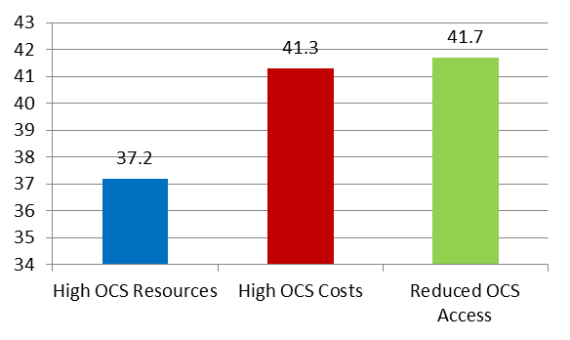
Chart 12. Relative Growth in Renewables, 2009 – 2035 (% Growth)
However, a closer look at these figures reveals reason for caution. The majority of this increase, in absolute terms, comes from hydropower and biomass (mostly wood). While the contribution of other renewable energy sources, including wind and solar, also increases by significant percentages (109.1% in the baseline case, 124.7% in the high-growth case, and 81.2% in the low-growth case), the absolute contribution of these high-profile renewables grows from 1.54 quads to just 3.22 quads in the baseline case (and to 3.46 quads in the high-growth case and 2.79 quads in the low-growth case). As a result, in the baseline case, the high-profile renewables contribute just 3.4% of all energy produced in the United States in 2035. The proportion is 3.5% in the high-growth case and 3.1% in the low-growth case.

The NRC report, previously referenced, also contends that renewables—while promising a bright future over the long term—still will satisfy only a minority of America’s energy needs in the near- to mid-term. “Even as the United States uses energy much more efficiently and diversifies its energy mix,” the report explains, “Americans will need natural gas and oil for the foreseeable future… [T]hese fuels are critical in the U.S. economy, particularly as part of a strategy to transition towards a low-carbon energy mix in the future.”

By way of comparison, renewables in the global energy portfolio are much more significant—fully 10% of all energy produced globally in 2008. However, even here, the renewables potential is constrained. According to the EIA’s “International Energy Outlook 2011,” “Renewable energy is the world’s fastest growing form of energy, and the renewable share of total energy use increases from 10% in 2008 to 14% in 2035” in the baseline forecast.

    - Renewables in the California Energy Portfolio

The arena of renewables is one of the few in which the 2011 Annual Energy Outlook provides at least some data specifically for California. Again, the raw figures are impressive. In California, in the baseline case, production of electricity from renewables is projected to grow from 54.4 billion kilowatt hours (bkWh) in 2010 to 94.89 bkWh in 2035, for a growth rate of 74.3% over the 25-year period. For the high-growth case, the comparable percentage increase is 76.8% and, for the low-growth case, 62.3%. (The EIA provides figures for California for electricity only, and not for all energy supply.)

The proportional gains for individual renewable technologies vary but, in general, are quite high as well. For instance, while electricity generation from hydropower grows only 28.2% and from biomass only 1.7% in the baseline case over this period, the respective growth figures for other renewable sources are much greater. Specifically:

- For geothermal, 252%.
- For solar thermal, 127%.

- For solar photovoltaic, 850%.
- For wind, 44.7%.

Nevertheless, these increases are from a very low base. When looked at compared to overall electricity generation, renewables on the whole contributed 27.9% of total electricity generation in California in 2010, a figure that is projected to rise to 34.9% by 2035, under EIA’s baseline scenario, a proportional increase of about one-quarter. The contributions of the individual renewable sources to the state’s electricity production under this scenario by 2035 are as follows (see Chart 13):

- Conventional hydropower, 14.8%
- Geothermal, 13.7%
- Wood & other biomass, 0.6%
- Solar thermal, 0.6%
- Solar photovoltaic, 0.1%
- Wind, 4.4%

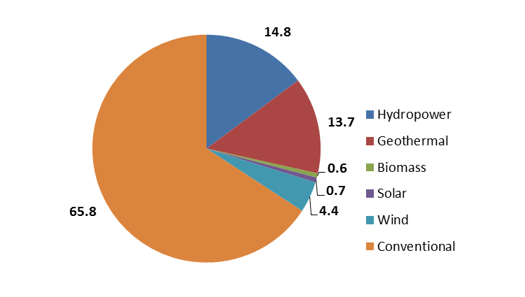
Chart 13. Renewables Contribution to California Energy, 2035

In other words, the high-profile “new” renewables (i.e., solar and wind) are expected to account for less than 6.0% of California’s electricity production even by 2035. By contrast, conventional energy sources will account for the following percentages of California’s electricity production:

- Natural gas, 42.2%
- Nuclear, 16.8%
- Coal, 6.1%

These figures are not fundamentally different for either the high-growth or low-growth scenarios. However, that they may differ under the implementation of the California Renewables Portfolio Standard (RPS), as discussed in detail in the companion analysis by Dr. Timothy Considine.

Conclusion. Despite their long-term potential, the high-profile renewable energy sources are not expected to make major contributions to either the U.S. or California energy supply in the near- or mid-term, at least outside the mandates of the California RPS. In the baseline EIA case, even by 2035, these renewables will contribute no more than 3.4% of total U.S. energy supply and no more than 6.0% of total California electricity production.

  - Energy Supply in Alternative EIA Scenarios

In addition to examining energy supply outcomes for baseline, high-growth, and low-growth scenarios, the EIA also investigated the impact of various economic, technological, and policy scenarios on energy consumption, supply, and prices. We will examine below the results of a number of the most relevant simulations. As we do, note that, while the EIA provides most of these forecasts only for the United States as a whole, for a certain segment of the analyses the agency supplies figures for the Pacific Region, which includes not only California but also Oregon, Washington, Alaska, and Hawaii. Since California’s energy activity dominates this group of states, the Pacific Region data sets should serve as a reasonable surrogate for California energy consumption and supply, and is used as the basis for the discussion that follows except in areas where otherwise specified.

    - Fossil-Fuel Technology Costs

The EIA looked at two main scenarios regarding fossil-fuel technology costs: (1) high technology costs, by which the costs of developing new fossil-fuel extraction and usage technologies do not fall below the current level through 2035; and (2) low technology costs, by which the costs of developing new fossil-fuel technologies immediately fall 20% below baseline costs and decline further until they are 40% below baseline costs by the year 2035.

The effect of fossil-fuel technology costs on the total consumption of energy in the Pacific Region by 2035 is minor. Total Pacific Region energy consumption is: (1) 14.25 quads in the high technology-cost case; and (2) 14.03 quads in the low technology-cost case. Both figures compare to a baseline energy consumption level of 14.31 quads in 2035. The impact of fossil-fuel technology costs on the use of renewable energy (all renewables, not just solar and wind) is similarly small: (1) in the high technology-cost case, renewables of all types account for 24.6% of all energy consumption in 2035, not appreciably different from the 24.7% in the baseline case; and (2) in the low technology-cost case, renewables account for 23.7% of all energy consumption in 2035. All of these latter figures are only about one-third higher than the 18.2% that renewables contributed to Pacific Region energy consumption in 2010.

The impact of the differences in high and low fossil-fuel technology costs on both the level of total U.S. oil and gas imports and on the level of U.S. domestic oil and gas production is similarly negligible.

    - Nuclear Technology Costs

A second set of variables examined the effect of nuclear technology costs, specifically: (1) high nuclear technology costs, by which the costs of developing new nuclear energy technologies do not fall below the current level through 2035; and (2) low nuclear technology costs, by which the costs of new nuclear energy technologies immediately fall 20% below baseline costs and decline further until they are 40% below baseline costs by the year 2035.

The effect of nuclear technology costs on the total consumption of energy in the Pacific Region by 2035 is small. Total Pacific Region energy consumption is: (1) 14.29 quads in the high technology-cost case; and (2) 14.18 quads in the low technology-cost case. Again, both figures compare to a baseline energy consumption level of 14.31 quads in 2035. In fact, the posited technology-cost differences do not even affect nuclear energy use over the medium term, as the proportion of electricity generated from nuclear power in 2035 is the same under both scenarios. In other words, even fairly significant changes in nuclear technology costs are unlikely to have a significant impact on nuclear’s contribution to the future California energy portfolio, probably due to the long lead times for plant construction, the restrictive permitting process, and related factors.

Finally, and as one might expect, there is also a negligible effect of nuclear technology costs on renewable energy use: (1) in the high technology-cost case, renewables of all types account for 24.8% of all energy consumption in 2035, again not appreciably different from the 24.7% in the baseline case; and, (2) in the low technology-cost case, renewables account for 24.5% of all energy consumption in 2035.

    - Renewable Technology Costs

A third EIA simulation probed the effect of the cost of renewables technology—a highly relevant consideration given the public interest in trying to speed up the development and use of renewable energy sources. The two variables considered were: (1) high renewables technology costs, by which the costs of developing new non-hydropower renewables technologies do not fall below the current level through 2035; and (2) low renewables technology costs, by which the costs of new non-hydropower renewables technologies immediately fall 20% below baseline costs and decline further until they are 40% below baseline costs by the year 2035.

The effect of renewables technology costs on the total consumption of energy in the Pacific Region by 2035, as in other scenarios, is projected to be relatively small. Total Pacific Region energy consumption is: (1) 14.03 quads in the high technology-cost case; and (2) 14.50 quads in the low technology-cost case. Again, both figures compare to a baseline energy consumption level of 14.31 quads in 2035.

There is a somewhat more pronounced (albeit still relatively minor) impact of renewables technology cost differences on the use of renewable energy sources themselves: (1) in the high technology-cost case, renewables of all types account for 23.5% of all energy consumption in 2035, again not appreciably different from the 24.7% in the baseline case; and (2) in the low technology-cost case, renewables account for 26.4% of all energy consumption in 2035. In other words, even when the development and deployment costs of non-hydropower renewable energy sources fall to 40% below baseline costs, the proportion of all energy consumption that renewable energy sources account for jumps by less than one-tenth, even over a horizon of a quarter of a century.

    - Oil & Gas Technology Development

A fourth set of variables examined the effect of the availability of new oil and gas technologies, specifically: (1) a slow-technology case, in which improvements in oil and gas exploration and development costs, production rates, and success rates fall 50% below the baseline level; and (2) a rapid-technology case, in which improvements in oil and gas exploration and development costs, production rates, and success rates increase to 50% above the baseline level.

The effect of new oil and gas technologies on the total consumption of energy in the Pacific Region by 2035 are somewhat greater than in other scenarios, though still relatively minor. Total energy consumption is: (1) 14.42 quads in the slow-technology case; and (2) 14.25 quads in the rapid-technology case. Again, both figures compare to a baseline energy consumption level of 14.31 quads in 2035. The speed of technology development has negligible effect on the consumption of petroleum products over the horizon of the study, but does affect the intensity of the use of natural gas: (1) in the slow-technology scenario, natural gas accounts for 22.8% of all of the energy consumed in the Pacific Region in 2035; whereas, (2) in the rapid-technology scenario, natural gas is responsible for 24.1% of all energy consumed in the state. This compares to a baseline consumption of 23.7%.

The EIA study, unfortunately, did not report the future effects of oil and gas technology development on the proportion of oil and gas accounted for by imports within the Pacific Region. It did so, however, for the United States as a whole—although these effects are relatively minor. For the entire United States, total oil and gas imports account for 24.9% of total energy consumption in 2035 in the slow-technology case but 24.2% of consumption in the rapid-technology case. Similarly, oil and gas imports account for 41.6% of total oil and gas consumption in 2035 in the slow-technology case but 39.6% of total oil and gas consumption in the rapid-technology case. As noted, the figures for these scenarios are somewhat but not markedly different from those of the baseline case in 2035—which are, respectively, 24.5% and 40.5%.

The United States analysis also looked at the future effects of oil and gas technology development on domestic oil and gas production. As the mirror image of import levels, domestic production of oil and natural gas in the baseline case accounts for 38.3% of all U.S. energy consumption in 2035 and 63.4% of total U.S. consumption of oil and natural gas (the figures for imports and production do not add to 100% because of small quantities of exports of these fuels, not considered here). In comparable figures for the two scenarios, domestic production of oil and gas technology accounts: (1) in the slow-technology case, for 37.0% of all U.S. energy consumption in 2035 and for 61.8% of oil and gas consumption; and (2) in the rapid-technology case, for 38.9% of all U.S. energy consumption in 2035 and for 63.9% of oil and gas consumption. In other words, with the faster development of new oil and gas technologies, U.S. oil and gas exports fall and domestic U.S. oil and gas production increase, although the relative effects are not large.

In concert with the elevated use of natural gas, the intensity of use of renewables actually falls slightly over time in these three EIA scenarios. Specifically: (1) in the slow-technology case, renewables of all types account for 24.9% of all energy consumption in 2035, again not appreciably different from the 24.7% in the baseline case; and (2) in the rapid-technology case, renewables account for 24.2% of all energy consumption in 2035.

    - Outer Continental (OCS) Development

A fifth EIA scenario investigated the impact of the oil exploration and reserves available on the U.S. Outer Continental Shelf (OCS). Three sub-cases were posited: (1) in the high OCS-resource case, undeveloped oil and natural gas resources on the OCS were assumed to be three times greater than in the baseline case; (2) in the high OCS-costs case, the costs for exploration on the OCS were assumed to be 30% greater than in the baseline; and (3) in the reduced OCS-access case, no new lease sales occur on the OCS region of the Eastern Gulf of Mexico, the Pacific Ocean, or the Atlantic Ocean through 2035.

The effects of OCS resource and policy differences on the total consumption of energy by 2035 are small. Total energy consumption is: (1) 14.34 quads in the high OCS-resource case; (2) 14.31 quads in the high OCS-costs case; and (3) 14.24 quads in the reduced OCS-access case. Again, both figures compare to a baseline energy consumption level of 14.31 quads in 2035. The three scenarios have negligible effects on the relative consumption of oil and natural gas.

As before, the EIA study did not report the effects of the proportion of oil and gas accounted for by imports within the Pacific Region over the study’s time horizon. For the United States as a whole, however, total oil and gas imports account for: (1) 22.5% of total energy consumption in 2035 in the high OCS-resource case; (2) 24.8% of consumption in the high OCS-costs case; and (3) 25.2% of consumption in the reduced OCS-access case. Looking at oil and gas alone, total oil and gas imports account for: (1) 37.2% of total oil and gas consumption in 2035 in the high OCS-resource case; (2) 41.3% of total oil and gas consumption in the high OCS-costs case; and (3) 41.7% of total oil and gas consumption in the reduced OCS-access case. As before, the comparable figures for the baseline case in 2035 are, respectively, 24.5% and 40.5%. (See Chart 14.)

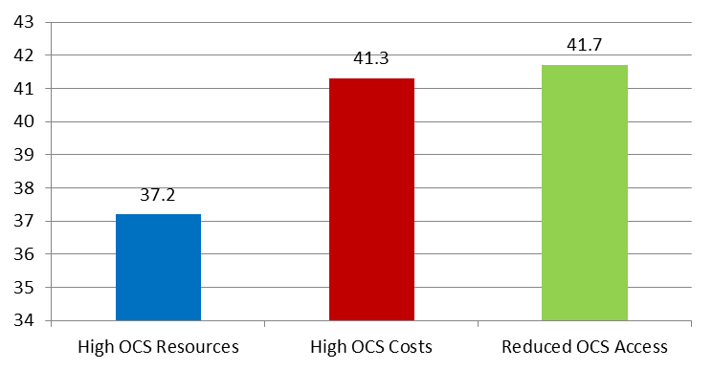
Chart 14. Effect of OCS Policies on US Oil & Gas Imports (% of Total)

As the mirror image of import levels, U.S. domestic production of oil and natural gas accounts for: (1) 40.5% of total U.S. energy consumption in 2035 in the high OCS-resource case; (2) 37.7% of consumption in the high OCS-costs case; and (2) 37.5% of total U.S. energy consumption in the reduced OCS-access case. Similarly, domestic oil and gas production accounts for: (1) 66.9% of U.S. oil and gas consumption in 2035 in the high OCS-resource case; (2) 62.6% of U.S. oil and gas consumption in the high OCS-costs case; and (3) 62.2% of U.S. oil and gas consumption in the reduced OCS-access case.

As before, the comparable figures for the baseline case in 2035 are, respectively, 38.9% and 63.9%. (Again, the figures for imports and domestic production do not add to 100% because of small quantities of exports of these fuels, not considered here.)

From the above, we can draw the following: unlike some other economic or policy parameters, the cost and degree of OCS access seem to have rather significant effects on both domestic energy supply and energy imports. Specifically, oil and gas imports as a proportion of both total U.S. energy consumption and U.S. oil and gas consumption are nearly 9% greater for the high OCS-costs and for reduced OCS-access scenarios than they are for the baseline, and are more than 11% greater than they are in the high OCS-resource case.

Likewise, U.S. domestic oil and gas production as a proportion of both total U.S. energy consumption and U.S. oil and gas consumption is more than 3% less for the high OCS-costs and for the reduced-OCS cases than they are for the baseline, and some 7% less than they are for the high OCS-resource case. Greater opportunities on the OCS therefore can appreciably reduce the United States’ (and, by extension, California’s) dependency on imports of oil and natural gas via increased domestic production of these resources, while greater restrictions on OCS activity can appreciably increase oil and gas imports via reduced domestic production of these same resources.

Despite the effect of these differing scenarios on the import and domestic production of oil and natural gas, the effects of the scenario differences on the use of renewable energy sources is minor: (1) in the high OCS-resource case, renewables of all types account for 24.5% of all energy consumption in 2035, again not appreciably different from the 24.7% in the baseline case; (2) in the high OCS-costs case, renewables account for 24.9% of all energy consumption in 2035; and (3) in the reduced OCS-access case; renewables account for 24.6% of all energy consumption in 2035.

    - Coal Costs

A sixth EIA scenario examined the impact of coal costs, specifically: (1) in the high coal costs case, productivity growth for coal mining was lower and costs for wages, equipment, mine supply, and transportation higher than in the baseline case; and (2) in the low coal costs case, productivity growth for coal mining was higher and costs for wages, equipment, mine supply, and transportation lower than in the baseline case.

The effect of coal costs on the total consumption of energy by 2035 are relatively small, in part because coal plays such a small role in energy supply in the Pacific region (especially as compared with the Eastern United States). Total energy consumption is: (1) 14.32 quads in the high-cost case; and (2) 14.26 quads in the low-cost case. Again, both figures compare to a baseline energy consumption level of 14.31 quads in 2035. The effects of coal costs on the relative consumption of oil, gas, natural renewables, and even coal itself are minor.

    - Shale Recovery

A seventh EIA scenario looked at the impact of shale-recovery success, specifically: (1) a high shale-recovery case, in which the total unproven but technically recoverable shale resources were approximately 50% higher than the baseline; and (2) a low shale-recovery case, in which the total unproven but technically recoverable shale resources were approximately 50% lower than the baseline.

The effects of shale-recovery success on the total consumption of energy by 2035 are somewhat greater than for coal costs. Total energy consumption is: (1) 14.26 quads in the high-recovery case; and (2) 14.45 quads in the low-recovery case. Again, both figures compare to a baseline energy consumption level of 14.31 quads in 2035. As with coal costs, however, the effects of shale-recovery success on the relative consumption of oil, natural gas, renewables, and coal are minor.

    - Oil Prices

An eighth EIA scenario examined the effect of oil prices, specifically: (1) in the high-price scenario, crude oil prices were projected to be $200 per barrel in 2035 (versus $125 per barrel in the baseline case); and (2) in the low-price case, crude oil prices were projected to be $50 per barrel.

As one would expect, the effect of differing oil price levels (especially as pronounced as they are in the study’s scenarios) by 2035 are fairly significant. Total energy consumption is: (1) 14.07 quads in the high-price case; and (2) 14.59 quads in the low-price case. Again, both figures compare to a baseline energy consumption level of 14.31 quads in 2035.

Despite this overall difference, however, the effect on the energy mix is fairly small. For instance, natural gas constitutes 26.1% of all energy consumption in 2035 in the high-price scenario but still 24.4% of all energy consumption in the low-price scenario. Likewise, renewables constitute 25.5% of all energy consumption in 2035 in the high-price scenario but 23.4% of all consumption in the low-price scenario. While these differences are not trivial, it is important to keep in mind how they are derived: in these scenarios, oil prices differ by a factor of four, and yet the contribution of natural gas and renewables vary by a couple of percentage points at most—and this after 25 years of adjustments.
In contrast, as one might predict, the effect of oil prices on the level of oil and gas imports is considerable. In the high-price scenario, oil and gas imports account for just 16.0% of total U.S. energy consumption in 2035, and 27.7% of total U.S. oil and gas consumption in that same year. By contrast, in the low-price scenario, oil and gas imports account for 31.5% of total U.S. energy consumption in 2035, and 50.3% of total U.S. oil and gas consumption in that year.

Looked at from the standpoint of production, this effect is equally strong. In the high-price scenario, domestic oil and gas production account for 40.6% of total U.S. energy consumption in 2035, and 70.4% of total U.S. oil and gas consumption in that year. By contrast, in the low-price scenario, domestic oil and gas production account for just 34.5% of total U.S. energy consumption in 2035, and just 55.0% of total U.S. oil and gas consumption in that year. The international level of crude oil prices, therefore, has a major and not unexpected effect on both domestic oil and gas production and, as a result, on oil and gas imports.

    - Greenhouse Gas Controls

A ninth EIA scenario looked at the impact of strict environmental constraints on the production and use of energy. The specific assumption was that the carbon allowance fee was set to the level of the cost containment provision as established in both the American Power Act of 2010 and the American Clean Energy and Security Act of 2009.

The effect of these greenhouse gas controls on the total consumption of energy in the Pacific Region by 2035 is relatively small. Total energy consumption in 2035 is 14.49 quads under the scenario, actually somewhat higher than the baseline forecast energy consumption level of 14.31 quads. The controls also result in an increase in the proportion of energy consumption accounted for by renewable sources in 2035: 26.2% for this scenario versus 24.7% for the baseline case. Again, while the figure is not trivial, it is also not terribly dramatic: very strict greenhouse gas controls do not lower overall energy consumption, and they increase the proportion of energy use accounted for by renewables by only 6%—and this after 25 years of operation.

Overall Conclusion. In most instances, the EIA simulation analyses reveal only limited effects on year-2035 Pacific Region energy consumption and supply due to economic, technological, or policy changes. However, there are a few areas in which rather substantial changes are evident—or else in which expected changes do not occur. These areas include:

- OCS development. One of the most pronounced effects identified in the analysis lies in the effect of outer continental shelf (OCS) access and development. Specifically, severe restrictions on OCS development (in the form of no new leases through 2035) increase U.S. oil and gas imports by 9% over the baseline and reduce domestic U.S. oil and gas production by 3%. More rigorous OCS leasing would have the opposite effect: domestic oil and natural gas production would increase by nearly 7% if significant new OCS reserves were discovered and developed.

- Oil prices. A second, very pronounced effect occurs with respect to oil and gas prices. Future oil and gas imports as a proportion of U.S. energy consumption are nearly twice as high when global crude oil prices are $50 a barrel as they are when they are $200 a barrel. However, domestic U.S. oil and gas production as a proportion of U.S. energy consumption is one-fourth higher in the high-price versus the low-price scenario.

- Renewables technology costs. Even a 40% drop in the technology costs of developing and deploying renewable energy sources results in only about a one-tenth increase in the proportion of energy consumption accounted for by renewable energy.

- Oil and gas technology. Faster development of new oil and gas technologies do result in a slight drop in oil and gas imports and a slight increase in domestic oil and gas production, although the effects are relatively small.

- Nuclear technology costs. Likewise, even fairly significant changes in nuclear technology costs are unlikely to have a significant impact on nuclear’s contribution to the future California energy portfolio, probably due to the long lead times for plant construction, the restrictive permitting process, and related factors.

- Greenhouse gas restrictions. Strict greenhouse gas controls do not lower overall energy consumption in the Pacific Region by 2035, and they increase the proportion of energy use accounted for by renewables by only 6%—and this after 25 years of operation.

- The bottom line. Essentially regardless of the scenario studied, neither the increased use of renewable energy sources nor the faster implementation of new non-renewable technologies is expected to have a major effect on either Pacific Region or U.S. energy consumption and supply in the near- or middle-term. At least through 2035, both Pacific Region and U.S. energy supply will remain heavily dependent, as it is today, on conventional fossil-fuel energy sources—namely, oil, natural gas, and (primarily outside the Pacific Region) coal.

- Energy Prices

4.1 Energy Price Overview

The EIA further examined the future course of energy prices in the Pacific Region according to three economic growth scenarios and found that prices generally will rise, although not in all cases. As might be expected, the price increases will be greatest in the high-growth case and lowest in the low-growth scenario. However, the differences among the scenarios, while noteworthy, are usually not dramatic.

In its aggregate conclusion, the EIA projected that total non-renewable energy expenditures across all energy types and all sectors, in real (inflation-adjusted) dollars, will grow by 46.1% in the baseline scenario. The increase for the high-growth scenario is projected to be 64.1% and, for the low-growth scenario, 29.6%

4.1.1 Price Increases by Energy Type

The EIA also projected real price increases by energy type. The relative increases for the most prominent energy sources are as follows (see Table 4):

- Motor-vehicle fuel prices. In the baseline case, motor-vehicle fuel prices rise by 36.2% by the year 2035. The increase is 42.2% for the high-growth scenario and 30.6% for the low-growth scenario.

- Residential fuel oil prices. In the baseline case, residential fuel oil prices rise by 60.5% by the year 2035. The increase is 66.5% for the high-growth scenario and 58.7% for the low-growth scenario.

- Natural gas prices. In the baseline case, natural gas prices rise by 37.1% by the year 2035. The increase is 38.6% for the high-growth scenario and 25.1% for the low-growth scenario.

- Electricity rates. In the baseline case, electricity rates fall by 11.9% by the year 2035. The decline is 7.8% for the high-growth scenario and 16.0% for the low-growth scenario.

 | Slow Growth | Baseline | High Growth
Motor-vehicle fuel | 30.6% | 36.2% | 42.2%
Residential fuel oil | 58.7 | 60.5 | 66.5
Natural gas | 25.1 | 37.1 | 38.6
Electricity rates | (16.0) | (11.9) | (7.8)
Table 4. Energy Price Changes by Energy Type Under Three Scenarios, 2035

    - Price Increases by Sector

Finally, the EIA projected real price increases by sector. As with individual energy sources, prices in each sector generally increase—sometimes dramatically. The difference in price increases among sectors is also more pronounced than the difference in price increases among types of energy (see Table 5).

Specifically:

- Residential sector. In the baseline case, residential sector energy expenditures rise by 9.6% by the year 2035. The increase is 21.9% for the high-growth scenario and, in the low-growth scenario, expenditures actually decline by 3.5%. Note that residential sector energy expenditures are heavily influenced by electricity costs, which are projected to decline over the same time period.

- Commercial sector. In the baseline case, commercial sector energy expenditures rise by 27.2% by the year 2035. The increase is 38.5% for the high-growth scenario and 15.2% for the low-growth scenario.

- Industrial sector. In the baseline case, industrial sector energy expenditures rise by 33.7% by the year 2035. The increase is 52.3% for the high-growth scenario and 13.5% for the low-growth scenario.

- Transportation sector. In the baseline case, transportation sector energy expenditures rise by 63.9% by the year 2035. The increase is 85.4% for the high-growth scenario and 45.9% for the low-growth scenario.

 | Slow Growth | Baseline | High Growth
Residential sector | (3.5%) | 9.6% | 21.9%
Commercial sector | 15.2 | 27.2 | 38.5
Industrial sector | 13.5 | 33.7 | 52.3
Transportation sector | 45.9 | 63.9 | 85.4
Table 5. Energy Price Changes By Sector Under Three Scenarios, 2035

Conclusion. For most energy sources and most sectors, energy prices will increase substantially by 2035. These increases will be the greatest for the high-growth scenario and least for the low-growth scenario, although the relative differences among scenarios likely will vary markedly among energy types and sectors.

  - Price Variations by Scenario

As it did in the supply simulations, discussed above, the EIA also carried out extensive analyses of differential energy-price paths according to a variety of scenarios. Following are the highlights of its findings.

- Fossil-fuel technology costs. The EIA found no appreciable differences in the overall Pacific Region energy-price path among the high and low fossil fuel technology-cost scenarios, described earlier.

- Nuclear technology costs. The EIA also found no appreciable differences in the overall Pacific Region energy-price path among the high and low nuclear technology-cost scenarios.

- Renewables technology costs. Pacific Region energy prices go up slightly more in the high renewables-cost scenario (46.9%) than in the low renewables-cost case (43.9%). The relatively small difference is likely due mostly to the limited role that, even by 2035, renewables are expected to play in the Pacific Region energy portfolio.

- Oil & gas technology development. Pacific Region energy prices also go up by 2035 slightly more in the slow-technology case (46.5%) than in the rapid-technology scenario (44.3%), although the differences are relatively small.

- OCS development. Pacific Region energy prices rise by somewhat less (43.4%) by 2035 in the high OCS-resource case as opposed to the high OCS-costs case (46.8%) and the reduced OCS-access case (46.9%).

- Coal costs. Pacific Region energy prices rise by only slightly more (46.1%) by 2035 in the high coal-cost scenario as opposed to the low coal-cost scenario (45.0%).

- Shale recovery. Pacific Region energy prices rise by somewhat less in the high shale-recovery case (43.7%) as opposed to the low shale-recovery case (47.2%).

- Oil prices. It is admittedly tautological, but Pacific Region energy prices rise by 2035 by substantially more in the high oil-price scenario than in the low oil-price scenario, as defined above. In fact, the difference is tenfold: in the high-price case, energy prices rise by 73.5% but, in the low-price case, by only 7.2%. Not surprisingly, almost all of this effect is concentrated in the transportation sector. The effects on the residential and commercial sectors are quite small, and, in the industrial sector, the differences are pronounced (56.8% vs. 10.3%), but only about half as great as in the transportation sector.

- Greenhouse gas controls. With the imposition of the greenhouse gas controls, as described earlier, Pacific Region energy prices increase by 61.7% by 2035—about one-third faster than the baseline case 46.1% increase. By sector, the largest absolute price increases are for transportation (74.3% vs. 63.9% in the baseline case) and industrial (65.9% vs. 33.7% in the baseline case). The absolute increases are smaller for the commercial sector (48.4% vs. 27.2% in the baseline case) and the residential sector (28.0% vs. 9.6% in the baseline case). However, in relative terms, the price increases are greatest for the residential sector (a nearly threefold acceleration in costs), the industrial sector (a twofold acceleration in costs), and the commercial sector (a two-thirds acceleration in costs).

Conclusion. In most cases, technological, resource, and related developments will have only a limited impact on the energy-price path in the Pacific Region. Only in two of the studied cases will prices be substantially accelerated—the high oil-price case and the greenhouse gas controls case. In these two cases, the price increases would be truly substantial, with price accelerations ranging from two-thirds to ten times over the baseline case.

- Economic Impacts

  - The Energy-Economic Relationship

It was noted earlier that there is a strong relationship between energy consumption and economic output. The principle stated was this: economic activity implies a certain level of energy use, such that the more economic output there is in an economy, the more energy is required to produce it. In corresponding fashion, energy consumption helps to determine the level of economic output: the more energy is available for consumption, the greater the opportunity for economic output; on the other hand, if energy availability is constrained, then economic output may be constrained as well.

    - Energy Intensity

The principle of efficiency is embodied in a variable termed “energy intensity,” or the amount of energy required to produce a specific dollar amount of economic output. As employed by the EIA, energy intensity is single, quantitative variable denominated in “thousand Btu per 2005 dollar of gross domestic product (GDP).” Hence, in 2010, the energy intensity of the U.S. economy was 7.39—meaning that 7,390 Btu of energy were required to produce each dollar of GDP.

The energy-intensity ratio is not fixed, but varies over time. Most importantly, it varies according to the efficiency with which energy is used in economic production. Like economic productivity, energy-efficiency tends to grow over time. Also, in part because of economies of scale and in part because of more efficient economic allocation, a more rapidly growing economy tends to use energy more efficiently—and to have a lower energy-intensity ratio—than a more slowly growing economy.

Hence, the EIA projects that: (1) according to its baseline scenario, energy intensity in the U.S. economic will decline from 7.39 to 4.44 by 2035 (meaning that just over half as much energy will be required in that latter year to produce one dollar of GDP than is the case today); (2) according to its high-growth scenario, energy intensity will decline to from 7.39 to 4.20 by 2035; and (3) according to its low-growth scenario, energy intensity will decline from 7.39 to 4.80 by 2035.

    - Energy Variables

We know from previous discussions that total U.S. energy consumption, production, and imports for the three economic scenarios in 2035 are as follows:

- Baseline scenario. (1) Energy consumption: 114.2 quads; (2) domestic energy production: 94.6 quads; and (3) energy imports: 27.9 quads. (Note: import and production numbers may not add due to rounding and the exclusion of the small quantity of energy exports.)

- High-growth scenario. (1) Energy consumption: 122.6 quads; (2) domestic energy production: 100.3 quads; and (3) energy imports: 30.7 quads.

- Slow-growth scenario. (1) Energy consumption: 106.4 quads; (2) domestic energy production: 89.1 quads; and (3) energy imports: 25.6 quads.

The energy price index (2005 = 100) in 2035 is:
  - 2.43 for the baseline scenario, representing an increase of 32.8% from 2010
  - 2.11 for the high-growth scenario, representing an increase of 15.3% from 2010
  - 2.74 for the low-growth scenario, representing an increase of 49.7% from 2010.

    - Economic Variables

The EIA study forecasts the time-path for a large number of U.S. economic variables through 2035. The most critical, according to the three respective scenarios, are the following (see Table 6):

- Baseline scenario: (1) Gross domestic product, $25.7 trillion; (2) population, 390.1 million; (3) employment, 170.8 million; (4) unemployment rate, 5.2%; and (5) consumer price index (1982-84 = 100), 3.66.

- High-growth scenario: (1) Gross domestic product, $29.2 trillion; (2) population, 422.9 million; (3) employment, 186.0 million; (4) unemployment rate, 5.1%; and (5) consumer price index (1982-84 = 100), 3.19.

- Slow-growth scenario: (1) Gross domestic product, $22.1 trillion; (2) population, 359.2 million; (3) employment, 155.4 million; (4) unemployment rate, 5.3%; and (5) consumer price index (1982-84 = 100), 4.12.

 | Slow Growth | Baseline | High Growth
Gross domestic product | $22.1 trillion | $25.7 trillion | $29.2 trillion
Employment | 155.4 million | 170.8 million | 186.0 million
Unemployment rate | 5.3% | 5.2% | 5.1%;
Consumer price index | 4.12 | 3.66 | 3.19
Table 6. Energy and Economic Impacts of Differing Growth Scenarios, 2035

Conclusion. The three economic scenarios outlined by the EIA yield some fairly significant differences in energy and economic variables, including energy consumption, economic output, and consumer prices. But perhaps the most notable in human terms is the number of employed individuals: the EIA’s high-growth economy supports some 30 million more employed people than the low-growth economy.

    - Projecting Economic Effects

The EIA model offers tremendous value, but it is also limited in its ability to make forecasts for the economic consequences of energy policies in California. Most importantly, the data provided in its macroeconomic results are for only the United States as a whole; the data are not disaggregated by state or even by region. Moreover, the scenario analysis, described above, which yielded at least some strong energy-related effects, shows very little difference in the economic outcomes for each of the scenarios. A closer look at the EIA’s macroeconomic model suggests a couple of possible reasons for this general lack of macroeconomic effects:

- Historically, faster U.S. economic growth has been associated with lower unemployment rates. However, in the EIA model, the unemployment rate varies trivially among scenarios, despite a 25% difference in 2035 GDP levels.
- Population levels vary substantially among the scenarios. This variation is not that unusual, in that the Davis study, cited earlier, also forecast significant differences in California’s future population levels. However, in the EIA study, population and economic growth vary simultaneously. The upshot of these variations in this particular study is that all of the differences in employment levels are absorbed by differences in population, meaning that there are no significant unemployment effects despite markedly different economic growth paths.
    - Energy Intensity & Economic Activity

These limitations notwithstanding, it may be possible to use the EIA’s forecasting data for the United States as a whole to at least suggest some macroeconomic effects for the state of California. While these results would need to be validated by more specific macroeconomic models and data incorporating actual and projected energy and economic variables specific to California, at a minimum they can serve to outline a research strategy and to provide hints at possible conclusions.

The first step lies in defining a formula for the relationship between energy consumption and economic output. This is fairly straightforward, at least for modest changes in energy usage levels. We know from the baseline EIA energy-intensity levels that: (1) for 2010, 7,390 Btu of U.S. energy consumed is associated with one 2005 dollar of U.S. GDP; and that (2) for 2035, 4,440 Btu of U.S. energy consumed is associated with one 2005 dollar of U.S. GDP. Indeed, the EIA provides energy-intensity ratios for each year and each of its three economic-growth scenarios. It therefore might seem that this data would help us to construct a simple model of long-term macroeconomic effects. However, energy intensity as defined by the EIA is a static measure and, in fact, is purely an arithmetic construct: because of the way it is formulated, its ratios to energy consumption and economic output in any given year are identical. As a result, the energy-intensity variable so provides no useful information concerning over-time trends in the influence of energy usage on economic output.

However, there is another strategy available that may be more helpful, and that is to examine the relationship over time between changes in economic output as a percentage of changes in energy usage. Call this variable the “energy accelerator.” For instance, if economic output grows by 10% over a given time period while energy usage grows by 2%, then the value of the energy accelerator would be 5.0 (e.g., 10% divided by 2%). Therefore, one could assume that if energy use grew instead by 3% over the same time period, economic output would grow by approximately 15% (3% times 5.0).

A couple of rather large cautions are in order. First, the energy accelerator is a representation purely of association and not causation. Energy usage certainly affects the level of attainable economic output but, by the same token, economic output feeds back into energy usage and helps to determine its level. Secondly, even if we can define an energy accelerator for a given time period and a given level of economic output, there is no assurance that the same accelerator value would apply for all energy-usage levels and all economic-output levels. For instance, if a 2% increase in energy usage were associated with a 10% increase in economic output, it is unlikely to be the case that a 20% increase in energy usage would be associated with a 100% increase in economic output. The accelerator is almost certain to be reliable only within a range relatively close to its initial values.

We help to ameliorate these problems by calculating the energy accelerator for any given time period as a five-year rolling average, which minimizes the effects of any annual fluctuations in the relationship between energy usage and economic activity and allows for the output-to-consumption feedback effect, mentioned above, to play itself out. Using this strategy and the EIA’s time-series data, the five-year rolling-average energy accelerator for the baseline case is 3.7 in 2015, rising to 4.8 in 2020, and to 5.2 in 2021, then falling back to 4.7 in 2030 and to 4.6 in 2035. Over the entire 21-year period, the energy accelerator averages 4.7—demonstrating a remarkable degree of stability for a variable that is purely a statistical artifact of other time-series data.

Performing a similar exercise for the high-growth and low-growth scenarios yields similar patterns and similarly satisfying results. For the high-growth case, the energy accelerator averages 3.8 over the 21-year period, while the somewhat less stable low-growth accelerator averages 7.2. In the high-growth case, the lower value of the accelerator is to be expected, since economic output is likely growing rapidly for reasons that have less to do with the level of energy usage than in the baseline case. In the low-growth scenario, the economy is likewise apt to be struggling for reasons apart from energy-usage levels, and so a higher value for the accelerator makes sense.

    - The Economic Consequences of Energy Use

In a model that has not been built explicitly to test economic hypotheses, there is a limited amount that can be said about the effect of energy usage trends on economic output. However, we can state at least a couple of rational and ultimately testable hypotheses based on the above formulation. We do so by making the reasonable assumption that the value of the energy accelerator for California at any given point in time would be roughly parallel to the accelerator’s value for the U.S. as a whole. While the actual value likely would be different, that difference is apt to be one of degree rather than of magnitude, and so we can use the U.S. value of the accelerator as at least a rough surrogate.

The first hypothesis that can be drawn is that increases or reductions in energy supply are apt to result in corresponding increases or reduction in economic output, the value of which will be intermediated by the economic accelerator. For instance, in its baseline (mid-demand) scenario, the California Energy Commission (CDC) concludes that the California economy will reach $2.84 trillion in value by 2022. Using the baseline energy accelerator of 4.6, this implies that:

- An increase in energy supply (and hence in energy usage) of 3% between now at 2022 could add as much as an extra 13.8% (3% x 4.6) to the state’s economic output during that year, or as much as $390 million (1.38% of $2.84 trillion) by 2022.

- Likewise, a reduction in energy supply (and hence in energy usage) of 3% between now at 2022 could subtract as much as 13.8% from the state’s economic output during that year, or again as much as $390 million by 2022.

A second hypothesis concerns the effect on employment levels. In the CEC study’s baseline (mid-demand) estimate, while the California economy is growing by 3.0% per year over the 2010 – 2022 time period, employment levels are growing by 1.2% per year. Therefore, employment effects are approximately 40% as great as the corresponding economic effects (where 1.2% = 40% of 3.0%). On that basis, by 2022, the data suggest that:

- A 3% increase in energy supply over the 2010 – 2022 time horizon, which would be associated with a 13.8% increase in California’s economic output for 2022, likewise would be associated with a 5.5% increase in employment levels (where 5.5% = 40% of 13.8%). On a basis of a projected 15.7 million jobs in California, a 3% increase in energy use thereby would be associated with an additional 867,000 jobs by 2022.

- By the same reasoning, a 3% reduction in energy supply over the 2010 – 2022 time horizon would be associated with a reduction of 867,000 jobs by the year 2022.

    - The Economic Consequences of Higher Energy Prices

Should the energy demand and supply balance in California deteriorate, energy prices can be expected to rise, perhaps sharply. Such would be the case if reliance on oil imports grows even more than expected or if importing capacity becomes insufficient. The resulting energy price increases could be quite harmful to California’s economy.

The LAEDC, in its March 2008 report referenced earlier, points out that “California is a high-cost location, and rising fuel prices simply add to the litany of reasons firms find it so expensive to do business in the Golden State.” Bain & Company further reported in a study for the California Business Roundtable that “nearly 40% of companies in California plan to move jobs out of the state. Half of the businesses interviewed… had explicit policies not to add additional workers in the state.”

The LAEDC notes that, despite the fact that many companies have no choice but to remain in the state, “for all firms that can serve the California market from outside the state—notably manufacturing, film production, and any service that can be provided over the phone or the Internet—the state’s poor business climate already offers a powerful incentive to leave” and that “California can ill afford to allow the price of refined oil products to rise even further than it already has relative to other U.S. states.”

5.2 Economic Consequences for California: The Considine Study

Unlike the above analyses, which are based on both national data and mathematical calculations, the companion Considine study draws both from California-specific data and a sophisticated econometric analysis of future energy and economic trends. Indeed, it is the first study of its kind—and the most comprehensive forecast to date of the likely impact of energy supply and demand trends on California’s economic future.

As described in more detail in the companion study itself, the Considine study envisions three primary scenarios—two related to electricity production (RPS and NG) and one primarily related to transportation fuels (OS). The three scenarios are:

- RPS: An enhanced and extended state renewable portfolio standard (RPS) program.
- NG: Development of additional natural gas-fired plants for producing electricity.
- OS: Development of offshore crude oil and natural gas resources.

The Considine study provides a detailed description of the results of its econometric analysis, but here are the primary conclusions (see Table 7):

- Employment. Through 2035, the RPS scenario results in an average annual net loss of between approximately 29,000 and 33,900 jobs statewide. The NG scenario results in an average annual net loss of between 13,700 and 20,600 jobs. The OS scenario, by contrast, yields an average annual net gain of from 22,000 to 24,700, or a net swing of as much as 58,600 jobs per year as compared to the RPS scenario.

- Gross state product (GSP). Through 2035, the RPS scenario envisions a cumulative loss of from $28.4 billion to $31.2 billion in GSP. The NG scenario imposes somewhat fewer costs—a cumulative loss of from $16.0 billion to $23.9 billion. By contrast, in the OS scenario, GSP actually increases over the time period by from $81.8 billion to $91.8 billion, for a net difference of as great as $132.0 billion as compared to the RPS scenario.

- State tax revenues. In the same vein, through 2035, the RPS scenario subtracts a cumulative $9.4 billion to $12.4 billion from state tax revenues. The NG scenario is more nearly revenue neutral, subtracting only from $2.0 billion to $2.4 billion from state tax revenues over the time period. By comparison, the OS scenario actually increases state tax revenues by between $23.3 billion and $23.8 billion, for a cumulative gain of as much as $37.2 billion in state tax revenues as compared to the RPS scenario.

Table 7. Cumulative Economic Effects of Three Different Energy Scenarios (Considine)

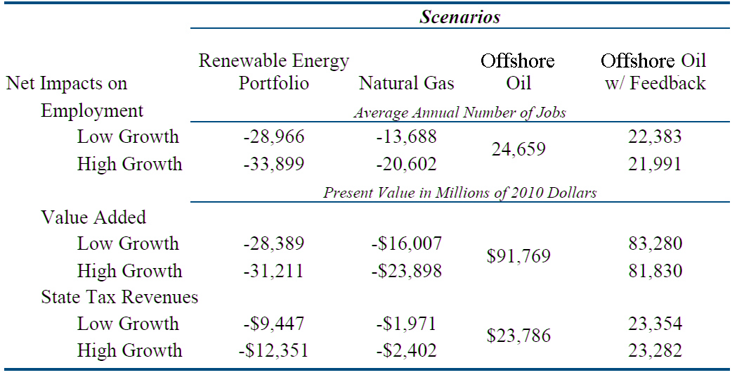

In other words, according to the Considine study, only in the case in which California aggressively develops its domestic oil and gas resources will the state’s residents benefit economically. The other scenarios, by contrast, result in a new loss of jobs, lower economic growth, and reduced state tax revenues.

Note that the Considine study is not the only one to arrive at findings like these. A similar study, conducted in 2009-2010 by Mark Schniepp of the California Economic Forecast (CEF), examined the economic effects of greater energy production on a local region. Specifically, the CEF study evaluated the impact of more aggressive development of the viable offshore oil and gas deposits in Santa Barbara County.

The study determined that, over the next 40 years:

- Offshore oil and gas leases would generate $375 million per year in additional property taxes for the county during peak years (in constant 2010 dollars), providing, for instance, an additional $150 million to $175 million to county schools during that time (see Chart 15).

- State oil and gas royalties would accumulate to $11.3 billion and local (county) royalties to $2.3 billion, or approximately $160 million to $200 million per year during the peak years of 2017 – 2022 (see Chart 16).

- The sum of potential property tax receipts and royalty revenues in peak years of production would finance 30% of all county general fund expenditures, providing an additional $240+ million per year during 2017 – 2022.

- In addition, all outstanding county debt could be paid off with just 25% of property tax revenues generated during a single year of peak-year offshore oil leases.

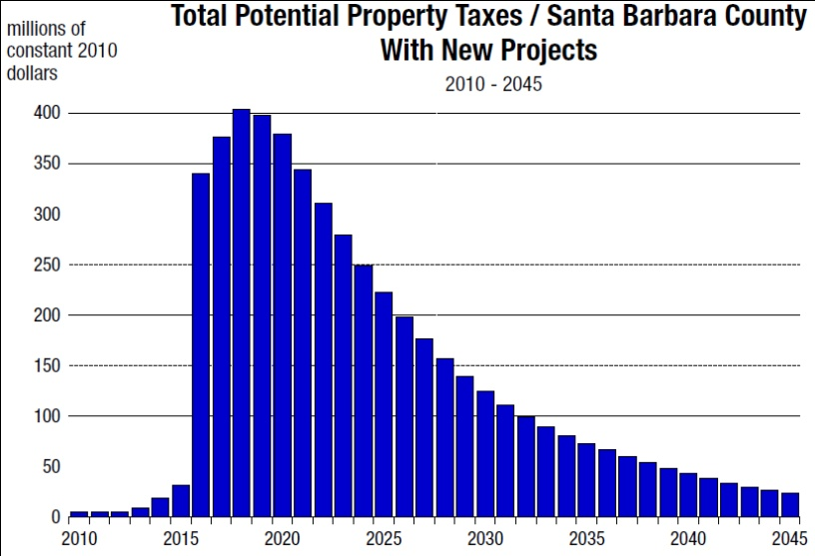
Chart 15. Additional Property Tax Revenues for
Santa Barbara County from Enhanced Leasing

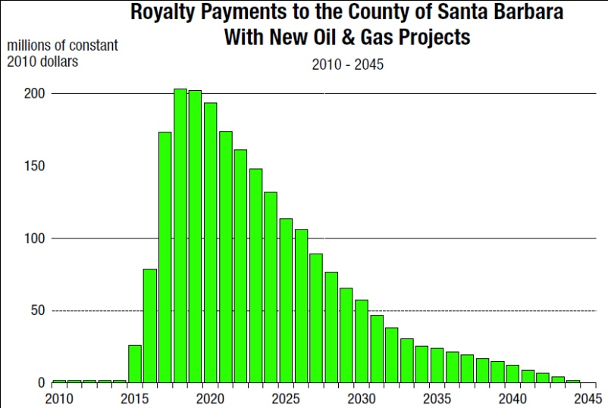
Chart 16. Additional Oil & Gas Royalties for
Santa Barbara County from Enhanced Leasing

Conclusion. As stated above, the energy supply and demand conclusions based on the EIA data should be used with a great deal of caution, as they are the result of arithmetic ratios rather than sophisticated econometric analyses. However, they clearly suggest that increases or restrictions in California’s energy consumption (and, by extension, in the state’s energy supply) over the coming decades is likely to be associated with, respectively, significant corresponding gains or reductions in statewide economic output and statewide employment levels.

In other words, as the late economist Milton Friedman liked to remark, there is no “free lunch”: while increased energy supply in California likely would contribute to appreciably greater statewide economic output and employment levels, reduced or constrained energy supply, on the other hand, is likely to result in marked diminutions in California’s economic output and employment levels, to the detriment of the economic health and well-being of California’s residents, businesses, and governmental entities.

The California-focused Considine study quantifies these potential costs by examining two supply-constrained scenarios. However, on the bright side, the Considine study documents substantial economic benefits to the State of California from further developing its indigenous oil and natural gas resources—results that are corroborated extended by the Schniepp analysis for Santa Barbara County.

- Conclusions

This report has reviewed and synthesized the findings from a number of comprehensive energy studies from the past several years and, where possible, has attempted to apply these findings to the California energy landscape. In the process, the report has attempted to address a number of key questions, including:

- What are the determinants of future energy demand in California and how will these determinants unfold over the coming years and decades?

- What will be the resulting mid- and long-term demand for energy from various sources within California?

- What will be the future course of energy supply in California?

- What level of contribution will renewable energy resources make to California’s energy future?

- What will be the future course of energy prices in California?

- What will be the economic consequences of various future energy scenarios?

  - Determinants of Energy Demand

Among the most important findings from this research synthesis concerning the determinants of California’s future energy demand levels are the following:

- Population growth. While California’s population growth rates are expected to slow sharply in the near- and mid-term, in at least one reasonable scenario they could remain close to the relatively high growth rates of the past 25 years. Hence, while California may expect some relief in pressures on energy demand from slower population growth, this result is far from certain. Moreover, even with relatively conservative forecasts, California’s population is still likely to grow by at least 1.0% per year for the foreseeable future, suggesting that energy demands will grow as well. This relationship can be seen clearly in motor vehicle fuel demand, as the number of vehicles and miles driven will grow in concert with the number of residents of the state.

- Economic growth. Even in the most optimistic growth scenario, the rate of expansion of California’s economy is expected slow substantially over the coming decades. Nevertheless, in the likeliest scenario, California’s economy is expected, on average, to grow faster than its population levels, thereby continuing to put upward pressure on the state’s energy demand.

- Employment growth. California’s employment growth will roughly parallel the growth of population in the state, but likely will be either somewhat or substantially lower than the economic growth rate (depending upon the scenarios used)—suggesting that in the future, as in the past, growth in economic output will be driven more by increases in productivity than by increases in employment. This projection also suggests that the level of economic output, more than the employment levels, will determine the course of the state’s energy demand. Nevertheless, even with these limitations, employment growth will serve to put additional pressure on energy demand over the coming years and decade.

- Income growth. Average household income will grow slightly faster than employment levels over the next dozen years, but somewhat less than the growth levels in overall economic output in the state. Still, as with the other economic variables, increasing income will continue to put upward pressure on energy demand as well.

- Determinants of demand. While the primary factors affecting the demand for energy in the state of California over the next 12 to 40 years are likely to become neither more intense nor influential than they have been, nor are they likely to wane. As a result, the annual growth rate in energy demand is likely to be just as pronounced in the near- to mid-term future as it has been over the recent decade. It is to that question that we next turn.

  - Future Energy Demand Levels

Key conclusions regarding energy demand levels themselves are the following:

- Current energy consumption. California’s current energy consumption, while substantial in absolute terms, is well below the U.S. average on a per capita basis. California therefore cannot be fairly accused of “over-consuming” energy when compared with other U.S. states.

- Future energy consumption. Regardless of the scenario and sector examined, the clear conclusion is that California will require significantly more energy in the future, with annual energy demand growth averaging in the range of 1.0% or more in most scenarios, in most sectors, and for most energy types. This growth rate roughly parallels the projected growth in California’s population, confirming the projection that California’s energy needs will rise in roughly linear fashion with its population. Only in the low-demand scenarios does energy demand rise more slowly (or even fall), but as noted in previous sections, these slower energy-growth scenarios are associated with significantly lower or even negative economic growth, as well as with somewhat slower income and employment growth, over the indicated timeframes. Note, in particular, that these increases in energy needs will take place even if California continues to make progress on its already impressive energy-efficiency achievements.

  - U.S. and California Energy Supply

Key findings regarding the United States’ and California’s current and future energy supply are as follows:

- Current California energy supply. California has an incredibly rich array of energy resources at its disposal, primarily petroleum and natural gas resources. It also possesses significant renewable energy resources, primarily hydroelectric resources. However, because of the public policy decisions of the past decade, California now must import sources for two-thirds of its population’s energy needs.

- Energy supply by sector. In general, California’s different economic sectors rely on differing combinations of energy resources. But one characteristic is common: petroleum and natural gas account for the significant majority of energy supplies consumed on a sector-by-sector basis with electricity (from all sources) being important especially for the commercial sector. By contrast, renewables represent only a relatively small minority of each sector’s energy resources.

- Future U.S. energy supply. Total U.S. energy supply is expected to rise by a substantial 25.1% over the next 25 years. This is almost identical to the projected 25.5% increase in the U.S. population age 16 and above during the same period. However, even if California’s energy supplies were to grow by a comparable percentage, they would fall well short of the 33.7% increase in California’s population and the estimated 57.2% increase in California’s economic output during the same time period, as calculated using data from the California Energy Commission. As a result of these disparities, California’s energy supplies are likely to be under serious pressure to keep up with statewide energy demand. While the U.S. data indicate that some of this increased demand may be satisfied by renewable energy resources, if the projected U.S. experience is any guide, the vast majority of energy supplies in California during the near- and mid-term will continue to come from conventional energy sources, primarily fossil fuels.

- Future California energy supply. California’s energy resources for the future are potentially great—if they are developed. Outside Alaska, California has the largest untapped potential for additional oil and gas production in the United States. Offshore California contains more than 10 billion barrels of oil and nearly 12 trillion cubic feet of natural gas. Onshore, the Monterey Shale may contain more than 15 billion barrels of oil. At current market prices, these reserves are worth more than $2 trillion.

- OCS development. One of the greatest opportunities for enhancing California’s energy future lies in continuing to develop resources on the outer continental shelf (OCS). On the other hand, severe restrictions on OCS development (in the form of no new leases through 2035) promise to increase U.S. oil and gas imports by 9% over the baseline case and to reduce domestic U.S. oil and gas production by 3%. Yet more rigorous OCS leasing would have the opposite effect: domestic oil and natural gas production would increase by nearly 7% if significant new OCS reserves were developed.

- The renewables future. Despite the promise that they obviously hold, the high-profile renewable energy sources are not expected to make major contributions to either the U.S. or California energy supply in the near- or mid-term. In the baseline case, even by 2035, these renewables will contribute no more than 3.4% of total U.S. energy supply and no more than 6.0% of total California electricity production. Moreover, even a 40% drop in the technology costs of developing and deploying renewable energy sources results in only about a one-tenth increase in the proportion of energy consumption accounted for by renewable energy.

- The central role of oil and natural gas. Essentially regardless of the scenario studied, neither the increased use of renewable energy sources nor the faster implementation of new non-renewable technologies is expected to have a major effect on either Pacific Region or U.S. energy consumption and supply in the near- or middle-term. At least through 2035, both Pacific Region and U.S. energy supply will remain heavily dependent, as it is today, on conventional fossil-fuel energy sources—namely, oil, natural gas, and (primarily outside the Pacific Region) coal.

  - Energy Prices

Future energy prices for the United States and California likely will be characterized by the following developments:

- Future price levels. For most energy sources and most sectors, energy prices will increase substantially by 2035. These increases will be the greatest for the high-growth scenario and least for the low-growth scenario, although the relative differences among scenarios likely will vary markedly among energy types and sectors.

- Determinants of future prices. In most cases, technological, resource, and related developments will have only a limited impact on the energy-price path in the Pacific Region. Only in two of the studied cases will prices be substantially accelerated—the high oil-price case and the greenhouse gas controls case. In these two cases, the price increases would be truly substantial, with price accelerations ranging from two-thirds to ten times over the baseline case.

  - Economic Impacts

Key findings regarding the economic impacts of future California energy demand and supply scenarios are as follows:

- Growth and employment. The three economic scenarios outlined by the EIA yield some fairly significant differences in energy and economic variables, including energy consumption, economic output, and consumer prices. But perhaps the most notable in human terms is the number of employed individuals: the EIA’s high-growth economy supports some 30 million more employed people than the low-growth economy.

- Energy supply and the economy. Energy supply and demand findings extrapolated from EIA data should be used with a great deal of caution, as they are the result of arithmetic ratios rather than sophisticated econometric analyses. However, they clearly suggest that increases or restrictions in California’s energy consumption (and, by extension, energy supply) over the coming years and decades is likely to be associated with significant corresponding gains or reductions in economic output and in employment levels. Specifically, while increased energy consumption and supply in California should contribute to significantly greater state economic output and employment levels, reduced or constrained energy consumption, on the other hand, are likely to result in marked diminutions in California’s economic output and employment levels, to the detriment of the economic health and well-being of California’s residents. When added to the near-certain potential for energy price increases, the threat to California’s economic and fiscal health could be substantial.

- Specific economic effects. The findings from the comprehensive econometric analysis by Dr. Timothy Considine indicates that an enhancement and extension of California’s renewable energy portfolio standard (RPS) would eliminate an average of up to 33,900 jobs per year, reduce California’s gross state product (GSP) by up to $23.9 billion, and reduce state tax revenues by up to $12.4 billion. By contrast, development of offshore crude oil and natural gas resources in the Santa Barbara region (only a small portion of California’s offshore oil and gas reserves) would create as many as 24,700 additional jobs per year, increase California’s GSP by up to $91.8 billion, and increase state tax revenues by up to $23.8 billion. These results are corroborated extended by the Schniepp analysis for Santa Barbara County.

In sum, California’s energy and economic future can be a bright one. But it will be a future founded largely on conventional and historically dominant oil and natural gas resources. And that potentially bright future will come to pass only in one circumstance: only if those resources are prudently and yet aggressively developed and brought to market.

- References

California Council on Science and Technology, May 2011, “California’s Energy Future: The View to 2050,” California Council on Science and Technology.

California Energy Commission, May 2011, “Updated California Energy Demand Forecast 2011-2022,” California Energy Commission, draft staff report.

California Energy Commission, undated, http://www.energy.ca.gov/, web site.

California Energy Commission, undated, “California Energy Almanac,” http://energyalmanac.ca.gov/, web site.

California Energy Commission, undated, “California Energy Consumption Database,” http://www.ecdms.energy.ca.gov/, web site.

Considine, Timothy, and Edward Manderson, September 16, 2011, “Powering California: Balancing Fiscal, Energy, and Environmental Concerns,” Center for Energy Economic & Public Policy, The University of Wyoming.

U.S. Department of Energy, “undated, Energy.gov,” http://energy.gov/, web site.

Freeman, Gregory, et al., March 2008, “California’s Uncertain Oil Future,” Los Angeles County Economic Development Corporation.

Kalt, Joseph P., March 2008, “Economics, Law, And Politics: What Will Drive Energy’s Future?” Mineral Law Institute, report.

McCarthy, Ryan, et al., November 7, 2006, “California Energy Demand Projections to 2050,” Institute of Transportation Studies, University of California, Davis.

National Petroleum Council, September 15, 2011, “Prudent Development: Realizing the Potential of North America’s Abundant Natural Gas and Oil Resources: Draft Report.”

Price, Snuller, et al., November 2009, “Meeting California’s Long-Term Greenhouse Gas Reduction Goals,” Energy and Environmental Economics, Inc. (E Three).

Pugliaresi, Lucian, September 29, 2011, “The Lessons of the Shale Gas Revolution,” The Wall Street Journal, online edition.

Scarpati, Kevin, October 2010, “Powering California with Nuclear Energy,” EnergyDigital.com, online edition.

Schniepp, Mark, October 2008 and May 2009, “Economic Benefits of Future Oil and Gas Production in Santa Barbara County,” California Economic Forecast, unpublished analysis presented to (1) the Santa Barbara Industrial Association Economic Conference, Santa Barbara, California (October 31, 2008), and (2) The Pacific Section of the American Association of Petroleum Geologists Convention, Panel on California Offshore Energy Exploration and Development, Venture, California (May 5, 2009). A more thorough report to update the findings presented in 2008 and 2009 is being prepared at this time.

Schremp, Gordon, July 12, 2007, “Outlook for Crude Oil Imports Into California,” Fuels and Transportation Division, California Energy Commission.

Schremp, Gordon, May 11, 2011, “Crude Oil Import Forecast & HCICO Screening,” Fuels and Transportation Division, California Energy Commission.

U.S. Energy Information Administration, April 26, 2011, “Annual Energy Outlook 2011,” U.S. Department of Energy, http://www.eia.gov/forecasts/aeo/index.cfm, web site.

U.S. Energy Information Administration, April 26, 2011, “Table Browser,” U.S. Department of Energy, http://www.eia.gov/oiaf/aeo/tablebrowser/, web site.

U.S. Energy Information Administration, June 30, 2011, “SEDS | State Energy Data System,” California, http://www.eia.gov/state/seds/seds-states.cfm?q_state_a=CA&q_state=California, web site.

U.S. Energy Information Administration, September 19, 2011, “International Energy Outlook 2011,” U.S. Department of Energy, http://www.eia.gov/forecasts/ieo/more_highlights.cfm#world, web site.

Yergin, Daniel, September 17, 2011, “There Will Be Oil,” The Wall Street Journal, online edition.

Balancing Fiscal, Energy, and Environmental Concerns
________________________________________________________________________________________________
Analyzing the Policy Options for California’s Energy and Economic Future

Timothy J. Considine, Ph.D.
Director, Center for Energy Economics and Public Policy
University of Wyoming

Edward Manderson
School of Energy Resources
University of Wyoming


A Research Study

Acknowledgements

The authors of this study acknowledge that this study was made possible through foundation support to the Communications Institute. The Thomas R. Brown Foundation funded the economic model that was used in the development of the research. It was also made possible through research support from the School of Energy Resources and the Center for Energy Economics and Public Policy at the University of Wyoming is also acknowledged.

Disclaimer

This report was prepared as an account of work sponsored by the Communications Institute. Neither the Department of Economics and Finance, the Center for Energy Economics and Public Policy, or the School of Energy Resources at the University of Wyoming nor the Communications Institute, nor any person acting on behalf thereof, makes any warranty or representation, express or implied, with respect to the accuracy, completeness or usefulness of the information contained in the report nor that its use may not infringe privately owned rights, or assumes any liability with respect to the use of, or for damages resulting from the use of, any information, apparatus, method or process disclosed in this report.

This report was written and produced for the Communications Institute by the Center for Energy Economics and Public Policy at the University of Wyoming. The opinions, findings, and conclusions expressed in the report are those of the authors and are not necessarily those of Communications Institute or the University of Wyoming. Questions regarding the content can be addressed to Timothy J. Considine
at tconsidi@uwyo.edu or (307) 760-8400.

Executive Summary
Some people view California’s energy sector as a blueprint for how America should be powered in the future. California leads the nation in non-hydroelectric renewable energy production. Although household energy use per capita in California has been increasing, industrial and service sector energy efficiency in the state continues to improve. Despite this, California is the second largest energy consuming state in the nation behind Texas and will continue to require more energy once economic growth returns.

Understanding the economic, fiscal, and environmental trade-offs in powering California’s energy future is the central objective of this study. California is increasingly dependent upon energy sources outside its borders. In 1970 California produced 62% of its energy yet by 2009 the state imported 67% of its energy needs. In addition to crude oil and natural gas, the Golden State is the largest importer of electric power in the United States.

California has a variety of energy supply options going forward. First, it could continue on its current path, increasing reliance on imported energy, which forms the business-as-usual scenario in this study. The second option is to increase production of wind, solar, and other forms of renewable energy. The recently passed California Renewable Energy Resources Act sets out the most ambitious renewable portfolio standard (RPS) in the country. The law requires 33% of electricity retail sales to be served by renewable energy resources by 2020. This study considers this scenario and an expansion to a 50% renewable standard by 2035.

Currently, natural gas plants are the most frequent choice for new power in California. Using natural gas fired electric power generation to replace electricity imports and cut carbon emissions, therefore, provides an alternative to development of renewable electric power generation. This study considers the costs and environmental trade-offs of replacing three-quarters of electricity imports from now to the year 2035 with combined cycle natural gas capacity. Some of this natural gas could be produced from deposits located within California.

Outside Alaska, California has the largest untapped potential for additional oil and gas production in the United States. Offshore California contains more than 10 billion barrels of oil and nearly 12 trillion cubic feet of natural gas. Onshore, the Monterey Shale may contain more than 15 billion barrels of oil. At current market prices, these reserves are worth more than $2 trillion. Given this enormous potential wealth, this report considers, as a case study, the development of a small portion of these reserves located off the coast of Santa Barbara.

To estimate the economic and environmental impacts of these energy supply options, this study develops an integrated framework that involves an econometric forecasting system of California energy demand coupled, engineering-economic models of energy supply, and economic input-output models of the California economy. The Jobs and Economic Development Impact (JEDI) models for California developed by the National Renewable Energy Laboratory provide estimates of the economic impacts of the electricity generation scenarios. Since the JEDI models are based upon input-output tables from Minnesota IMPLAN Group (MIG), Inc. these models are used to estimate the economic impacts of developing oil and natural gas resources off the coast of Santa Barbara.
During the early years of the RPS and natural gas scenarios employment and value added increase over the baseline scenario because construction of these plants provides substantial economic stimulus to the local economy. As the higher costs of these facilities are recovered, however, electricity rates increase. These higher rates reduce consumer discretionary income and cash flow for businesses. These higher energy expenditures reduce value added and employment in the long run, so much so that they offset the short-run economic stimulus from building renewable or natural gas power generation plants.

The net effects of these impacts are displayed below in Table ES1 below. Despite an increase during the early years of the RPS scenario, the present discounted value of gross state product declines between $28.4 and $31.2 billion over the forecast horizon from 2012 to 2035. Annual employment levels are on average between 29 and 34 thousand lower than without the RPS. State tax revenues are between $9 and $12 billion lower over the 24-year forecast period. While greenhouse gas emissions are lower, they are achieved at relatively high cost. Early in the forecast period, these carbon emission reductions cost between $200 and $240 per ton. While these costs decline to about $120 per ton by 2035, they remain well above market prices for carbon permit prices. Investments in renewable energy may create jobs in the short run but raise energy prices and reduce economic growth in the long run.

Table ES1: Summary of Economic, Fiscal, and Environmental Impacts
 | Scenarios
Net Impacts on | Renewable Energy  Portfolio | Natural  Gas Generation | Santa Barbara Crude Oil & Natural Gas
Employment | Average Annual Number of Jobs
Low Growth | -28,966 | -13,688 | 22,383
High Growth | -33,899 | -20,602 | 21,991
 | Present Value in Millions of 2010 Dollars
Gross State Product
Low Growth | -28,389 | -16,007 | 83,280
High Growth | -31,211 | -23,898 | 81,830
State Tax Revenues
Low Growth | -$9,447 | -$1,971 | 23,354
High Growth | -$12,351 | -$2,402 | 23,282
 | Cumulative in millions of tons
Carbon Emissions
Low Growth | -620.2 | -187.2 | 12.1
High Growth | -896.2 | -312.1 | 15.1

The fiscal and economic impacts of building natural gas fired electricity capacity are not as severe as those under the RPS scenario with losses in gross state product between $16 and $24 billion (see Table ES1). These results, however, underscore the importance of inexpensive sources of base load generation from coal, nuclear, and hydroelectric resources in maintaining low cost electricity for the California economy. Even though natural gas is now relatively inexpensive, the projections of real cost increases for natural gas in future years used in this study increase the relative cost of electricity import replacement for California.
These cost increases, however, may be mitigated if California could develop its own oil and natural gas resources. The economic and fiscal impacts of developing Santa Barbara crude oil and natural gas are uniformly positive with the creation of between 22,000 and almost 25,000 jobs annually, between $81 and $91 billion in gross state product, and over $23 billion in state tax revenues over the next 25 years.

With no feedback between economic growth and energy expenditures, carbon emissions under the Santa Barbara scenario are actually lower due to savings arising from reduced oil tanker traffic. If higher economic growth due to oil and gas development is considered, carbon emissions rise slightly compared to the baseline scenarios. Hence, allowing the production of crude oil and natural gas from Santa Barbara would unambiguously increase employment, output, and tax revenues with minimal increases in greenhouse gas emissions. These reserves can be tapped using a technology called slant drilling in which offshore oil and gas are extracted from on-shore drilling rigs and wells, which greatly reduces environmental risks.

This study finds that renewable energy portfolio standards are an expensive way to cut carbon emissions. Moreover, any economic benefits derived from building renewable energy facilities in the short-run are more than offset by losses in economic output and employment as consumers struggle to pay for these facilities in the long run.

In contrast, a strategy of replacing crude oil and natural gas that would have been consumed anyway from imported sources with domestic production using indigenous resources increases gross state product, employment, and tax revenues. While the additional prosperity this strategy generates may slightly increase carbon emissions, it seems a small price to pay for the considerable benefits domestic oil and natural gas production generate.

If California decides to continue down the RPS path, one way to pay for this program is to allow the development of crude oil and natural gas resources. Indeed, with the prospect of developing the Monterey Shale, which could be considerably larger than the Santa Barbara oil development scenario examined in this study, the economy of the Golden State could once again shine.

Energy development choices need not be a zero sum game. Indeed, environmentally responsible development of fossil fuel resources could be complementary with renewable energy development, creating jobs and generating tax revenues to ensure a robust economy capable of creating and funding innovative energy technologies of the future.

Table of Contents

Executive Summary 59
List of Tables 63
List of Figures 64
1. Introduction 65
2. Overview of California Energy Markets 66
3. Modeling Framework 72
3.1 The Energy Market Forecasting Model 73
3.2 Economic Impact Analysis and Models 75
4. Scenario Development 78
4.1 Baseline Scenario 79
4.2 California Renewable Energy Resources Act 80
4.3 Natural Gas Based Electricity Generation 82
4.4 Developing Oil and Natural Gas Resources 83
5. Energy, Economic, and Environmental Impacts 85
5.1 The Baseline Forecast 85
5.2 Impacts of Renewable Portfolio Standard 90
5.3 Impacts of Adopting Natural Gas Electricity Generation 95
5.4 Impacts of Developing Santa Barbara Oil 99
6. Summary and Conclusions 104
7. References 106
Appendix A. Econometric Formulation and Results for California Energy Demand 108
A.1 End-Use Stationary Energy Demand 108
A.2 Demand for Gasoline and Diesel 110
A.3 Electricity Generation & Fuel Use 110
A.4 Econometric Results 111
Appendix B. Electricity Rates by Region within California 120

List of Tables

Table 1: Summary of California Energy Consumption by Sector, 2009 70
Table 2: Model endogenous variables and identities 75
Table 3: Economic and Environmental Impacts from RPS under low growth scenario 94
Table 4: Economic and Environmental Impacts from RPS under high growth scenario 95
Table 5: Economic and environmental impacts of natural gas scenario under low growth 97
Table 6: Economic and Environmental Impacts of natural gas scenario under high growth 98
Table 7: Economic and environmental impacts of developing Santa Barbara Oil 100
Table 8: Impacts of developing Santa Barbara oil with feedback low growth 102
Table 9: Impacts of developing Santa Barbara oil with feedback high growth 103
Table 10: Summary of economic and environmental impacts 105
Table A1: Parameter estimates for residential energy model 112
Table A2: Estimated elasticities of demand for California residential energy 113
Table A3: Parameter estimates for California commercial energy model 115
Table A4: Elasticites of demand for California commercial energy model 116
Table A5: Parameter estimates for California industrial energy model 117
Table A6: Elasticities of demand for California industrial energy model 118
Table A7: Elasticities of demand for California gasoline and diesel 119
Table B1: Average electricity rates in 2010 cents per kilowatt-hour 120
Table B2: Electricity rates in 2010 cents per kilowatt-hour by region under low growth 121
Table B3: Electricity rates in 2010 cents per kilowatt-hour by region under high growth 122

List of Figures

Figure 1: California’s energy production by source, 2009 67
Figure 2: Energy consumption by type of fuel, 1970-2009 68
Figure 3: California Energy Flows in 2008 69
Figure 4: Per capita electricity use and relative electricity prices, 1960-2009 71
Figure 5: Electricity intensity of use by sector, 1960-2009 72
Figure 6: Energy model overview 74
Figure 7: Projected baseline electricity generation capacity 80
Figure 8: Levelized costs of renewable generation capacity 82
Figure 9: Levelized costs of new natural gas generation capacity 83
Figure 10: Capital expenditures for new crude oil production from Santa Barbara Channel 84
Figure 11: Possible new crude oil production from Santa Barbara Channel 85
Figure 12: Historical and projected energy intensity of use 86
Figure 13: Historical and projected oil, natural gas, and electricity use 87
Figure 14: Projected shares of oil, natural gas, and electricity use 88
Figure 15: Projected electricity demand and imports 88
Figure 16: Real Monthly Household Energy Expenditures 89
Figure 17: Projected greenhouse gas emissions 90
Figure 18: New and existing renewable energy capacity under RPS 91
Figure 19: Capital and operating expenditures for renewable energy under RPS 91
Figure 20: Gross employment gains under RPS scenario 92
Figure 21: Net valued added and jobs under the RPS scenario 93
Figure 22: New and existing natural gas generation capacity 96
Figure 23: Net value added and jobs under the natural gas scenario 96
Figure 24: Jobs and tax revenues under the natural gas scenario 99
Figure 25: Economic Impacts under the oil scenario with feedback 101

Introduction

More than 25 states have adopted renewable energy portfolio standards under the belief that wind, solar, and other renewable forms of energy will create jobs, reduce greenhouse gas emissions, and lower reliance on foreign oil imports. At the same time, the development of oil and natural gas resources in shale formations is stimulating output, employment, and tax revenues in several states, including North Dakota, Texas, Pennsylvania, and Louisiana. Development of offshore oil and natural gas resources would have similar impacts. The benefits of renewable and fossil fuel energy are widely touted by their proponents. What is not known, however, is the comparative magnitude of the benefits and environmental impacts of these two paths for energy development. The goal of this paper is to perform such an analysis.

The development of renewable and non-renewable resources need not be mutually exclusive. Brazil with its significant biofuels industry and rapidly developing offshore oil industry illustrates that producing renewable energy need not preclude the possibility of expanding oil and natural gas production. Could developing both renewable and fossil fuel energy serve the best interests of society to ensure economic growth, job creation, fiscal balance, and environmental quality? This study attempts to shed light on this question with an analysis of California’s energy future.

California represents a compelling case study for addressing these questions. With passage of the California Renewable Energy Resources Act (Senate Bill X 1-2), California is seeking to supply a third of its retail electricity sales from renewable energy by 2020. This goal will require the construction of a large number of renewable energy facilities that will directly generate a significant number of construction jobs and indirectly stimulate many support industries that provide goods and services for the construction and operation of these plants. If these renewable energy goals are not achieved, the most likely alternative to be adopted is natural gas based electricity generation.

Outside Alaska, California has the largest untapped potential for additional oil and gas production in the United States. Humphries et al. (2011) report that offshore California contains more than 10 billion barrels of oil and nearly 12 trillion cubic feet of natural gas. Onshore, the Monterey Shale may contain more than 15 billion barrels of oil. At current market prices, these reserves are worth more than $2 trillion.

This study estimates the impacts of developing a subset of these resources; the crude oil and natural gas reserves under the Santa Barbara Channel. Developing additional oil and gas production in California would create jobs. Moreover, crude oil and natural gas production would generate significant royalty and tax revenues for the state. From an environmental perspective, an expansion of oil and gas production in California would simply displace imported fuels, and in this respect would be carbon neutral.

California has a diverse mix of energy sources. In 2009, 8% of California’s energy production was from renewable sources. The two nuclear power plants in the state supply 4%. Crude oil and natural gas production in California supply 21% of state energy production. Imports of oil, natural gas, and electricity supply the remaining 67% of California’s energy, with 54% from imported oil and natural gas and 13% from imported electricity. These imports cost the California economy $62 billion during 2008.

Therefore, expanding production of renewable or fossil fuel production or some combination thereof could be an attractive possibility for California, generating higher economic output, greater job creation, and additional tax revenues. The objective of this study is to estimate the financial, economic, and environmental impacts of these energy production options.

To estimate these impacts, the future energy needs of California must be projected. Despite considerable energy efficiency improvements, California will continue to need more energy in the future while it confronts the fiscal challenges that threaten the state’s economy. In other words, while energy conservation activities will reduce future needs for additional energy supplies, it is unlikely to fully offset additional energy requirements from economic and population growth.
How much energy will be needed, where it could come from, and at what cost to society are the central questions of this study. Addressing these questions can facilitate a serious discussion of the fiscal, economic, and environmental trade-offs of various energy supply options. Environmentally responsible energy development can enhance environmental quality, pioneer green energy development, and fund education and health care.

To consider these options, this study develops an integrated framework for energy, economic and environmental analysis, which involves two modeling stages to estimate the impacts of the alternative energy choices facing California. The first stage is an econometric forecasting system of California energy demand coupled with engineering-economic models of energy supply very similar to the studies by Considine and McLaren (2008). The formulation and econometric estimates from this analysis are presented in Appendix A. The second stage uses the output from the California energy model to estimate the impacts of energy technology choices on output, employment, and tax revenues. These impacts are estimated using the Jobs and Economic Development Impact (JEDI) models for California developed by the National Renewable Energy Laboratory for the electricity generation scenarios. Since the JEDI models are based upon input-output tables from Minnesota IMPLAN Group (MIG), Inc. these models are also used to estimate the economic impacts of developing oil and natural gas resources off the coast of Santa Barbara.

The next section examines trends in California’s energy markets and energy efficiency. Section three provides an overview of the modeling framework. The overall modeling framework then is presented. Section four develops the energy supply scenarios considered in this study, including the baseline (business-as-usual) scenario in which California continues to rely on electricity imports, and alternative scenarios of implementing the renewable portfolio standard, increasing natural gas generation, and developing Santa Barbara oil and gas resources. Given assumptions on future prices for the primary fuels and projections of population, inflation, and economic growth, section five presents the baseline projections for energy demand, supply, and prices and carbon emissions. Section five presents the economic impacts associated with the renewable energy portfolio, natural gas based electricity supply, and new oil and gas production. The final section summarizes the major findings, identifying the major trade-offs relevant for policy decisions.

Overview of California Energy Markets

Some people view California’s energy sector as a blueprint for how America should be powered in the future. With higher energy efficiency and a greater share of renewable energy than other states, many people believe California is a blazing path for energy conservation and clean energy development for the rest of the nation to follow.

California has a diverse and rather unique mix of energy sources including hydroelectric and geothermal power, but remains quite dependent upon fossil fuels for the lion’s share of its energy needs. With a mild climate, sprawling urban centers, and a large information technology sector, the demand for energy in California is quite different from the rest of the United States. In addition, California’s energy policies have sought to promote more efficient use of energy.
While these factors among others have allowed California’s economy to grow with proportionately less energy over time, they have not offset the expansion of energy demand resulting from both population and economic growth. Consequently, despite this progress in efficiency, California will need more energy in the future, especially once the economy recovers. How much energy and where it will come from are the two central questions addressed in this study.

Figure 1 illustrates California’s energy supply by source in 2009. California is a significant producer of crude oil, producing the equivalent of roughly 700,000 barrels per day. Crude oil and natural gas production within California, however, has been steadily declining in recent years, to the point that in 2009 they collectively supplied only 21% of state energy consumption.
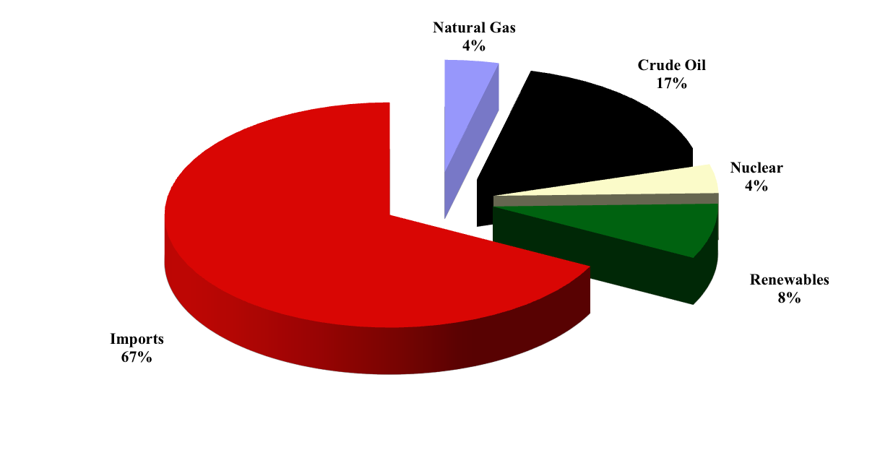

Figure 1: California’s energy production by source, 2009

In contrast, California is expanding renewable energy production, which has been increasing at an average annual rate of 3.5% since 1970, supplying 8% of the state’s energy in 2009. Of this renewable energy, 49% is hydroelectric power, 26% is geothermal power, 12% is biomass, 11% is wind power, and 1% is solar energy. The two nuclear power stations in the state supply 4% of the state’s energy.

The shortfall in domestic energy supply is met with imported crude oil, natural gas and electricity. In 1970, the state of California produced 62% of its domestic energy needs. By 2009, California imported 67% of its needs. In addition to imported crude oil and natural gas, California’s net imports of electricity were 13% of total energy requirements during 2009. Besides Alaska, California has the largest untapped potential for additional oil and gas production. A study by the Congressional Research Service (2008) reports that California offshore areas contain 10.13 billion barrels of oil and 11.73 trillion cubic feet of natural gas.

Energy consumption is pro-cyclical, generally tracking economic growth. Since 1970, total energy consumption in California increased 1% per annum. Real gross state product over the same period of time increased at an average rate of 2.9%. Hence, the energy intensity of use, i.e. the ratio of energy use to gross state product, declined at 1.9% per annum. A declining energy intensity of use can result from a multitude of factors, including higher real prices, fuel switching, government policies such as fuel efficiency standards, and shifts in the mix of industries in the economy. Despite the rising energy efficiency, economic growth in California requires additional energy consumption.

As Figure 2 illustrates, total energy consumption is dominated by oil and natural gas. Consumption of imported electricity increased 7% per year from 1970 to 2009 with most of the growth occurring during the 1970s and 1980s. Since 2000 consumption of imported electricity has grown at just 2.2% per annum.

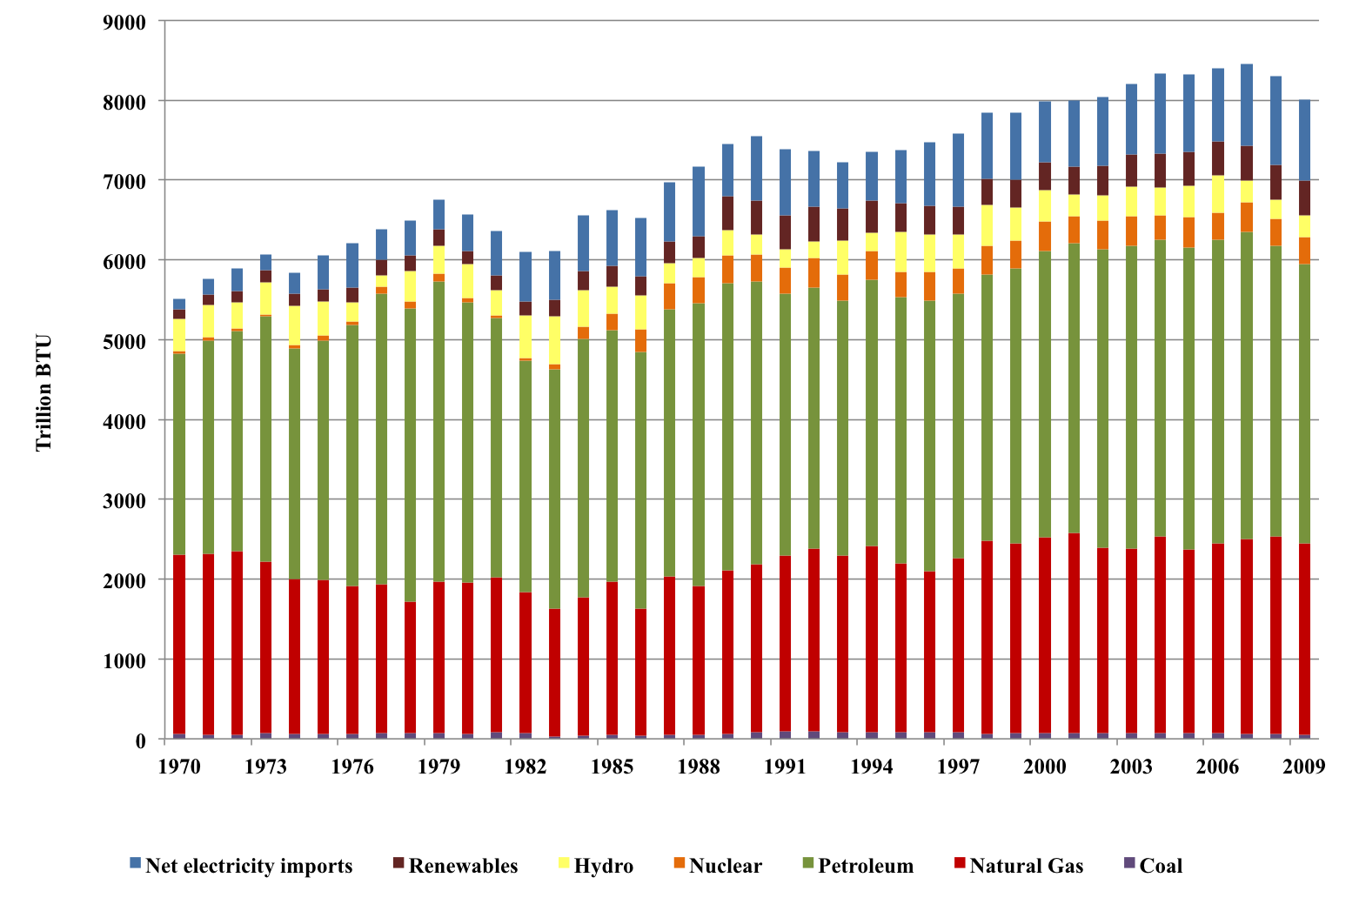
Figure 2: Energy consumption by type of fuel, 1970-2009

A depiction of California’s energy flows developed by Simon and Belles (2011) is displayed in Figure 3 and illustrates the diversity of California energy sources while demonstrating the important role played by fossil fuels, such as oil and natural gas. Notice the dichotomy in energy use with petroleum largely serving transportation and industrial users and natural gas principally providing energy to non-transportation sectors.

Figure 3: California Energy Flows in 2008

Table 1 summarizes California’s energy consumption by sector. The largest end-use of energy in California is transportation. Petroleum products constitute 96.8% of total transportation energy use. Ethanol constitutes 2.6% of transportation use and natural gas comprises 0.6%. Of total oil use in transportation, 59.5% is gasoline, 17.9% is jet fuel, 14.2% is distillate fuel, 7.8% is residual fuel oil, and the remaining is lubricants, aviation gasoline and liquid propane gasoline.

The next largest energy-consuming sector is industrial, which includes manufacturing, agriculture and mining. Natural gas constitutes 55.6% of total industrial energy use and petroleum 28.6%. Electricity is the next largest energy source in the industrial sector with an 11.4% market share.

Natural gas and electricity comprise an even greater share of energy use in the residential and commercial sectors, constituting 90.6 and 94.2% of use respectively. Outside the transportation sector, the California economy is quite dependent upon natural gas. This dependency is actually even greater since almost 40% of electricity generated within the state is fired with natural gas. Dramatic improvements in the efficiency of household gas furnaces and in integrated combined cycle gas turbines used in electric power generation contributed to the expanding use of natural gas, which in turn played a role in the declining energy intensity of use in the California economy.

Sector | Trillion BTU | Share | Sector | Trillion BTU | Share
Residential | 882.7 | 100.0% | Industrial | 1426.5 | 100.0%
Electricity | 306.4 | 34.7% | Electricity | 163.2 | 11.4%
Natural Gas | 493.6 | 55.9% | Natural Gas | 792.8 | 55.6%
Petroleum | 31.3 | 3.5% | Petroleum | 408.1 | 28.6%
Renewable | 51.4 | 5.8% | Coal | 31.3 | 2.2%
 |  |  | Renewable | 31.1 | 2.2%
Commercial | 709.2 | 100.0% | Transportation | 3203.8 | 100%
Electricity | 413.2 | 58.3% | Petroleum | 3100.6 | 96.8%
Natural Gas | 254.3 | 35.9% | Ethanol | 83.2 | 2.6%
Petroleum | 31.5 | 4.4% | Natural Gas | 20.0 | 0.6%
Renewable | 10.2 | 1.4%
Table 1: Summary of California Energy Consumption by Sector, 2009

Another factor affecting these trends in the aggregate intensity of use is the expanding use of electricity. Even though electricity production and transmission require energy, end-use efficiency of electricity is considerably greater than competing fuels in many applications. Moreover, electricity enables completely new technologies, such as computing and communications. Here too California appears to be leading the nation.

Figure 4 is the so-called Rosenfeld curve comparing per capita electricity use in California with the rest of the United States. The per capita consumption of electricity in California has been essentially flat since 1980. In contrast, per capita electricity consumption increased 1.1% per annum for the rest of the U.S.

There are several reasons for these divergent trends. First, the price of electricity in California relative to the rest of the U.S. increased substantially over this time frame. Another factor is California’s climate, which is considerably milder than the rest of the country. For example, from 1990 to 2005 California’s combined degree-days were almost 62% less than the rest of the country. As the rest of the country developed with increased population and with the expanding use of electricity-intensive air conditioning in the southern states of the U.S., these climate-induced differences in energy use were magnified over time.

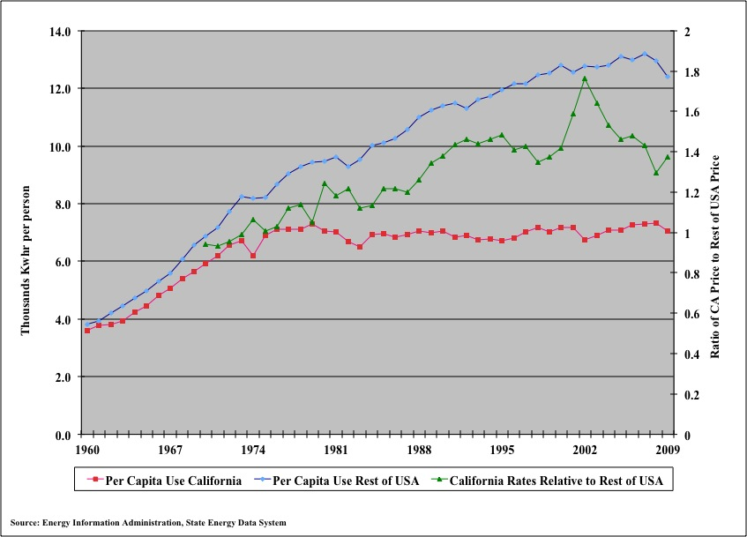
Figure 4: Per capita electricity use and relative electricity prices, 1960-2009

Another explanation is that per capita measures can be misleading. For example, below is electricity consumption broken down by sector and divided by sector specific measures of activity, such as residential electricity per customer and in the commercial and industrial sectors electricity use per gross domestic product.

Using these measures a very different picture emerges. Residential electricity consumption per capita is actually increasing in California, with growth at 0.6% per annum since 1990. Commercial electricity consumption per dollar of gross domestic product declined 0.7% per annum from 1990 to 2009. Industrial electricity use per dollar of gross product has been declining at 2.4% per annum since 1990. Compositional shifts in the mix of manufacturing within California may be behind this trend as well as sharply higher industrial electricity prices.

To summarize, while the evidence for energy efficiency gains may be slightly mixed, there is no doubt California will use more energy as the economy expands. This suggests that relying on energy efficiency alone will not accomplish goals such as dramatic reductions in greenhouse gas emissions. Renewable energy use is significant in California but much of it to date is geothermal and hydroelectricity. Solar and wind power have yet to produce significant amounts of power but seem poised to do so in the future.

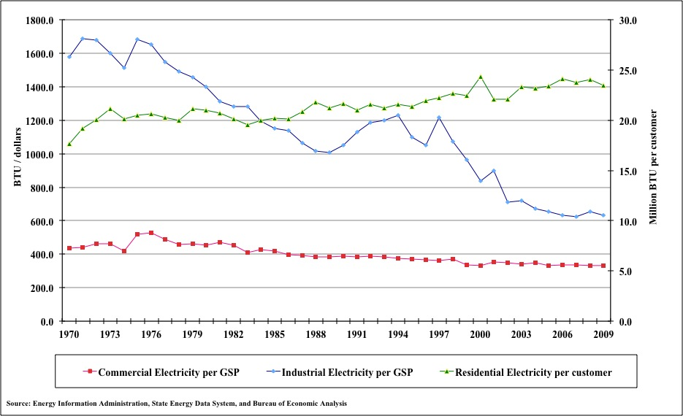
Figure 5: Electricity intensity of use by sector, 1960-2009

Another somewhat surprising finding is that California produced 62% of its energy in 1970 yet by 2009 imported 67%. In addition to crude oil and natural gas, California imports significant amounts of electric power and some of this power is generated from coal. How these imports, rates and demand would be affected under California’s renewable energy portfolio standard is an important question, which will be considered in this study.

Modeling Framework

The modeling framework involves projecting energy demand and economic impacts associated with the aforementioned energy supply scenarios given assumptions on energy prices, population, and economic growth. Electricity costs and rates are determined based upon assumptions for fuel prices and capital costs associated with each electricity technology scenario. Capital expenditures to build generation capacity under each scenario are also estimated. Likewise, the oil and gas resource development scenario involves estimating the capital requirements and operating costs of these new facilities.

As new electricity production capacity goes into operation, the costs are passed through to consumers in the form of higher electricity rates that then affect the demand for electric power. For example, in the two scenarios that involve replacing imported electricity with renewable energy and natural gas, electricity rates increase as these sources of more expensive energy replaces cheaper imported electricity. These higher rates reduce discretionary income of households and profits by businesses, in effect acting like a tax increase that reduces income, employment, and tax revenues. On the other hand, building and operating these facilities stimulate the economy. The key question that this study examines is whether the stimulus from investments in either renewable or natural gas generation capacity offsets the negative effects of the higher energy prices needed for recovery of the investment and operating costs of these facilities.

While developing California’s oil and natural gas resources also involves replacing imported energy, prices for petroleum and natural gas paid by California consumers are unlikely to be affected. Producing more crude oil in California is unlikely to affect prices for refined petroleum products because crude oil prices are determined in world markets and any increase in California production would constitute a small fraction of world production with a negligible impact on world oil prices. Likewise, prices for natural gas paid by California consumers would not be affected because the volumes of natural gas under the development scenario discussed below are quite small relative to U.S. natural gas production. So any additional California crude oil or natural gas production would simply replace imports and not affect prices paid by consumers.

The emissions associated with the consumption of these products would remain the same. Lower imports of crude oil into California, however, would require fewer voyages of oil tankers that would lead to lower emissions of greenhouse gas emissions and, in particular, lower levels of particulate, nitrous oxide, and sulfur dioxide pollution. Additional oil and gas production in California would directly increase gross state product, employment, and tax revenues. If these gains in gross state product are sizable, energy demand and carbon emissions would be higher potentially offsetting the reductions in emissions from lower crude oil imports.

The next two sections describe the energy, environment, and economic modeling tools employed in this study to address these questions. The next section describes the energy demand models employed to project California’s energy consumption between now and the year 2035. The economic input-output analysis tools used to estimate the impacts of the energy supply scenarios on employment, value added, and tax revenues are then discussed. The two modeling approaches are used in a sequential or recursive fashion, which allows a clear delineation of the gains and losses associated with each of the three energy technology scenarios considered in this study.

The Energy Market Forecasting Model

The energy-forecasting framework is built from two different perspectives. First, the end-use demand for fuels in the residential, commercial and industrial sectors are modeled from an economic perspective in which energy demand is a function of relative prices, population, and the level of economic activity. On the supply-side for electricity, however, an engineering-economic perspective is adopted in which capacity, utilization rates and heat rates are specified exogenously. Imports of electricity are determined endogenously as the difference between demand and electricity generation within California. Hence, imports of electricity are modeled as the swing fuel, which is consistent with the recent past in California.

The forecasting model determines energy consumption including electricity demand, generation, and prices, given exogenous assumptions for primary fuel prices, economic growth, inflation, and electricity capacity expansion plans. A schematic of the line of causality between these assumptions and the endogenous variables is presented below in Figure 6. End-use electricity demands and net electricity exports determine electric power generation requirements, which then drive the consumption of fuels in power generation. Generation capacity, operating rates and heat rates of operating units determine the composition of fuel consumption by electric utilities and the average cost of electricity generation. Retail electricity prices are calculated by adding transmission and distribution charges to average generation costs.
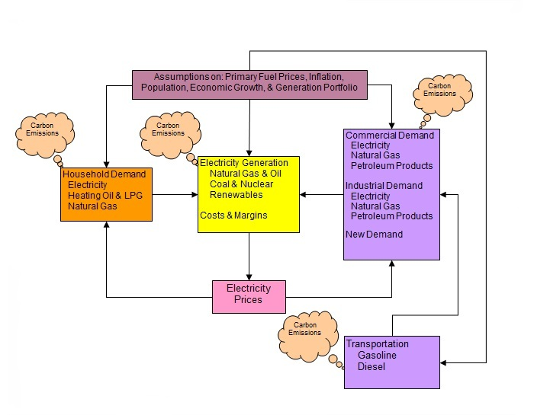
Figure 6: Energy model overview

As Figure 6 illustrates, carbon emissions are tracked for each sector of the economy. The carbon tracking provides a nearly complete account of carbon dioxide emissions in California. Carbon emissions, therefore, are endogenous and depend upon energy prices and economic activity driving energy demand and the choice of electricity generation capacity. The feedback of final electricity demand on the demand for fuels and end-use electricity prices allows an integrated evaluation of electricity demand and fuel choice in power generation.

There are five main components of the model. The first three include systems of energy demand equations for the residential, commercial and industrial sectors. The fourth involves the demand for transportation fuels, including gasoline and diesel fuel. The fifth and final component involves the electricity generation sector. Appendix A describes the formulation of these energy demand models and the econometric findings.

A list of the endogenous variables in the energy demand model appears in Table 2. Coal, petroleum, nuclear, hydroelectric, solar, other renewable sources, or natural gas-fired fossil fuel power generation can meet demand requirements. Each cost share system includes an aggregate energy quantity equation. The quantities are derived by multiplying energy expenditures, which equal the divisia price index multiplied by the corresponding quantity index, by the respective cost share and then dividing by the appropriate price. The model is programmed using the econometric software package, Time Series Processor (TSP) 5.1 from Stanford University.
Endogenous Variables | Type | Endogenous Variables | Type
Residential Sector |  | Commercial Sector
Divisia energy price | I | Divisia energy price | I
Aggregate energy quantity | B | Aggregate energy quantity | B
Cost shares & quantities |  | Cost shares & quantities
Natural Gas | B | Natural Gas | B
Liquid Propane Gas, etc. | B | Petroleum Products | B
Electricity | B | Electricity | B
Electricity Generation |  | Industrial
Generation & Fuel Use |  | Divisia energy price | I
Natural Gas | I | Aggregate energy quantity | B
Nuclear | B | Cost shares & quantities
Coal | B | Boiler & Process Fuels | B
Hydroelectric | B | Natural Gas | B
Other Renewables | B | Coal | B
Electric power generation | I | Petroleum products | B
Electricity consumption | I | Electricity | B
Average Generation Costs | I | Other petroleum products | B
Retail Electricity prices | B | Electricity | B
 |  | Transportation
 |  | Gasoline in road travel | B
I = Identity, B= Behavioral |  | Diesel in road travel | B
Table 2: Model endogenous variables and identities

3.2 Economic Impact Analysis and Models

The three alternative energy supply scenarios under investigation in this study all involve significant capital investments either to build renewable energy plants, natural gas power generation stations, or oil and gas production facilities. These capital investments generate an array of direct, indirect, and induced impacts on the California economy. Once construction is complete, these facilities go into production, which requires the purchase of goods and services from the local economy generating another round of economic stimulus.

While a drilling rig or power plant may be the most widely associated symbol of energy development, many activities before and after construction generate significant economic impacts. In the case of oil and gas development, many people are required to identify lease properties, write leases, and conduct related legal and regulatory work. Similar activities are required to site renewable energy facilities. Seismic surveys used to delineate and target resources for extraction also require manpower, local business services, and other provisions. Once a prospective site is identified, site preparation and drilling in the case of oil and gas or construction of a power plant begins and with it the need for services, labor, and other locally supplied activities. Moreover, infrastructure, such as electrical transmission lines or oil and gas processing plants and pipelines are constructed, which again stimulates local business activity. Finally, in the case of oil and natural gas extraction, as production flows, royalties are paid to landowners. These expenditures in turn stimulate the local economy and provide additional resources for community services, such as health care, education, and charities.
Expenditures at all stages of production generate indirect economic impacts as the initial stimulus from expenditures on energy development is spent and re-spent in other business sectors of the economy. For example, in developing mineral leases oil and gas drilling companies employ the services of land management companies that in turn purchase goods and services from other businesses. Similarly, the construction of wind turbine farms requires the construction of access roads built by contractors who purchase local materials and services from local businesses. These impacts are known as indirect economic impacts. The wages earned by these employees increase household incomes, which then stimulates spending on local goods and services. These impacts associated with household spending are called induced impacts. The total economic impacts are the sum of the direct, indirect, and induced spending, set off from the expenditures by investment spending to develop energy projects. These economic impacts are can be measured in terms of gross output, value added, tax revenues, and employment.

Regional economic impact analysis using input-output models provide a means for estimating these economic impacts. Input-output models track transactions between various sectors of the economy and, in so doing, provide a means for estimating how spending in one sector affects other sectors of the economy. IO tables are available from MIG, Inc., formerly Minnesota IMPLAN Group based upon data from the Bureau of Economic Analysis in the US Department of Commerce. This project uses these tables to estimate the economic impacts from our estimates for the construction and operation of energy production facilities.

Following the estimation of the energy demand model, this study estimates the economic impacts of the alternative electricity technology scenarios using the JEDI program developed by the National Renewable Energy Laboratory. These economic impacts include employment, gross output, and tax revenues arising from construction and operation of new electricity generation capacity. Spending levels are based upon the costs of new electricity capacity and generation from the energy demand model. The economic impacts from JEDI are estimated based upon multipliers derived from IMPLAN. Accordingly, the economic impacts of oil and natural gas development are estimated using the IMPLAN model for California based upon estimates of the direct employment requirements for construction and operation of these facilities. IMPLAN is widely used to estimate the economic impact of new energy production but a side-by-side comparison of three energy supply technologies is unique.

There are several studies, however, that estimate some of the impacts associated with the adoption of renewable energy performance standards. An early report by the California Public Utilities Commission by Hamrin et al. (2005) found that a 33% RPS would provide a net saving to California’s electricity consumers over a twenty year period (2011-2030). In this case, the 33% RPS would have a positive economic impact, even without considering the fiscal benefits of building and operating new renewable capacity. Similarly, Roland-Holst (2009) used the Berkeley Energy and Resources (BEAR) computable general equilibrium (CGE) model to find that an aggressive RPS, along with incentives and standards to promote energy efficiency, would help protect California from higher fossil fuel prices and, thereby, promote economic growth.

Findings across the wider literature, however, indicate that renewable standards increase energy prices. In a review of 31 studies of state or utility-level RPS cost impact analyses in the U.S. completed since 1998, Chen et al. (2009) find that only 6 projects lower retail electricity rates. Studies that predict cost increases find they are typically modest, with only 10 studies predicting rate increases above 1% (and just 2 studies predicting rate increases of more than 5%). Chen et al. (2009) also find that, of the studies that evaluate macroeconomic impacts, 11 out of 12 predict some level of net employment gain to RPS policies.

The magnitude of the impact, however, varies widely and appears to largely depend on the assumptions of the studies rather than on the amount of incremental renewable generation required. Overall, Chen et al. (2009) argue that there is some considerable room for improvement in the analytical methods of the studies considered.

Studies that incorporate fiscal impacts of expanding the renewable generation base, alongside the impacts on energy prices, include a series of studies by the Beacon Hill Institute at Suffolk University. These studies evaluate the impact of renewable standards in Montana, Colorado and Oregon using the STAMP (State Tax Analysis Modeling Program) CGE model (Tuerck et al. 2011a, 2011b, 2011c respectively). In each case, the RPS will increase electricity costs, and in turn lead to a significant net loss in jobs, wages and income. This net employment loss includes jobs that would be created to build out renewable electricity power plants.

Dismukes (2005) estimates the impact of New Jersey’s RPS (20% renewables by 2020) on the cost of electricity relative to a baseline of fossil fuel generation (coal and natural gas). The Dismukes study then uses IMPLAN to analyze the total net economic impacts from the proposed changes in rates and the investment in renewable technologies. The results suggest that the RPS leads to significantly higher electricity rates and that these costs outweigh the benefits of building and operating the renewable energy plants under the RPS.

For this study, under each energy supply technology scenario, there are economic benefits from constructing and operating new electrical generation capacity. The higher generation costs of the RPS and natural gas scenarios relative to the baseline scenario, however, raise electricity rates due to the displacement of relatively cheap imports with more expensive domestically produced energy.

Studies of oil price shocks suggest that higher energy prices reduce consumption and employment (Davis and Haltiwanger, 2001; Edelstein and Kilian, 2009). Hence, this study models the impacts of higher energy expenditures as a tax increase for households. The aggregate increase in household utility costs relative to the baseline scenario is estimated from the energy model and then disaggregated by income class. Household incomes are then reduced by these amounts and the IMPLAN model is solved to estimate the induced impacts of these higher household energy expenditures.

The energy demand model also provides estimates of the increase in energy expenditures under the RPS and natural gas scenarios from the baseline scenarios. The broad aggregates of commercial, industrial, and transportation energy demand, however, cannot be disaggregated to the more than 400 sectors in the IMPLAN model. Accordingly, for each of these three sectors the estimated economic impacts on the commercial, industrial and transport sectors are estimated by multiplying the increases in energy expenditures by value added multipliers from IMPLAN.

These multipliers are calculated as weighted averages across the commercial, industrial, and transport sectors. The results indicate that these multipliers, which equal the ratio of direct, indirect, and induced impacts relative to the direct impact, are 1.79, 2.79, and 2.46 for the commercial, industrial, and transport sectors respectively. The employment multiplier, which is an average across all sectors of the economy, is derived implicitly from the estimated impacts returned by IMPLAN. Based upon simulations of the JEDI and IMPLAN models, this study uses an average value of 11 jobs per million dollars of value added for the renewable portfolio standard and natural gas scenarios, and 4.5 jobs per million dollars of value added for oil and gas development.

For each scenario, the loss in value added due to higher energy expenditures is subtracted from the gain in value added due to the construction and operation of new capacity. This allows an estimate of the net impact on value added for each year over the forecast horizon. The net impact on jobs and earnings over the forecast horizon is computed similarly using the weighted average employment and income multipliers from IMPLAN.

The associated impact on net state tax revenues are also calculated in the same way, although in the renewable portfolio standard scenario there is an additional loss of state revenues due to subsidy payments made to renewable power generation.

The energy model under each scenario calculates greenhouse gas emissions. Under the Santa Barbara oil production scenario, however, there is a reduction in emissions from crude oil tankers, which are no longer required to transport oil imports that are displaced by Santa Barbara development. This study calculates this carbon emission offset by using the CO2 efficiency formula provided by the International Maritime Organization (2009). This formula allows computation the total CO2 emissions produced by crude oil tankers for a given amount of ton-kilometers of work done. This study assumes the displaced oil imports would be coming from Valdez, Alaska, and delivered to Long Beach, California, in crude oil tankers with an average cargo capacity of 150,000 tons.

Scenario Development

This study uses the energy demand forecasting model discussed above to project future energy consumption by sector in the California economy from 2010 to 2035 given assumptions on primary fuel prices, economic growth, and population. The full econometric model, including the behavioral equations discussed above, the cost, generation and retail rate equations for the electric power sector, and the carbon accounting relations, involves the simultaneous solution of 133 equations. Simulations are performed using TSP 5.1 Gauss-Newton algorithm.

The projection, which assumes that any excess electricity demand beyond the existing capacity base is met by imports, constitutes the baseline or business-as-usual scenario used as the basis of comparison to evaluate the energy, environmental, and economic impacts of the following three groups of alternative scenarios:

- Full implementation of California Renewable Energy Resources Act.
- Adoption of integrated combined cycle natural gas power generation.
- Development of crude oil and natural gas reserves under the Santa Barbara channel.

This project uses the aforementioned energy model along with the economic impact models to determine the impacts of each of these scenarios on the overall energy balance, environment, and the economy of California, including the fiscal implications. In particular, the following metrics are compared across all three scenarios:

- The level and composition of energy consumption.
- Greenhouse gas emissions.
- Employment.
- Gross economic output.
- Tax revenues.

As a result, policy makers should be able to obtain a comprehensive overview of the relative merits and shortcomings of each of these energy technology paths. The following sub-sections discussed the assumptions used to develop each of these scenarios.

There is a high degree of uncertainty surrounding future trajectories of primary fuel prices. The U.S. Energy Information Administration’s (EIA’s) latest set of projections calls for real oil price increases of less than 2% per annum. However, the International Energy Agency anticipates faster growth in real oil prices, with world oil production capacity struggling to keep pace with demand growth. This study assumes that recent tightness in primary fuel prices will continue into the future.

Specifically, from 2010 averages of $68.35 per barrel for oil, $4.19 per thousand cubic feet for natural gas and $2.19 per ton for coal, real growth rates for oil, natural gas and coal, are 4%, 3% and 1% on average over the sample period, respectively.

For economic growth, this study considers an historic (high) growth path and a low growth path. For the historic growth path, the average growth trends displayed over the 1970-2009 period in California continue until 2035. Hence, inflation is 4.0%, real value added in the commercial and industrial sectors grow at 3.7% and 3.0% respectively, and real personal disposable income grows at 3.7%.

For the low growth path, high budget deficits and increasing fuel prices take a toll on the future growth performance of the California economy. Under this scenario, inflation grows at 1.8% (as projected by the EIA), real value added in the commercial and industrial sectors grow at 2.4% and 1.3% respectively, and real personal disposable income grows at 2.7%. In both scenarios this study assumes the population grows at the 1% per annum, which is consistent with U.S. Census forecasts.

Baseline Scenario

In the baseline business-as-usual scenario, the model is constructed such that electricity demand requirements in excess of the existing generation capacity are met by imports. These imports currently are supplied by a combination of coal (47%), natural gas (20%), hydroelectric (23%), and nuclear resources (10%). These shares are assumed fixed during the forecast horizon except under the California Renewable Energy Resources Act scenario in which 10% of electricity imports are met with renewable energy. Marginal generation costs for hydroelectric and nuclear resources are constant in real terms. For coal and natural gas, real marginal generation costs increase at 0.5 and 2.5% respectively. The weighted average cost of imported electricity rises 0.75% in real terms from 2011 to 2035.

The baseline forecast also requires projections of available electricity generation capacity. This study conducted a survey of capacity investment and retirement plans by the major investor owned utilities and other major power producers out to the year 2020. These plans indicate a sharp increase in renewable energy capacity from roughly 10,000 MW in 2010 to about 15,000 MW by 2020 (see Figure 7). Hydroelectric capacity is expected to decline as well. Nuclear capacity is expected to remain and current levels while fossil fuel generation capacity within California is expected to decline. Capacity is expected to remain at 2020 levels through the end of the forecast horizon.

Electricity demand, generation costs and retail rates under each of these scenarios are simulated using the econometric model based upon estimates of the costs of installing and operating these generation technologies, which are known as levelized costs. Levelized costs are defined as the variable costs of operation plus a capital cost recovery component, which are the amortized capital costs of installation.

This study assumes a 12% discount rate in the computation of the capital recovery factor. Operating and capital costs are estimated for a base year and then projected into the future based upon the EIA’s forecasts of future generation costs. Given recent price increases in basic materials, such as steel and concrete, capital costs have escalated dramatically in recent years.

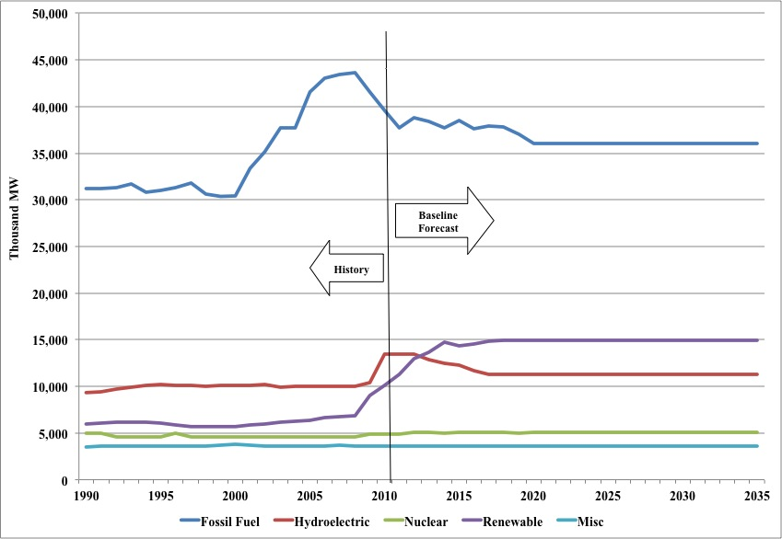
Figure 7: Projected baseline electricity generation capacity

4.2 California Renewable Energy Resources Act

The California Renewable Energy Resources Act (Senate Bill X 1-2) is the most ambitious renewable portfolio standard (RPS) in the country. The law requires 33% of electricity retail sales to be served by renewable energy resources by 2020. The standard applies to all electricity retailers in the state, including publicly owned utilities (POUs), investor-owned utilities (IOUs), electricity service providers and community choice aggregators. Under the RPS compliance schedule, these entities are required to achieve 20% of retails sales from renewables by 2013, 25% by 2016, and 33% by 2020.

Prior to passage of SB X 1-2, California aimed to achieve 20% renewable energy by 2010. However, according to the California Public Utilities Commission the state fell short of this target, with the three large IOUs collectively serving 18% of their 2010 retail electricity sales with renewable power.

SB X 1-2 generally favors in-state development, but does allow for some importation of out-of-state renewables. This is specified by section 399.16, which imposes a “loading order” requiring each provider to attain a balanced portfolio of renewables under three categories:

- (1) Products that have a first point of interconnection with a California Balancing Authority (CBA) (or with distributing facilities servicing a CBA), or which are scheduled into a CBA, or which have an agreement to dynamically transfer electricity to a CBA;
- (2) Firmed and shaped products scheduled into a CBA; and
- (3) Other products (including unbundled renewable energy credits, or RECs).

Unbundled RECs are sold as a separate commodity from the underlying energy itself. These credits can be purchased from any state within the Western Electricity Coordinating Council. Sales under category (3), therefore, effectively permit some out-of-state renewable energy to count towards California’s RPS. Under section 399.16, after 2017 all providers must procure no less than 75% of their renewables from category (1) and no more than 10% from category (3), with the rest coming from (2). Hence, to represent this feature within our model, this study assumes that 10% of the RPS targets are met by out-of-state generation (i.e. electricity imports).

California has traditionally provided strong support for renewable generation, such as the statewide campaign called Go Solar California. This campaign is a joint effort by the Energy Commission and Public Utilities Commission to establish 3,000 MWs of new grid-connected solar generating capacity by the end of 2016 with a budget of $3.35 billion. This project includes the California Solar Initiative and the New Solar Homes Partnership, which offer substantial incentives to the solar industry in California. Much of the RPS is, therefore, expected to come from solar. In fact, the largest solar thermal power project currently under construction in the world is the 392 MW Ivanpah Solar Electric Generating System, located to the southwest of Las Vegas in California. Many far larger solar thermal power stations also have been proposed, including the Blythe Solar Power Project (968 MW), the Calico Solar Energy Project (850 MW) and the Imperial Valley Solar Project (709 MW).

There are, however, a wide range of technologies in addition to solar thermal that qualify for California’s RPS. These include biomass, photovoltaic (PV), wind, geothermal, fuel cells using renewable fuels, small hydroelectricity (under 30 MW), digester gas, trash conversion (without utilizing combustion), landfill gas, ocean wave, ocean thermal, and tidal current. This study considers an expansion of California’s current procurement path (44% wind, 24% solar thermal, 15% geothermal, 10% PV and 7% biomass) to achieve California’s 33% renewable target by 2020. Beyond 2020, this scenario assumes that California continues an aggressive development path for renewable energy, reaching 50% of total retail sales by the end of the forecast period.

The levelized costs of the non-renewable and renewable technologies appear below in Figure 8. Costs for solar thermal and photovoltaic (PV) costs are substantially higher than the other generation technologies. Costs of solar are highly sensitive to its operating rate. The solar industry recognizes the challenge to increase operating rates in order to lower the actual delivery price of energy from these facilities. Sandia National Laboratory reports that without energy storage, the annual capacity factor of any solar technology is generally limited to about 25%.

This study, therefore, assumes that solar thermal plants operate at a 25% capacity utilization rate. In addition, this study adopts EIA’s 2010 Annual Energy Outlook assumption that the capacity utilization of PV systems is 21%. If the solar operating rates could be increased further, this would dramatically reduce the cost of solar generated electricity.

The levelized costs for these technologies change in rough proportion to the estimated change in the overnight capital costs of generation capacity because solar technology has no fuel costs and relatively small operating and maintenance costs. Hence, the progress this study forecasts will be made in bringing down solar generation costs reflects the substantial fall in overnight capital costs for solar technology projected by the EIA. By 2035, solar thermal technology is nearly cost competitive with the traditional energy generation sources. Although PV systems are considerably more expensive, other considerations may tip the balance in favor of PV systems. These include generous federal and state grants, tax rebates and exemptions. Indeed, PV power is rapidly expanding in California, which has more PV installed than any other state.

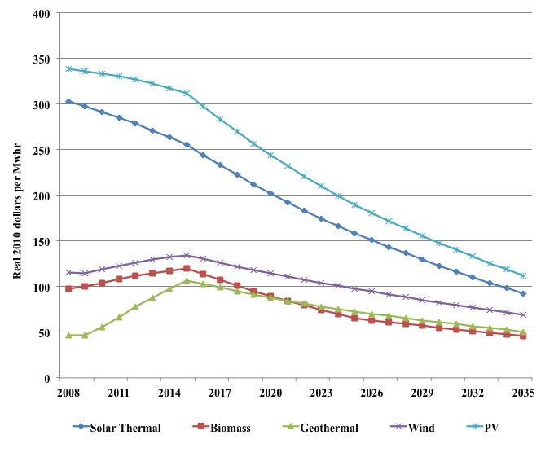
Figure 8: Levelized costs of renewable generation capacity

The U.S. Department of Energy recently announced the Sunshot Initiative to advance solar development and manufacturing. This initially included the awarding of $27 million for nine new solar projects, and was followed by an announcement that $110 million would be invested in the development of advanced PV manufacturing. The aim is to achieve cost competitive solar energy by 2020, which is actually substantially earlier than the EIA projections suggest. Hence if this objective is met then our projections of the cost gains may turn out to be on the conservative side.

4.3 Natural Gas Based Electricity Generation

Rather than using renewable energy to supply new electricity requirements natural gas based generation could be used to supply those needs. The baseline assumption is that all new electricity demand is supplied by imports. However, California already imports more electricity from other states than any other state. Hence, this study considers the costs and environmental trade-offs of replacing three-quarters of electricity imports from now to the year 2035 with the combined cycle natural gas capacity.

Currently, natural gas plants are the most frequent choice for new power in California. The assumed levelized costs for new natural gas combined cycle capacity is displayed below in Figure 9. Costs for new natural gas generation technology falls markedly in 2009 due to a large decline in natural gas prices, before costs gradually increase as natural gas prices recover.

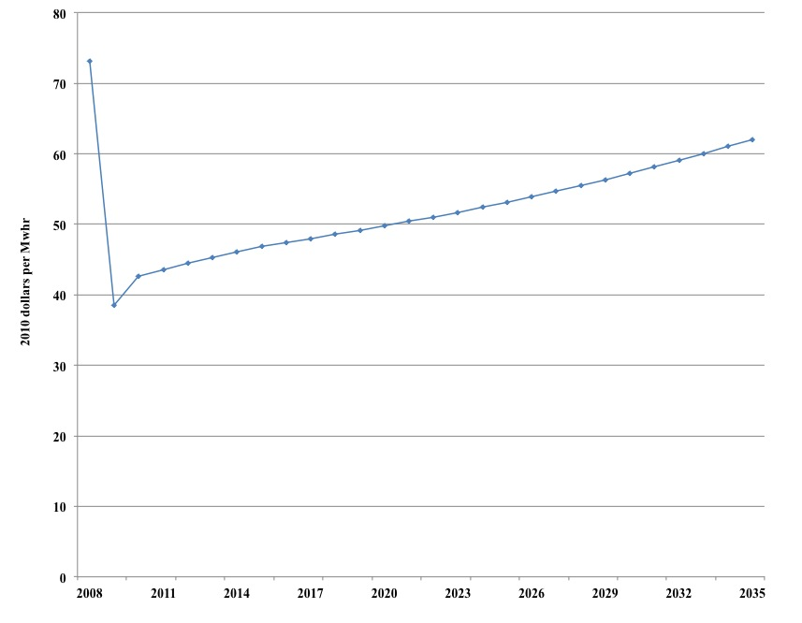
Figure 9: Levelized costs of new natural gas generation capacity

4.4 Developing Oil and Natural Gas Resources

The third and final scenario examined in this study involves additional development of crude oil and natural gas under the Santa Barbara Channel. This field has been under development for many years but environmental concerns led to a permanent moratorium on new oil and gas leasing and development in state waters offshore California. Federal leasing has been deferred with temporary moratoria in place for the past 28 years.

In 1990 President G.H. Bush issued an executive moratorium banning new federal leasing through the year 2000 in many areas of the U.S. including California. In 1998, President W.J. Clinton extended the moratorium through 2012. In July 2008, President G.W. Bush rescinded this executive order.

The California Lands Commission halted additional leasing of state offshore tracts after the Santa Barbara oil spill in 1969. In 1994 the California legislature codified the ban on new leases by passing the California Coastal Sanctuary Act that prohibited new oil and gas leasing in state waters from Mexico to the Oregon border.

No new leasing in state offshore waters will occur unless the legislature acts to eliminate or modify the prohibition. The State Land Commission is prohibited from issuing new leases unless it determines that oil and gas resources are being drained from wells in federal waters. The prohibition also may be modified under a severe energy supply disruption or if the new leases are found to be in the best interest of the state. Development may still occur on state and federal leases granted prior to the moratorium. Currently, there are 82,000 acres under lease within the Santa Barbara Channel.

Recent technological advances now allow environmentally safe extraction of these resources. For example, extended reach drilling can extract offshore oil from land without the need for new offshore platforms. So the threat of oil spills in coastal environments would be minimized with this technological solution. Moreover, increasing California oil and gas production would reduce the need for crude oil imports, reducing air emissions associated with oil tanker traffic.

Emissions associated with energy consumption would be unaffected because Californians would be consuming the same amount of oil and gas as under the baseline scenario because the incremental production from California is too small in relation to world production to affect petroleum product prices and, hence, consumption and emissions.

Increasing production of crude oil and natural gas offshore Santa Barbara would require the construction of onshore facilities for production and transportation of crude oil and natural gas from five new projects and four existing producing areas within the Santa Barbara Channel. This construction activity involves expenditures on equipment, drilling structures, storage tanks, pipelines, and processing facilities. Total project costs are $2.9 billion in 2010 dollars including exploratory drilling, wells construction, support and processing facilities, water treatment plants, other facilities, and operating expenditures (see Figure 10). The project also involves outlays near the end of the 30-year life of the project to abandon the operation.

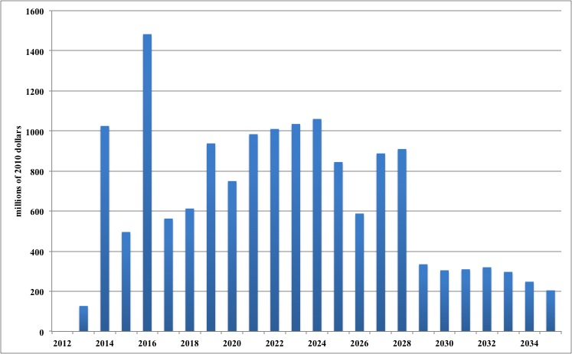
Figure 10: Capital expenditures for new crude oil production from Santa Barbara Channel
The projected incremental production of crude oil from these investments is displayed above in Figure 10. Production rises sharply during the first four years of the project and then declines thereafter (see Figure 11). Total cumulative production over the 30-year horizon is 1.54 billion barrels. The estimated economic impacts of this project will be discussed in the following section.

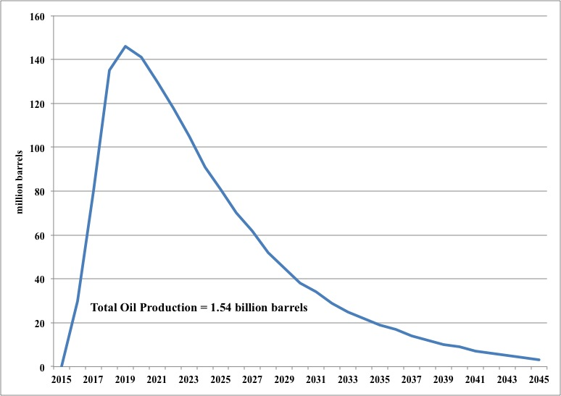
Figure 11: Possible new crude oil production from Santa Barbara Channel

Energy, Economic, and Environmental Impacts

5. Energy, Economic, and Environmental Impacts

The baseline business-as-usual forecast and the three alternative energy development scenarios are discussed in each of the four sub-sections below. For the baseline scenario, the major trends affecting energy use and production are identified and discussed. For the three alternative scenarios, the energy, economic, and environmental impacts are compared to the baseline forecast. The focus is on six metrics: employment, value added, tax revenues, energy consumption, energy production, and environmental emissions.

5.1 The Baseline Forecast

The business-as-usual forecast provides a baseline of comparison. Under the low growth scenario with the average annual increase in gross domestic product of 2.23% and our assumptions of primary fuel price escalation, total energy consumption including consumption of coal, natural gas, and petroleum products in the residential, commercial, and industrial sectors plus consumption of electricity including conversion and transmission losses grows at 0.81% per annum from 2010 to 2035. Hence, the energy intensity of use or the ratio of total energy consumption to gross state product declines on average 1.39% per year during the low growth forecast scenario. Under the high growth scenario, gross state product increases 3.6% per annum and total energy use increases 1.48% per year. In this case, the energy intensity of use declines 2.09% per annum. These scenarios extend the trend toward greater energy efficiency as illustrated in Figure 12 below.

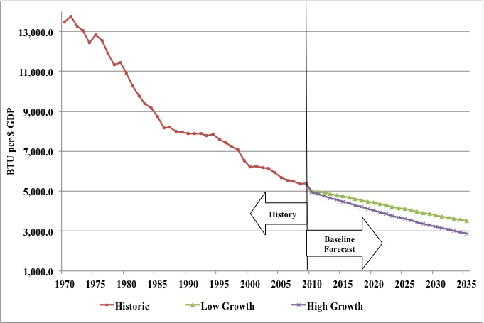
Figure 12: Historical and projected energy intensity of use
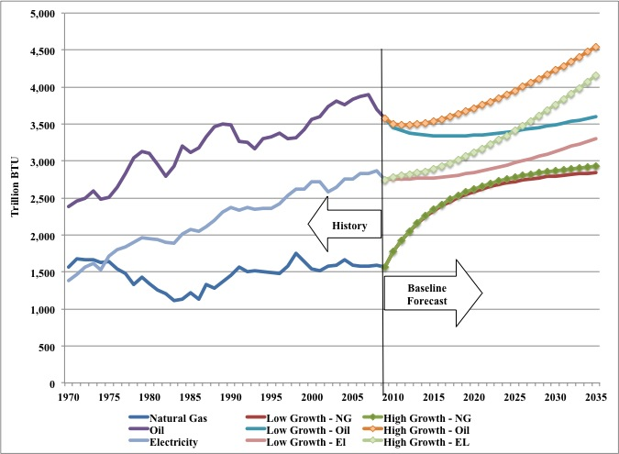
Figure 13: Historical and projected oil, natural gas, and electricity use

As Figure 13 illustrates above, natural gas use is projected to expand much faster than petroleum use for an average of 1.92% under the lower growth scenario and 2.03% under the high growth scenario. Electricity use follows a similar track expanding 0.72% per annum under the low growth scenario and 1.61% under the high growth scenario.

These projections envision California becoming more reliant upon natural gas and electricity at the expense of petroleum. This shift in the composition of total energy consumption away from petroleum toward natural gas and electricity is illustrated below in Figure 14. Under both baseline scenarios the share of oil declines from about 45% to under 40% of total energy consumption. The electricity share of total energy use actually declines from roughly 35% of total use to 33% by 2017 and then begins a gradual recovery to present levels by 2035. The share of natural gas rises about eight percentage points over the forecast horizon.

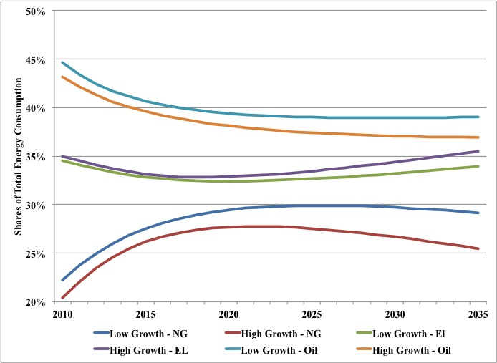
Figure 14: Projected shares of oil, natural gas, and electricity use

The trade balance for electricity is displayed below in Figure 15. Under both baseline scenarios electric generation capacity within California declines over the next decade and then stabilizes at that reduced level. As a result, California is likely to become ever more dependent upon imported electricity. For example, under the low growth scenario, imports of electricity increase from 43 million MWhr in 2010 to 54.7 million MWhr in 2020 and eventually to 98 million MWhr in 2035. In contrast, under the high growth scenario, electricity imports rise to 80 million MWhr in 2020 and to slightly over 178 million MWhr in 2035.

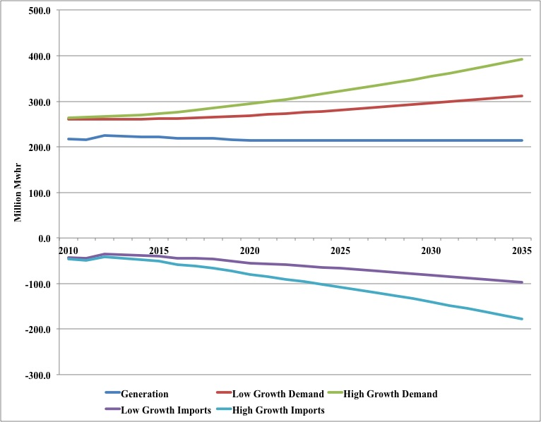
Figure 15: Projected electricity demand and imports

Under the high growth scenario, electricity demand reaches 294 million MWhr by 2020 and 392 million MWhr by 2035. Average annual growth in consumption is 0.6%. Alternatively, under high growth demand eventually rises to 392 million MWhr by 2035 and so in this case California requires an additional 129 million MWhr of electricity. Average annual growth in consumption under this scenario is 1.5%.

One factor dragging down future electricity demand growth is increasing real rates for electric power. Real generation costs rise from around $45 / MWhr in 2010 to around $59 / MWhr in 2020 and to $61 /MWhr in 2035 (for both growth paths). After the fall in energy prices following the 2009 recession, we find these higher costs translate into increased retail electricity prices until 2015. After this point, retail prices remain stable.

Primarily due to swiftly rising oil prices, real monthly household expenditures on energy rise throughout the forecast period: expenditures increase from $275 per month in 2010 to $450 per month by 2035 under low growth, and from $280 per month in 2010 to $494 per month by 2035 under high growth (see Figure 16). In the low growth scenario, residential electricity consumption per customer, which was increasing until the recession in the late 2000s, is essentially flat over the forecast horizon. On the other-hand, under high growth electricity consumption per customer in the residential sector continues an upward trend.

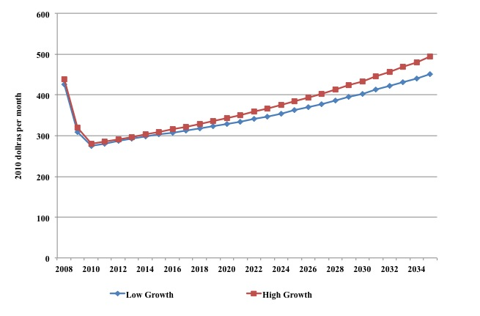
Figure 16: Real Monthly Household Energy Expenditures

Figure 17 reveals the forecasted future trends in total carbon dioxide emissions. Under low growth, emissions increase from 2010 levels of 415 million tons to 503 million tons by 2035. Under high growth, emissions increase from 2010 levels of 420 million tons to 622 million tons by 2035. Note that these emissions result from the combustion of natural gas, coal and petroleum products in the residential, commercial, industrial and transportation sectors of the California economy, or other states if the electricity is imported.
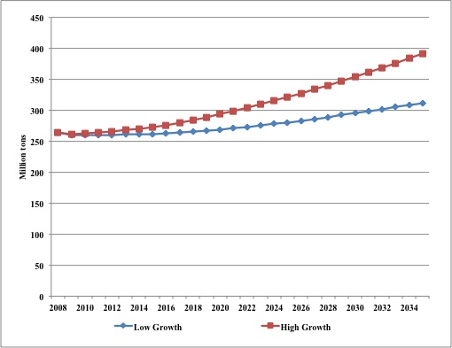
Figure 17: Projected greenhouse gas emissions

5.2 Impacts of Renewable Portfolio Standard

To achieve the renewable portfolio standard envisioned under the California Renewable Energy Resources Act, a significant amount of renewable electricity production capacity must be constructed. A projection of these capacity requirements under the low and high economic growth scenarios is displayed below in Figure 18. For example, under the low growth scenario 4,839 megawatts of new capacity is added on average from 2012 to 2020 to meet the 33% RPS standard. Under the high growth scenario, this average increases to 6,348 megawatts of new capacity. Beyond 2020 to meet a 50% RPS goal by 2035 would require an average of 3,518 megawatts of new annual capacity additions under the low growth scenario and 5,945 megawatts under the high growth scenario.

This build out of renewable energy capacity requires significant capital outlays. These expenditures along with spending associated with operating these plants are displayed below in Figure 19. Notice that capital spending peaks at over $8 and $10 billion under the low and high growth scenarios respectively. Also, note that spending for inputs and supplies to operate these plants increases steadily as installed renewable capacity grows but is far less than capital outlays during construction.

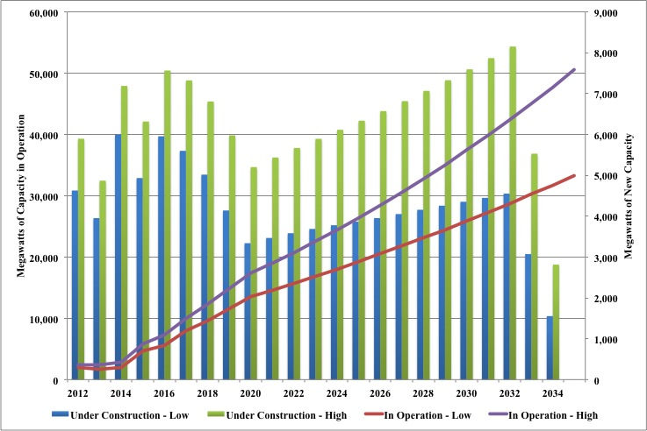
Figure 18: New and existing renewable energy capacity under RPS

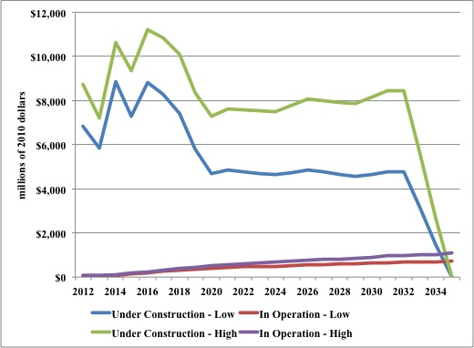
Figure 19: Capital and operating expenditures for renewable energy under RPS

These capital and operating expenditures generate additional value added and employment for the California economy. Figure 20 below plots the job gains from building and operating the renewable energy plants required to meet the RPS goals mentioned above. As mentioned above, these estimates are obtained by running the RPS scenario through the JEDI model discussed above.

Under the low growth scenario, the gross employment gains approach 100,000 jobs per year during the next five years and settled in just below 60,000 per year until 2032 when construction is no longer needed to meet the 50% renewable portfolio goal in 2035. The estimated job gains are considerably higher under the high growth scenario exceeding 120,000 jobs per year and averaging about 90,000 jobs per year until the drop off in construction at the end of the forecast period.

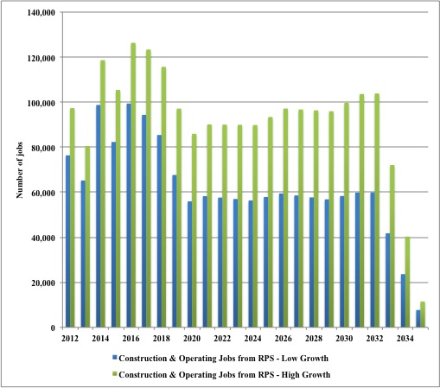
Figure 20: Gross employment gains under RPS scenario

During most of the forecast horizon, imports of electricity into California under the RPS scenario decline over time as increasing amounts of renewable generation come on line. In contrast, electricity imports increase under the baseline. By 2035, electricity imports approach zero under the low growth RPS scenario compared with 97,953 thousand MWhr under the low growth baseline scenario. On the other hand, electricity imports remain positive at 28,174 thousand MWhr in 2035 under the high growth scenario in contrast to 178,186 thousand MWhr at the end of the forecast period under high growth baseline scenario.

Meeting the required renewable generation targets increases electricity rates and reduces consumption below the baseline forecasts. Under the low growth scenario, average electricity rates across the residential, commercial, and industrial sectors increase from1.5% in 2012 to 9% over the baseline scenario by the end of the forecast horizon. Electricity consumption declines from 0.26% from the baseline in 2012 to 2.5% below the baseline in 2035. The implied own price elasticity of electricity, therefore, is -0.26, reflecting the econometric estimates discussed in Appendix A.

Given this very inelastic demand, as electricity prices increase in real terms, expenditures for electricity increase. For instance, in 2012 consumer pay almost $700 million dollars more for electric power than under the baseline scenario when economic growth is low. These additional expenditures rise to over $4.5 billion during 2020 and average more than $6 billion per year thereafter.

During the early years of the RPS scenario, the stimulus from building the renewable energy facilities offsets the contractionary impacts of higher electricity expenditures. From 2012 to 2018, the net gains in employment are roughly 84,000 and 96,000 under the low and high growth scenarios respectively (see Figure 21). After 2018, however, the net gains in employment and value added turn negative and increasingly so as the drag on economic growth from higher energy prices offsets any employment and output gains from building and operating the renewable energy facilities (see Figure 21).

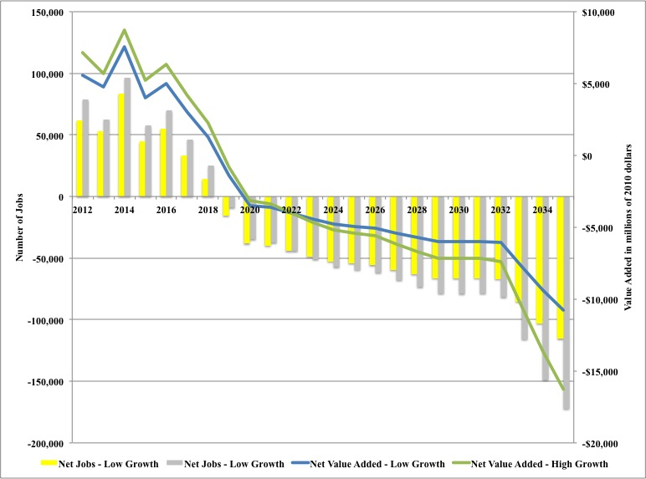
Figure 21: Net valued added and jobs under the RPS scenario

State tax revenues display a similar track. At first, state tax revenues increase, by more than $100 million in 2012. Lower value added and employment under the RPS, however, leads to lower tax revenues as well, especially in the distant years. By 2035, state tax revenues are nearly $1.9 billion lower than under the baseline scenario with low growth and nearly $2.5 billion lower than the high growth baseline forecast. So from an economic and fiscal perspective, the RPS scenario examined in this study appears to generate short-term benefits but incurs significant long-term costs.

 |  | Million Tons | Millions of 2010 dollars
Year | Jobs | Carbon Emissions | Value Added | State Tax Revenues | Energy Expenditures
2012 | 61,531 | -3 | 5,570 | 107 | 698
2013 | 52,688 | -3 | 4,770 | 6 | 590
2014 | 83,762 | -3 | 7,583 | 86 | 707
2015 | 44,575 | -7 | 4,037 | -171 | 1,792
2016 | 55,257 | -9 | 5,004 | -183 | 2,099
2017 | 33,624 | -12 | 3,046 | -388 | 2,900
2018 | 14,281 | -15 | 1,294 | -450 | 3,405
2019 | -15,549 | -18 | -1,412 | -674 | 3,999
2020 | -38,234 | -21 | -3,475 | -721 | 4,539
2021 | -39,839 | -22 | -3,621 | -737 | 4,733
2022 | -44,328 | -24 | -4,030 | -681 | 4,925
2023 | -48,612 | -26 | -4,420 | -668 | 5,107
2024 | -52,632 | -27 | -4,786 | -635 | 5,274
2025 | -54,110 | -29 | -4,921 | -601 | 5,425
2026 | -55,760 | -31 | -5,072 | -625 | 5,584
2027 | -59,554 | -33 | -5,412 | -661 | 5,726
2028 | -63,021 | -35 | -5,722 | -695 | 5,849
2029 | -66,166 | -37 | -6,002 | -728 | 5,953
2030 | -66,361 | -39 | -6,020 | -746 | 6,036
2031 | -66,129 | -41 | -6,000 | -837 | 6,098
2032 | -66,880 | -43 | -6,067 | -934 | 6,142
2033 | -85,283 | -45 | -7,749 | -1,137 | 6,162
2034 | -102,952 | -47 | -9,394 | -1,273 | 6,159
2035 | -115,497 | -50 | -10,786 | -1,873 | 6,131
Table 3: Economic and Environmental Impacts from RPS under low growth scenario

From an environmental perspective, however, the RPS scenario involves significant reductions in greenhouse gas emissions. Under the low growth scenario, carbon emissions steadily decline with annual reductions of 3 million tons early on to 50 million tons by 2035. The reductions under the high growth scenario are larger starting out 4 million tons lower than the baseline scenario to over 77 million tons by 2035.

 |  | Million Tons | Millions of 2010 dollars
Year | Jobs | Carbon Emissions | Value Added | State Tax Revenues | Energy Expenditures
2012 | 78,807 | -4 | 7,135 | 165 | 873
2013 | 62,784 | -4 | 5,684 | -1 | 835
2014 | 96,449 | -5 | 8,732 | 74 | 1,049
2015 | 57,618 | -10 | 5,219 | -212 | 2,275
2016 | 69,677 | -12 | 6,311 | -243 | 2,701
2017 | 46,499 | -16 | 4,213 | -484 | 3,679
2018 | 25,088 | -20 | 2,274 | -539 | 4,347
2019 | -8,999 | -24 | -817 | -791 | 5,113
2020 | -34,726 | -28 | -3,155 | -859 | 5,831
2021 | -37,436 | -30 | -3,401 | -894 | 6,173
2022 | -44,323 | -33 | -4,028 | -852 | 6,511
2023 | -50,950 | -35 | -4,630 | -857 | 6,836
2024 | -57,262 | -38 | -5,205 | -841 | 7,145
2025 | -59,433 | -41 | -5,403 | -815 | 7,432
2026 | -61,715 | -44 | -5,611 | -853 | 7,735
2027 | -67,770 | -47 | -6,159 | -904 | 8,015
2028 | -73,407 | -50 | -6,667 | -953 | 8,272
2029 | -78,630 | -54 | -7,138 | -1,002 | 8,504
2030 | -78,947 | -57 | -7,168 | -1,035 | 8,708
2031 | -78,573 | -61 | -7,135 | -1,138 | 8,884
2032 | -81,680 | -65 | -7,416 | -1,260 | 9,028
2033 | -115,796 | -69 | -10,533 | -1,546 | 9,139
2034 | -148,699 | -73 | -13,594 | -1,730 | 9,214
2035 | -172,148 | -77 | -16,265 | -2,449 | 9,250
Table 4: Economic and Environmental Impacts from RPS under high growth scenario

5.3 Impacts of Adopting Natural Gas Electricity Generation

Using natural gas fired electric power generation to replace electricity imports and cut carbon emissions provides an alternative to development of renewable electric power generation. Like the previous scenario, this scenario requires the construction of new generation facilities. As Figure 22 below illustrates, this scenario involves the construction of more than 5,000 MW of new natural gas based electric power generation capacity from 2012 to 2014. The capacity additions then drop back to around 2,000 MW in subsequent years until 2033 when the construction phase ends. Given this pattern of construction over time, the economic impacts follow a pattern similar to those of the renewable energy portfolio standard scenario.

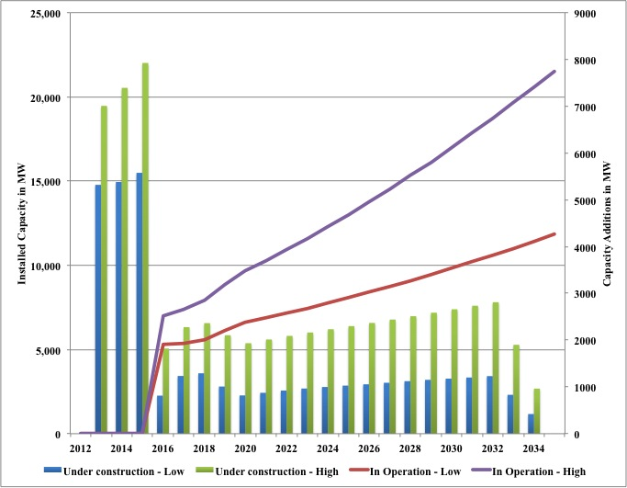
Figure 22: New and existing natural gas generation capacity

As Figure 23 illustrates, during the first three years of this scenario, employment and valued added are higher than the baseline scenarios. For instance, in the low growth scenario, more than 13,000 jobs are created during the plant construction phase from 2012 to 2014. Under the high growth scenario, the capacity requirements are greater and the employment gains are commensurately larger. Value added follows a similar track, expanding $1.2 billion and $1.7 billion per year during the build out phase.

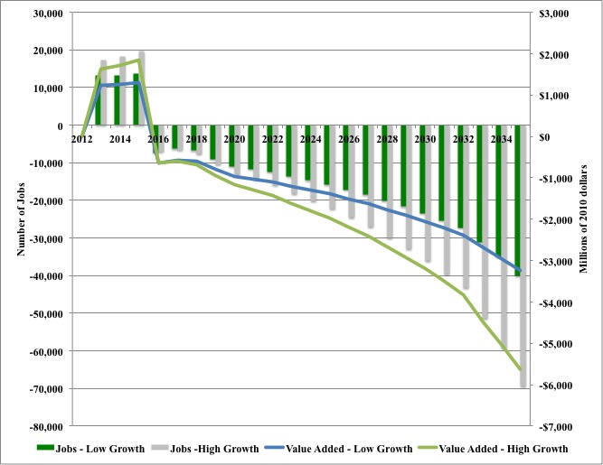

Figure 23: Net value added and jobs under the natural gas scenario

Once construction ceases, however, the higher electricity rates to pay the costs of constructing and operating these facilities cause a decline in economic activity. These new facilities are replacing relatively inexpensive imported electricity derived from coal, hydroelectric, and nuclear resources in the baseline scenarios. Like the renewable energy portfolio standard, as these new natural gas plants enter the rate base, electricity rates increase and consumers and businesses pay for these higher rates by reducing spending, which has multiplied impacts on employment and output in the California economy that are tabulated below in Tables 5 and 6 for the low and high growth scenarios.
 |  | Million Tons | Millions of 2010 dollars
Year | Jobs | Carbon Emissions | Value Added | State Tax Revenues | Energy Expenditures
2012 | 0 | 0 | 0 | 0 | 0
2013 | 13,158 | 0 | 1,234 | 55 | 0
2014 | 13,299 | 0 | 1,247 | 56 | 0
2015 | 13,782 | 0 | 1,293 | 58 | 0
2016 | -7,321 | -6 | -648 | -65 | 492
2017 | -6,338 | -6 | -569 | -61 | 503
2018 | -6,779 | -6 | -609 | -87 | 534
2019 | -9,042 | -7 | -802 | -91 | 606
2020 | -11,013 | -7 | -966 | -105 | 675
2021 | -11,697 | -8 | -1,028 | -112 | 717
2022 | -12,490 | -8 | -1,098 | -119 | 764
2023 | -13,658 | -8 | -1,201 | -130 | 817
2024 | -14,715 | -9 | -1,293 | -139 | 874
2025 | -15,865 | -9 | -1,394 | -148 | 935
2026 | -17,159 | -9 | -1,507 | -158 | 1,003
2027 | -18,518 | -10 | -1,626 | -169 | 1,074
2028 | -20,114 | -10 | -1,767 | -192 | 1,152
2029 | -21,713 | -11 | -1,907 | -204 | 1,235
2030 | -23,445 | -11 | -2,057 | -218 | 1,324
2031 | -25,337 | -12 | -2,222 | -232 | 1,421
2032 | -27,283 | -12 | -2,391 | -246 | 1,520
2033 | -31,098 | -13 | -2,683 | -303 | 1,629
2034 | -35,077 | -13 | -2,955 | -365 | 1,742
2035 | -40,081 | -14 | -3,246 | -349 | 1,866
Table 5: Economic and environmental impacts of natural gas scenario under low growth

As Table 5 and 6 illustrate, building natural gas generation capacity to replace inexpensive electricity imports increases energy expenditures and reduces employment and value added. After 2016, job losses are from 7,000 to 40,000 under the low growth scenario and from 7,000 to almost 70,000 under the high growth scenario. Losses in value added over the same time period are from $600 million to $3.2 billion and between $600 million and $5.6 billion under the low and high growth scenarios respectively.

 |  | Million Tons | Millions of 2010 dollars
Year | Jobs | Carbon Emissions | Value Added | State Tax Revenues | Energy Expenditures
2012 | 0 | 0 | 0 | 0 | 0
2013 | 17,344 | 0 | 1,625 | 66 | 0
2014 | 18,298 | 0 | 1,714 | 70 | 0
2015 | 19,614 | 0 | 1,838 | 75 | 0
2016 | -7,079 | -8 | -637 | -54 | 626
2017 | -6,634 | -8 | -600 | -52 | 666
2018 | -7,670 | -9 | -694 | -71 | 731
2019 | -10,453 | -10 | -939 | -87 | 840
2020 | -13,048 | -11 | -1,166 | -105 | 949
2021 | -14,465 | -12 | -1,292 | -116 | 1,033
2022 | -16,011 | -12 | -1,428 | -127 | 1,123
2023 | -18,277 | -13 | -1,628 | -153 | 1,222
2024 | -20,202 | -14 | -1,798 | -167 | 1,329
2025 | -22,270 | -15 | -1,981 | -182 | 1,444
2026 | -24,578 | -16 | -2,184 | -199 | 1,570
2027 | -27,067 | -17 | -2,403 | -216 | 1,705
2028 | -30,021 | -18 | -2,667 | -243 | 1,852
2029 | -32,946 | -18 | -2,925 | -263 | 2,010
2030 | -36,110 | -19 | -3,203 | -284 | 2,179
2031 | -39,559 | -20 | -3,507 | -307 | 2,363
2032 | -43,243 | -22 | -3,830 | -330 | 2,558
2033 | -51,379 | -23 | -4,472 | -414 | 2,771
2034 | -59,263 | -24 | -5,031 | -509 | 2,995
2035 | -69,431 | -25 | -5,631 | -468 | 3,240
Table 6: Economic and Environmental Impacts of natural gas scenario under high growth

Construction and operation economic impacts of natural gas are far lower than the RPS scenario. There are a number of reasons why. Firstly, each MW of natural gas capacity requires lower capital and operating expenditures than each MW of solar thermal and PV capacity. Capital expenditures for natural gas plants are also lower than wind turbines per MW of capacity. Secondly, due to the relatively low capacity utilization rates of renewable technologies, a far greater MW requirement of renewable capacity must be installed in order to generate the same level of electricity as natural gas capacity. Thirdly, a lower percentage of each dollar invested in natural gas is returned to California in benefits.

Nevertheless, while these impacts are not as severe as those under the RPS scenario, they underscore the importance of inexpensive sources of base load generation from coal, nuclear, and hydroelectric resources in maintaining low cost electricity for the California economy. Even though natural gas is now plentiful and relatively inexpensive, the projections of real cost increases for natural gas in future years used in this study increase the relative cost of electricity import replacement for California. These cost increases, however, may be mitigated if California could develop its own oil and natural gas resources.

5.4 Impacts of Developing Santa Barbara Oil

The third and final scenario involves developing crude oil and natural gas off the Santa Barbara coast. As the Santa Barbara scenario relates to the development of oil and gas extraction, rather than a generation portfolio choice, it could be undertaken alongside the RPS or natural gas scenarios. Moreover, all the benefits in the Santa Barbara scenario are windfall gains, because retail electricity prices and expenditures do not rise, and the expansion of oil and gas production simply displaces imported fuels and so in this respect is carbon neutral.

Unlike the previous two scenarios, developing crude oil and natural gas reserves off the coast of Santa Barbara increase employment and state tax revenues over the next 25 years, as Figure 24 illustrates. At its peak, development creates over 43,000 jobs and generates more than $3 billion in tax revenue in 2020. This ability to increase employment and tax revenues at the same time stands in sharp contrast to the previous two scenarios.

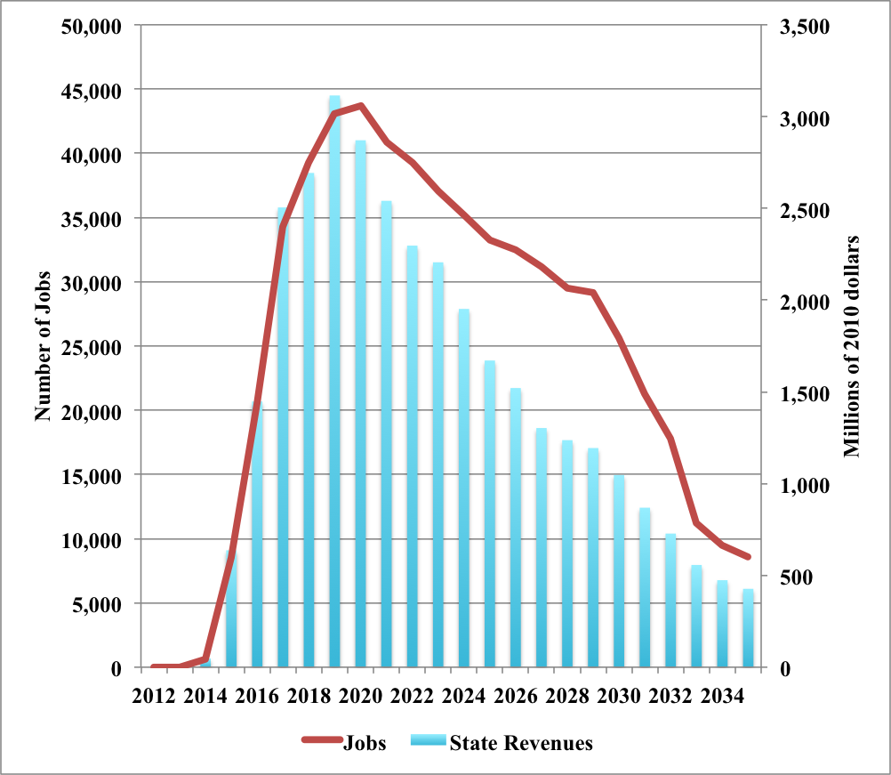
Figure 24: Jobs and tax revenues under the natural gas scenario

Indeed perhaps the most impressive impact of the Santa Barbara project, however, comes from the additional state tax received by California. The vast majority of these revenues are property tax and royalty payments. The sizable windfall tax gains are similar those generated by the Marcellus shale in Pennsylvania described by Considine et al. (2010). In 2016, the total increase in revenue to the state purse is $1.4 billion, a figure that rises to $3.1 billion in 2019 (see Table 7). By 2030 oil and gas development continues to provide over $1 billion in annual state and local taxes. Assuming the profile of these tax receipts to public agencies is similar to that observed in recent fiscal years in California, the state’s contributions to the general fund, school districts and incorporated cities will all rise significantly under the Santa Barbara scenario.
 |  | Million Tons | Millions of 2010 dollars
Year | Jobs | Carbon Emissions | Value Added | State Revenues
2012 | 0 | 0.00 | 0 | 0
2013 | 0 | 0.00 | 0 | 0
2014 | 611 | 0.00 | 92 | 48
2015 | 8,499 | 0.00 | 1,367 | 637
2016 | 20,514 | -0.02 | 3,490 | 1,448
2017 | 34,312 | -0.10 | 5,667 | 2,505
2018 | 39,302 | -0.24 | 6,854 | 2,693
2019 | 43,050 | -0.28 | 8,350 | 3,115
2020 | 43,700 | -0.29 | 9,057 | 2,871
2021 | 40,840 | -0.27 | 8,744 | 2,541
2022 | 39,295 | -0.25 | 8,698 | 2,297
2023 | 37,077 | -0.23 | 8,474 | 2,206
2024 | 35,180 | -0.20 | 8,310 | 1,952
2025 | 33,219 | -0.18 | 8,154 | 1,671
2026 | 32,453 | -0.15 | 8,179 | 1,521
2027 | 31,195 | -0.13 | 8,143 | 1,303
2028 | 29,473 | -0.11 | 7,849 | 1,237
2029 | 29,184 | -0.10 | 8,115 | 1,194
2030 | 25,600 | -0.08 | 7,118 | 1,047
2031 | 21,248 | -0.07 | 5,908 | 869
2032 | 17,792 | -0.05 | 4,947 | 728
2033 | 11,188 | -0.04 | 3,004 | 557
2034 | 9,522 | -0.04 | 2,557 | 474
2035 | 8,570 | -0.03 | 2,301 | 427
Table 7: Economic and environmental impacts of developing Santa Barbara Oil

Driving the gains in tax revenues and employment is higher valued added, which rises by $9 billion in 2020 and over $8 billion during most of the ensuing decade. Only when production declines after 2030 does value added decline. By 2035 the incremental gain in value added is $2.3 billion (see Table 7). Accordingly, if restrictions on offshore oil development were removed, additional Santa Barbara crude oil and natural gas production would by itself constitute a major new industry for the California economy.

Carbon emissions actually fall relative to the baseline scenarios because higher crude oil production in California reduces oil imports and the emissions associated with fewer oil tanker voyages (see Table 7). Higher oil and natural gas production, however, would increase gross domestic state product that in turn could lead to higher energy consumption and carbon emissions.

To assess the importance of this feedback effect, the energy model is solved with higher gross state product values from the first round impacts of development and the economic impact analysis is recomputed. Higher value added, employment, and income increase energy demand and expenditures that in turn offset some of the gains from development.
The results of this analysis appear below in Figure 25. The employment and value added gains are all slightly smaller under the low and high growth scenarios. Carbon emissions reported in Tables 8 and 9 are slightly higher than the baseline scenarios because the emissions savings from reduced tanker traffic are offset by higher energy consumption and emissions resulting from the economic gains of Santa Barbara development. The increase in carbon emissions, however, is rather slight.

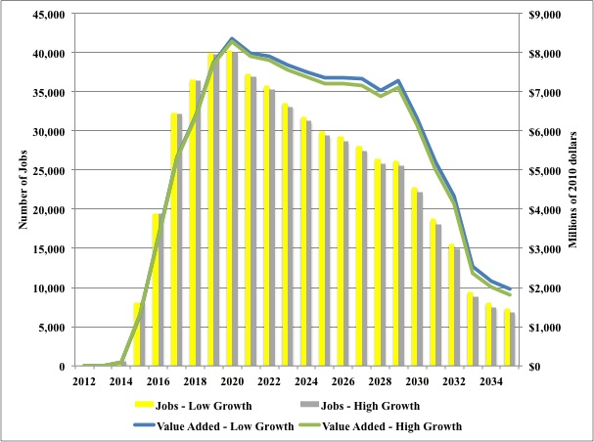
Figure 25: Economic Impacts under the oil scenario with feedback

So even allowing for a feedback of higher economic growth on energy demand and carbon emissions, developing crude oil and natural gas reserves off the Santa Barbara coast of California, the environmental impacts from an air emissions standpoint are very minor. Any damages to land and water are also likely to be minimized since development of these offshore resources would actually take place on land using innovative directional drilling technologies.

 |  | Million Tons | Millions of 2010 dollars
Year | Jobs | Carbon Emissions | Value Added | State Tax Revenues | Energy Expenditures
2012 | 0 | 0.0 | 0 | 0 | 0
2013 | 0 | 0.0 | 0 | 0 | 0
2014 | 595 | 0.0 | 90 | 48 | 2
2015 | 8,076 | 0.1 | 1,299 | 633 | 27
2016 | 19,387 | 0.3 | 3,298 | 1,438 | 79
2017 | 32,215 | 0.4 | 5,320 | 2,485 | 143
2018 | 36,571 | 0.4 | 6,378 | 2,668 | 196
2019 | 39,888 | 0.6 | 7,737 | 3,077 | 253
2020 | 40,241 | 0.7 | 8,340 | 2,833 | 296
2021 | 37,294 | 0.7 | 7,985 | 2,505 | 314
2022 | 35,726 | 0.8 | 7,908 | 2,263 | 327
2023 | 33,569 | 0.8 | 7,672 | 2,154 | 332
2024 | 31,755 | 0.8 | 7,501 | 1,905 | 334
2025 | 29,932 | 0.8 | 7,347 | 1,630 | 334
2026 | 29,222 | 0.8 | 7,365 | 1,483 | 337
2027 | 28,057 | 0.8 | 7,324 | 1,270 | 339
2028 | 26,432 | 0.8 | 7,039 | 1,205 | 335
2029 | 26,209 | 0.8 | 7,287 | 1,153 | 342
2030 | 22,806 | 0.7 | 6,341 | 1,008 | 322
2031 | 18,744 | 0.6 | 5,212 | 834 | 288
2032 | 15,590 | 0.5 | 4,335 | 697 | 254
2033 | 9,459 | 0.4 | 2,540 | 534 | 192
2034 | 8,089 | 0.3 | 2,172 | 455 | 159
2035 | 7,332 | 0.3 | 1,969 | 410 | 137
Table 8: Impacts of developing Santa Barbara oil with feedback low growth

The gains in employment and value added from Santa Barbara development allowing for the feedback of higher economic growth under the low growth scenario reported (see Table 8) are slightly smaller than the gains reported in Table 7 without this feedback. Higher energy expenditures resulting from higher income and output account for this finding. Under the high growth scenario, however, the feedback effect is stronger than under the low growth scenario gains because the economic multipliers are affecting a larger base of economic activity. Thus, the net gains of Santa Barbara development are slightly lower with high as opposed to low growth.

 |  | Million Tons | Millions of 2010 dollars
Year | Jobs | Carbon Emissions | Value Added | State Tax Revenues | Energy Expenditures
2012 | 0 | 0.0 | 0 | 0 | 0
2013 | 0 | 0.0 | 0 | 0 | 0
2014 | 595 | 0.0 | 90 | 48 | 2
2015 | 8,093 | 0.1 | 1,302 | 633 | 27
2016 | 19,371 | 0.3 | 3,295 | 1,437 | 79
2017 | 32,139 | 0.4 | 5,308 | 2,484 | 147
2018 | 36,452 | 0.5 | 6,357 | 2,667 | 205
2019 | 39,703 | 0.6 | 7,701 | 3,075 | 269
2020 | 39,963 | 0.8 | 8,282 | 2,830 | 320
2021 | 36,935 | 0.9 | 7,908 | 2,501 | 346
2022 | 35,302 | 0.9 | 7,814 | 2,258 | 366
2023 | 33,084 | 1.0 | 7,562 | 2,147 | 378
2024 | 31,235 | 1.0 | 7,378 | 1,898 | 386
2025 | 29,364 | 1.0 | 7,208 | 1,623 | 392
2026 | 28,629 | 1.0 | 7,215 | 1,476 | 400
2027 | 27,437 | 1.0 | 7,162 | 1,264 | 407
2028 | 25,784 | 1.0 | 6,866 | 1,199 | 407
2029 | 25,545 | 1.0 | 7,103 | 1,143 | 418
2030 | 22,109 | 0.9 | 6,147 | 999 | 400
2031 | 18,052 | 0.8 | 5,019 | 825 | 367
2032 | 14,909 | 0.7 | 4,146 | 688 | 332
2033 | 8,807 | 0.6 | 2,365 | 525 | 265
2034 | 7,500 | 0.5 | 2,014 | 447 | 226
2035 | 6,790 | 0.4 | 1,823 | 403 | 197
Table 9: Impacts of developing Santa Barbara oil with feedback high growth

So on balance, allowing the development of Santa Barbara offshore oil would create jobs, increase gross state product, and reduce the state’s budget deficit with rather minimal environmental impact. Indeed, developing crude oil and natural gas resources in California may be a good strategy to offset the economic losses resulting from implementation of the California Renewable Energy Resources Act.

These findings also suggest that development of crude oil and natural gas resources onshore in the prospective Monterey Shale could provide similar benefits, potentially at a much larger scale, enhancing economic growth, job creation, and fiscal balance and providing the resources for education, social services, and environmental protection.

Summary and Conclusions

California’s economic and environmental future is tied to energy. In the light of mounting evidence that greenhouse gas emissions are driving anthropogenic climate change, which President Obama warned at the 2009 Copenhagen Climate summit would pose an “unacceptable” risk to the world’s economies if left unchecked, California has earned a reputation as the pioneer of green energy in the United States.

In particular, California is aggressively moving away from its reliance on conventional fuels, and towards renewable energy technologies. This is reflected by its recent adoption of the most ambitious Renewable Portfolio Standard in the country. Considerable gains in energy efficiency have also contributed to California’s credentials as the greenest state in the U.S.

However, achieving reductions in carbon dioxide emissions in response to concerns about climate change will also require consumers to pay more for their energy. Hence dealing with environmental issues involves economic trade-offs. With limited resources but infinite demands, the economic reality is that priorities will have to be established. Public expenditures for energy or environmental measures mean there will ultimately be fewer dollars to pay for other public and private needs, from health care to education. The question is whether the trade-off is worth the cost required.

The aim of this paper is to shed some light on the trade-offs involved in California’s energy future. In particular, we consider alternative technological paths for supplying California’s energy, and in each case look at how much energy will be required, the costs to society of supplying this energy, the implications for carbon emissions, and the economic impacts. If the recent past is any guide, the most likely course is that excess electricity demand requirements will be met with imports. This is our baseline scenario. Although it would make California even more reliant upon other states, it would also save on the capital installation costs required to increase its own generation capacity base. What would this scenario mean for the typical California household? During 2010, the average household spent around $280 per month on electricity, gasoline and other fuels. These expenditures rise to $450 per month in today’s dollars by 2035 with low growth, and to $494 per month with high growth, under our baseline forecast.

This study estimates the economic, fiscal, and environmental impacts of three scenarios for California’s energy future. The first scenario involves full implementation of the California Renewable Energy Resources Act, which would require 33% of electricity be supplied by renewable energy by 2020. This study assumes that this scenario also would involve achieving a 50% renewable energy share by 2035. To achieve these goals, California utilities and power companies would need to invest heavily in new solar, wind, and other renewable energy capacity. These policies by default would make California more energy self-sufficient, moving away from its current reliance on imports of electricity generated from coal, nuclear, natural gas, and hydroelectric plants located in surrounding states. The second scenario is based upon the same import displacement strategy by expanding natural gas capacity to generate electricity within California.

The third and final scenario involves developing crude oil and natural gas deposits off the coast of Santa Barbara, California. Like the previous two scenarios, capital investments are required to build facilities to extract these resources. Given that oil prices are determined internationally, this scenario does not affect prices for petroleum products paid by California consumers, unlike the previous two scenarios. Accordingly, two separate scenarios are developed for this case, with and without a feedback between economic growth and energy demand.

A summary of the key findings appears below in Table 10. The first finding is that the economic and fiscal impacts of developing Santa Barbara are positive with the creation of between 22,000 and almost 25,000 jobs annually, between $81 and $91 billion in value added, and over $23 billion in state tax revenues over the next 25 years. These gains are achieved with minimal environmental impact. Carbon emissions are actually lower due to savings arising from reduced imported oil tanker traffic. If higher economic growth is considered, carbon emissions rise compared to the baseline scenarios but the increases are very minor. In contrast, the first two scenarios significantly reduce greenhouse gas emissions but involve substantial reductions in employment, value added, and tax revenues (see Table 10).

 | Scenarios
Net Impacts on | Renewable Energy Portfolio | Natural Gas | Santa Barbara Oil | Santa Barbara Oil w/ Feedback
Employment | Average Annual Number of Jobs
Low Growth | -28,966 | -13,688 | 24,659 | 22,383
High Growth | -33,899 | -20,602 | 24,659 | 21,991
 | Present Value in Millions of 2010 Dollars
Value Added
Low Growth | -28,389 | -$16,007 | $91,769 | 83,280
High Growth | -31,211 | -$23,898 | $91,769 | 81,830
State Tax Revenues
Low Growth | -$9,447 | -$1,971 | $23,786 | 23,354
High Growth | -$12,351 | -$2,402 | $23,786 | 23,282
 | Cumulative in millions of tons
Carbon Emissions
Low Growth | -620.2 | -187.2 | -2.9 | 12.1
High Growth | -896.2 | -312.1 | -2.9 | 15.1
Table 10: Summary of economic and environmental impacts

During the early years of the RPS and natural gas scenarios employment and value added increase over the baseline scenario. As the higher costs of these facilities are recovered, however, electricity rates increase. These higher rates reduce consumer discretionary income and cash flow for businesses. The overall impact of these higher energy expenditures is to offset the economic stimulus from building renewable or natural gas power generation plants. In conclusion, investments in renewable energy may create jobs in the short run but raise energy prices and reduce employment and economic growth in the long run. Producing crude oil and natural gas to replace imported fuels, however, unambiguously increases employment, output, and tax revenues with minimal environmental impacts.

References

California Public Utilities Commission, 2009, 33% Renewables Portfolio Standard: Implementation Analysis Preliminary Results, June, 75 pages.

Chavas, J.P., and Segerson, K. 1986, “Singularity and Autoregressive Disturbances in Linear Logit Models,” Journal of Business and Economic Statistics 4, 161-169.

Chen, C., Wiser, R., Mills, A. and Bolinger, M., 2009, Weighing the costs and benefits of state renewables portfolio standards in the United States: A comparative analysis of state-level policy impact projections, Renewable and Sustainable Energy Reviews, 13, pp. 552-566.

Considine, T. J., and T. D. Mount, 1984, “The use of linear logit models for dynamic input demand systems,” The Review of Economics and Statistics 64, 434-443.

Considine, T. J, and Rose, 2001, “The future role of natural gas in the world energy market: An overview,” in The future role of natural gas in the world energy market, Markaz, ed. 9-23.

Considine, T.J. and D. McLaren, 2008 “Powering Arizona: Choices and Trade-Offs for Electricity Policy,” The Communications Institute, Arizona State University, June, 34 pgs.

Considine, T. J., 1989, “Separability, functional form, and regulatory policy in models of interfuel substitution,” Energy Economics 11, 82-94.

Considine, T.J., 2010, “The Economic Impacts of the Marcellus Shale: Implications for New York, Pennsylvania, and West Virginia,” American Petroleum Institute, July, 38 pages.

Davis, S. and Haltiwanger, J., 2001, “Sectoral Job Creation and Destruction Responses to Oil Price Changes,” Journal of Monetary Economics 48, pp. 465-512.

Dismukes, D., 2005, Economic Impacts of New Jersey’s Proposed Renewable Portfolio Standard, Prepared for the New Jersey Office of Ratepayer Advocate, 33 pages.

Edelstein, P. and Kilian, L., 2009, “How sensitive are consumer expenditures to retail energy prices?” Journal of Monetary Economics 56:6, pp. 766-779.

EIA State Energy Data System. Available at: http://www.eia.gov/state/seds/.

Jones, C., 1995, “A dynamic analysis of interfuel substitution in U.S. industrial energy demand,” Journal of Business and Economic Statistics 13, 459-465.

Hamrin, J., Dracker, R., Martin, J., Wiser, R., Porter, K., Clement, D. and Bolinger, M., 2005, Achieving a 33% Renewable Energy Target, Prepared for the California Public Utilities Commission, 164 pages.

Humphries, M. R. Pirog, and G. Whitney, 2011, “U.S. offshore oil and gas resources: Prospects and Processes,” U.S. Congressional Research Service, May 4, 7-5700, 33 pgs.

Second IMO GHG Study 2009, International Maritime Organization (IMO), London, UK, April 2009.

Minnesota IMPLAN Group, 2011, Regional Economic Modeling System. Available at: http://www.implan.com/index.html.

National Renewable Energy Laboratory, 2011, Jobs and Economic Development Impact (JEDI) Models. Available at: http://www.nrel.gov/analysis/jedi.

Pennsylvania Department of Labor & Industry, 2010, “The Pennsylvania Green Jobs Report,” 40 pages.

Roland-Holst, D., 2009, Energy Prices and California’s Economic Security, Research Paper No. 0910071, 57 pages.

Schniepp, Mark, October 2008 and May 2009, “Economic Benefits of Future Oil and Gas Production in Santa Barbara County,” California Economic Forecast, unpublished analysis presented to (1) the Santa Barbara Industrial Association Economic Conference, Santa Barbara, California (October 31, 2008), and (2) The Pacific Section of the American Association of Petroleum Geologists Convention, Panel on California Offshore Energy Exploration and Development, Venture, California (May 5, 2009). A more thorough report to update the findings presented in 2008 and 2009 is being prepared at this time.

Segerson, K., and Mount, T.D., 1985, “A Non-Homothetic Two-Stage Decision Model Using AIDS, Review of Economics and Statistics,” 67, 630-639.

Simon, A. J. and Belles, R. D., 2011, Estimated State-Level Energy Flows in 2008 United States, Lawrence Livermore National Laboratory.

Tuerck, D., Bachman, P. and Head, M. (2011a), The Economic Impact of Montana’s Renewable Portfolio Standard, American Tradition Institute, 22 pages.

Tuerck, D., Bachman, P. and Head, M. (2011b), The Economic Impact of Colorado’s Renewable Portfolio Standard, American Tradition Institute, 24 pages.

Tuerck, D., Bachman, P. and Head, M. (2011c), Economic Impact of Oregon’s Renewable Portfolio Standard, Beacon Hill Institute and Cascade Policy Institute, 24 pages.

Appendix A. Econometric Formulation and Results for California Energy Demand

This Appendix describes the formulation of the energy demand models for the residential, commercial, industrial, and transportation sectors of the California economy and the results of the econometric analysis.

A.1 End-Use Stationary Energy Demand

The energy demand equations in the residential, commercial and industrial sectors are specified as expenditure systems. This approach incorporates two key features of demand systems consistent with consumer utility maximization or producer cost minimization. The first feature is that only relative prices matter in determining the mix of fuels. The importance of relative price changes follows from the homogeneity condition of demand equations, which implies that if all prices increase by the same proportionate amount then total energy expenditures also increase by the same percentage. The other important property involves symmetry. If the demand for fuel oil increases when relative propane prices increase, then propane and oil are substitutes. In this case, the demand for propane should increase with relatively higher oil prices. An energy demand forecasting system with inter-fuel substitution should have these symmetric price effects.

Economists have developed a variety of methodologies for ensuring consistency between demand equations. One group of methods uses flexible functional forms to approximate systems of demand equations derived from neoclassical cost or expenditure functions, such as the translog (TL) and generalized Leontief (GL). Considine (1989) shows that the nonlinear price elasticities associated with these forms often result in counter-intuitive results, such as positive own price elasticities. In addition, incorporating dynamic quantity adjustments is impossible using the TL and is highly restrictive for the GL.

The linear logit (LL) model of cost shares developed by Considine and Mount (1984) provides an attractive alternative to conventional demand systems. Many researchers associate logit functions with discrete choice models. Logistic functions ensure that probabilities are non-negative and sum to one. These properties also must hold for cost shares. Considine and Mount (1984) derive the symmetry and homogeneity conditions for the linear logit cost share system. They also show that this specification is particularly well suited for modeling dynamic adjustments. A dynamic specification is essential because it is unlikely that energy consumers would respond fully to shocks within one period. Furthermore, Chavas and Segerson (1986) argue that the logit approach does not place any restrictions on autoregressive processes of structural error terms.

There are several applications of linear logit demand models that examine various aspects of energy demand. Considine (1989) uses the model to examine how fuels should be grouped in substitution models and estimates the impacts of environmental regulations and policies on natural gas allocation. The report by Jones (1995) applies the model to U.S. industrial energy demand and finds that it out performs other models in terms of fitting observed data and in providing sensible demand elasticities. Considine (2000) estimates linear logit demand models to examine the sensitivity of energy demand to fluctuations in climate conditions. Considine and Rose (2001) use the model to forecast world natural gas, petroleum and coal consumption out to the year 2020 under alternative oil price scenarios and carbon tax policies.

This study uses a nested two–stage structure for the demand for natural gas, petroleum products and electricity in the residential, commercial and industrial sectors. The first stage determines the level of total energy consumption. The second stage model disaggregates aggregate energy consumption by fuel type. The demand models involve a non-homothetic, two-stage optimization framework. The first tier assumes an aggregate energy demand relationship:
, (1)
where is a divisia quantity index of total energy demand for sector s in period t; is a divisia index of aggregate fuel prices; is a price deflator;is an exogenous demand shifter that differs by sector, is a time trend for technological change, are unknown parameters, and is a random error term. For the residential sector, this study accounts for the effect of a change in population on total energy demand by scaling by the population of California.

The divisia price index is a share weighted moving average of logarithmic first differences in fuel prices defined by the following identity:
, (2)
where n indexes the fuels used in the particular sector. For instance, prices for electricity, liquid propane gas and natural gas comprise the divisia price index for the residential sector. The corresponding divisia quantity index is defined as energy expenditures divided by the divisia price index.

This specification assumes that the fuels in the energy price index are weakly separable from other goods and services. In other words, the marginal rate of substitution between two fuels is independent of the rate at which aggregate energy substitutes with other goods. Substitution possibilities between energy and other goods and services are likely to be very limited within the time span considered in this study.

In the second stage, a system of linear logit share equations determines the mix of fuels within each sector’s energy aggregate. The unrestricted linear logit model of cost shares is as follows:
, (3)
where:
, (4)
where is the quantity of fuel i in period t; is the price of fuel i; is expenditure on fuels in the aggregate, is a time trend, is real income or sector output, and are heating and cooling degree days respectively; are unknown parameters to be estimated; and is a random disturbance term. The inclusion of in equation (4) allows for non-homothetic demand functions within a two-stage demand model similar to the formulation developed by Segerson and Mount (1985).

Substituting (4) into (3), taking logarithms, normalizing on the n^{th} cost share, and imposing symmetry and homogeneity following the procedures developed by Considine and Mount (1984), yields the following share system:

(5)

For all fuels, , in the cost share model, where are the mean cost shares. The energy cost share systems for the residential, commercial and industrial sectors all include equations of this basic form. Equations (1) and (5) contain lagged quantities, which allow dynamic adjustments in demand and the computation of short and long–run elasticities. The price and income (output) elasticities are cost share-weighted functions of the parameters. The adjustment parameter,, determines the difference between short and long–run elasticities.

A.2 Demand for Gasoline and Diesel

A baseline projection of gasoline and diesel fuel is required in order to track carbon emissions from the transportation sector. Unlike the residential, commercial and industrial sectors, very limited or no interfuel substitution yet occurs in the transportation sector. The models in this sector take the same form as equation (1). In this case, the demand shifter includes real personal disposable income and price is the real price including taxes.

A.3 Electricity Generation & Fuel Use

The model computes electricity generation by fuel type on the basis of available capacity and average operating rates. For instance, generation from capacity i in year t in megawatt hours is defined as follows:

, (6)

whereis the number of hours capacity is operated and is rated capacity in megawatts. Fuel demand is simply generation multiplied by the average heat rate:

, (7)

where is the heat rate in tons of oil equivalent per megawatt hour. The forecasts produced below assume fixed operating hours and heat rates, computed using historical values.

The computation of forecasted power generation and fuel use by electric utilities can be seen as a sequence of steps. First, total electricity production is determined by adding predicted electricity demand and power line losses. Electricity imports are determined by the difference between power demand and the sum of generation from all sources.
Marginal generation costs for electricity are computed by taking an output-weighted average of generation costs by capacity, which is simply the product of fuel prices and heat rates. Margins for transmission and distribution costs are estimated over the historical period by subtracting marginal generation costs from end-use electricity prices. Adding these margins to average generation costs projects end-use electricity prices. This formulation allows end-use electricity prices to vary with oil, coal and natural gas prices, which then feedback on electricity demand and production.

A.4 Econometric Results

The parameters of the four energy demand models—residential, commercial, industrial and transportation—are estimated with econometric techniques. The presence of total energy quantity on the right-hand side of the cost share equations requires instrumental variable estimation to avoid simultaneous equation bias in the estimated coefficients. The Generalized Method of Moments (GMM) estimator is employed, which corrects for hetereoscedasticity and autoregressive moving average error components in the stochastic error terms.

The strategy for selecting the instrumental variables is the same for each sector; using prices lagged one-period, quantities lagged two periods, a time trend, and lagged values of the exogenous variables in the total energy quantity models, such as the number of customers or real production.

The GMM estimates for the residential energy model, which contains three estimating equations, appear below in Table 3. The parameters reported in the top half of Table 3 correspond with those that appear in equation (5) above. Six of the fourteen parameters of the residential cost share system are significantly different from zero at the 5% level.

Reported in the center of Table 3 are the parameter estimates from equation (1) above. The double log partial adjustment formulation of the total energy demand equation implies that the coefficients on price and the other exogenous variables in the equation are short-run elasticities. For example, the short-run own price elasticity of total residential energy demand, which is the sum of electricity, natural gas and petroleum products, is -0.15 (see Table A1). The adjustment parameter –0.488 (see Table A1) implies that the long-run own price elasticity for residential energy is -0.29. Also included in this equation are real per capita personal disposable income and heating degree and cooling degree days as exogenous demand shifters. Our estimates imply that for a one% increase in per capita disposable income there is a 0.26% increase in total energy demand in the short-run and a 0.5 increase in the long-run. In addition, for a one% increase in heating and cooling degree days, total energy demand increases 0.26 and 0.06% and in the short-run, respectively.

The summary fit statistics reported in Table A1 result from computing the predicted cost shares and using the cost share identity to compute predicted quantities. Although a dynamic simulation, which involves using lagged endogenous quantities, is used below in the forecasts, a static method of fit assessment is preferred so that errors are not propagated. Using a static-fit method reveals that the residential model provides an excellent fit of the quantities as measured by the correlation between fitted and actual values. In particular, theses correlation coefficients are above 0.9 for natural gas, electricity and total energy consumption per capita. Moreover, the Durbin-Watson statistics suggest the absence of auto-correlation in the residuals.

Parameters* | Coefficient | t-statistic | P-value
₁₂ | 0.131 | 0.1 | [.898]
₂₃ | -1.211 | -4.7 | [.000]
₁₃ | -0.884 | -13.3 | [.000]
 | 0.589 | 3.4 | [.001]
₁ | -0.414 | -1.0 | [.323]
₁ | -0.009 | -3.1 | [.002]
₁ | 0.700 | 5.7 | [.000]
 | -0.120 | -2.4 | [.018]
σ₁ | -7.761 | -1.9 | [.056]
₂ | 1.364 | 1.1 | [.251]
₂ | 0.005 | 0.7 | [.461]
₂ | 0.283 | 0.6 | [.534]
 | -0.002 | -0.0 | [.988]
σ₂ | 6.840 | 0.6 | [.577]
Dependent variable: ln(Q_{e}/POP)
Constant | -8.848 | -5.7 | [.000]
ln(P_{e} / PGDP) | -0.154 | -4.7 | [.000]
ln(Q_{e,t-1}/POP) | 0.488 | 4.8 | [.000]
Trend | -0.004 | -2.2 | [.027]
ln(Real DPI/POP) | 0.257 | 2.5 | [.013]
ln(HDD) | 0.264 | 6.6 | [.000]
ln(CDD) | 0.056 | 2.0 | [.042]
Dependent Variable | Correlation Coefficient | Durbin Watson
Natural Gas | 0.940 | 1.815
Liquid Propane Gas | 0.784 | 1.831
Electricity | 0.997 | 1.874
Total Energy Consumption per capita | 0.931 | 1.504
NOTE: 1 = Natural Gas, 2 = Liquid Propane Gas, 3 = Electricity
*See equations (1) and (5).
Table A1: Parameter estimates for residential energy model

Three sets of elasticities calculated from these parameter estimates appear in Table A2 below. The gross elasticities are short-run holding the level of total energy use constant. The net elasticities allow for the induced effect of prices and other explanatory variables to affect the aggregate level of energy use. Finally, the net long-run elasticities allow dynamic adjustments.

Quantities | Natural  Gas | LPG | Electricity | Real  Income | Heating  Days | Cooling  Days | Trend
 | Gross Elasticities
Natural gas | -0.104 | 0.029 | 0.075 | -0.312 | 0.46 | -0.08 | -0.006
t-statistic | -2.3 | 1.1 | 1.8 | -1.1 | 5.4 | -2.4 | -3.2
p-value | [.022] | [.272] | [.079] | [.289] | [.000] | [.017] | [.001]
Liquid Propane Gas | 0.376 | -0.241 | -0.136 | 1.466 | 0.043 | 0.038 | 0.007
t-statistic | 1.1 | -0.6 | -0.8 | 1.2 | 0.1 | 0.3 | 1.25
p-value | [.272] | [.533] | [.415] | [.231] | [.924] | [.790] | [.211]
Electricity | 0.039 | -0.005 | -0.033 | 0.102 | -0.24 | 0.04 | 0.003
t-statistic | 1.8 | -0.8 | -1.9 | 0.8 | -6.1 | 2.2 | 2.64
p-value | [.079] | [.415] | [.062] | [.430] | [.000] | [.026] | [.008]
 | Net Elasticities
Natural gas | -0.155 | -0.022 | 0.024 | 0.177 | 0.724 | -0.024 | -0.01
t-statistic | -3.3 | -0.8 | 0.5 | 1.7 | 7.0 | -0.5 | -4.29
p-value | [.001] | [.424] | [.598] | [.094] | [.000] | [.642] | [.000]
Liquid Propane Gas | 0.372 | -0.245 | -0.14 | 0.633 | 0.307 | 0.094 | 0.003
t-statistic | 1.1 | -0.6 | -0.8 | 2.0 | 0.7 | 0.6 | 0.45
p-value | [.276] | [.526] | [.401] | [.043] | [.497] | [.557] | [.647]
Electricity | -0.06 | -0.104 | -0.132 | 0.283 | 0.024 | 0.096 | -0.002
t-statistic | -1.9 | -4.7 | -5.0 | 2.3 | 0.5 | 4.2 | -0.73
p-value | [.058] | [.000] | [.000] | [.021] | [.615] | [.000] | [.461]
 | Net Long-Run Elasticities
Natural gas | -0.354 | -0.028 | 0.082 | 0.121 | 1.637 | -0.085 | -0.02
t-statistic | -2.5 | -0.3 | 0.9 | 0.2 | 2.7 | -0.6 | -6.4
p-value | [.014] | [.743] | [.345] | [.815] | [.007] | [.556] | [.000]
Liquid Propane Gas | 0.908 | -0.594 | -0.338 | 2.292 | 0.621 | 0.201 | 0.01
t-statistic | 0.8 | -0.5 | -0.9 | 1.2 | 0.6 | 0.5 | 0.47
p-value | [.423] | [.599] | [.388] | [.213] | [.561] | [.586] | [0.638]
Electricity | -0.099 | -0.206 | -0.274 | 0.626 | -0.069 | 0.207 | -0.002
t-statistic | -1.9 | -6.6 | -6.3 | 2.4 | -0.2 | 4.6 | -0.75
p-value | [.059] | [.000] | [.000] | [.018] | [.859] | [.000] | [0.452]
Table A2: Estimated elasticities of demand for California residential energy

The gross own price elasticity of demand for electricity reported in Table A2 is -0.03 with a 6.2% probability of being zero suggesting a very price inelastic demand for electricity, which is consistent with findings in many other parts of the world. The own price elasticity for natural gas is somewhat larger in absolute terms at -0.10 with a probability value of 2.2. Similarly, the own price elasticity for liquid propane gas is considerably larger in absolute terms at -.24 but the probability value is rather high at 53.3%.

Changing relative fuel prices affect the price of aggregate fuels to households that in turn changes the desired level of household energy budgets. The second group of elasticities in Table A2, labeled net elasticities, account for these effects on total energy consumption. The net own price elasticities of demand are larger in absolute terms. This is logical, given the negative own price elasticity of demand for aggregate household energy demand. The net elasticities are -0.16, -0.25 and -0.13 for natural gas, liquid propane gas and electricity respectively, where the net elasticities for natural gas and electricity are statistically significant. The net long run elasticities, provided in the third panel of Table A2, are as expected even larger. They are a function of the net elasticities divided by one minus the respective adjustment parameters. For example, the long-run own price elasticity of demand for electricity is -0.27.

Also provided in Table A2 are elasticities for the exogenous demand shifters. These include real per capita disposable income elasticities, which measure how the demand for fuels by households varies with the level of income. The short-run net income elasticities for natural gas, liquid propane gas and electricity are 0.18, 0.63 and 0.28, respectively. All are significant at the 10% level. However, only the long-run net income elasticity for electricity (equal to 0.63) is significant at the 10% level.

In addition, there are elasticities for heating and cooling degree-days. The short-run net elasticities indicate that a 1% increase in heating degree-days leads to a 0.72% increase in natural gas demand, which is highly significant. This increases to 1.6% in the long-run. In addition, a 1% increase in cooling degree-days leads to a 0.1% increase in electricity demand, which is also highly significant. This increases to 0.21% in the long-run. Otherwise, the heating and cooling degree-day net elasticities are insignificant.

Also reported in Table A2 are elasticities of fuel demand with respect to the time trend variable, which is a proxy for technological change. More energy efficient energy consuming durables induced by technological change or efficiency standards imposed by state or federal regulations are just one example. The time trend variable commonly used in many studies of energy demand serves as a proxy for these gradual adjustments in energy consumption patterns. Of the three fuels included in the residential energy demand model, only natural gas has a significant technological change effect, in this case, a negative one indicating that holding prices, income, and weather constant, the trend is for lower per capita natural gas use, consistent with the gradual replacement of old furnaces with more fuel-efficient models.

The objective function value of the GMM estimator is distributed as a Chi-Squared statistic, providing a test of the over-identifying restrictions for the model. For the residential model the probability value for the over-identifying restrictions is 0.737, suggesting that the restrictions cannot be rejected. Hence, the overall model is supported by the data sample. The curvature conditions, which follow from consumer utility maximization, are checked at the mean of the data by computing the Eigen values of the first derivatives of the estimated demand functions. The residential estimates imply that these conditions are satisfied.

The same model specification for the residential sector provided the basis for initial estimation for the commercial sector. In this case, however, the weather variables and trend terms were consistently insignificant. As a result, these variables are dropped from consideration in the commercial model. Nonetheless, the overall findings from the econometric estimation of the commercial energy demand model are quite similar to the residential result (see Table A3).

Cost Share System
Parameters* | Coefficient | t-statistic |  | P-value
₁₂ | -0.629 | -0.4 |  | [.672]
₂₃ | -0.861 | -1.7 |  | [.085]
₁₃ | -0.839 | -8.5 |  | [.000]
 | 0.491 | 3.4 |  | [.001]
₁ | -0.497 | -1.9 |  | [.062]
 | 4.001 | 1.7 |  | [.098]
₂ | -1.294 | -1.5 |  | [.147]
 | 10.857 | 1.3 |  | [.199]
Dependent variable: ln(Q_{e})
Constant | 4.387 | 2.5 |  | [.012]
ln(P_{e} / PGDP) | 0.008 | 0.2 |  | [.873]
ln(Commercial Output) | 0.323 | 2.3 |  | [.019]
ln(Q_{e,t-1}) | 0.666 | 5.1 |  | [.000]
Dependent Variable | Correlation  Coefficient | Durbin  Watson
Natural Gas | 0.735 | 1.558
Petroleum Products | 0.828 | 2.514
Electricity | 0.994 | 2.462
Total Energy Consumption | 0.976 | 2.264
NOTE: 1 = Natural Gas, 2 = Petroleum Products, 3 = Electricity
* See equations (1) and (5)
Table A3: Parameter estimates for California commercial energy model

The exogenous demand shifter in this model is value added in the service sectors of the California economy. As Table A3 indicates, five out of the eight parameters in the commercial cost share system have probability levels less than ten%. While the own price elasticity for aggregate commercial energy has an 87.3% probability of being zero, the output elasticity is 0.323 in the short-run with a probability value of 1.9%. The overall fit of the commercial sector is also quite good and the Durbin-Watson statistics do not suggest autocorrelation.

The elasticities for the commercial sector are reported in Table A4. As with the residential sector, all the own-price elasticities are negative but are not estimated with sufficient precision. The test of the over-identifying restrictions for the commercial model cannot be rejected, while the curvature conditions are all satisfied.

 | Gross Elasticities
Quantities | Natural Gas  Price | LPG Price | Electricity Price | Commercial Sector Production
Natural gas | -0.144 | 0.014 | 0.130 | -0.373
t-statistic | -1.4 | 0.2 | 1.6 | -1.9
p-value | [.162] | [.803] | [.104] | [.061]
Liquid Propane Gas | 0.057 | -0.170 | 0.113 | -1.170
t-statistic | 0.2 | -0.7 | 0.3 | -1.4
p-value | [.803] | [.504] | [.781] | [.156]
Electricity | 0.025 | 0.005 | -0.030 | 0.124
t-statistic | 1.6 | 0.3 | -1.3 | 1.8
p-value | [.104] | [.781] | [.190] | [.080]
 | Net Elasticities
Natural gas | -0.142 | 0.015 | 0.131 | 0.294
t-statistic | -1.4 | 0.3 | 1.7 | 1.1
p-value | [.168] | [.793] | [.096] | [.266]
Liquid Propane Gas | 0.058 | -0.170 | 0.113 | -0.504
t-statistic | 0.3 | -0.7 | 0.3 | -0.6
p-value | [.802] | [.504] | [.780] | [.555]
Electricity | 0.031 | 0.012 | -0.023 | 0.790
t-statistic | 0.8 | 0.3 | -0.5 | 5.8
p-value | [.440] | [.791] | [.639] | [.000]
 | Net Long-Run Elasticities
Natural gas | -0.281 | 0.028 | 0.257 | -0.066
t-statistic | -1.4 | 0.3 | 1.4 | -0.2
p-value | [.177] | [.787] | [.174] | [.810]
Liquid Propane Gas | 0.113 | -0.334 | 0.221 | -1.634
t-statistic | 0.3 | -0.6 | 0.3 | -1.5
p-value | [.793] | [.535] | [.791] | [.139]
Electricity | 0.055 | 0.016 | -0.052 | 0.910
t-statistic | 1.2 | 0.3 | -0.7 | 6.5
p-value | [.216] | [.756] | [.507] | [.000]
Table A4: Elasticities of demand for California commercial energy model

The econometric estimates for the industrial sector are displayed below in Tables A5. Like the commercial model, heating and cooling-degree days were not significant. In contrast, industrial production was not found to be significant in the share equations but the time trend terms were found to be highly significant. Hence, industrial production was dropped from the share equations, which implies that the energy demand equations are homothetic. The estimation results in Table A5 show that the short-run output elasticity of aggregate energy demand is 0.096 for the industrial sector, which is significant at the 1% level, which together with the adjustment coefficient implies a long-run elasticity of 0.18. The short-run own price elasticity of industrial energy demand is -0.078 with a long-run own price elasticity of -0.15.

Cost Share System
Parameters* | Coefficient | t-statistic | P-value
₁₂ | -0.397 | -1.7 | [.081]
₂₃ | -1.154 | -13.7 | [.000]
₁₃ | -0.779 | -6.4 | [.000]
 | 0.823 | 11.3 | [.000]
₁ | 0.006 | 3.1 | [.002]
 | -0.088 | -1.5 | [.146]
₂ | -0.004 | -3.5 | [.000]
 | 0.217 | 2.4 | [.017]
Dependent variable: ln(Q_{e})
Constant | 4.022 | 5.1 | [.000]
ln(P_{e} / PGDP) | -0.078 | -3.5 | [.000]
ln(Industrial Output) | 0.096 | 3.9 | [.000]
ln(Q_{e,t-1}) | 0.481 | 5.2 | [.000]
Dependent Variable | Correlation  Coefficient | Durbin  Watson
Natural Gas | 0.931 | 1.963
Petroleum Products | 0.825 | 2.084
Electricity | 0.844 | 1.638
Total Energy Use | 0.701 | 1.766
NOTE: 1 = Natural Gas, 2 = Petroleum Products, 3 = Electricity
* See equations (1) and (5).
Table A5: Parameter estimates for California industrial energy model

For the industrial sector model, the tests of the over-identifying restrictions are not rejected. The estimates also satisfy the curvature conditions, implying that the demand equations are consistent with producer cost minimization. Like the residential and commercial sectors, the short-run demand for electricity is extremely price inelastic with a gross own price elasticity of -0.01. This increases to -0.12 for the net long-run elasticity, although it remains insignificant. On the other-hand, the net long-run own price elasticities for natural gas and petroleum, equal to -1.65 and -0.67 respectively, are significant at the 1% level. Finally, the time trend coefficients imply that technological change had insignificant changes in the industrial demand for electricity but technological change is significantly natural gas using and petroleum product saving in the industrial sector (see Table A6).

 | Gross Elasticities
 | Natural Gas | Petroleum | Electricity | Time
Quantities | Price | Prices | Price | Trend
Natural Gas | -0.285 | 0.199 | 0.086 | 0.006
t-statistic | -2.7 | 2.7 | 1.8 | 3.4
p-value | [.007] | [.008] | [.069] | [.001]
Petroleum | 0.17 | -0.11 | -0.06 | -0.005
t-statistic | 2.7 | -2.4 | -1.8 | -3.7
p-value | [.008] | [.015] | [.067] | [.000]
Electricity | 0.062 | -0.051 | -0.011 | 0.000
t-statistic | 1.8 | -1.8 | -0.5 | -0.9
p-value | [.069] | [.067] | [.647] | [.382]
Quantities | Net Elasticities
Natural Gas | -0.307 | 0.177 | 0.064 | 0.006
t-statistic | -2.9 | 2.3 | 1.4 | 3.4
p-value | [.004] | [.020] | [.166] | [.001]
Petroleum | 0.144 | -0.136 | -0.086 | -0.005
t-statistic | 2.2 | -3 | -2.6 | -3.7
p-value | [.028] | [.003] | [.009] | [.000]
Electricity | 0.032 | -0.081 | -0.042 | 0.001
t-statistic | 1 | -2.9 | -1.4 | -0.9
p-value | [.340] | [.004] | [.159] | [.382]
Quantities | Net Long-Run Elasticities
Natural Gas | -1.652 | 1.082 | 0.443 | 0.034
t-statistic | -4.2 | 5.0 | 1.9 | 3.6
p-value | [.000] | [.000] | [.063] | [.000]
Petroleum | 0.908 | -0.67 | -0.388 | -0.027
t-statistic | 5.0 | -3.3 | -3.0 | -4.1
p-value | [.000] | [.001] | [.003] | [.000]
Electricity | 0.292 | -0.345 | -0.123 | -0.002
t-statistic | 1.8 | -3.1 | -0.8 | -0.9
p-value | [.078] | [.002] | [.445] | [.389]
Table A6: Elasticities of demand for California industrial energy model

The final block of estimated econometric equations includes the demands for gasoline and diesel fuel used in transportation. These equations are estimated to track the carbon emissions from the transportation sector. The results of this estimation appear in Table A7. The short and long-run price and income elasticities of demand have the expected signs. Like electricity, the short-run price elasticity of demand for both fuels is very inelastic, indicating that consumer expenditures do not fall sharply as prices increase. In the long run, the elasticities increase but remain inelastic. The price elasticity for gasoline is statistically significant in the short run at the 1% level, and in the long run at the 10% level, while the price elasticities for diesel in the short and long run are insignificant.

 | Coefficient | t-statistic | P-value
Dependent variable: ln(Q_{gasoline})
Constant | 0.970 | 2.8 | [.004]
ln(P_{gasoline} / PGDP) | -0.048 | -3.1 | [.002]
ln(Real Personal Income) | 0.103 | 2.4 | [.018]
ln(Q_{gasoline,t-1}) | 0.727 | 6.7 | [.000]
Dependent variable: ln(Q_{diesel})
Constant | -11.828 | -5.3 | [.000]
ln(P_{diesel} / PGDP) | -0.057 | -1.0 | [.334]
ln(Real GDP) | 0.775 | 6.0 | [.000]
ln(Q_{diesel,t-1}) | 0.017 | 0.1 | [.915]
Dependent Variable | Correlation  Coefficient | Durbin  Watson
Gasoline | 0.979 | 1.430
Diesel | 0.932 | 1.845
 | Short-Run
 | Price Changes
 | Gasoline | Diesel | Income
 | -0.048 |  | 0.103
Gasoline | -3.1 |  | 2.4
 | [.002] |  | [.018]
 |  | -0.057 | 0.775
Diesel |  | -1.0 | 6.0
 |  | [.334] | [.000]
 | Long-Run
 | -0.176 |  | 0.377
Gasoline | -1.8 |  | 10.6
 | [.079] |  | [.000]
 |  | -0.058 | 0.789
Diesel |  | -0.9 | 17.1
 |  | [.351] | [.000]
Table A7: Elasticities of demand for California gasoline and diesel

Appendix B. Electricity Rates by Region within California

Electricity rates vary substantially between different regions within California. In this section, we disaggregate the statewide impact on electricity rates estimated by our energy model in order to estimate an impact on electricity rates by region. Hence, this will paint a picture of how each region within California is individually affected by the alternative generation portfolio choices we have considered.

The current variation in electricity rates within California is due to a number of factors. For instance, some regions are likely to enjoy lower rates than others as they import a greater share of inexpensive electricity from outside the state. Variation in the portfolio mix of generation within California will also play a role. In addition, the cost of distribution and transmission represents a large component of electricity rates and may differ between regions.

Two electric utilities in particular supply a very large share of California’s electricity market. In 2008, Southern California Edison Company and Pacific Gas and Electric Company together supplied 68% of electricity sales to California’s residential sector, 71% of the commercial sector sales and 51% of the industrial sector sales. 53 other utility companies supply the remainder of the electricity market.

The adoption of the Renewable Energy Portfolio standards discussed may reduce the variation in electricity rates by region, raising rates proportionately more for regions with below average rates. Without knowing the exact locations of new electric power plants nor the terms under which electricity is imported into various localities within California, there is no basis for determining how this variation could be reduced.

Accordingly, this Appendix assumes that electricity rates in each region change by the same percentage as the statewide rate predicted by the energy model. An overall average electricity rate for each region is computed by calculating a weighted average over the residential, commercial and industrial sectors (see Table B1)

 | 2010 | 2020 |  |  |  | 2030
Scenario | Base | Base | RPS | NG |  | Base | RPS | NG
Low Growth | 13.47 | 14.84 | 16.79 | 15.13 |  | 14.87 | 17.23 | 15.38
High Growth | 14.08 | 15.35 | 17.78 | 15.74 |  | 15.26 | 18.28 | 16.00
Table B1: Average electricity rates in 2010 cents per kilowatt-hour

The most expensive electricity in California is provided in the region Anza. Focusing on the low growth path, rates in Anza increase from 19 cents per Kwh in 2010 to 21 cents per Kwh in 2020 and 2030 under the baseline scenario (real 2010 dollars). The RPS scenario increases rates in Anza to 24 cents per Kwh by 2030. In contrast, the least expensive electricity is found Tuolumne County, where rates increase from just 6 cents per Kwhr in 2010 to 7 cents per Kwhr in 2020 and 2030 under the baseline scenario. With the RPS or portfolio scenario, rates rise to 8 cents per Kwhr in 2030, still far below current rates in Anza. The rate increases, which are forecasted with high growth, are only very marginally greater.

 | 2010 | 2020 |  |  |  | 2030
Region | Base | Base | RPS | NG |  | Base | RPS | NG
Alameda | 14.25 | 15.61 | 17.53 | 15.89 |  | 15.64 | 17.96 | 16.14
Anaheim | 12.65 | 14.05 | 16.03 | 14.34 |  | 14.08 | 16.48 | 14.60
Anza | 19.42 | 21.20 | 23.72 | 21.57 |  | 21.24 | 24.28 | 21.89
Azusa | 13.74 | 15.17 | 17.20 | 15.47 |  | 15.20 | 17.65 | 15.73
Banning | 17.81 | 19.57 | 22.06 | 19.93 |  | 19.61 | 22.62 | 20.25
Biggs | 14.10 | 15.73 | 18.03 | 16.07 |  | 15.77 | 18.55 | 16.37
Burbank | 14.57 | 16.18 | 18.46 | 16.51 |  | 16.22 | 18.97 | 16.81
Colton | 16.94 | 18.78 | 21.38 | 19.16 |  | 18.82 | 21.96 | 19.50
Corona | 15.03 | 16.68 | 19.02 | 17.02 |  | 16.72 | 19.55 | 17.33
Glendale | 18.17 | 20.07 | 22.74 | 20.46 |  | 20.11 | 23.35 | 20.81
Gridley | 16.58 | 18.18 | 20.45 | 18.52 |  | 18.22 | 20.96 | 18.81
Healdsburg | 13.15 | 14.48 | 16.36 | 14.75 |  | 14.51 | 16.78 | 15.00
Imperial | 15.25 | 16.68 | 18.71 | 16.98 |  | 16.71 | 19.16 | 17.24
Lassen | 17.57 | 19.25 | 21.62 | 19.60 |  | 19.29 | 22.16 | 19.90
Lodi | 17.27 | 19.02 | 21.49 | 19.38 |  | 19.06 | 22.05 | 19.70
Lompoc | 13.90 | 15.35 | 17.39 | 15.65 |  | 15.38 | 17.85 | 15.91
Los Angeles | 12.09 | 13.28 | 14.96 | 13.53 |  | 13.31 | 15.34 | 13.74
Merced | 12.58 | 13.95 | 15.89 | 14.24 |  | 13.99 | 16.33 | 14.49
Modesto | 12.29 | 13.53 | 15.29 | 13.79 |  | 13.56 | 15.68 | 14.01
Needles | 16.18 | 17.70 | 19.86 | 18.02 |  | 17.74 | 20.34 | 18.30
Pacific Gas & Electric Co | 13.63 | 14.96 | 16.85 | 15.24 |  | 14.99 | 17.27 | 15.48
PacifiCorp | 11.19 | 12.29 | 13.83 | 12.51 |  | 12.31 | 14.18 | 12.71
Palo Alto | 10.35 | 11.47 | 13.03 | 11.69 |  | 11.49 | 13.39 | 11.90
Pasadena | 15.30 | 16.77 | 18.85 | 17.07 |  | 16.80 | 19.32 | 17.34
Plumas-Sierra | 15.55 | 17.22 | 19.57 | 17.56 |  | 17.25 | 20.10 | 17.86
Redding | 12.09 | 13.24 | 14.85 | 13.47 |  | 13.26 | 15.21 | 13.68
Riverside | 13.89 | 15.36 | 17.45 | 15.67 |  | 15.40 | 17.92 | 15.94
Roseville | 11.46 | 12.62 | 14.26 | 12.86 |  | 12.64 | 14.63 | 13.07
Sacramento | 11.73 | 13.01 | 14.81 | 13.27 |  | 13.04 | 15.21 | 13.50
San Diego Gas & Electric Co | 17.12 | 18.78 | 21.13 | 19.13 |  | 18.82 | 21.66 | 19.43
San Francisco | 9.28 | 10.21 | 11.52 | 10.40 |  | 10.23 | 11.82 | 10.57
Santa Clara | 9.26 | 10.44 | 12.09 | 10.68 |  | 10.46 | 12.47 | 10.89
Sierra Pacific Power Co | 15.00 | 16.47 | 18.56 | 16.78 |  | 16.50 | 19.03 | 17.05
Southern California Edison Co | 15.69 | 17.22 | 19.37 | 17.53 |  | 17.25 | 19.86 | 17.81
Southern California Water Co | 23.48 | 25.70 | 28.84 | 26.16 |  | 25.74 | 29.54 | 26.56
Shasta | 12.14 | 13.55 | 15.54 | 13.84 |  | 13.59 | 15.99 | 14.10
Surprise Valley | 7.15 | 7.93 | 9.04 | 8.10 |  | 7.95 | 9.29 | 8.24
Trinity County | 8.34 | 9.12 | 10.22 | 9.28 |  | 9.14 | 10.47 | 9.42
Tuolumne County | 6.08 | 6.69 | 7.55 | 6.82 |  | 6.70 | 7.74 | 6.93
Truckee Donner | 16.73 | 18.30 | 20.50 | 18.62 |  | 18.33 | 21.00 | 18.90
Turlock | 11.76 | 13.02 | 14.81 | 13.28 |  | 13.05 | 15.22 | 13.52
Ukiah | 13.99 | 15.33 | 17.23 | 15.61 |  | 15.36 | 17.65 | 15.85
Vernon | 9.39 | 10.54 | 12.15 | 10.77 |  | 10.57 | 12.51 | 10.98
Valley Electric | 9.64 | 10.90 | 12.69 | 11.17 |  | 10.94 | 13.10 | 11.40
Table B2: Electricity rates in 2010 cents per kilowatt-hour by region under low growth

 | 2010 | 2020 |  |  |  | 2030
Region | Base | Base | RPS | NG |  | Base | RPS | NG
Alameda | 14.63 | 15.85 | 18.20 | 16.22 |  | 15.76 | 18.68 | 16.47
Anaheim | 12.97 | 14.25 | 16.67 | 14.63 |  | 14.17 | 17.18 | 14.90
Anza | 19.94 | 21.53 | 24.61 | 22.02 |  | 21.40 | 25.23 | 22.33
Azusa | 14.09 | 15.39 | 17.87 | 15.78 |  | 15.30 | 18.38 | 16.05
Banning | 18.28 | 19.86 | 22.91 | 20.35 |  | 19.75 | 23.53 | 20.67
Biggs | 14.46 | 15.95 | 18.76 | 16.39 |  | 15.86 | 19.36 | 16.71
Burbank | 14.94 | 16.41 | 19.20 | 16.85 |  | 16.31 | 19.78 | 17.16
Colton | 17.38 | 19.05 | 22.23 | 19.55 |  | 18.94 | 22.89 | 19.90
Corona | 15.41 | 16.92 | 19.78 | 17.37 |  | 16.82 | 20.38 | 17.69
Glendale | 18.65 | 20.36 | 23.64 | 20.88 |  | 20.24 | 24.31 | 21.23
Gridley | 17.02 | 18.46 | 21.23 | 18.90 |  | 18.35 | 21.80 | 19.19
Healdsburg | 13.49 | 14.69 | 16.99 | 15.06 |  | 14.61 | 17.47 | 15.30
Imperial | 15.65 | 16.93 | 19.42 | 17.33 |  | 16.84 | 19.92 | 17.59
Lassen | 18.04 | 19.54 | 22.45 | 20.01 |  | 19.43 | 23.04 | 20.31
Lodi | 17.72 | 19.30 | 22.33 | 19.78 |  | 19.19 | 22.95 | 20.11
Lompoc | 14.26 | 15.57 | 18.07 | 15.97 |  | 15.48 | 18.59 | 16.24
Los Angeles | 12.41 | 13.48 | 15.54 | 13.81 |  | 13.40 | 15.95 | 14.02
Merced | 12.90 | 14.15 | 16.53 | 14.53 |  | 14.07 | 17.02 | 14.79
Modesto | 12.61 | 13.73 | 15.88 | 14.07 |  | 13.65 | 16.33 | 14.30
Needles | 16.61 | 17.98 | 20.61 | 18.39 |  | 17.87 | 21.15 | 18.67
Pacific Gas & Electric Co | 13.98 | 15.19 | 17.50 | 15.55 |  | 15.10 | 17.97 | 15.80
PacifiCorp | 11.48 | 12.47 | 14.37 | 12.77 |  | 12.40 | 14.75 | 12.97
Palo Alto | 10.62 | 11.63 | 13.55 | 11.93 |  | 11.56 | 13.95 | 12.14
Pasadena | 15.70 | 17.03 | 19.57 | 17.43 |  | 16.93 | 20.09 | 17.70
Plumas-Sierra | 15.96 | 17.46 | 20.34 | 17.92 |  | 17.36 | 20.94 | 18.23
Redding | 12.41 | 13.44 | 15.42 | 13.75 |  | 13.36 | 15.82 | 13.96
Riverside | 14.25 | 15.58 | 18.13 | 15.99 |  | 15.50 | 18.66 | 16.27
Roseville | 11.76 | 12.80 | 14.81 | 13.12 |  | 12.73 | 15.23 | 13.34
Sacramento | 12.03 | 13.19 | 15.40 | 13.54 |  | 13.12 | 15.86 | 13.78
San Diego Gas & Electric Co | 17.57 | 19.07 | 21.94 | 19.52 |  | 18.96 | 22.53 | 19.82
San Francisco | 9.52 | 10.36 | 11.97 | 10.62 |  | 10.30 | 12.30 | 10.79
Santa Clara | 9.49 | 10.57 | 12.59 | 10.89 |  | 10.51 | 13.03 | 11.12
Sierra Pacific Power Co | 15.39 | 16.72 | 19.27 | 17.12 |  | 16.62 | 19.80 | 17.39
Southern California Edison Co | 16.10 | 17.48 | 20.12 | 17.90 |  | 17.38 | 20.66 | 18.17
Southern California Water Co | 24.09 | 26.09 | 29.94 | 26.70 |  | 25.94 | 30.72 | 27.10
Shasta | 12.45 | 13.74 | 16.17 | 14.12 |  | 13.66 | 16.68 | 14.40
Surprise Valley | 7.33 | 8.04 | 9.40 | 8.26 |  | 8.00 | 9.69 | 8.41
Trinity County | 8.56 | 9.26 | 10.61 | 9.48 |  | 9.21 | 10.89 | 9.61
Tuolumne County | 6.24 | 6.79 | 7.84 | 6.96 |  | 6.75 | 8.06 | 7.07
Truckee Donner | 17.18 | 18.58 | 21.28 | 19.01 |  | 18.47 | 21.83 | 19.29
Turlock | 12.06 | 13.21 | 15.40 | 13.56 |  | 13.13 | 15.85 | 13.80
Ukiah | 14.35 | 15.56 | 17.89 | 15.93 |  | 15.47 | 18.36 | 16.17
Vernon | 9.63 | 10.68 | 12.65 | 10.99 |  | 10.62 | 13.07 | 11.21
Valley Electric | 9.88 | 11.04 | 13.23 | 11.39 |  | 10.98 | 13.70 | 11.64
Table B3: Electricity rates in 2010 cents per kilowatt-hour by region under high growth

