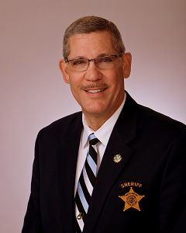

***OFFICE OF THE***

***SHERIFF OF ROCKINGHAM COUNTY***

Law Enforcement Center

170 NC 65 Reidsville, NC 27320



***WANTED PERSON-INTIMIDATING A WITNESS***

*Date of Release: September 29, 2017*

[WENTWORTH, NC]—

Investigators with the Rockingham County Sheriff’s Office are currently trying to locate 27 year old Carlos Deangelo Clark for outstanding charges of Intimidating a Witness. Clark was last seen in the Reidsville area. Anyone who sees Carlos Clark or knows his whereabouts is asked to call the Rockingham County Sheriff’s Office at 336-634-3232 or Rockingham County Crime Stoppers at 336-349-9683. Callers can remain anonymous and may qualify for a reward.

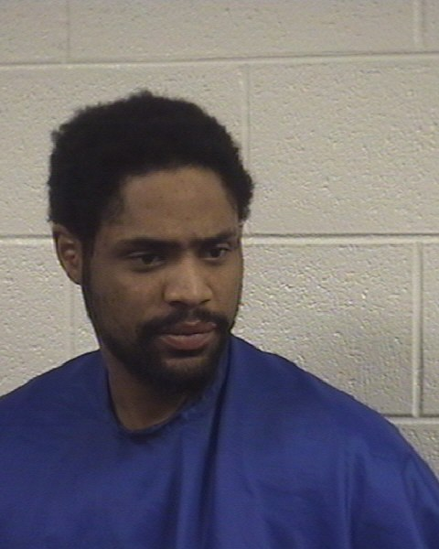

 Carlos Deangelo Clark