Spring Term 2020 Newsletter
Yellow Brick Road Projects
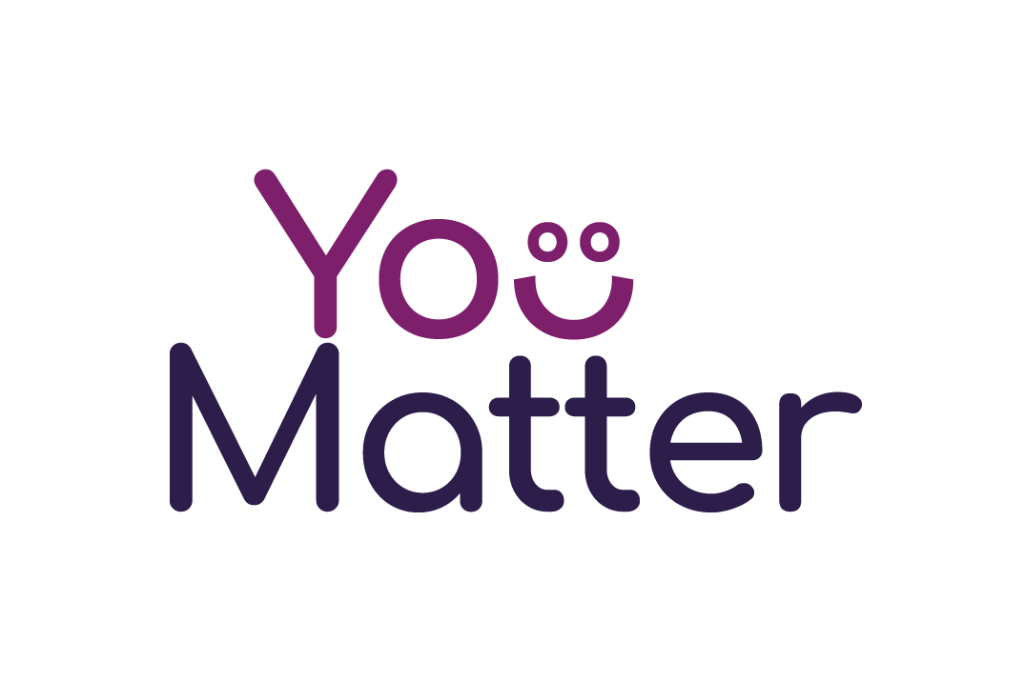

Nominations
If you would like to nominate someone for a You Matter programme please contact us on admin@ybrp.org.uk
You Matter In School (YMIS)
Is for young people in year 8 and above. Trained tutors support young people to gain life skills through group work sessions. The course is based on our adult You Matter programme with the themes of Money, Housing, Life and Future. Each YMIS course is created around the needs identified by the young people in the group.
You Matter
Is for people aged 16 – 35. This accredited life skills course teaches learners what they need to know to get & maintain a tenancy. We work in partnership with local agencies to deliver sessions on budgeting, housing rights & responsibilities, mental health & coping mechanisms, healthy relationships & goal setting.

Office 29, Basepoint, Portway Industrial Estate. Andover SP10 3FG
Welcome to the Yellow Brick Road Projects Spring newsletter.
Happy Reading!!
Abi, Siobhan, Karen, Tanya, Tara and Hilary

You Matter programmes
This term we are running 6 programmes:
Winchester - You Matter in the Private Rented Sector
Andover - You Matter in the Private Rented Sector
Havant – You Matter for local families
East Grinsted – You Matter In School
Burgess Hill - You Matter In School
Andover - You Matter In School
Next term we aim to deliver in:
Hart – You Matter for Mums
Portsmouth – You Matter for Southern Housing Group Residents
Romsey – You Matter for local families
North Baddesley - You Matter for local families
Selsey - You Matter In School

Headlines
Yellow Brick Road Projects were nominated for a Positive Partners Award by Clarion Housing at the HAYN Room 4 Young People Achievement Event.
In November 2019, Yellow Brick Road Projects celebrated 5 years as a charity with an AGM and Tea Party held at Andover Guiildhall. We were delighted that our learners were in attendance, other guests included the Mayor and Mayoress and lots of valued partners and supporters from local agencies.
We trained 6 new tutors, who can now deliver You Matter. Welcome Denise, Vince, Anne Clare, Jamie, Susannah and Naomi, we are delighted to have you on board!!
In December 2019, Abi took part in the Portsmouth Coastal Waterside Marathon and raised £725 for Yellow Brick Road Projects. Thank you for everyone who supported by sponsoring and cheering along on the day.
Yellow Brick Road Projects are a trauma informed service; making an assumption that everyone we meet has experienced trauma and supporting learners with compassion and flexibility to uncover their seams of gold. In January 2020 staff undertook a Trauma Informed training session.
Yellow Brick Road Projects are now a Real Living Wage employer – ‘we believe in a fair day’s pay for a hard day’s work’ www.livingwage.org.uk
We have a new partnership with Centrepoint. As a result there is a range of training we can access plus fantastic opportunities for our learners to obtain bursaries to education and training, and free legal advice.
Four of our Andover learners have just completed the Inspiring Enterprise programme with ActionHampshire. They are moving to work with mentors to develop their social enterprise ideas. Well done!!
