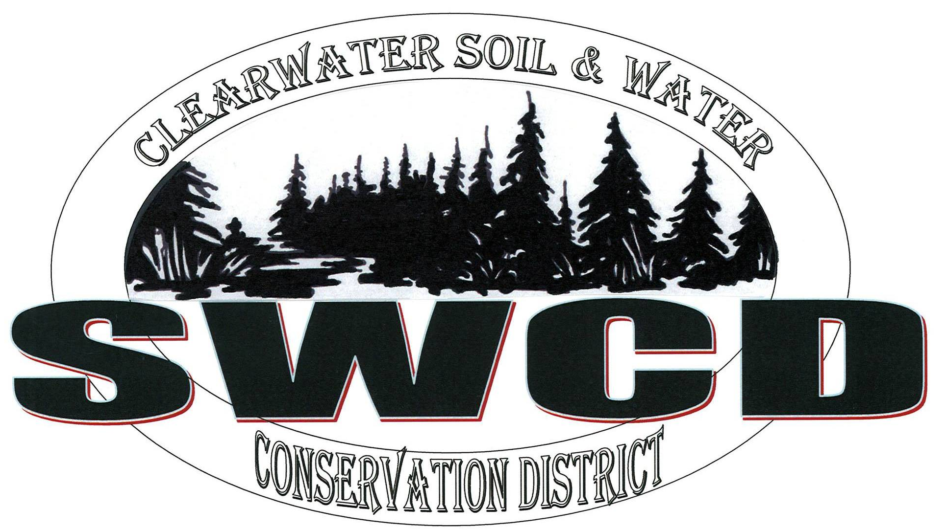
Clearwater Soil & Water Conservation District
312 Main Avenue North, Suite 3, Bagley MN 56621  (218)694-6845  www.clearwaterswcd.org

BOARD OF SUPERVISORS REGULAR MEETING JANUARY 19th, 2017

MEETING MINUTES

Board Members Present:
Harlan Strandlien, Alroy Lewis and Marty Cobenais

SWCD Staff: Nathan Nordlund, Lori Buell and Nickolaus Phillips
NRCS Staff: Cari Roepke
Guests:

The meeting was called to order at 1:02 p.m. by Vice Chair Cobenais in the USDA Service Center. The Pledge of Allegiance was recited.

Agenda: Vice Chair Cobenais called for additions or corrections to the agenda. Reopke noted that she has to attend a conference call and would like her report moved up on the agenda. A motion to accept the agenda with the change of NRCS report was made by Strandlien. Second by Lewis. Motion carried 3-0.

NRCS

Roepke reported that she and Knick have been helping the office in Crookston due to Management transition. Reopke noted that Crookston currently has roughly 70 applications that need to be completed by Friday. Roepke noted that she has been working on eligibility for 7 EQUIP applications at the local office, those also need to be completed by Friday. Roepke reported that she is wrapping up the 2016 CSP payments with only 2 left to disburse. Roepke reported that the 2017 sign up ends February 3rd, she currently has 3 applications.

Appointment of Officers: A motion to continue with the established office rotation for 2017 (new officers: Chair: Cobenais; Vice Chair: Gunvalson; Secretary: Lewis; Treasurer: Strandlien; Member-at-Large: Rydeen) was made by Strandlien. Second by Lewis. Motion carried 3-0.

Cobenais is appointed Chair and continues to running the meeting.

Minutes: Minutes of the regular December meeting were reviewed. Lewis made a motion to approve the minutes as submitted. Second Strandlien. Motion carried 3-0.

PROGRAM TECHNICIAN REPORT

Conferences/Workshop: Phillips reported that he will be presenting at the Soil health/Community workshop in Ponemah on the evening of January 23rd. Phillips attended an off-season AIS meeting for region 1 on the 18th and a pine Lake/Four Legged Lake Planning meeting on December 16th.

Cost Share: Phillips noted that he reviewed and completed the year end pollution reduction reporting for 2016 Cost Share.

Precipitation Network: Phillips noted that he ordered a replacement rain gauge for one of the volunteers and a couple extra to keep on-site.

AIS: Phillips reported that he submitted an activities report to the county for review. Phillips noted that he will be coordinating a work plan with DNR, Always There Staffing Company and the County to discuss renewing the delegation agreement that expired December 31st.

Buffer Law: Phillips reported that he is working on updating the GIS database to start planning the efforts for the year.

MPCA: Phillips reported that he submitted a summary of MPCA’s TALU framework updates. Phillips noted that MPCA is taking requests until February 2^{nd,} if at least 25 people submit a written request then a public hearing will be held on February 16th in Detroit Lakes.

Other: Phillips noted that he completed additional reporting for the Bagley Wastewater Treatment Wetland Vegetation Survey.

DISTRICT MANAGER REPORT

Financial Reports: financial statements showing revenue and expenditures for the month of December were presented to the Board for review. Nordlund Reported that we are currently at the year’s end. Nordlund noted that not all end of the year financial reconciliations have been made and there are still some expenses that need to be claimed but the 2016 final financials should be ready for approval at the February meeting.

Profit & Loss: Income: Nordlund noted that in December the SWCD realized $97305 of revenue mostly a transition of deferred grant revenues. Nordlund noted that there was also revenue from Plat Books Sales, County AIS, the County Water Plan, RLWD, the BWSR Conservation Delivery Grant and BWSR Cost Share fund. Along with regular monthly expenses, additional expenses included project expenses for JD72, JPB engineering fees, payment to Stormo’s, Cost Share payment to Aakre and CWF13 expenses.

Monthly Treasurer’s Report: Nordlund noted that along with expected regular bills for the month of December payments were made to Midway Ford in the amount of $28203.00 for the district’s new Ford Pickup, $2,150.00 to Michael Peterson for the audit, $9885.75 to tom Anderson for a Cost Share Project, $6045.81 to Mark Larson for a Cost Share Project and $500.00 to Overmoe and Nelson for 2016 Flex Plan Administration.

Deposit Detail: Nordlund noted that in the month of December deposits included plat book income, and PERA Aid reimbursement.

Balance Sheet: Nordlund reported that the Accounts Receivable balance was $4152.23. This includes $3435 from the County for AIS expenses and the remainder is outstanding invoices to Plat Book vendors. Nordlund noted that the Net Income line showed a loss of ($6383.18) but the financials do not reflect outstanding income of $11,900 from BWSR for the 2013 CWF grant that was closed out.

A motion to accept the January financial reports was made by Strandlien. Second by Lewis. Motion carried 3-0.

DISTRICT OPERATION

2017 Rates: A motion to make the 2017 SWCD mileage reimbursement rate the same as the IRS rate ($0.535/mile) was made by Strandlien. Second Lewis. Motion carried 3-0.

A motion to keep supervisor Per Diem ($65) unchanged for now and address it at the February meeting when more board members are present; to keep breakfast and lunch meal rates the same ($9, breakfast and $11, lunch); increase dinner rates ($20, dinner) was made by Lewis. Second Strandlien. Motion carried 3-0.

2017 Meeting Dates, Times and Locations: A motion to keep meetings on the third Thursday of each month at the following times and locations was made by Strandlien:
February 16, 1:00 a.m., Bagley USDA Service Center
March 16, 1:00 a.m., Bagley USDA Service Center
April 20, 8:30 a.m., Bagley USDA Service Center
May 18, 8:30 a.m., Bagley USDA Service Center
June 15, 8:30 a.m., Bagley USDA Service Center
July 20, 8:30 a.m., Bagley USDA Service Center
August 17, 8:30 a.m., Bagley USDA Service Center
September 19, 8:30 a.m., Bagley USDA Service Center
October 20, 8:30 a.m., Bagley USDA Service Center
November 16, 1:00 a.m., Bagley USDA Service Center
December 21, 1:00 a.m., Bagley USDA Service Center
Second by Lewis. Motion carried 3-0.

Committee Assignments: Nordlund gave the board a list of the previous year’s Committee Assignments. Lewis made a motion to keep a committee assignments as they were in 2016. Second by Strandlien. Motion Carried 3-0.

Designation of Authorized Signer and Representative for BWSR grants. Nordlund reported that someone need to be authorized as the signer and Representative for BWSR grants. Nordlund noted that this should be done annually. Lewis made a motion to authorize Nordlund as the Authorized Signer and Representative for BWSR grants. Second by Strandlien. Motion Carried 3-0.

2017 Local Capacity Service Grant Agreement: Nordlund reported that he received the 2017 Local Capacity Service Grant Agreement between SWCD and BWSR in the total of $122,750. Nordlund noted that $100.000 is funding for SWCD Administration, programs and projects and $22,750 to support the Clearwater Lake Access Enhancement Project which the county has partnered with. Strandlien made a motion to approve the 2017 Local Capacity Service Grant agreement as outlined. Second by Lewis. Motion Carried 3-0.

Cost Share Policy: Nordlund distributed copies of the Clearwater SWCD Erosion Control & Water Management Policy for the board to review. Lewis made a motion to approve the policy as outlined with the exception, staff may follow Iowa Farm Rates as an estimate but are subject to board review prior to approval. Second by Strandlien. Motion Carried 3-0.

2107 MASWCD State Dues: Strandlien made a motion to pay the MASWCD State Dues in the amount of $2,355.75. Second by Lewis. Motion Carried 3-0.

MCIT: Lewis made a motion to pay the annual MCIT insurance premium in the amount of $4,218.00. Second by Strandlien. Motion carried 3-0

Clearwater Lake Eco footprint Grant Partnership: Nordlund reported that Beltrami County is requesting the Clearwater SWCD form a partnership to address slumping on high banks around the lake. Nordlund noted that funding would come from the Enbridge Eco footprint Grant Fund with match provided by SWCD’s, RLWD and volunteer efforts. Strandlien made a motion for the Clearwater SWCD to become a partner in the Clearwater Lake Eco footprint Grant Partnership proposal. Second by Lewis Motion Carried 3-0.

Local Capacity Work Plan: Nordlund handed out a copy of the 2017 Local Capacity Work Plan for the board to review. Nordlund requested that $10,000.00 be moved from “Equipment” and moved into “Special Projects” making the total for “Special Projects” $30,000.00. Lewis made a motion to approve the Local Capacity Work Plan with the changes as requested by Nordlund. Second by Strandlien. Motion Carried 3-0.

Beef Producers Magazine: Lewis approved running one ¼ page ad at $90.00 per ad per quarter in the “Beef Producers Magazine” for a total of 4 ads in 2017. Second by Strandlien. Motion Carried 3-0.

DISTRICT OPERATION-Info Items

Area 8 meeting: Nordlund reported that there will be an Area 8 meeting on March 10th at 9:00 a.m. and on June 2nd at 9:00 a.m. both in Bemidji. Nordlund noted that it will be Clearwater SWCD’s turn to host the June meeting.

2017 No-Till Program: Nordlund reported that he is still working on getting quotes from dealers for the rental/lease agreement of a tractor and has put together a tentative work plan to assess potential workload. Nordlund noted that he would like to have a committee meeting to discuss contracting help vs. hiring a position.

OTHER:

Meetings: Nordlund reported that he met with the County board to discuss AIS activities and the MPCA TALU. Nordlund also attended a JPB meeting and the BWSR Grant Management Workshop.

Ms. Nordlund noted that he has been working on End of the Year Reporting.

A motion to adjourn the meeting at 3:15 p.m. was made by Lewis. Second by Strandlien. Motion carried 3-0.

______________________________________ _____________________________
Alroy Lewis, District Secretary Date

“It is every man’s obligation to put back into the world at least the equivalent of what he takes out of it.
Albert Einstein

Our mission is simple - to promote the wise use and improvement of our county resources, in order that future generations will inherit an economically viable county that has made wise choices in resource management.

