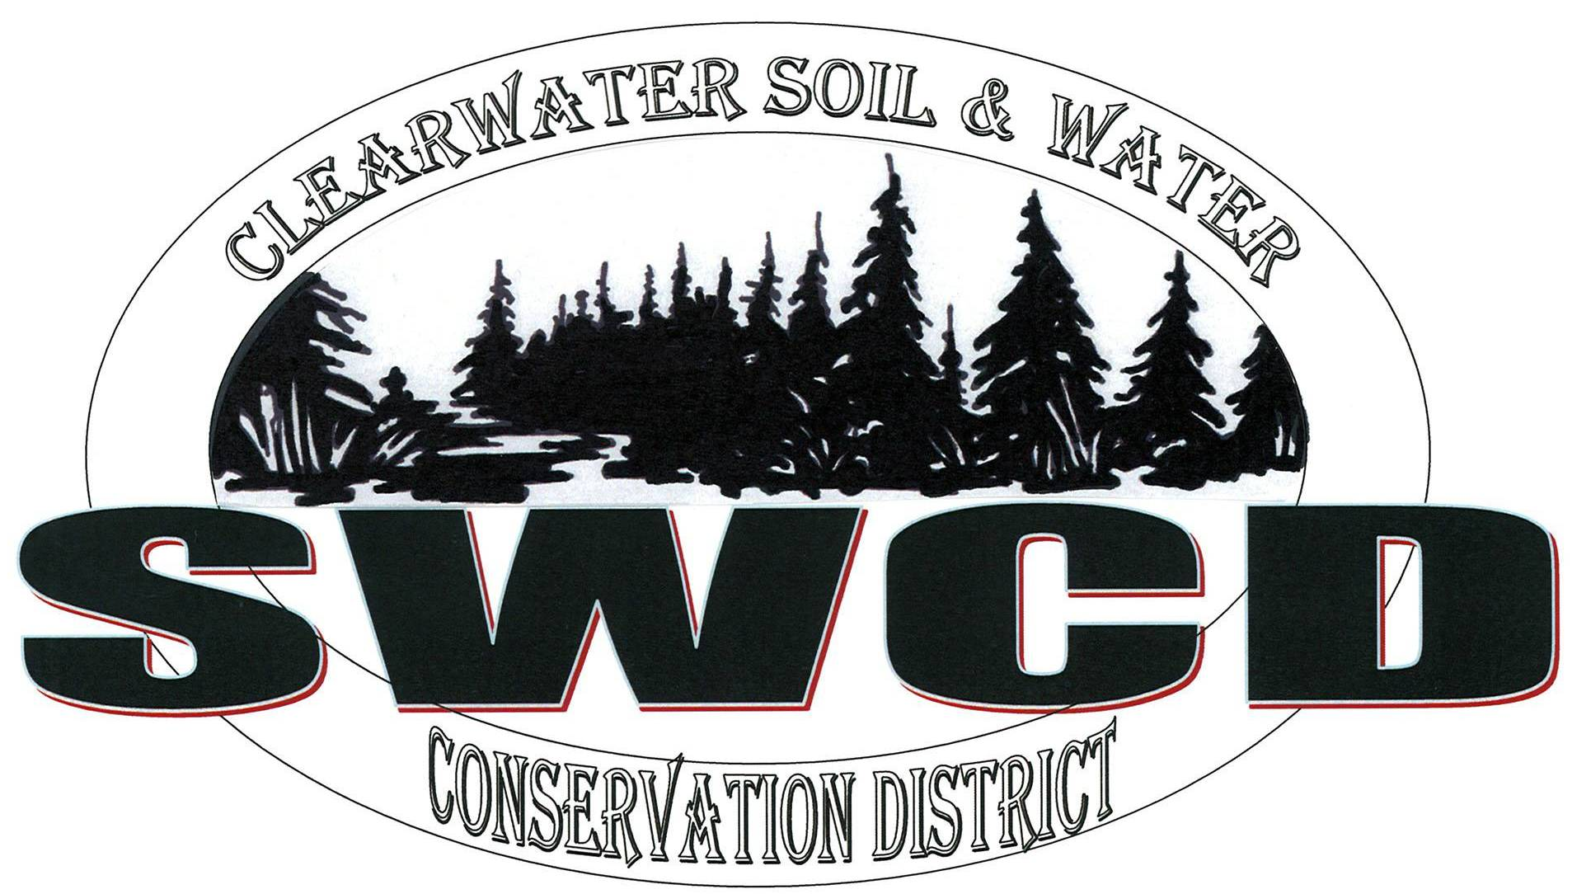
Clearwater Soil & Water Conservation District
312 Main Avenue North, Suite 3, Bagley MN 56621  (218)694-6845  www.clearwaterswcd.org

BOARD OF SUPERVISORS REGULAR MEETING JULY 20th, 2017

MEETING MINUTES

Board Members Present:
Marty Cobenais, Harlan Strandlien, Alroy Lewis, Paul Rydeen and John Gunvalson

SWCD Staff: Nathan Nordlund, Lori Buell and Nickolaus Phillips
NRCS Staff: Cari Roepke
Guests: John Nelson

The meeting was called to order at 8:35 a.m. by Chair Cobenais in the USDA Service Center. The Pledge of Allegiance was recited.

Agenda: Chair Cobenais called for additions or corrections to the agenda. Nordlund requested that the action item, Phillips resignation, be added under the Program Technician Report and that the action items Program Technician position posting and revision of August board meeting date be added under the District Managers report. Lewis made a motion to approve the agenda with the changes as requested by Nordlund. Second by Strandlien. Motion carried 5-0.

Minutes: Minutes of the regular June meeting were reviewed by the board. Lewis made a motion to approve the minutes as submitted. Second by Strandlien. Motion carried 5-0.

NRCS

EQIP (Environmental Quality Incentive Program): Roepke reported that she has an EQIP sign up ending on August 18th and has been slowly receiving applications.

CSP (Conservation Stewardship Program): Roepke reported that she currently has 1 approved CSP application and has been working on that.

CRP (Crop Rotation Program): Roepke reported that she has been working on finishing up the CRP contracts. She noted that she has a few field checks left to do and needs to check eligibility.

Other: Roepke reported that Knick resigned from her position so Roepke is currently the only one in her office. Roepke noted that she is still detailed in McIntosh office 2-3 days a week and may have to continue doing so for up to a year.

Roepke noted that she will be on vacation the week of August 14th-18th and will be at a training in D.C. the week of the 21st-25th.

PROGRAM TECHNICIAN REPORT
Workshops/Trainings/Events: Phillips reported that he will be attending a Pine Lake/ Four Legged Lake Work Plan meeting in Thief River Falls on Friday, 21st, a RLWD JD 72 landowner meeting in McIntosh on July 31st and a County work planning session on Friday, July 28th.

AIS: Phillips reported that he has been inspecting traffic counters and zebra mussel substrate tubes. Phillips noted that there are some volunteers watching the tubes on their own docks and he is still looking for more. Phillips is planning on performing veliger sampling /netting on 10 area lakes.

Vehicles: Phillips reported that he picked up the truck and Aerator and noted that the hydraulic system seems to be working well.

“Soil Health Program”: Phillips reported that there were not any Aerator users so far this month but did receive multiple calls about use in August after the next haying. Phillips reported that there was 35.3 acres ran on the No-Till-Drill this month with a total of 227.3 acres so far for the entire season.

2015 CWF No-Till-Grant Phillips reported that the Mark Larson Cattle Exclusion project is complete and ready for final payment $250 per acre x 5.29 acres total $1,322.50 for exclusion acres. Rydeen made a motion to approve paying Larson an incentive of $1322.50 from the 2015 CWF No-Till-Drill Grant. Second by Gunvalson Second. Motion Carried 5-0.

Tree Planting: Phillips reported that he did a site visit at Bob Birnstengel’s tree planting and created a final planting plan for 2018.

Buffer Law: Phillips reported that he has drafted a version of a County APO plan and template letters for enforcement use. Phillips noted that he will be meeting with the County Board on the 28th to work through detail of the enforcement implementation, ongoing coordination with BWSR on process the details, conducting site visits and removal of additional sites from the compliance list.

Other

Resignation Letter: Phillips distributed copies of his letter of resignation to each board member, noting that his final day would be July 31st. Lewis made a motion to accept Phillips resignation as submitted. Second by Rydeen. Motion carried 5-0.

DISTRICT MANAGER REPORT

Financial Reports: Financial statements showing revenue and expenditures for the month of June were presented to the Board for review.

Profit & Loss: Income: Nordlund noted that we are currently 50% through the year. Nordlund reported that in the month of June the SWCD recognized revenue from Plat Books Sales, the County Water Plan, the 2015 CWF Grant and Buffer Law grant billing. Expenses: Nordlund noted that outside of regular expenses for the month of June additional charges were registration costs for the Leadership Institute that Nordlund plans on attending and some No-Till-Drill expenses.

Monthly Treasurer’s Report: Nordlund noted that for the month of June payments were made to Raphael’s Bakery for the Area 8 meeting, to Tree Pro for tree tubes and No-till Soil Health payments.

Deposit Detail: Nordlund noted that in the month of June deposits included a Tree Planter rental payment, Plat Books sale deposits, soil health program payments and a payment for a County Wall Map.

Balance Sheet: Nordlund reported that the Accounts Receivable balance was $21,602.00. Nordlund noted that most of this balance is the $20,887 for the Water Plan and the remainder is outstanding Plat Book invoices to vendors.

A motion to accept the July financial reports was made by Lewis. Second by Gunvalson. Motion carried 5-0.

DISTRICT OPERATION-Board Action Items

BWSR Riparian Buffer Cost Share Grant Agreement: Nordlund reported that the Buffer Cost Share dollars have been designated for each county and Clearwater’s portion of the allocation is $50,000. Nordlund noted that the SWCD has until the end of the year to encumber these funds for buffer projects at this time unencumbered funds will have to be returned. Strandlien made a motion to approve to contract as presented by Nordlund. Second by Lewis. Motion carried 4-1 with Rydeen Opposed.

2016 Local Capacity Budget Revision: Nordlund reported that he has made some revisions to the 2016 Local Capacity Budget. Lewis made a motion to accept the 2016 Local Capacity budget revisions as submitted by Nordlund. Second by Gunvalson. Motion Carried 5-0.

2018 Budget: Nordlund distributed a copy of the proposed 2018 Budget. Lewis made a motion to accept the budget as submitted by Nordlund. Second by Gunvalson. Motion Carried 5-0.

DISTRICT OPERATION

First National Bank Certificate Renewal: Nordlund reported that the CD valued at $5,535.83 is up for renewal. Nordlund passed out copies of interest rates from local banks. Lewis made a motion to keep the CD at the bank it is currently at and make it a 2-year term. Second by Strandlien. Motion Carried 5-0.

Governance 101: Nordlund reported that the Governance 101 conference will be held on Bloomington at the Airport Marriot on September 14-15th. Nordlund noted that Registration is $150 and hotel rooms are $119 plus tax/night. Cobenais said he was interested in attending. Lewis made a motion to approve covering the cost of registration and room cost for Cobenais to attend the Governance conference. Second by Rydeen. Motion Carried 5-0.

August Board Meeting Date: Nordlund reported that his first Leadership training session is on the date of the August Board Meeting and is wondering if it would be best to reschedule the meeting. Gunvalson made a motion to reschedule the August Board Meeting date to Tuesday August 15th at 8:30 a.m. instead of Thursday August 17th. Second by Lewis. Motion Carried 5-0.

Position Announcement: Nordlund handed out a description of the Program Technician Position. Rydeen made a motion to Post the position description as outlined by Nordlund. Second by Lewis. Motion carried 5-0.

A motion to adjourn the meeting at 10:42 a.m. was made by Rydeen. Second by Gunvalson. Motion carried 5-0.

______________________________________ _____________________________
Alroy Lewis, District Secretary Date

"Leadership is the art of giving people a platform for spreading ideas that work." --Seth Godin

Our mission is simple - to promote the wise use and improvement of our county resources, in order that future generations will inherit an economically viable county that has made wise choices in resource management.

