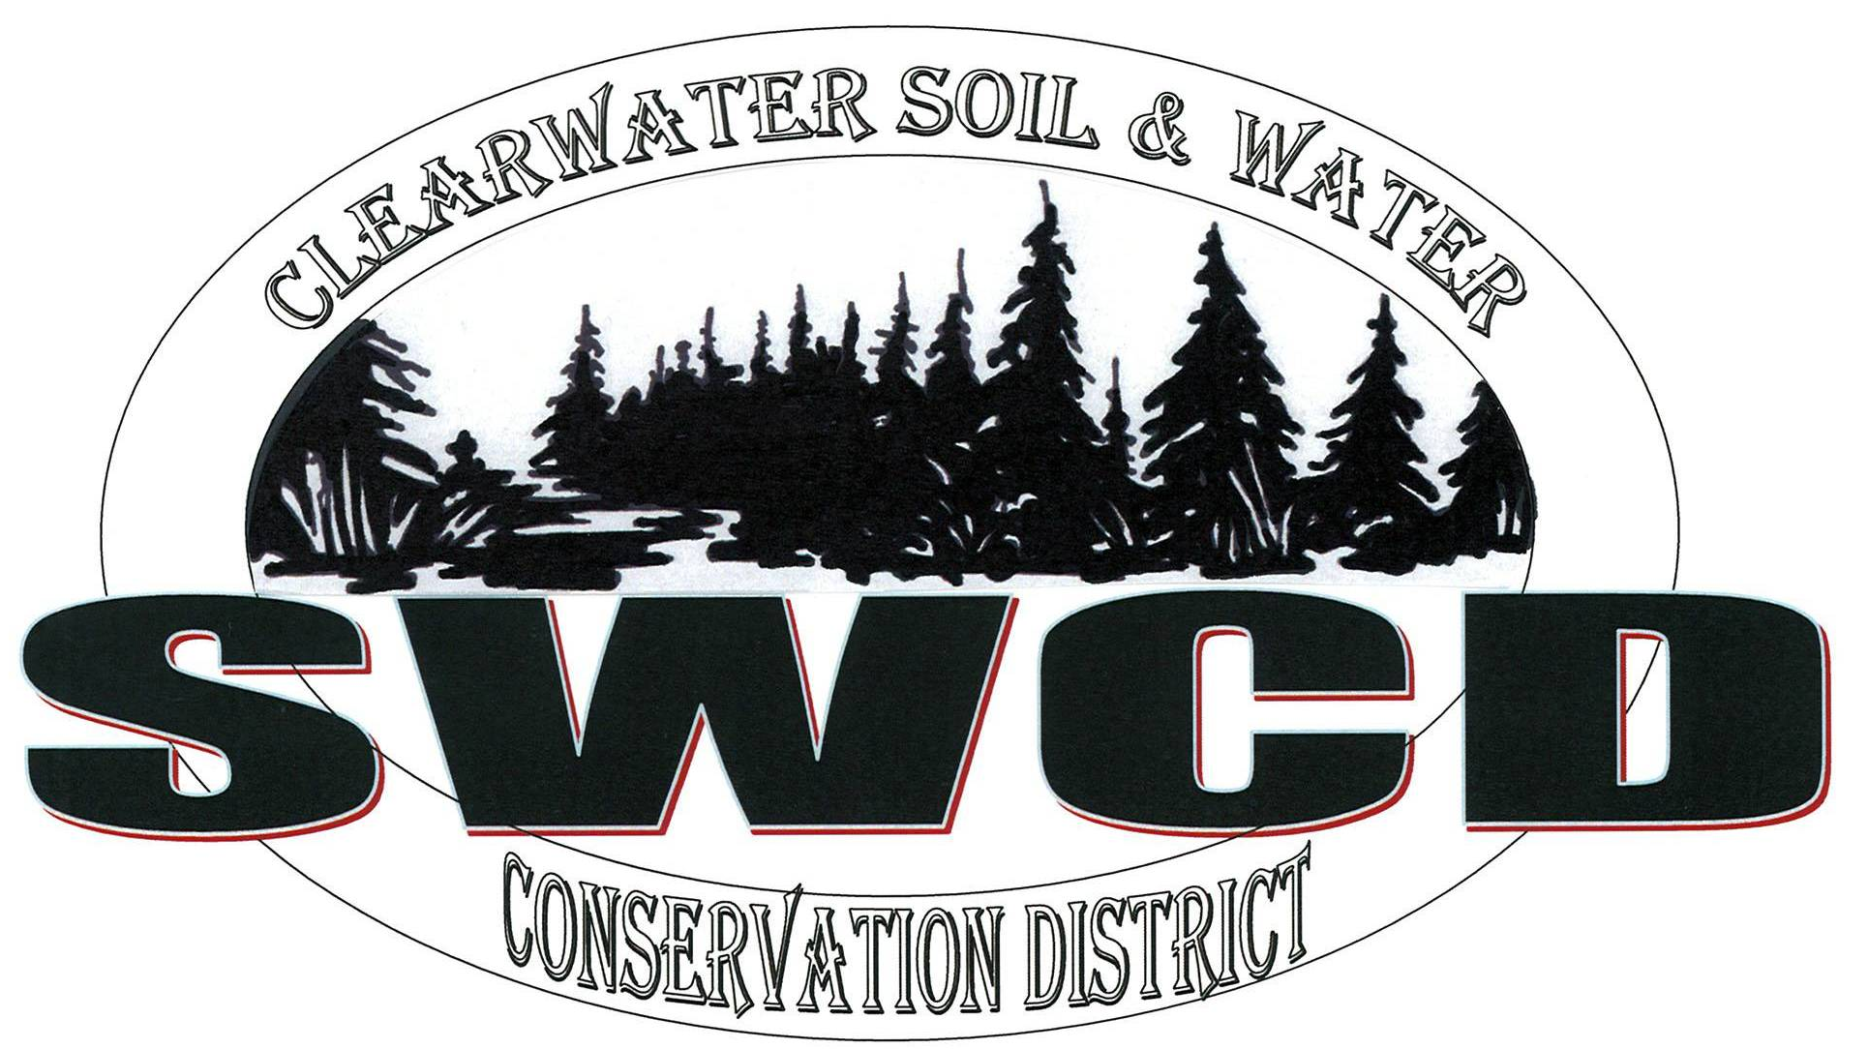
Clearwater Soil & Water Conservation District
312 Main Avenue North, Suite 3, Bagley MN 56621  (218)694-6845  www.clearwaterswcd.org

BOARD OF SUPERVISORS REGULAR MEETING DECEMBER 14th, 2017

MEETING MINUTES

Board Members Present:
Marty Cobenais, Harlan Strandlien, Alroy Lewis, Paul Rydeen and John Gunvalson

SWCD Staff: Nathan Nordlund, Lori Buell and Chester Powell
NRCS Staff: Cari Roepke
Guests:

The meeting was called to order at 12:56 p.m. by Chair Cobenais in the USDA Service Center. The Pledge of Allegiance was recited.

Agenda: Chair Cobenais called for additions or corrections to the agenda. Nordlund requested that action item, approval of 2018 & 2019 BWSR grant agreements be added under District Manager Report. Rydeen made a motion to approve the agenda with the addition as requested by Nordlund. Second by Strandlien. Motion carried 5-0.

Minutes: Minutes of the regular November meeting were reviewed by the board. Rydeen made a motion to approve the minutes as submitted. Second by Lewis. Motion carried 5-0.

NRCS:

EQIP: Roepke reported that she has been working on EQIP eligibility and currently has 11 applications. Roepke noted that the deadline to apply is January 9th.

CSP: Roepke reported that she has 4 CSP renewals approved and obligated. Roepke noted that she has processed 22 total CSP payments.

Misc.: Roepke reported that she is done as acting D.C. in McIntosh and will no longer be going over there during the week. Roepke noted that as soon as the freeze is over NRCS will be advertising for a Conservation Technician for the Bagley office.

PROGRAM TECHNICIAN REPORT

AIS: Powell reported that the 2017 AIS plan has been submitted to the DNR and the 2018 AIS plan has been approved by the county board.

Cost Share: Powell reported that the Mark Larson well sealing project is complete. Powell noted that total project cost came in at $305. Rydeen made a motion to approve paying 50% total project cost in the amount of $152.20 from 2016 Cost Share funds. Second by Lewis. Motion Carried 5-0.

Powell noted that he assisted the JPB Technician with surveying ditch cutting in Pine Lake Township.

Shevlin Township Nitrate Testing: Powell noted that the MDA is working to develop a nitrate testing plan for areas of concern based on soil composition and land use. Powell reported that Shevlin Township has been preselected and MDA is looking for SWCD input and assistance. Lewis made a motion to deny working with the MDA to test for nitrates in Shevlin Township. Second by Rydeen. Motion Carried 5-0.

Water Plan: Powell presented the board with a resolution from Wild Rice Watershed District for the One Watershed One Plan. Cobenais made a motion to amend the resolution by adding the language “and the tribe” in three locations. Cobenais made a motion to approve the amendments to the resolution Rydeend second the motion. Motion carried 5-0. Cobenais made a motion to approve the resolution with the amendments. Second by Lewis. Motion Carried 4-1 Rydeen opposed.

Office Supplies: Powell is interested in getting a second monitor and a GPS. Powell noted that he has located a monitor for $98.98 and a Garmin GPSMAP 64st for $235.11. Rydeen made a motion to approve the purchase of both items. Second by Strandlien. Motion Carried 5-0.

Other:
Meetings: Powell reported that he and Nordlund attended an Ag Water Quality Certification meeting in McIntosh on 11/30/17

Upcoming Meetings: Powell plans on attending the Pine Lake and Four Legged Lake Project team meeting in Thief River Falls on 12/15/17 and the MASWCD conference in Bloomington Dec 3-5.

Midwest Soil Health Conference: Powell reported that he was interested in attending the Midwest Soil Health Summit on February 14-15. Powel Noted that cost of registration is $150 plus room. Lewis made a motion to approve the SWCD cover the cost of registration and lodging for Powell to attend the Conference. Second by Gunvalson. Motion Carried 5-0.

DISTRICT MANAGER REPORT

Financial Reports: Financial statements showing revenue and expenditures for the month of November were presented to the Board for review.

Profit & Loss: Income: Nordlund noted that we are currently 91.67% through the year. Nordlund reported that in the month of November the SWCD recognized revenue from Plat Book sales, BWSR Cost Share and the MN Buffer Law grant.

Expenses: Nordlund noted that outside of regular expenses for the month of November additional charges were for vehicle gas, and expenses recognized for the County Lake Access Project.

Monthly Treasurer’s Report: Nordlund noted that for the month of November, outside of regular expenses, there was a payment of $250 for our tree vendor license and a $1,359 deposit from MCIT for our annual dividend. Nordlund noted that there was also a $900 expense to RMB that would be reimbursed from the County for AIS.

Deposit Detail: Nordlund noted that in the month of November deposits included, a MCIT dividend, the Leadership training refund and Plat Book Sales.

Balance Sheet: Nordlund reported that the Accounts Receivable balance was $360.00. Nordlund noted that most of that balance has since been paid.

A motion to accept the November financial reports was made by Rydeen. Second by Lewis. Motion carried 5-0.

Other Reports/Meetings:

DISTRICT OPERATION-Board Action Items

NRCS Contribution Agreement: Nordlund updated the board, reporting that as of now we are currently waiting for further instructions before moving ahead with the printer replacement.

Soil Health Brochure and Website Update: Nordlund reported that the Area VIII JPB has contracted with a Marketing designer to assist SWCD’s with their Marketing needs.

Clearwater Lake Shore land Protection Project: Nordlund reported that the project is being managed by the Beltrami SWCD and the plans have been developed by the JPB. Nordlund noted that funding is coming from the Eco footprint grant by Enbridge but they are looking for additional contributions of $15,000 in the coming months.

Position Description: Rydeen made a motion post the District manager Position as presented for one week internally before the next board meeting and to offer the District Manager position to Lori Buell at $19.75 per hour if no other interest is shown internally. Rydeen noted that Powell’s wage is to increase to $18.00 per hour following his 6 month probationary period if the board is satisfied with his performance. Second by Lewis. Motion Carried 5-0.

BWSR 2018 & 2019 Programs and Operations Grant: Nordlund Lewis made a motion to approve the 2018 & 2019 Programs and Operations Grant agreement from BWSR. Second by Strandlien. Motion Carried 5-0.

Budget: Nordlund reported that he will be waiting until the January meeting to present the budget to the board.

A motion to adjourn the meeting at 2:58 p.m. was made by Rydeen. Second by Gunvalson. Motion carried 5-0.

______________________________________ _____________________________
Alroy Lewis, District Secretary Date

"Leadership is the art of giving people a platform for spreading ideas that work." --Seth Godin

Our mission is simple - to promote the wise use and improvement of our county resources, in order that future generations will inherit an economically viable county that has made wise choices in resource management.

