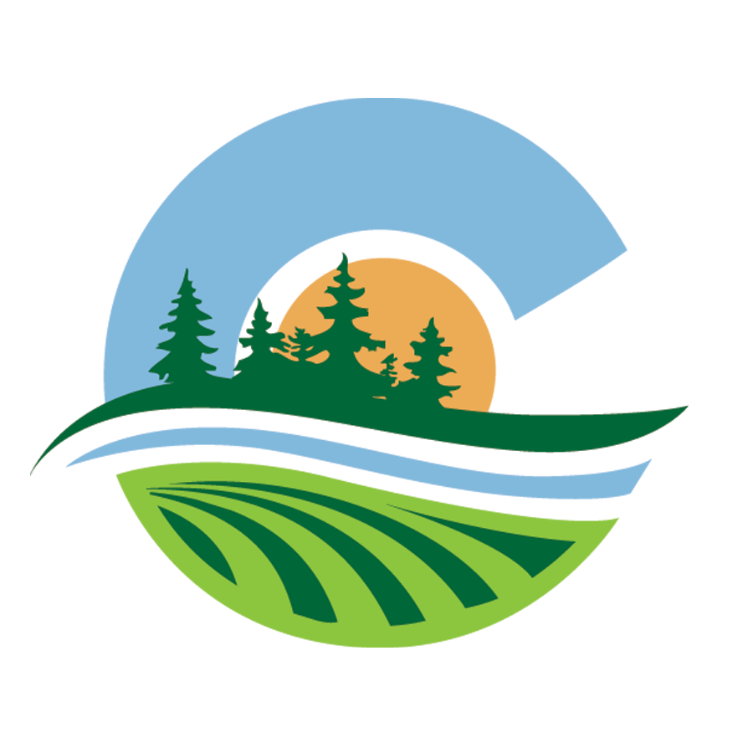

CLEARWATER SOIL & WATER CONSERVATION DISTRICT **|** SUMMER 2022

**Clearwater’s Conservation**

**Chronicles**

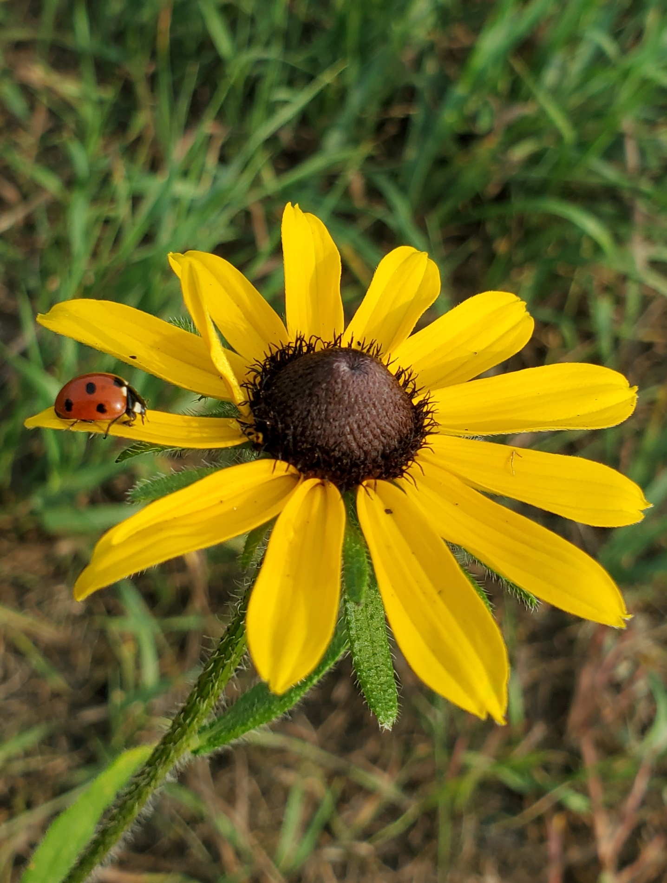

**IN THIS ISSUE:**

1. Forest Stewardship Plan Page 2

2. 1 Watershed, 1 Plan

1. Rain Barrels Page 3

1. Drinking Water Testing Page 4

2. Watch ‘Em Grow

1. Burning for Pollinators Page 5

1. Rain Gauge Page 6

1. Puzzle Page Page 7

**District Staff**

Lori Buell

District Manager

Lori.Buell@mn.nacdnet.net

Chester Powell

Water Plan Coordinator/

Program Technician

Chester.Powell@mn.nacdnet.net

Brielle Prokosch

Program Technician

Brielle.Prokosch@mn.nacdnet.net

Kaleb Buesing

District Technician ClearwaterSWCD1954@gmail.com

Office Phone: (218) 694-6845

Photo by: Brielle Prokosch

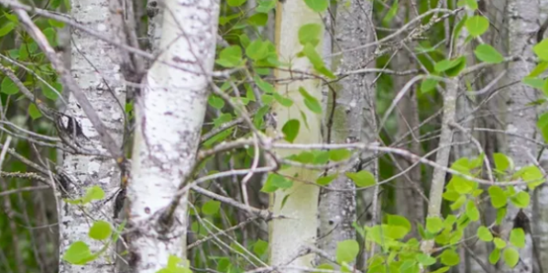

# 1 Watershed, 1 Plan

## Mississippi Headwaters and Clearwater River

Forest Stewardship Plans

### We Can Help!

Did you know Clearwater SWCD can help with the financial aspects of Forest Stewardship Plans? Forest Stewardship Plans are one of the few programs that Clearwater SWCD runs that can qualify for a percentage of reimbursement; this partial reimbursement is called cost share. Clearwater SWCD’s cost share can assist landowners who want their private forests to be actively managed to create wildlife habitat, improve your woods, harvest timber, etc.

There are a few guidelines Clearwater SWCD has when assisting landowners with a Forest Stewardship Plan:

1. The landowners must own a minimum of 20 acres of land within Clearwater County with at least 50% of the property forested.

2. The plan must be written by a DNR certified plan writer.

3.The plan must be written with management goals that benefit water quality.

4. The landowner must talk to Clearwater SWCD BEFORE starting any plan.

If you think you may be interested in managing your land and forest related resources in a healthy way, give our office a call for more information. We can even put you in touch with a certified plan writer.

**Mississippi Headwaters Watershed:**

In 2022 Clearwater SWCD was asked to implement Soil Health throughout the watershed. The Mississippi Headwaters Watershed spans from Itasca State Park at the headwaters downstream to the Pokegama Dam in Cohasset. The vast majority of the farmed acres in the watershed are located on the western edge from eastern Clearwater County to Cass Lake. Since Clearwater SWCD already had a well-established Soil Health Program the neighboring districts requested that Clearwater SWCD expand their existing program to go watershed wide. The watershed wide soil health program officially started in spring of 2022. In the past couple months over 500 acres have been no-till planted via the watershed wide soil health program. Similar amounts are expected to be planted for cover crop this growing season yet. Eligible landowners whose property falls within the Upper Mississippi Headwaters Watershed boundaries are encouraged to partake in the program. Landowners within the watershed can be eligible for $40 per acre for soil health practices.

For questions regarding eligibility please contact our Clearwater SWCD office.

**Clearwater River Watershed:**

The Clearwater River Watershed is nearing the final stages of plan writing and is on schedule to start implementation in early 2023. The Clearwater River Watershed spans from northeast Mahnomen County and ends where it joins the Red Lake River in Red Lake Falls. The watershed is highly diverse and covers a large variety of landscapes from Forested lands to the Red River Valley.

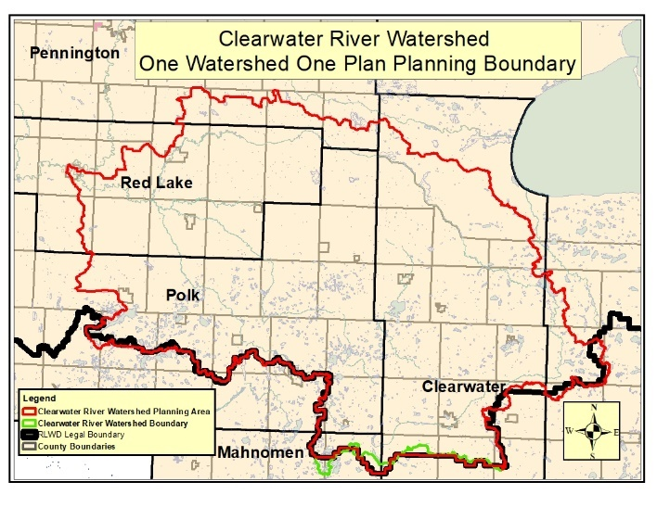For questions about the Clearwater River Watershed One Watershed One Plan please contact Clearwater SWCD.

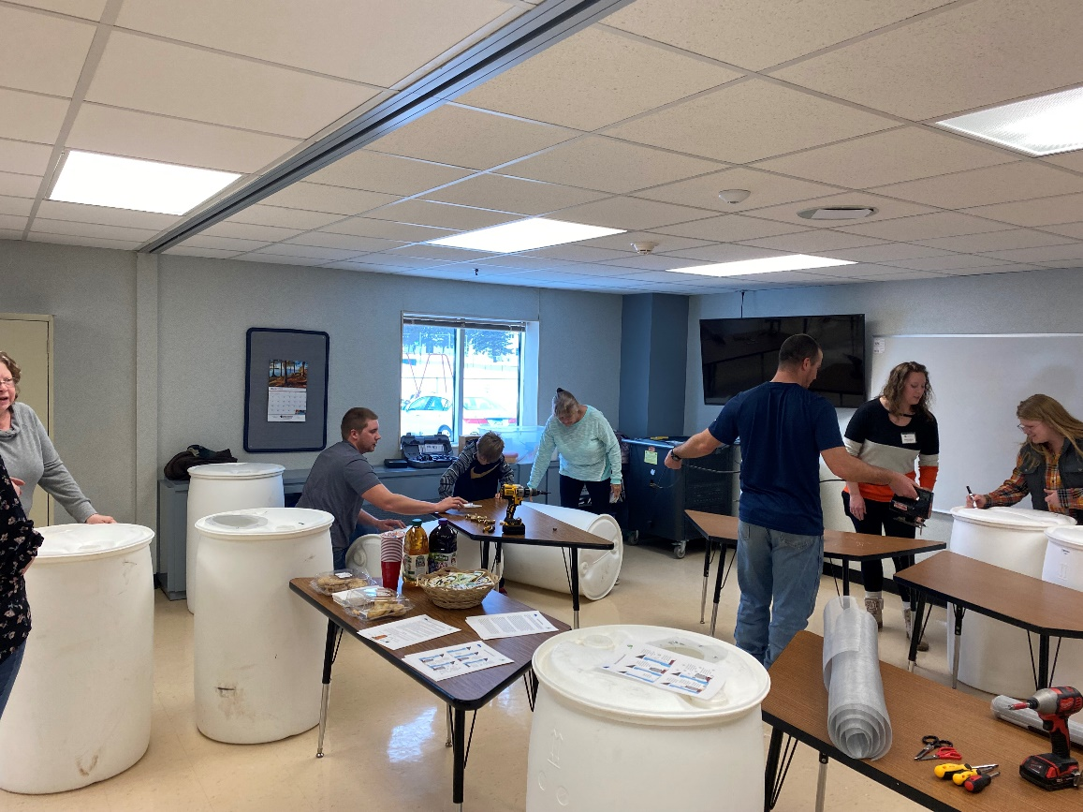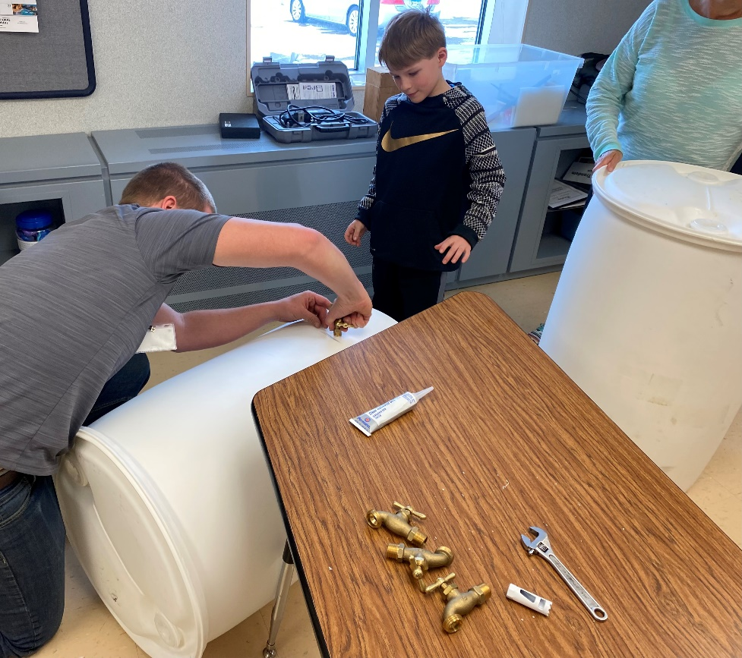

# Rain Barrels

## Clearwater SWCD’s Urban Education Classes Have Begun!

During this spring on April 7th, Clearwater SWCD hosted a Rain Barrel Education class at Bagley’s Community Education room. Participants were instructed on how a rain barrel works and the environmental benefits of conserving rainwater. Staff explained how install one on the participants own property and how to maintain rain barrels throughout the year. Each participant was then able to construct their own rain barrel with provided supplies with help of SWCD staff. The class was successful, and every participant was able to take home their fully constructed rain barrel after the class!

A rain barrel captures water from rooftops and collects it in order to use it for gardening uses. Collecting water runoff from roofs can reduce the amount of water that can damage lawns and therefore prevent soil erosion. Rain barrels can help entire communities by reducing storm runoff which can accumulate pesticides, fertilizers and pet waste that can harm local natural bodies of water. Natural debris like sticks and leaves can also collect in the runoff and clog storm drains when it heavily rains. With rain barrels you can save money on water bills and conserve water during droughts like in 2021!

Clearwater SWCD hopes to hold more community education classes in the future, so keep an eye out on our Facebook page or website for any more classes. We hope to expand into rain garden, pollinator gardens, composting and other urban conservation classes eventually.

A special thank you to the Bagley Public School Community Education for allowing us to put on this rain barrel class.

### Drinking Water Testing

### SWCD + RMBEL = Easy at Home Water Testing for You!

Need your drinking water tested? Clearwater SWCD has partnered with RMB Environmental Laboratories (located in Detroit Lakes) to provide drinking water testing kits and a courier service.

You can use the kits for a variety of test including total coliform bacteria, nitrates, arsenic, etc. If you would like a drinking water testing kit, please stop by our office to pick one up during normal office hours. After following the instructions that RMB provides in the kit, making a check out to them, you can drop off your filled out kit right back here at the Clearwater SWCD office for the lab’s courier service to pick up.

The fee is about $25.00 per test, depending on what you want to test for of course. Currently the lab can only pick up kits that are dropped off at our office Monday through Thursday and only before 10:00 a.m. Give us a call for any pick-up/drop-off questions. Give RMB Labs a call for any water testing

questions you might have at (218) 846-1465.

# Watch ‘Em Grow

## First Graders Learn About Planting Trees

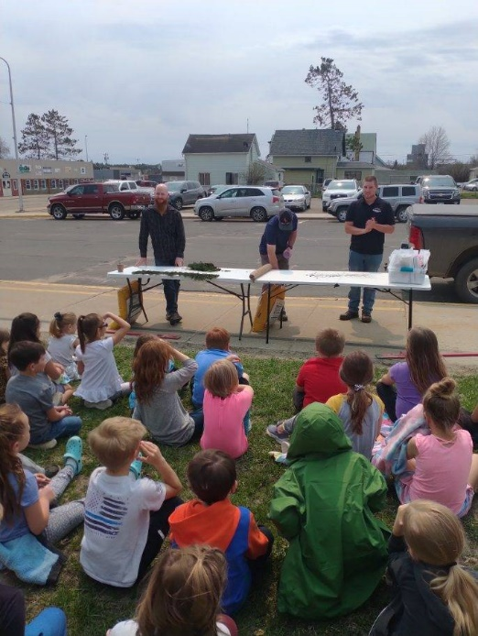

First grade classes at Bagley Elementary and Clearbrook-Gonvick Schools had the chance to learn about planting trees while taking home a Balsam Fir of their very own.

First graders learned about what a tree needs to become successful, how pollinators have an impact on trees and the food they produce. They

also learned how to take care of their own trees. First graders were able to plant their own Balsam Fir in a peat pot with potting soil and received informational handouts about their Firs, pollinators, and planting steps (along with some snacks, of course!).

Every spring before school lets out, Clearwater SWCD holds our Watch ‘Em Grow educational program for the first graders in Clearwater County.

### Burning for Pollinators

### Burning the Pollinator Plot at the Conservation Farm

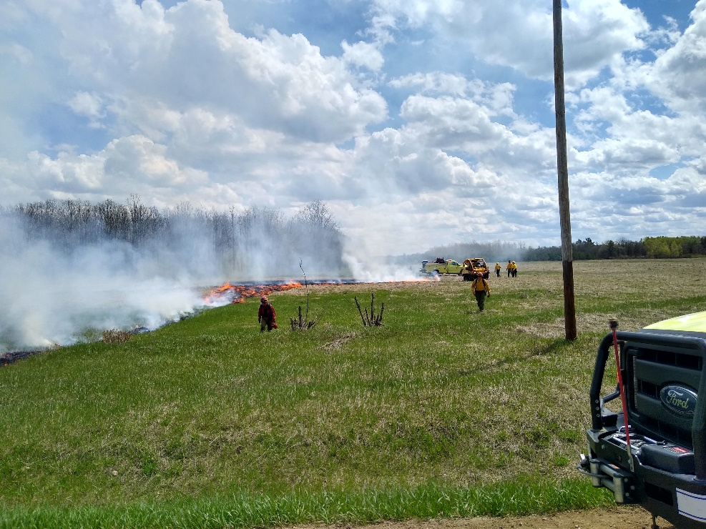A prescribed burn was conducted by the Minnesota DNR at the District's Conservation Farm on May 24th. The DNR used staff mostly from the Bemidji and Bagley offices to conduct the burn. They used this prescribed burn for the training of new personnel. The purpose of the burn was to rid of excess thatch so new growth could occur more easily. The burn had to be timed right so it would burn off enough thatch for new growth, but not burn too hot as it would potentially kill the existing plants root stock.

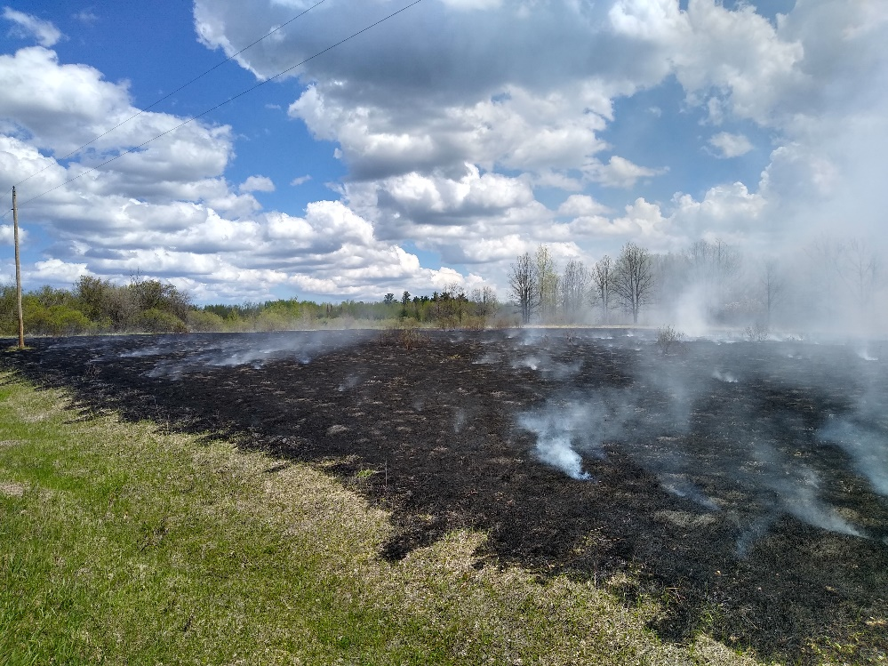With the thatch gone, seed that has been on or in the ground for years will have a chance to sprout and survive to replenish the population of grass and flowering species that were originally planted 20 years ago. Along with allowing new seeds to germinate, the existing vegetation that is there is given better growing conditions so growth is vigorous right after a burn. This was the third time the plot has been burned since the original seeding. Ideally prairie plots like this are burned every 4 or 5 years to keep the plant community healthy. Before intervention by humans, prairies naturally burned in similar time intervals allowing the natural plant communities that were there to persist for centuries.

After the burn, we inter-seeded a new mix of flowering species using our no-till drill and a broadcast seeder. We did two strips using each method to see which, if either, produced better results. We will likely not be able to make that determination until 2024 or 2025 as native flowering species generally take 2 to 3 years to put on good growth and possibly flower.

**Clearwater County Rain Gauge**

A Look at Rainfall for 2021 and 2022

Clearwater County had an averaged total of 21.30 inches of rainfall in 2021. October was our wettest month with roughly 4 inches of precipitation (oof!) and March being our driest with 0.27 inches of precipitation converted from snow. July was close in second being the driest month at 0.6 inches. With such high temperatures, 2021 had parts of Minnesota experiencing the worst drought in almost 40 years.

Luckily it looks like we’re back on the wet track this year in 2022. Maybe even too wet considering the amounts of flooding in fields and roadways this spring… April already had a high average with a whopping 7.01 inches in Clearwater. May went through a fairly high rate of thunderstorm activity and has been one of the more active months in years according to the MN Climatology Dept. And for June there seemed to be a decently heavy rainfall once a week. Temperatures have been fluctuating this summer, but the NOAA outlook model suggests warmer than normal temperatures in Minnesota for the rest of the summer.

Clearwater SWCD, along with local volunteers have been working with the Minnesota Climatology Network to gather rainfall data since 1978. We currently have volunteers collecting rainfall data in Falk, Greenwood, Minerva, Moose Creek, Popple, Itasca, Eddy and Rice townships. If you are in a township that does not have a volunteer and would like to become a part of our rain monitoring volunteers, give the office a call for more information.

**Clearwater County Average Annual Rainfall**

**2021 & 2022**

**Clearwater’s Puzzle Page! **

## Digital art of a red umbrella under the rainThis newsletter’s event: **Rain Crossword**



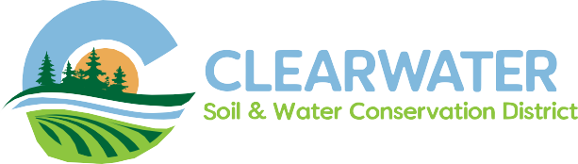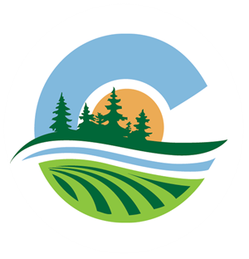

POSTAGE

312 Main Ave N, Suite 3

Bagley, MN 56621





**Visit Our Website**



### Mission:

Our mission is simple - to promote the wise use and improvement of our county resources, in order that future generations will inherit an economically viable county that has made wise choices in resource management.

**312 Main Ave North Suite 3, Bagley, MN 56621**

**218-694-6845 ext 4 | www.ClearwaterSWCD.com**