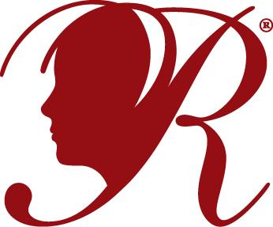
2020 – 2021
REFLECTIONS PROGRAM
UNIT PARTICIPATION AGREEMENT FORM
No entries will be accepted by Corona-Norco Council of PTAs unless this form is completed and returned. Thank you!
As president of my PTA/PTSA Unit, I have read and reviewed the 2020-2021 National PTA Reflections packet. I will ensure that both my PTA Reflections Chairperson and I have a copy. I will make sure my Reflections Chairperson has the Council Reflections email to use for any questions: d23reflections@aol.com.
I have read the guidelines and deadlines. I understand that Council PTA will not accept entries after November 10, 2020. It is the responsibility of my Reflections Chairman and myself to make sure that all our entries are submitted on or before the Council deadline.
Furthermore, I understand that entries not advancing to the 23rd District PTA level (Riverside County) will be not be returned until or after the Council PTA meeting in February 2021. If no representative from my school picks up the entries at that time, Council will keep them stored in the PTA office at the school district office. I understand that it is my PTA’s responsibility to pick up entries within a reasonable amount of time and return them to the students. Entries that advance to the 23rd District PTA level will be returned to Council in the spring. My unit will advise families participating in the Reflections program that PTA is not responsible for any lost or damaged entries, despite all efforts to return entries unharmed.
My Unit will be offering the following categories for submissions: (If ALL-please write ALL)

PTA President: __________________________________Phone #_____________________ School: ________________________________________ Date: _________________ Unit Reflections Chairperson: _______________________Phone #__________________ Current school student enrollment: _______________________
National PTA id # (from bylaws cover page): _______________________
PLEASE RETURN THIS FORM TO PTA COUNCIL AT THE SEPTEMBER 8, 2020 MEETING. No entries will be accepted if this form is not completed and returned. Thank you!
___________________
Signature Date

