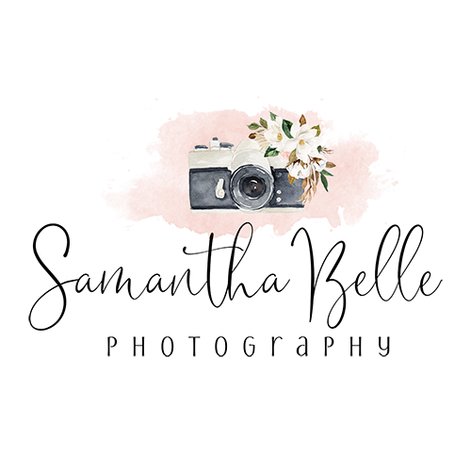

Lifestyle Session Client Questionnaire

**First Name Last Name**

**Address:**

**Email Address:**

**Phone #:**

**Your Spouse/Partner Name:**

**Your children’s name and ages:**

**I’d love to hear one fun fact about each person in your family:**

**What is the most important aspect of your Lifestyle Session that you want me to capture?** Is there a certain aspect of your life - as it is right now - that you would love documented?

**Activity\***

What makes a lifestyle session even more fun is doing an activity! Do you like to bake cookies as a family? Or build crazy towers with blocks? If you have your session outside the home, what about going for a walk? List up to 3 activities - you could do one or maybe even all of them!

**Is there anyone in your group who is extra shy and may need some time to warm up to me?:**

**What is the most important shot for you to walk away from this session?:**

**How would you describe your family?**

Urban, Traditional, Artistic, Modern, Rural, Mix of Everything

**Tell me about the architectural/decorating style of your home.**

**What was about my photography that caught your eye?**

**Any additional information or special requests?**