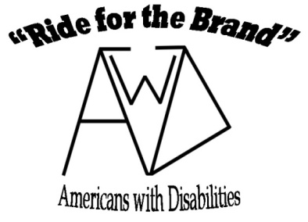
2021 Registration & Liability Waiver/Acknowledgement of Risk Form
(Must be signed and dated before participation in any Mowry’s Lazy Meadows, “Ride for the Brand” activities.)

Participants Name ________________________________________________ Age _______ Phone#___________________
Address______________________________________________________________________________________________
Email _____________________________________________________ Type of Disability (optional) ___________________
We are currently looking to have riding events for 2021 in June. We will have 2 different sessions and require pre-registration for the events so we can plan support staff accordingly. Note: We will be limiting the number of riders for each session to a maximum of 15 and acceptance will be “first come, first serve”. Please indicate the dates which you plan on attending the Ride for the Brand – AwD events in 2021, remember you must sign up for one or the other session no mixing of dates. If we exceed the limit on signups for either event we will notify you to see if we can try to meet your request; remember this is a “first come, first serve” signup!

“Ride for the Brand- Americans with Disabilities”
2021 Riding Sessions

June 3 & June 10 _________ or June 17 & 24 _________
Mowry’s Lazy Meadows will make every attempt to follow current health guidelines currently in effect, but we accept no responsibility should anyone become ill due to the interaction with others while here at our location. If you do not feel comfortable being in crowds or if you are not feeling well please stay safe at home.
Being around and riding horses and ponies are potentially dangerous activities. I fully understand the potential dangers and risks involved with anyone under my guardianship being around and riding horses and ponies. This includes but not limited to death or serious injuries associated with the head, neck, and back, which may result in complete or partial impairment of general health, and well being. As the parent and/or legal guardian of _____________________________________; I hereby voluntary assume all risks associated with this activity and agree to discharge and release Monte and Nancy Mowry of Mowry’s Lazy Meadows sponsors of the “Ride for the Brand-Americans with Disabilities ” (RftB-AwD) program and its volunteers from any and all liability, claims, cause of action or demands of any kind and nature whatsoever which may arise by or in connection with participating in any of the activities offered by the RftB-AwD program.
The terms hereof shall serve as a release and assumption of risk for my heirs, estate, executor, administrator, assignees, and all members of my family.
I fully understand the potential dangers of being around and riding horses and ponies, including death and paralysis, and I hereby give permission to the above defined participant and voluntarily assume all risks to health associated with participation in this activity, and release Monte and Nancy Mowry, the RftB-AwD program, and its volunteers from any and all liability in the event of any injurious accident that occurs while on their property. I also agree with indemnify the RftB-Awd program, and any other persons associated with them, from any claims which may arise in connection with participation in horse, pony, or any other form of wagon rides offered by any of the forgoing.
Photos: During each event we feel that people and possibly local news media will attend and take pictures and use them in various publications. We will try to abide by your wishes in regards to using any photos of individuals under your guardianship to be used in any future published materials in our control. We will also try to have any other forms of media to also abide by your wishes when using the photos they take. Please be aware that we cannot guarantee your wishes are followed by everyone. Please indicate your wishes with a (X) I do allow (_____) or I do not allow (_____) photos taken at the events of ___________________________________________ to be used in any future publication regarding the RftB-AwD program or any independent news media coverage of the event.
Note: please be sure to wear appropriate clothing, safety apparel, and footwear to each event. Riding helmets will be available for use at each event.

_____________________________________________ __________________________________________________ ________________________
Name of parent or legal guardian (print) Signature of parent of legal guardian Date
Mowry’s Lazy Meadows, 2549 34th Ave SE. Owatonna, MN 55060
Email – mowryslazymeadows@gmail.com Website: rideforthebrandh4h
2021 Registration revised January 2021

