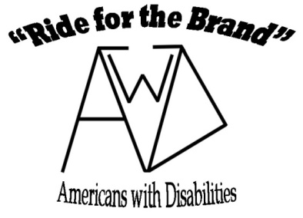

**2023 Registration & Liability Waiver/Acknowledgement of Risk Form**

(*Must be signed and dated before participation in any Mowry’s Lazy Meadows, “Ride for the Brand” activities.)*

***Participants Name*** ***____________________________________________________________******Age* _____________**  ***Phone#*_________________________ *Address ______________________________________________________***

***Email ______________________________________________________ Type of Disability (optional)*__________________**

***Please indicate the session in which you plan on attending the Ride for the Brand – AwD event in 2023.***

***Session #1 - June 1 _________ June 8 _________***

***Session #2 - June 15 ________ June 22________***

***\*\*\* Note you can only sign up for one session and we may have limited capacity so participation will be on a “first come first serve” basis. We will try to meet your request if possible.\*\*\****

***Please read the liability waiver and acknowledgement of risk form carefully and sign it if you fully understand, acknowledge and agree with its content.***

Being around and riding horses and ponies are potentially dangerous activities. I fully understand the potential dangers and risks involved with anyone under my guardianship when being around and riding horses and ponies. This includes but not limited to death or serious injuries associated with the head, neck, and back, which may result in complete or partial impairment of general health, and well being. As the parent and/or legal guardian of _____________________________________, I hereby voluntary assume all risks associated with this activity and agree to discharge and release Monte and Nancy Mowry, and the “Ride for the Brand-Americans with Disabilities ” (RftB) program, and its volunteers from any and all liability, claims, cause of action or demands of any kind and nature whatsoever which may arise by or in connection with participating in any of the activities offered by the RftB program.

Photos: During each event we feel that people and possibly local news media will attend and take pictures and use them in various publications. We will try to abide by your wishes in regards to using any photos of individuals under your guardianship to be used in any future published materials in our control. We will also try to have any other forms of media to also abide by your wishes when using the photos they take. Please be aware that we cannot guarantee your wishes are followed by everyone. Please indicate your wishes with a (X) **I do allow** (_____) or **I do not allow** (_____) photos taken at the events of ___________________________________________ to be used in any future publication of RftB program or any independent news media coverage of the event.

***Note: please be sure to wear appropriate clothing and footwear to each event.***

__________________________________ ________________________________________ Date ________________________

Parent or legal guardian (print) Signature of parent of legal guardian

Mowry’s Lazy Meadows, 2549 SE 34th Ave, Owatonna, MN 55060

507-455-0913, [mowryslazymeadows@gmail.com](mailto:mowryslazymeadows@gmail.com), [www.rideforthebrandh4h](http://www.rideforthebrandh4h)