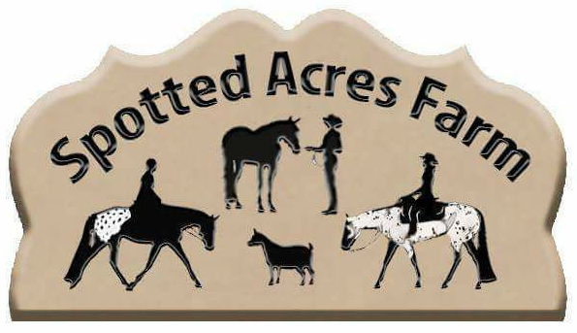
Spotted Acres Farm
Kelly M. Kauffman-Cole
1090 Cole Road, Oakland, Oregon 97462
(541)643-3010 ~ gotspottedacresfarm@gmail.com

THIS AGREEMENT is made on today’s date, by and between your name here,

Residing at: your address here, Oregon, USA, here after referred to as Buyer, and

Kelly M. Kauffman-Cole and family residing at 1090 Cole Road, Oakland, Oregon 97462, here in after

referred to as Seller/Spotted Acres Farm.

Buyer agrees to purchase animal(s) below:

Bill of Sale:
Goat Name | Breed | Color | Registered | Price
2020 Kid | Nigerian Dwarf | TBA | Yes | $ TBD

Deposit received in the amount of $100 paid by way of PayPal received on Today’s Date

Full payment of $___________ received on ___________ paid by way of __________.

Buyer to be in possession of goat(s) on_7 days post weaning date at 12 weeks of age

Date of Sale __________________________________.

*** *** *** *** *** *** *** *** *** *** *** *** *** *** ***
Upon confirmation of payment in full as set forth in paragraph above, SELLER agrees to promptly provide all necessary papers for registration and transfer of ownership to BUYER at BUYER'S expense.

1 SELLER warrants she has clear title to said goat(s).
2 SELLER makes no other warranties, express or implied, including the warranties of fitness, height, show quality, kid production, udder quality, etc.
3 SELLER warrants the said goat(s) are healthy at time of sale and BUYER has had the option to review the condition and health of the goat, including any veterinarian examinations, at BUYER’s expense. If SELLER or veterinarian deems animal unhealthy, SELLER will issue a replacement animal to BUYER upon final approval.
4 Reservations require a $100 deposit accompanied by this signed contract and is NON-REFUNDABLE.
5 If the BUYER’S chosen sex of the kid is not available from their chosen kidding, BUYER has the option to roll the reservation to another kidding.
6 Spotted Acres Farm reserves the right to retain any kid from any breeding.
7 Reserved kids MUST be picked up by 7 days after weaning date unless other arrangements are made prior to this date.
8 All kids will be dis-budded (unless naturally polled), tattooed, and wethers will be castrated, before leaving Spotted Acres Farm.
9 Deposit refunds are not given due to the BUYER changing their mind at any time.
10 In the event of the loss of the goat kid prior to receipted delivery to BUYER, SELLER shall roll over deposit to next choice of goat kid for BUYER.
11 We do not offer any health or wellness guarantees once the goat has left our farm since we cannot control the management of said goat(s) once it is no longer in our care.
12 Any kids who are the result of a doe purchased bred will carry the herd name: Spotted Acres Farm and the BUYERS tattoo numbers. Any animals sold bred are guaranteed bred at time of sale, however SELLER offers no guarantees or has any control over abortion, absorption or loss of fetus, after delivery due to stress, management, natural causes, etc.
13 Goats will not leave the farm and will not be issued registration papers until full payment is received.
14 Spotted Acres Farm requires a $100 deposit to hold adult stock or kids.
15 Reserved kids/goats not picked up after 14 days will be charged $2/day board to the BUYER or the BUYER’S reservation will be forfeited and the kid/goat will be placed for sale.
16 Should a doe or buck be sold as a pet/unregistered, no registration papers will be given to BUYER, only a bill of sale.

Upon material breach of this AGREEMENT by one party the other party shall have the option to terminate sale. This AGREEMENT shall be governed by the laws of the State of Oregon, County of Douglas.

Buyer's signature indicates full agreement with the terms and conditions of this contract.

Seller’s Name: Kelly M. Kauffman-Cole/ Spotted Acres Farm

Seller's signature Kelly M Kauffman-Cole/ Spotted Acres Farm

Email: gotspottedacresfarm@gmail.com Phone: 541-643-3010

Seller's Address: 1090 Cole Road, Oakland, Oregon 97462

Buyer’s Name: ____________________________________________________ ADGA #

Buyer's signature: ______________________________________________________

Address: ______________________________________________________________

City: ____________________________________State:_______ ZIP: ______________

Phone Number: (___)____________________

E-mail: ___________________________________________________

www.spottedacresfarm.com

