Site-Specific Orientation Package

Battle River Archers – The Outdoor Range

1. Welcome & Purpose
Welcome to the Battle River Archers Outdoor Range. This orientation package is designed to:
- Familiarize all members and guests with the range layout.
- Ensure safe and responsible use of the facilities.
- Outline club expectations, policies, and emergency procedures.
- Promote a respectful and enjoyable archery environment.
All participants must review this package and sign the acknowledgment form before using the range. The gate and job box combination code will be provided upon receipt of this signed acknowledgement form and verification of membership registration. Please email your completed form to battleriverarcherscorp@gmail.com

2. Requirements
- All users must have a valid BRA membership or an outdoor range only membership or pay the drop in fee.
- All users must have a valid SAA or CAA membership for insurance purposes.
- All users over the age of 16 MUST complete the Archery Canada Range Safety Officer Course. This is a requirement established by the City of North Battleford during our negotiations for the lease. Its free and takes approximately 30mins. Please visit https://archerycanada.ca/programs/range-safety-officer/
- Children under 16 must be accompanied by an adult with the above Range Safety Officer Certification.

3. Hours of Operations
- The range is NOT to be used while the city staff are working at the office.
- The range is closed during normal business hours (8am-5pm) on weekdays.
- It is open outside of normal business hours (5pm-dark) on weekdays. It is also open on weekends and holidays.

4. Range Layout & Facilities

Entry Gate: The entry gate is located on the left hand side of the River Valley Center office. The gate is identified with BRA signs. It is locked with a combination lock.
Range Flag: The flag poles are located near the entrance and pond area. The red flag must be raised while the range is in use.
BRA Job Box: The job box is located at the base of flag poles. It is locked with a combination lock.
BRA Entry Logbook: The logbook is located inside the BRA Job Box. All users must sign in and out.
Pond Area: The pond is located near the entrance. Respect the safety rope. Swimming is prohibited. Do not disturb the wildlife and fish. Failure to comply will result in a loss of your membership.
Pheasant Area: Pheasant cages are located on the NW corner of the compound. Keep away from the cages. Failure to comply will result in a loss of your membership.
Bathrooms: Located outside of the compound at the front of the River Valley Center Office. Keys for the bathrooms are locked and stored in the BRA job box. Bathrooms must be locked at all times!
Boardroom: The board room is not included with the BRA joint use agreement. It can be rented from the city at an additional cost.
Parking Area: Vehicles must remain in designated parking spaces.
City Office Area: City Maintenance staff utilize the River Valley Center office. This area is off limits to range members.
Emergency Access: Keep fire lanes, entrance gates and emergency access points clear.
Equipment Storage and Seating Area: Seating area and bow case storage is located under the covered shelter next to the pond. Picnic tables are provided. There is no permanent equipment storage area onsite for members. Members must take their equipment home after each use.
Targets: Fixed target butts are numbered and located at marked yardages.

Range map:
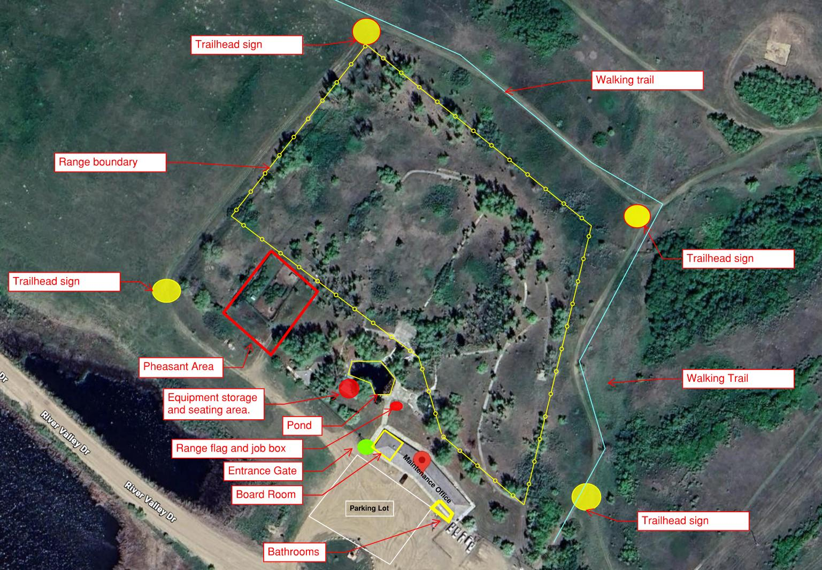

4. Rules
- Use the range at your own risk. Battle River Archers and the City of North Battleford are not liable for any injuries attained while using the facility.
- Children under 16 must be accompanied by an adult.
- Keep the entrance gate, bathrooms and job box locked at all times
- Raise the red flag will using the range
- Users must be a member of their respective provincial archery association and a member of Archery Canada for insurance purposes.
- Alcohol, cannabis, and recreational drugs are strictly prohibited.
- Respect fellow archers, volunteers, and the environment.
- Children under 16 must be accompanied by an adult with the Archery Canada Range Safety Officer Course.
- No pets allowed on the shooting field.
- No littering. Keep the range clean.
- No Sky draws
- Keep away from the pheasant area
- Respect the Pond. Keep out of the pond

5. Shooting Procedures
Shooting Locations: Clearly marked; all shooting must occur from these areas at each individual target. Only nock arrows at the shooting stations, pointing downrange.
Use proper shooting commands:
- 'Clear to shoot' – Shooting may begin.
- 'Hold' – Stop shooting immediately; lower bow, remove arrow if safe.
- 'Clear to retrieve' – All archers may advance to targets.

Safe Handling
- Always treat bows and arrows as if ready to fire.
- Never point a drawn bow at anything other than a targets.
- Broadheads are not permitted.

6. Stray Arrow Incident Report
- All arrows that leave the range compound MUST be reported.
- This is a requirement by City to keep our Joint Use agreement.
- These reports are NOT intended to punish users who accidentally loose an arrow or shoot one over/through the fence.
- These forms are to be used to ensure public safety and make or modify changes to the course preventing future incidents.
- This is an honor system. Please use it.

7. Emergency Procedures
First Aid Kit: Located inside the BRA Job Box.
Emergency Contact: Call 911 for injuries requiring medical attention, fire or police services.
Range Address: Identified on the entrance gate signs. 801 River Valley DR, North Battleford, SK S9A 2X5. Located below King Hill.
Incident Reports: Report all incidents to a Battle River Archers Executives. Please email battleriverarcherscorp@gmail.com.
Incident forms: Located in the BRA Job Box. Incident report forms must be completed for:
* Stray arrows leaving the range area.
* Any injury or near miss.
* Damage to property or equipment.

8. Environmental Awareness
- Stay on designated trails and shooting areas.
- Know where the pedestrian trails are outside of the compound.
- Watch for pedestrians outside of the fenced compound while shooting.
- Respect local wildlife—do not disturb animals on or near the range.
- Pack out all garbage and recycling.
- Keep out of the pond. Do not disturb the fish.
Fire bans and environmental restrictions must be followed.

9. Accountability & Enforcement
- The Outdoor Range compound is under video surveillance.
- Failure to follow safety and conduct rules may result in:
* Immediate removal from the range.
* Suspension or termination of membership.
- The BRA Board of Directors reserves the right to review all incidents.

10. Member Responsibilities
- Keep membership and Saskatchewan Archery Association (SAA) registrations current.
- Sign in upon arrival. Sign out upon leaving.
- Assist with maintaining targets and grounds when possible. BRA will schedule work days through their FB page and email.
- Report unsafe behavior or equipment concerns and recommendations to the BRA Board Executives. Email battleriverarchercorp@gmail.com

11. Acknowledgment
I have read and understood the Outdoor Range Site-Specific Orientation Package. I understand that Battle River Archers and the City of North Battleford are not responsible for lost or stolen equipment. I agree to abide by the rules, safety requirements, and expectations of Battle River Archers.
Please send proof of your Archery Canada Range Safety Officer Training to battleriverarcherscorp@gmail.com. Once received, we will email you the facility combination lock codes.

