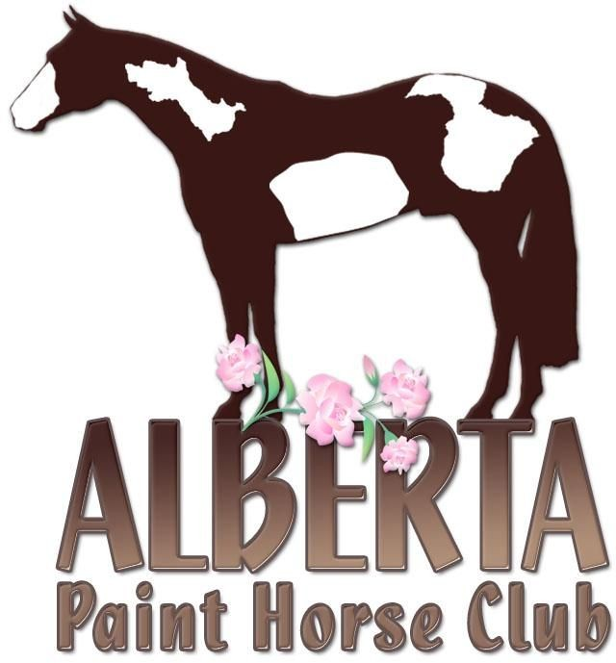
2021 APHC SPRING CLASSIC HIGH POINT WINNERS

JUNIOR HORSE – J LOPE SHOWN BY TYREL POIER OWNED BY RAFTER P QUARTER HORSES
Res: Machined Fancy - Owned by Laura Malyk & Shown by Caitlyn Malyk & Deserie Rieu-Bitz
SENIOR HORSE – HEATHSENSATIONAL – OWNED &SHOWN BY MELISSA JOHNSTON
Res: Simply Encountered – Owned by Cathy Glover & Shown by Devon Smith
SOLID BRED PAINT – HES LOPIN SPOTLESS OWNED & SHOWN BY CAITLYN MALYK
RANCH HORSE – ROCKN TE IRISH OWNED & SHOWN BY BONNIE QUANCE
Sponsored by Eagle Hill Equine
Res: Styled to be Radical – Owned by Bonnie Quance & Shown by Melissa Johnston
YOUTH WALK TROT – AXEL KIMBLE & SHEZ AN ELIMINATOR
NOVICE YOUTH – RAELYNN DIXON & PP DRESSED IN BLACK
Res: Teaira Tracksell & Spotless Gentleman
YOUTH 13 & UNDER – ALLYSSA BELANGER & LAZY SPECIALTY
Res: Megan Waugh & PRR Classy Whiskey
YOUTH 18 & UNDER - RAELYNN DIXON & PP DRESSED IN BLACK
Res: Mya Benoit & PP Invitation to Win
AMATEUR WALK TROT – SHANNON MORIN & I AM PRETTY SPECIAL
Res: Heather Grovet & Three Times A Lazy
NOVICE AMATEUR – TAMARA JAMESON & BESTUNANSWERED PRAYERS
Res: Lieke Poier & Gonna Be Somebody
AMATEUR – DEVON SMITH & SIMPLY ENCOUNTERED
Res: Angela Turcotte & Diamonds Only
AMATEUR SOLID PAINT BRED – CAITLYN MAYLK
YEARLING TRIATHLON – LUCKY N TALLENTED - SHOWN BY LEAH CURRIE OWNED BY NANCY LEYEN
Res: Cindy Loper – Owned by Rafter P Ranch Shown by Tyrel Poier
SPB YEARLING TRIATHLON – MY SLEEPY BUGATTI – OWNED & SHOWN BY DIANNE ROUSE
Res: Version Of Lazy – Owned & Shown by Sandra Wallin
AMATEUR YEARLING TRIATHLON – AWESOMES IMPRINT – OWNED & SHOWN BY JIM STUPNISKI
Sponsored by LaPlaine Paint & Quarter Horses
Res: EHE Shez Curvy – Owned by Kim Baerg Shown by Samantha Dewitt
GRAND CHAMPION STALLION – LETMETELLYOUASTORY owned by Taylor Gardner
GRAND CHAMPION MARE – I GOTTALL THE VIRTUS
GRAND CHAMPION GELDING – SPOTLESS GENTLEMAN owned by Teaeria Tracksell
SUPREME HALTER CHAMPION – HCF BABY DARLING owned by Kim Baerg
All reserve awards sponsored by Greenhawk and Devon Smith

